Statistics 500.002: Summer 2014
Project Instructions

Name: Team 06 / Daljeet Maken

Project Report Guidelines

- All students will submit an individual report by 8/12 and team project by 8/13 to the appropriate dropboxes. Students are encouraged to submit the same project for the individual and team submissions but they may also be different. E-mail me by 8/12 if your two submissions are different. The project grade is computed as the sum of individual and team project grades.

- The report will be in Microsoft Word. Minitab outputs must be included wherever necessary to justify your conclusions. There must be a cover page with your names and the project title.

- Late penalty: 10% off for each day.

- Only one team report needs to be submitted by each team.

Project Description

Use the data collected from a class at University Park campus of Penn State University which is stored in the Minitab project called ourdata.mpj. The data collection form for this data set is also posted separately for your reference. You may use Minitab whenever appropriate. The first part deals with data cleaning. Then you proceed to perform statistical procedure to draw inferences about one or more parameters of interest to you.

- You will use descriptive methods such as graphical methods to locate entry mistakes for quantitative variables that you may use for the inference part. Note that data may be outliers but not errors. A data entry mistake may be a head circumference of 20 cm since it is not a realistic measurement for an adult head circumference. You only need to provide one such quantitative variable for this question and detail how you resolve the problem. However, when you proceed to work on the other problems, you should use the data that had been cleaned by you. Note that if you determine to remove a data value that is a clear error, you should replace it by * in Minitab, denoting missing data. The reason is if you eliminate the whole row when only one variable has a mistake, you would also be removing useful information for other variables.

Data Entry Mistakes

The box plots for the various columns are:
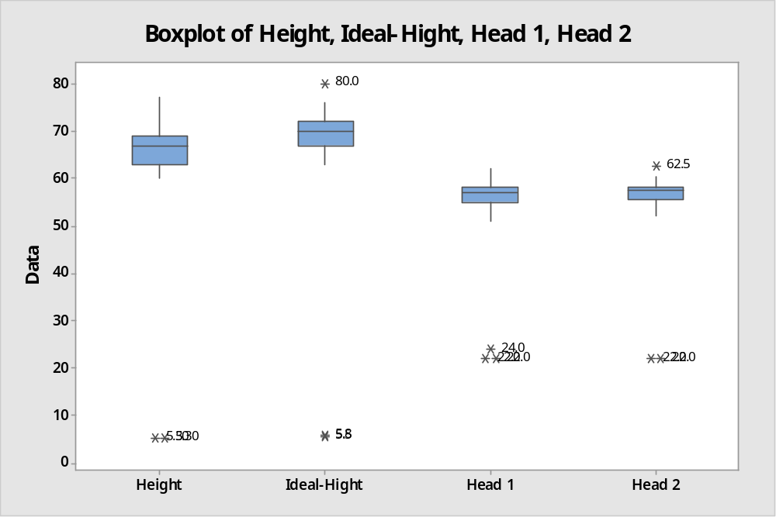

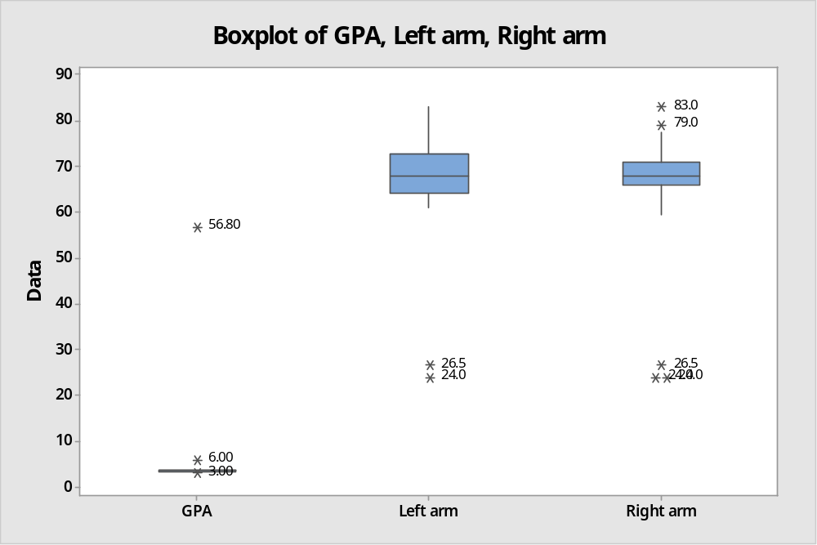

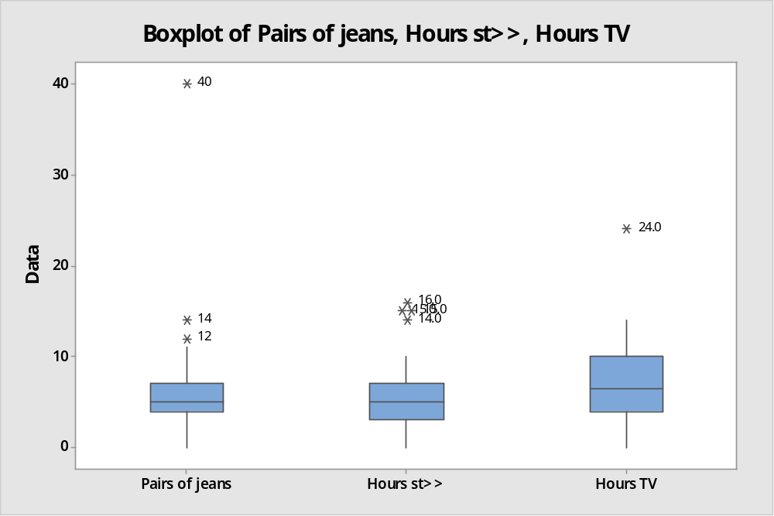

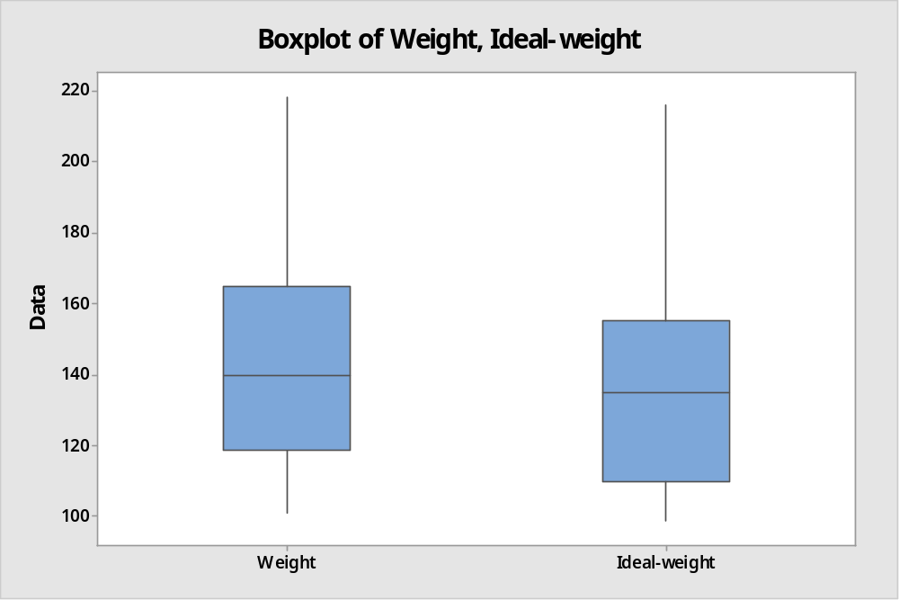

The data indicates the following mistakes:
- The height column has two entries with values 5.3 each. We have marked these entries with a *.
- The ideal-height column also has issues in the same rows as the height. The values are: 5.8 and 5.5. We have marked these entries with a *.
  - There is another outlier row of ideal height= 80. Kept this data since it is plausible
- There is a GPA row with 56.8. We have marked these entries with a *.
- There are three rows with head 1 size between 22 and 24. Also two rows have head 2 as 22. We have marked these entries with a *.
- One entry for column Hours TV is 24 (assuming the unit is hrs, this is an error)
- In the arm length columns (Left Arm, Right Arm) there are values 26.5 and 24. There is one row where the left arm and right arm are far apart (Left: 74 and Right: 24). What do you think about this? Could it be an error or can it be on account of disabled adults? (not replaced these entries with *)

Resolutions of Data Entry Mistakes
We have marked the entries highlighted above with a *.
- Use a graphical method to locate entry errors for qualitative variables you may use in the following problems. You only need to give one example of a qualitative variable with entry error and you should detail how to fix the problem.

Mistakes:
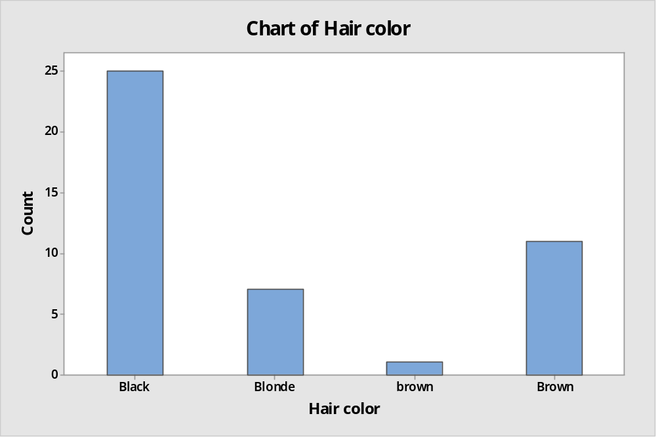
As shown in the bar graph for Hair Color, we have entries for color brown and Brown (difference in case). We will change all the entries with brown to be Brown. So we will get the bar chart as:

Corrected:
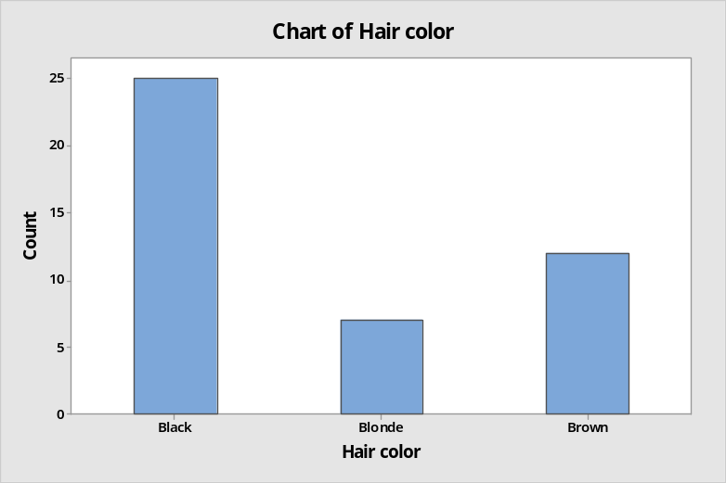

We also have issues with column: Hub Food
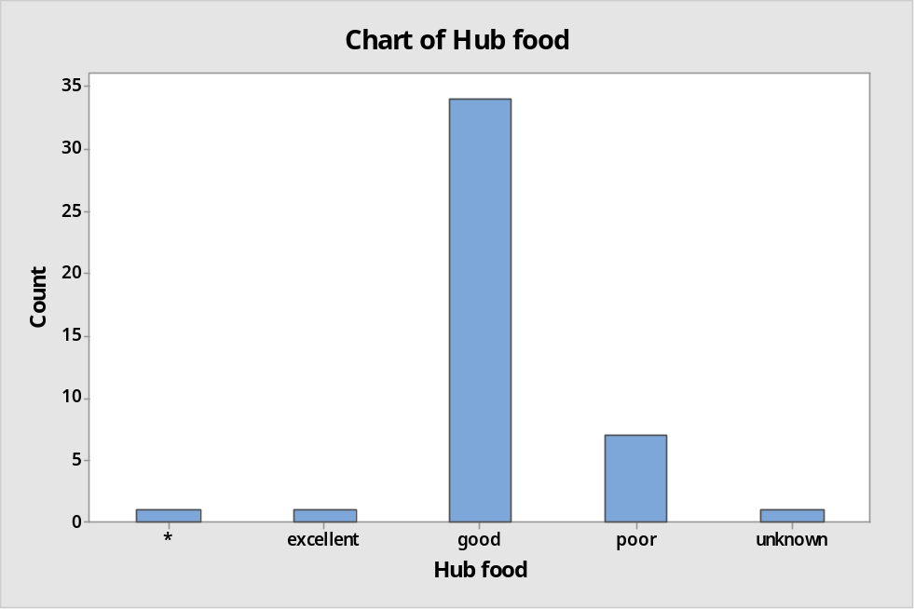

The data entry form has no entry for unknown, but we have occurrences for this value. We will mark these as *.

We again have issues with having same value in different cases within the race column:
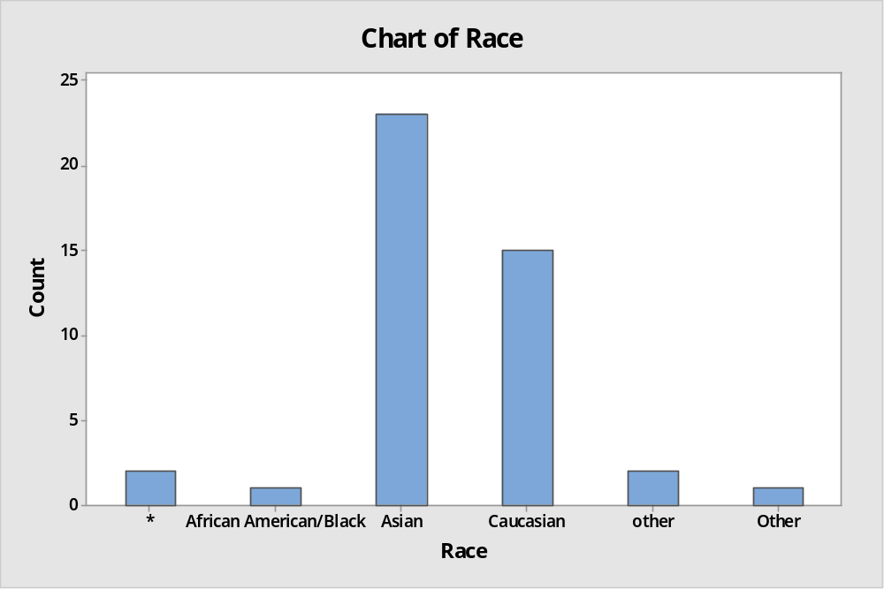
We will change all “other” to “Other”

There are many discrepancies in the column “Chart of College”. This type of column is best handles by providing options.
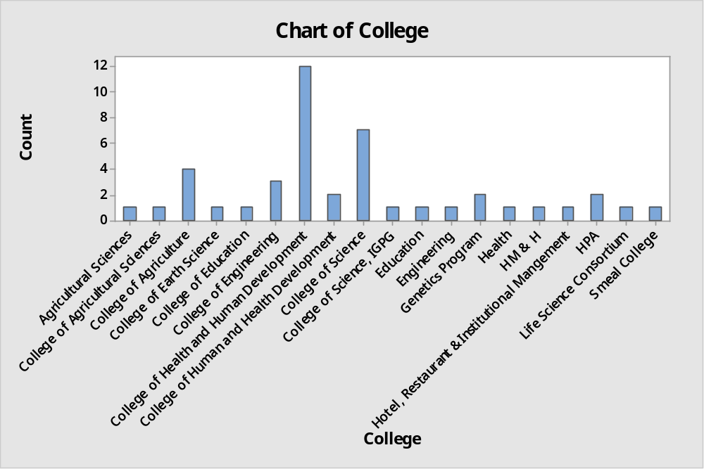

There are numerous entries that refer to same entity but are entered differently (incorrectly):
- Agricultural Sciences, College of Agricultural Sciences, College of Agriculture. Merged as College of Agricultural Sciences
- Education and College of Education. Merged as College of Education
- Engineering and College of Engineering. Merged as College of Engineering
- College of Health and Human Development vs College of Human and Health Development. There is also an entry marked “Health”. Merged all as College of Human and Health Development
- College of Science vs College of Science, IGPG. Merged as College of Science
The bar chart after making the above corrections is:
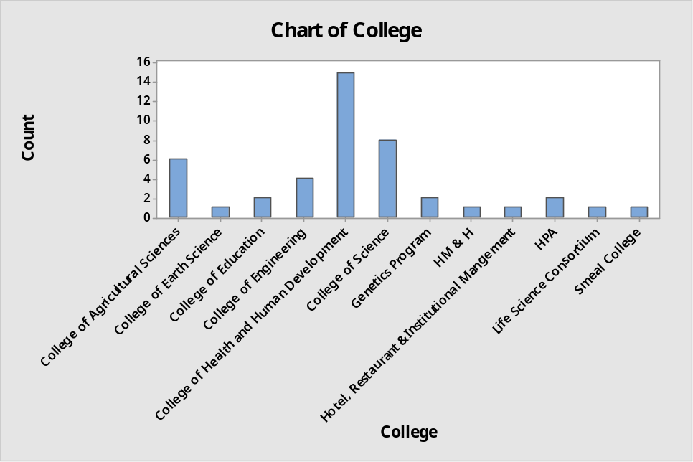

- Test of two means, independent samples: Consider a scenario where a two-sample t-test is the appropriate tool of analysis. Set up a hypothesis for a one-tailed test. Show your work on checking the assumptions in order to use the two-sample t-test. Also, give some justifications for using the separate variances test or the pooled variances test that you use. What is the p-value of the test? Draw a conclusion for α=0.01. Give an interpretation of the interval. (Note: two-sample t-test is for independent samples, two measurements from the same subject usually form paired data, not independent samples)

- Test of two means, paired samples: Consider a scenario where a paired t-test is the appropriate tool of analysis. Set up a hypothesis for a two tailed test. Show your work on checking the assumptions in order to use the paired t-test. What is the p-value of the test? Draw a conclusion for α=0.05.

- Suppose you want to test whether on an average graduate students want to weigh less than what their weights actually are. How many students would you sample so that you may get a power of 0.80 if the minimum detectable difference is 1 lb and α=0.05?
(Pay attention to estimation of the sample standard deviation, whether the data is paired or independent. Is this a one-tailed or a two tailed test?)

- Pick two qualitative variables that you are interested in and give a scenario for using the chi-square test of independence. Perform the hypothesis test and draw a conclusion for α=0.05. Check conditions to see whether you can use the chi-square test.

