STAT500 HW#11 Solution

- Problem in Handout (15pts)
a)
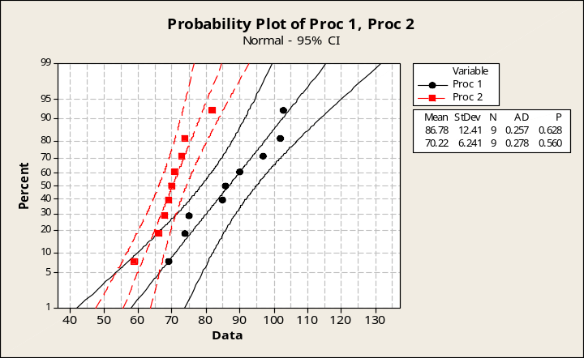

b) From the normality plots (shown above), the assumption of normality seems reasonable.

c) We want to test the following hypotheses, H_{o}: σ²₁ = σ²₂, H_{a}: σ²₁ ≠ σ²₂ (this is two-sided test), where 1 = procedure 1, 2 = procedure 2; α = 0.10.

Homogeneity of Variance
Response psi
Factors procedure
ConfLvl 90.0000

Bonferroni confidence intervals for standard deviations

Lower Sigma Upper N Factor Levels
8.38069 12.4074 23.7698 9 Procedure 1
4.21522 6.2405 11.9555 9 Procedure 2

F-Test (normal distribution)
Test Statistic: 3.953
P-Value : 0.069

Levene's Test (any continuous distribution)
Test Statistic: 4.547
P-Value : 0.049

Since normality assumptions are valid, we can use the F-Test. We reject H₀ (F = 3.953; p = 0.069) at α = 0.10 significance level due to p-value = 0.069 < α. Therefore, given the data, we can conclude that the population variances are not equal.

- Problem 6.43 (15 pts)
(a) The data are not paired. Need to determine whether to use pooled variance or separate variance. Also both n₁ and n₂ are less than 30. So need to check normality assumption for both sets.

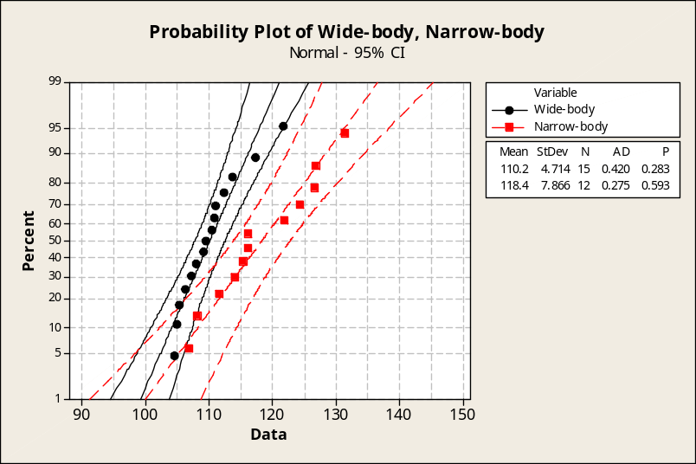

Normality assumptions in both cases are satisfied.

Thus F-test can be applied to test the equality of variances.

Test for Equal Variances: C1, C2

95% Bonferroni confidence intervals for standard deviations

N Lower StDev Upper
C1 15 3.30876 4.71442 7.9907
C2 12 5.31926 7.86619 14.5407

F-Test (Normal Distribution)
Test statistic = 0.36, p-value = 0.075

Levene's Test (Any Continuous Distribution)
Test statistic = 3.36, p-value = 0.079

From the output, we have p-value=0.075 > 0.05, and thus conclude that there’s no significance difference between the variances of the two areas. Pooled StDev can be applied.
[Note that here the Rule of Thumb that we followed for HW 10 led us to use separate variances]

Two-Sample T-Test and CI: C1, C2

Two-sample T for C1 vs C2

N Mean StDev SE Mean
C1 15 110.20 4.71 1.2
C2 12 118.37 7.87 2.3

Difference = mu (C1) - mu (C2)
Estimate for difference: -8.17

95% CI for difference: (-13.19, -3.14)

T-Test of difference = 0 (vs not =): T-Value = -3.35 P-Value = 0.003 DF = 25

Both use Pooled StDev = 6.2986

From the output, P-value = 0.003 < 0.05, indicating that we can reject the null hypotheses of mean noise level being equal and conclude that narrow-body jets have a higher noise level.

(b) 95% confidence interval of the difference between the two noise levels is
(-13.19, -3.14)

[Naturally the c.i. is also different from what we got in HW10]

- Problem in Handout (15 pts)
Let π₁ = population proportion of registered Republicans in favor of additional tax incentives, π₂ = population proportion of registered Democrats in favor of additional tax incentives. Using Minitab we will perform the following hypothesis test
H_{o}: π₁ – π₂ = 0, H_{a}: π₁ – π₂ > 0 (one-sided right tailed test); α = 0.05.
n₁ = n₂ = 200; 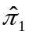= 109/200 = 0.545, 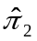= 86/200 = 0.430
Since n₁= 109 > 5, n₁(1-) = 91 > 5 and n₂= 86 > 5, n₂(1-) = 114 > 5, thus we can use the 2-proportion z-interval.

Test and CI for Two Proportions
Sample X N Sample proportion (p)
1 109 200 0.545000
2 86 200 0.430000

Estimate for p(1) - p(2): 0.115
95% CI for p(1) - p(2): (0.0176828, 0.212317)
Test for p(1) - p(2) = 0 (vs > 0): Z = 2.30 P-Value = 0.011

We should reject H_{o} (z = 2.30; p = 0.011<0.05) at α = 0.05 level and conclude that the population proportion of registered Republicans is greater than that of registered Democrats who favor additional tax incentives.

- Problem 10.65 (15 pts)

H_{o}: The opinion is independent of membership status
H_{a}: The opinion is dependent of membership status

Chi-Square Test: Favor, Indifferent, Opposed

Expected counts are printed below observed counts
Chi-Square contributions are printed below expected counts

Favor Indifferent Opposed Total
1 140 42 18 200
70.00 80.00 50.00
70.000 18.050 20.480

2 70 198 132 400
140.00 160.00 100.00
35.000 9.025 10.240

Total 210 240 150 600

Chi-Sq = 162.795, DF = 2, P-Value = 0.000

Reject the independence hypothesis (p-value<0.01). We can conclude that the opinion is dependent of membership status (not independent). The evidence is strong since the p-value is 0.000, very small.

- Problem in Handout (10 pts)
χ² = 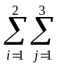[(n_{ij} – E_{ij})²/E_{ij}]
=(140-70)²/70 + (42-80)²/80 + (18-50)²/(50) + (70-140)²/(140) + (198-160)²/(160) + (132-100)²/(100) = 70 + 18.05 + 20.48 + 35 + 9.025 + 10.24 = 162.795
df = (3-1) (2-1) = 2

- Problem 10.80 (15 pts)

a) Expected counts are given as the following table.
 | 0 – 4.5 | 4.5 – 9 | 9 – 13.5 | 13.5
0 – 2.5 | 17.902 | 20.971 | 23.784 | 26.342
2.5 – 5 | 24.138 | 28.276 | 32.069 | 35.517
5 – 7.5 | 16.695 | 19.557 | 22.181 | 24.566
7.5 | 11.264 | 13.195 | 14.966 | 16.575

b)The testing hypotheses are
H_{o}: “length of time on first job” is unrelated (independent) to “amount of education,
H_{a}: “length of time on first job” is related (dependent) to “amount of education”.
We use the “chi-square” statistic to test the hypotheses.

You can use the SAS output to work this problem out. The minitab output is provided below for your reference only.

Chi-Square Test
Expected counts are printed below observed counts
0-4.5 4.5-9 9-13.5 13.5 Total
0-2.5 5 21 30 33 89
17.90 20.97 23.78 26.34
2.5-5 15 35 40 30 120
24.14 28.28 32.07 35.52
5-7.5 22 16 15 30 83
16.70 19.56 22.18 24.57
7.5 28 10 8 10 56
11.26 13.20 14.97 16.57

Total 70 82 93 103 348

Chi-Sq = 9.299 + 0.000 + 1.624 + 1.683 +
3.459 + 1.599 + 1.961 + 0.857 +
1.685 + 0.647 + 2.325 + 1.202 +
24.864 + 0.774 + 3.242 + 2.608 = 57.830

DF = 9, P-Value = 0.000
From χ² = 57.83 with d.f. = 9 and p-value = 0.000. Since the p-value is relatively small, we can reject H_{o} and conclude that “length of time on first job” is related to the “amount of education”.

c) The level of significance for the test is the p-value defined in part (b) = 0.001 (using SAS output) and 0.000 using the minitab output. This is simply a different choice in the presentation style of SAS versus minitab and both are acceptable.

- Using α = 0.05, again, we can reject H_{o} (p = 0.000) and make the conclusion drawn in part (b).

- Problem in Handout (15 pts)
Social status | A few | some | lots | Total
Middle | 7( 7.397 ) | 13( 11.836 ) | 16(16.767 ) | 36
working | 8( 7.603 ) | 11( 12.164 ) | 18( 17.233) | 37
Total | 15 | 24 | 34 | 73

Expected counts are printed below observed counts
Chi-Square contributions are printed below expected counts

A few Some Lots Total
1 7 13 16 36
7.40 11.84 16.77
0.021 0.115 0.035

2 8 11 18 37
7.60 12.16 17.23
0.021 0.111 0.034

Total 15 24 34 73

Chi-Sq = 0.337, DF = 2, P-Value = 0.845

Conclusion: At α = 0.05, fail to reject H₀ (P-value=0.845). There is not sufficient sample evidence to reject that nursery-rhyme knowledge and social status are independent.

