Stat 500: Practice Midterm 2

Note that the purpose of this practice exam is to let you know about the format for the midterm. It does not indicate the length of or the subjects that will appear on the midterm.

Note: Setting up a null and an alternative hypotheses is crucial to solving hypotheses testing problems. Full credits will not be given if hypotheses are not properly set.

- A doctor is interested in estimating the percentage of blood donor member that have blood type A. Identify the population of interest to the doctor. Is this an estimation problem or a hypothesis testing problem?

Population of interest: Blood type of blood donors.
This is an estimation problem

- A rancher is interested in estimating how many hours his tractor runs on a full tank of gas. A random sample of n = 25 tanks of gas was monitored and the number of hours the tractor ran was recorded for each tank. The average number of hours that the tractor ran for one tank of gas was found to be 23.6, with a standard deviation of 0.8. Using the Normal Probability Plot, we have checked that the sample may have come from a Normal distribution. Construct a 90% confidence interval for the mean number of hours that the tractor runs on a full tank of gas.

Sample size n = 25
Sample mean = 23.6 s = 0.8
T(0.05) = 1.711 when degree of freedom is 24
90% Confidence interval is
23.6 ± 1.711 x 0.8/ sqrt(25) = 23.6 ± 0.27376
The 90% confidence interval is (23.326, 23.874)

- In a study of radio listening habits, a station owner would like to estimate the average number of hours that teenagers spend listening to any radio station every day. It is reasonable to assume that it ranges from 0 to 6 hours. How many teenagers should he sample so that he can estimate the average number of hours to within 0.5 hours with 94% confidence?

E = 0.5
Standard deviation can be approximated by range/4 = 6/4 = 1.5
Use Z-table to find the value corresponding to a probability of 1-0.03 = .9700
Z(0.03) = 1.881

Estimated sample size
n = (1.881)**2 x (1.5)**2 / (0.5)**2
= 31.84

Round it up to 32.

- True or False: In order to check the normality assumption, we obtain the following normal probability plot of the sample using Minitab. We can conclude that the normality assumption is violated.

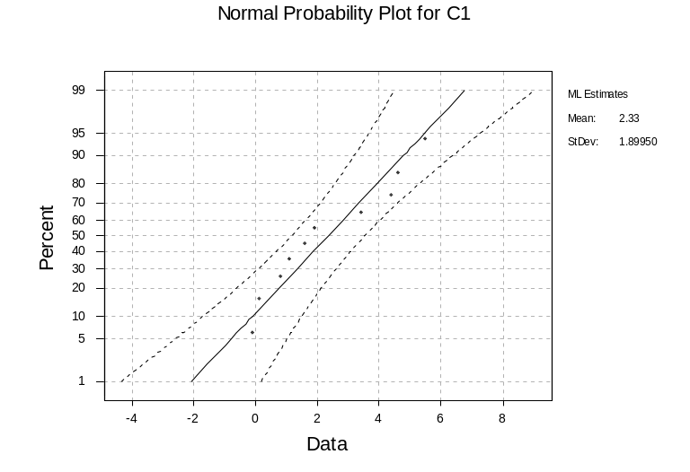

False. All points fall within the confidence bands of the plot, thereby allowing us to assume that the population follows a normal distribution

(If 1 or 2 points were slightly outside the bands we would still conclude that normality holds)

- In a study of radio listening habits, a station owner would like to estimate the proportion of teenagers that listen to radio for at least one hour each day. How many teenagers should he sample so that he can estimate the proportion to within 0.1 with 90% confidence?

Use conservative method
E = 0.1 α = 0.1, Z(α/2) = 1.645
Pi-hat = 0.5

N = (1.645)² (0.5) (0.5) / (0.1) ² = 67.65

We round it up to 68

- A researcher want to estimate the proportion of U.S. employees that “play hooky”, that is, call in sick at least once a year when they simply need time to relax. A poll was taken of 1000 and 200 respond ‘yes’. Use these data to obtain a 95% confidence interval for the population proportion.

Check whether one can use z-interval:

n x pi-hat = (0.2) ( 1000) =200 >= 5
n x ( 1- pi-hat) = (0.8) (1000)=800 >= 5

pi-hat = 0.2 st. dev(pi-hat) =√(0.2)(1 - 0.2) / 1000)
Z(.025) = 1.96

The 95% confidence interval is: 0.2 ± 1.96 x 0.0126
= 0.2 ± 0.02479 = (0.175, 0.225)

- What is a type I error? What is a type II error?

Type I is the probability of rejecting H₀ when, in fact, it is true.
Type II error is the probability of failing to reject H₀ when, in fact, it is false.

- An expert claims that the proportion of people with blood type O is 0.25. Out of 40 randomly selected persons, 8 have blood type O. Does one conclude that the proportion of blood type O is different from 0.25?

H₀: π = 0.25 Ha: π ≠0.25

n*π₀ = 40*0.025 = 10 > 5 and
n*(1-π₀) = 40*0.75 = 30 > 5.

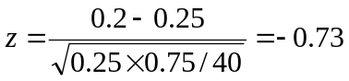,

p-value=2*p(z≥|-0.73|) = 2*0.2327 = 0.4654.
Because p-value = 0.4654 > α,
we cannot reject the null hypothesis.

