Lesson 10
 Reading: An Introduction to Statistical Methods and Data Analysis, Chapters 6.1, 6.2 and 6.4.
In this homework, one important issue is to identify whether to use 2 sample-t procedure or to use paired-t procedure. Another issue is whether to use a pooled or separate variance estimate. See sample problems to make the distinction

Sample Homework Problem
- Is the data in Problem 6.57 (6.65 in 5th ed) paired data or independent data?
- Is the data in Problem 6.64 (6.86 in 5th ed) paired data or independent data?
- According to the publication, High School Profile Report, in past years college-bound males have out-performed college-bound females on the mathematics portion of tests given by ACT Program. Samples of this year’s score yield the following data.
Males | 34 | 34 | 30 | 18 | 24 | 16 | 15 | 26 | 13 | 21 | 24 | 11 | 11 | 15
Females | 18 | 33 | 27 | 11 | 23 | 23 | 18 | 20 | 26 | 10 | 20 | 22 | 14 | 21
Does it appear that college-bound males are, on the average, still outperforming college-bound females on the mathematics portion of ACT tests? Set up the hypothesis. Indicate whether you are going to use 2-sample t-test or paired t-test for the problem. If you use 2-sample t test, will you use pooled or non-pooled variances? What conditions will you check before you perform the test?
- Eleven tires were each measured for treadwear by two methods, one based on weight and the other on groove wear. Here are the data in thousands of miles:
Weight method | 30.5 | 30.9 | 31.9 | 30.4 | 27.3 | 20.4 | 24.5 | 20.9 | 18.9 | 13.7 | 11.4
Groove method | 28.7 | 25.9 | 23.3 | 23.1 | 23.7 | 20.9 | 16.1 | 19.9 | 15.2 | 11.5 | 11.2
Does it appear the two methods, on the average, give different results? Set up the hypotheses. Indicate whether you are going to use 2-sample t-test or paired t-test for the problem. If you use 2-sample t test, will you use pooled or non-pooled variances? What conditions will you check before you perform the test?

Solutions:
- The data in 6.57 is paired data. Observations for ‘before’ and ‘after’ are paired since from each grid two observations are taken and compared.

- The data in 6.86 is independent data. There is no paired structure between the SUV sampled and the Midsize cars sampled. All cars are crashed under the same condition.

- We have two independent samples because there is no paired relationship between the scores of males and females. We do not choose the male female samples according to any paired structure.

Since the sample size for each population is not large enough, we need to check the normality assumption for both samples.

After checking the normal probability plots of both populations, we can conclude that both of the two samples may come from a normal distribution. You should include the two normal probability plots. (The plots are omitted here for the sake of space.)

Set up the hypotheses:
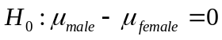 vs. 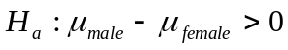

Now we need to decide to use pooled or non-pooled variance.

For that, we will need to compare the standard deviation of the two populations.
Printout from Minitab:

Stat>Basic Statististic

Variable N Mean Median TrMean StDev female 14 20.43 20.50 20.25 6.20 male 14 20.86 19.50 20.58 8.00

Using the rule of thumb to determine whether to use the pooled versus the separate variances (see handout in the “Handout” folder :

S1/S2 = 6.20/8.00 = 0.775 > 0.707.

We thus choose to use pooled t-test and check the box “Assume equal variances”.

Using:

Stat > Basic Statistics > 2-sample t

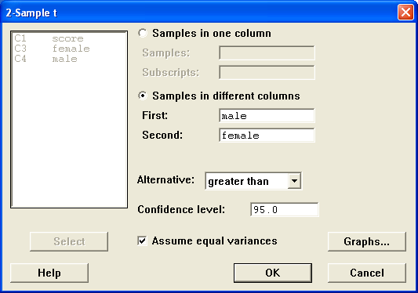

The output is:

Two Sample T-Test and Confidence Interval

Two sample T for male vs female

N Mean StDev SE Mean
male 14 20.86 8.00 2.1
female 14 20.43 6.20 1.7

95% CI for mu male - mu female: ( -5.1, 6.0)
T-Test mu male = mu female (vs >): T = 0.16 P = 0.44 DF = 26
Both use Pooled StDev = 7.16

The p-value of the test is 0.44 . In the problem, the level of significance is not given. We will then use the default value 0.05. Since p-value = 0.44 > 0.05 , we fail to reject the null hypothesis. Based on the data, we cannot conclude that male has higher math ACT score than female on the average.

- The data are paired since the two methods are measured on the same tire. The two measurements from the same tire are dependent since we do anticipate that tires with high measurement on one of the method will also have high measurements from the other method.

Since the sample size is not large, we need to check whether the differences follow a normal distribution.
First we need to compute the differences:

Calc> diff = weight method – groove method

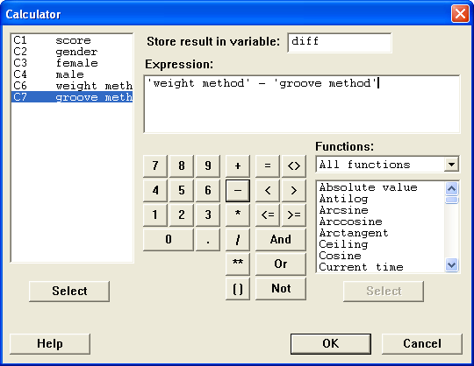

You should draw the normality plot for “diff”. (The plot is omitted here for the sake of space.)

The plot suggests that the differences may come from a normal distribution. We can proceed with a paired t-test.

Set up the hypotheses:
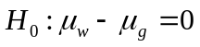 versus 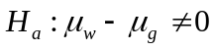

Stat> Basic Statistics > Paired t
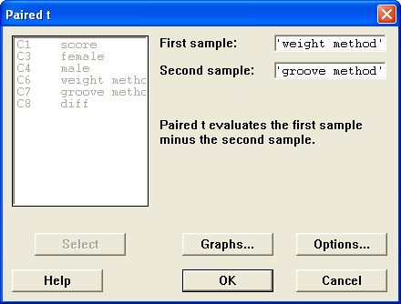

Minitab output:

Paired T-Test and Confidence Interval

Paired T for weight method - groove method

N Mean StDev SE Mean
weight m 11 23.71 7.19 2.17
groove m 11 19.95 5.77 1.74
Difference 11 3.755 3.221 0.971

95% CI for mean difference: (1.590, 5.919)
T-Test of mean difference = 0 (vs not = 0): T-Value = 3.87 P-Value = 0.003

Based on the Minitab output above, we have computed t value =3.87 with the p-value=0.003 for the two-tailed test. In the problem, the level of significance is not given. We will then use the default value 0.05. Since 0.003<0.05, we can reject the null hypothesis and conclude the alternative. We conclude that the two methods on average give different results.

Practice Homework: (Please do not submit these problems): 6.11, 6.27, 6.46.

Submit the following Homework Problems to “Dropbox for HW 10”
Notes:
- The answers to the problems will be posted on the Sunday after the due date.
- You may use Minitab whenever appropriate and include the Minitab output in your homework. To place Minitab output into your homework, highlight the portion of the Minitab printout you want, copy that to the clipboard, and then paste it into the document.
- Problem 6.13 (6.16 in 5th ed) (note that the output is given in the problem and thus you do not need to use minitab to find the output again)
- Problem 6.29 (6.32 in 5th ed) (again, for this problem, the Minitab output is given in the book)
- Problem 6.43 (6.39 in 5th ed) (a), (b) (Do not use Minitab for testing)
- Problem 6.55 (6.63 in 5th ed) (you may use Minitab, remember to check condition)
- Problem 6.56 (6.64 in 5th ed)
- Current Population Reports presents data on the ages of married people. Ten married couples are randomly selected and have the ages shown here:
Husband | 64 | 21 | 32 | 78 | 70 | 33 | 68 | 35 | 51 | 52
Wife | 53 | 22 | 33 | 79 | 64 | 35 | 67 | 30 | 51 | 48
Do the data suggest that the mean age of married men is greater than the mean age of married women? Determine whether you will use two sample t-test or paired t-test. (Hint: is the data paired? ) Check conditions and use Minitab to perform the test. Test at 3% level of significance.
- The costs of major surgery vary substantially from one state to another due to differences in hospital fees, malpractice insurance cost, doctors’ fees and rent. A study of hysterectomy costs was done in California and Montana. Based on a random sample of 200 patient records from each state, the sample statistics shown here were obtained.
State | n | Sample Mean | Sample Standard Deviation
Montana | 200 | $6,458 | $250
California | 200 | $12,690 | $890

- Is there significant evidence that California has a higher mean hysterectomy cost than Montana?
- Estimate the difference in the mean costs of the two states using a 95% confidence interval.
- Justify your choice between using the pooled t-test and the separate variance t-test in part (a)

