An Overview of Statistical Inference

Objective is to draw conclusion about a population based on information contained in a sample.

Building blocks
- A population is characterized by its parameters, which are constant.
- Sample statistics may vary from one sample to the other.
- Sample statistics are random variables and a probability distribution is attached to each sample statistic.
Normal distribution plays a major role in statistical inference
[Note: Assumption of normal distribution is to make the inference procedure easier. This is the reason large samples and central limit theorem are important. They justify application of normal distribution. When sample size is small, different procedure is required for statistical inference. Those are called Exact procedures]
Statistical Inference may be of two types
- Estimation of a Parameter
  - Point Estimation
  - Confidence Interval
- Testing of Hypothesis
Point Estimation has already been covered. A sample statistic that is used in lieu of a population parameter may be called a point estimate of the parameter. Some examples are
- Sample proportion is a point estimate of population proportion
- Sample average is a point estimate of population mean
- Sample standard deviation is a point estimate of population standard deviation

- Inference about Population Proportion: Binomial Parameter π

If y is the number of successes in n sample trials then π-hat = y/n
Mean of π-hat = π
Std error of π-hat = √(π(1-π)/n)

If nπ >= 5 AND n(1-π) >= 5
  - π-hat follows NORMAL distribution with above parameters
  - normal distribution may be utilized for construction of confidence intervals and hypothesis testing

If nπ < 5 OR n(1-π) < 5 mean and std error of π-hat is as given above but the distribution of π-hat is no longer normal. In this case application of EXACT procedure is mandated

  - Confidence Interval for π with Confidence Coefficient of (1 – α): 1-proportion Z Interval

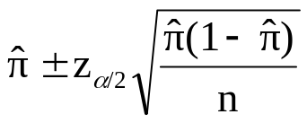

  - Hypothesis Testing for π: 1-proportion Z Test

Null hypothesis H_{o} : π= π_{o}
Alternative hypothesis H_{a} : π ≠ π_{o} or H_{a} : π > π_{o} or H_{a} : π < π_{o}

Test statistics constructed under H_{o}
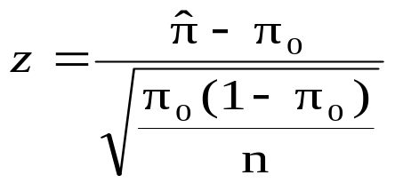

[Note: Computation of confidence interval involves π-hat only whereas computation of test statistics involves π-hat as well as π_{o}]

    - Rejection Region approach

H_{a} : π ≠ π_{o ,} reject H_{o} if computed z ≥ z_{α/2} or computed z ≤ - z_{α/2}
H_{a} : π > π_{o,} reject H_{o} if computed z ≥ z_{α}
H_{a} : π < π_{o} reject H_{o} if computed z ≤ - z_{α}

    - P-value approach
      - Computation of p-value of test statistic

H_{a} :, π ≠ π_{o} p-value = 2 P(z ≥ |computed z|)
H_{a} : π > π_{o} p-value = P(z ≥ computed z)

H_{a} :, π <π_{o,} p-value = P(z ≤ computed z)

      - How to use p-value of test statistic

Reject H_{o} if p-value ≤ α
Fail to reject H_{o} if p-value > α

- Inference about one Population Mean µ (Assuming population standard deviation σ is unknown)

Consider y-bar to be the sample mean and s to be the sample standard deviation from a sample of size n

If Sample size is large n > = 30
OR Date shows approximate normality
Normal distribution may be utilized for construction of confidence intervals and hypothesis testing

t-statistic is used to construct confidence interval for population mean and for testing hypothesis on population mean
t-statistic is characterized by its degrees of freedom (df)
t-statistic for one population mean has df = n-1 where n = sample size

  - Confidence Interval for µ with Confidence Coefficient of (1 – α): 1-sample t Interval

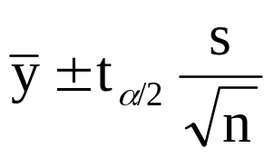

  - Hypothesis Testing for µ: 1 sample t Test

Null hypothesis H_{o} : µ= µ_{o}
Alternative hypothesis H_{a} : µ ≠ µ_{o} or H_{a} : µ > µ_{o} or H_{a} : µ < µ_{o}

Test statistics constructed under H_{o}

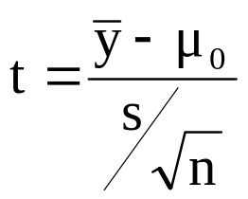

[Note: Computation of confidence interval involves y-bar = µ-hat only whereas computation of test statistics involves y-bar as well as µ_{o} . In both cases sample standard deviation s is used since population standard deviation σ is assumed unknown]

    - Rejection Region approach

H_{a} : µ ≠ µ_{o ,} reject H_{o} if computed t ≥ t_{α/2} or computed t ≤ - t_{α/2}
H_{a} : µ > µ_{o,} reject H_{o} if computed t ≥ t_{α}
H_{a} : µ < µ_{o} reject H_{o} if computed t ≤ - t_{α}

    - P-value approach
      - Computation of p-value of test statistic

H_{a} :, µ ≠ µ_{o} p-value = 2 P(z ≥ |computed t|)
H_{a} : µ > µ_{o} p-value = P(z ≥ computed t)

H_{a} :, µ <µ_{o,} p-value = P(z ≤ computed t)

      - How to use p-value of test statistic

Reject H_{o} if p-value ≤ α
Fail to reject H_{o} if p-value > α

Result for rejection region approach is the same as p-value approach

Only one of the two approaches should be employed for any testing problem. Once you choose one of the two approaches, you should follow that to the end.

A Note of Caution: Do not mix up the two approaches

