Lesson 4 - Homework
Notes:
- The following numbered homework assignments refer to the problems in the textbook: An Introduction to Statistical Methods and Data Analysis, e.g., 1.2 is problem 1.2 (found on p.14 in chapter 1 for the fifth edition and p.13 in chapter 1 for the sixth edition).
- The answers to the problems will be posted on Sunday after the due date. To view the answers, click on the Homework Solutions link in the menu bar to the left.
- You may use Minitab whenever appropriate and include the Minitab output in your homework.

Useful learning tool: “Lesson 4 Viewlet” is posted in the “Additional Course Resources” folder. The viewlets there show:
- the relationship between probability and cumulative probability of binomial distribution
- how to use standard normal table to find probability to the left of z
- given probability, how to find z value
- using minitab to find cumulative probability and probability of binomial distribution, also using minitab to find z-value of normal distribution
- a viewlet for sample homework problem 5

1. Let Y be a binomial random variable with n = 12 and π = 0.4. Find the following values (you may use minitab) :
a. P( Y ≤ 2)
b. P( Y > 2) you should be able to get this pretty easily, without adding up lots of numbers
c. P(Y > 3)

- P(Y<=2) is cumulative = 0.0834
- P(Y > 2) = 1 – P(Y<=2) = 1 – 0.0834 = 0.9166
- P(Y > 2) = 1 – P(Y<=3) = 1 - P(Y<=2) - P(Y=3) = 1 – 0.0834 - 0.1419 = 0.7747

2. The demand of a certain book in a bookstore on any given day is given by the following table:
y | 0 | 1 | 2 | 3 | 4 | 5 | 6 | 7
P(y) | 0.1 | 0.2 | 0.3 | 0.15 | 0.1 | 0.05 | 0.05 | 0.05

Find: a. The probability that on any given day the demand is more than 4
  - The probability that on any given day the demand is less than or equal to 2
  - On 5 randomly chosen days, what is the probability that 3 of the 5 days have demand more than 4
- P(Y > 4) = 0.05+0.05+0.05 = 0.15
- P(Y <= 2) = 0.1+0.2+0.3 = 0.6
- Binomial with P=0.15, n =5
P(Y = 3) = 0.0243844

3. Construct a table similar to the one listed under problem 4.45 of the 6th edition which is problem 4.39 of the 5th edition for n =9 p=0.3. [Pay attention to the relation between P(X=x) and P(X <=x).Note that you may use minitab to find the probabilities, etc.] Thus, for this problem, the probability of failing the inspection is 0.3 and there are 9 automobiles. Use the table to answer:
a. What is the probability that exactly 2 of the 9 failed the inspection
b. What is the probability that 6 and more of the 9 failed the
inspection

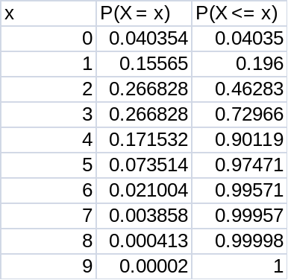

- P(Y = 4) = 0.266828
- P(Y >= 6) = 1 – P(Y <= 5) = 1 - 0.97471 = 0.02529

4. Refer to sample problem 3: Problem 4.46 of the 6th edition which is problem 4.47 of the 5th edition, compute the probability that three out of the 10 trainees are rated as satisfactory or excellent/good.

- n=10, = satisfactory or excellent/good=0.10+0.75=0.85
Probability Density Function

Binomial with n = 10 and p = 0.85

x P( X = x )
3 0.0001259
Therefore P(Y=3) = 0.0001259

5. Problem 4.63 same for both 6th and 5th editions

P(-z0 < z < z0) = .95
Due to symmetry of P (-z₀ < Z < z₀) = 0.95 we have
2 × P (Z > z₀) =1-0.95= 0.05
P (Z > z₀) = 0.025=1 − P (Z ≤ z₀)
Therefore P (Z ≤ z₀) = 0.975
The z-value corresponding to this entry is 1.96

6. Problem 4.72 of the 6th edition which is problem 4.76 of the 5th edition (hint: the score that separates the top 20% of the population from the bottom 80% is called the 80th percentile)

7. In a large construction company, 9 workers are randomly selected, only 2 are female. Is there evidence to doubt that the proportion of female workers is 0.4 or more ? (a probability less than the default value of 0.05 is considered doubtful ) Note that here it is not appropriate to use the empirical rule approach since the distribution is not mound shape. You should use the alternative approach mentioned in the lesson.

Reading: An Introduction to Statistical Methods and Data Analysis, chapters 4.8, 4.9, 4.10.
Sample homework problems: (solution given below)
1. Let y be a binomial random variable with n=8, p=0.4. Use minitab to find
a. P(y ≤ 4)
b. P(y > 4)
2. Use minitab to get the table for problem 4.45 of the 6th edition which is problem
4.39 of the 5th edition
3. Problem 4.46 of the 6th edition which is problem 4.47 of the 5th edition
4. Find the value z such that there is an area of 0.01 to the right of z.
5. Find a value for z, say z₀ such that P (-z₀ < z < z₀) = 0.90.

Solution to Sample Homework problems:
1. One can use minitab to find the probability for each of the value 0,1,2,3,4 and then sum up the probabilities.
An alternative simpler way is to use cumulative probability since the cumulative probability at 4 is defined as 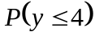. Refer to Lesson 4 viewlet for details.

The following shows how to find the Cumulative probability of Binomial distribution:

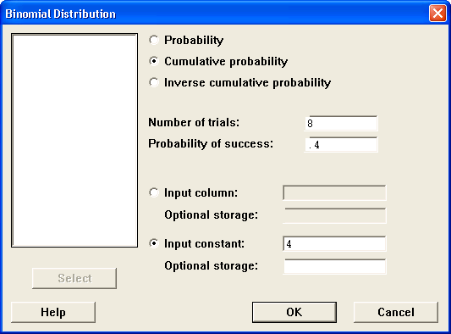

Cumulative Distribution Function

Binomial with n = 8 and p = 0.4

x P( X <= x )
- 0.826330

Thus, 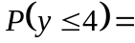0.8263
b.
2. To use minitab to compute the probabilities, you will need to enter the data: 0,1,2,……,10 to C1, then Calc> Probability Distribution. Choose input column instead of input constant. If you choose the dial for Probability, then you get the Probability Distribution Function. If you choose the dial for Cumulative probability, then you get the Cumulative Distribution Function.

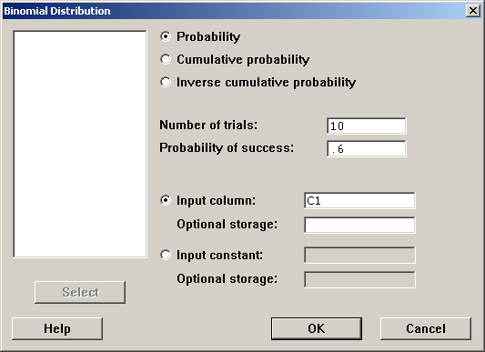

3. Problem 4.47 n=10, =outstanding=0.1
a. 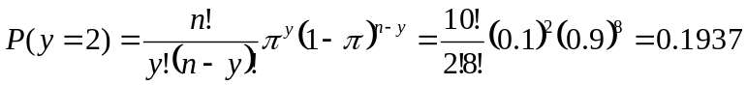
If you prefer, you can also use Minitab>Calc>Probability, set number of trial =10, Probability of success = 0.1, select Input constant: 2 to find the probability.

or 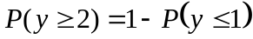= 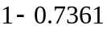=0.2639

- n=10, =outstanding or excellent/good=0.10+0.75=0.85
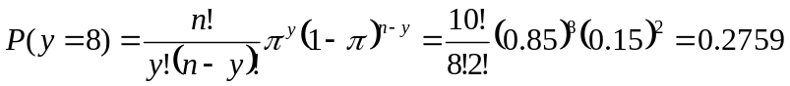

- n=10, =unsatisfactory=0.05
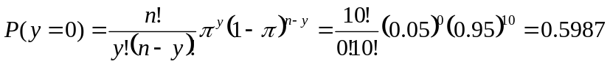

4. An area 0.01 to the right of z means that P (Z > z₀) = 0.01, that is,
1 − P (Z ≤ z₀) = 0.01. Thus P (Z ≤ z₀) = 0.99. And we can find z₀ = 2.33 from The Standard Normal Cumulative Probability for POSITIVE z-values Table.

One can also use minitab to find the z-value:
Minitab>Calc>Probability Distribution>Normal
Since we want to find z-value, we should choose inverse cumulative probability, which is the z-value such that to the left of this z-value has the probability as given. Since to the right of the z-value has probability 0.01, that means to the left of this z-value has probability 0.99.

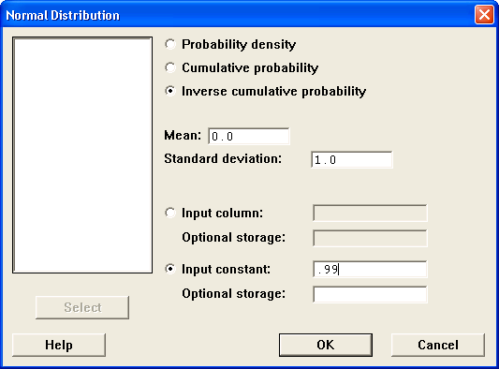

Inverse Cumulative Distribution Function

Normal with mean = 0 and standard deviation = 1

P( X <= x ) x
0.99 2.32635

Thus, the required z-value is 2.33.

5. Find a value, say z₀ such that P (-z₀ <Z < z₀) = 0.90.
For this sample problem, there is a viewlet for it in “Lesson 4 Viewlet”

Due the symmetry of the normal distribution, from P (-z₀ < Z < z₀) = 0.90 we have
2 × P (Z > z₀) =1-0.90= 0.10, that is, P (Z > z₀) = 0.05=1 − P (Z ≤ z₀).
Thus we have P (Z ≤ z₀) = 0.9500. The entry in the Standard normal curve areas that is closest to 0.9500 is 0.9505. The z-value corresponding to this entry is 1.65.

