Minitab 17 Two-way ANOVA (Factorial) model specification

Toolbar Sequence:

Stat > ANOVA > General Linear Model > Fit General Linear Model

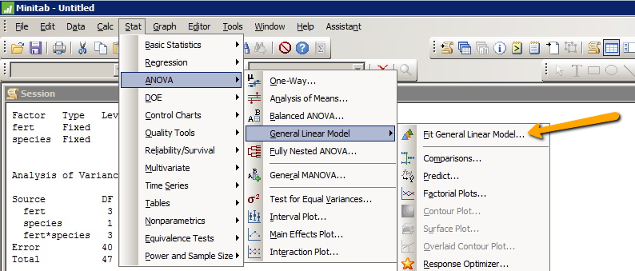

Fill in the Boxes for Responses and Factors:

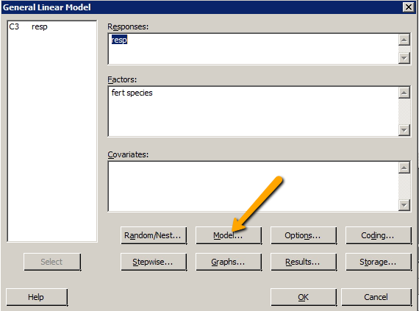

And then click on the “Model” box (arrow above).

Highlight the first of the crossed factors:

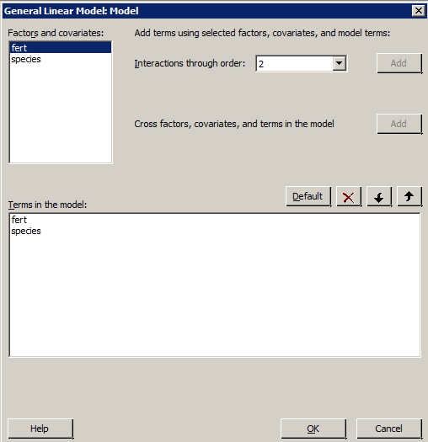

Then hold down the Shift key and highlight the second of the crossed factors:

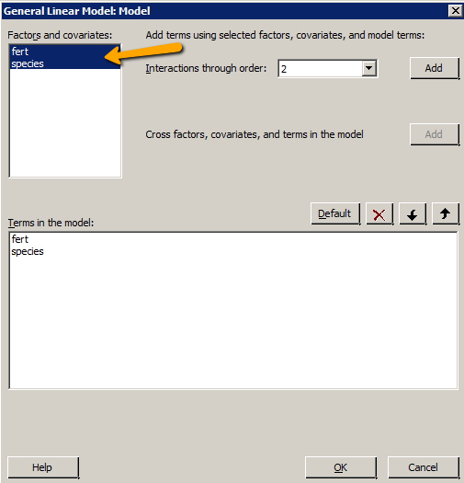

Then you can hit the “ADD” button:

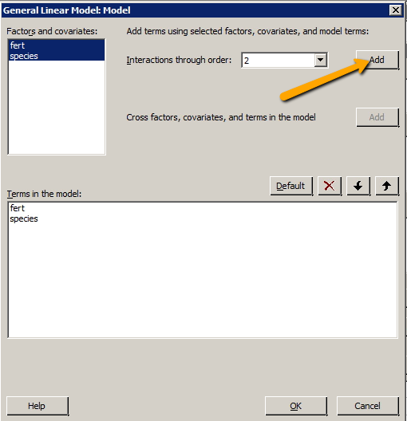

And then OK, OK and the model will run.

Your output should look like this with the two-factor interaction included:

