To run a nested ANOVA in Mintab v. 17, use

Stat > ANOVA > General Linear Model > Fit general linear model. For the data below, considering Factor B to be nested within the levels of Factor A,

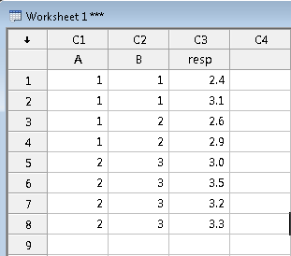

We get the following prompt from the GLM procedure:

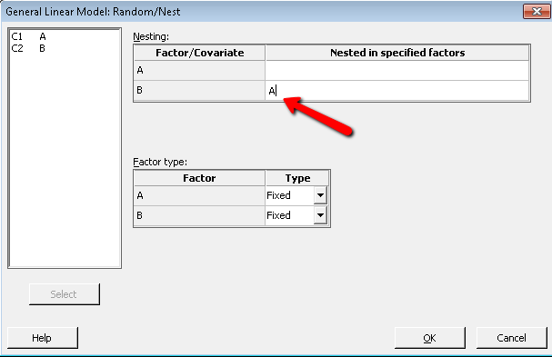

We specify what the nesting variable (here Factor A). Note the default is ‘Fixed’ for Factor Type. For models we encounter later on in the course when we introduce random effects, you have to specify ‘Random’ instead.

Hit OK and you return to the prompt where you can also specify additional factors to the model which may be crossed.

For example, if we also had data with a Factor C, which is crossed with Factor A,

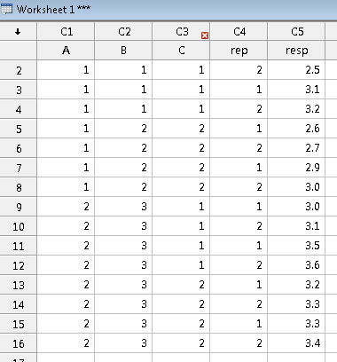

We would add FactorC to the Factors Box, and then click on the Model box:

Then use the ‘CTRL’ key to highlight the two factors you want to cross:

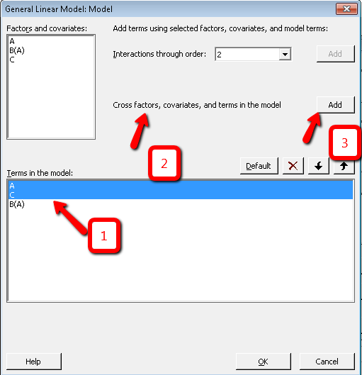

Hit Ok and you will then have the 3-factor cross-nested model with FactorA, FactorB nested with FactorA, FactorC, and the FactorA x FactorC interaction.