Stat 502 Exam 1 Review (Assume α=0.05 for the exam unless otherwise stated).

For equations, you can use terms like mu_i for $μ_{i}$ to save time if using text editors like word.

**1)** A study was conducted to evaluate the effect of three different drugs on blood cholesterol concentration (mg/100 ml plasma) in women. Each drug could be obtained from two different sources and these were also of specific interest to the researchers.

|  |  |  |  |  |  |
| --- | --- | --- | --- | --- | --- |
| **DRUG 1** | | **DRU** | **G 2** | **DRUG 3** | |
| **Source A Source Q** | | **Source D Source B** | | **Source L Source S** | |
| 102 | 103 | 108 | 109 | 104 | 105 |
| 104 | 104 | 110 | 108 | 106 | 107 |

a) (10pts) State the Null and Alternative hypotheses for this experiment.

b) (10pts) Write out the first two columns of the ANOVA table (i.e. Source and df columns).

|  |  |  |  |  |
| --- | --- | --- | --- | --- |
|  |  |  |  |  |

**2)** Consider the following 2-factor factorial, with factor A having 4 levels and factor B having 3 levels, and n=3 observations per treatment combination. Given that the SSA + SSB + SSAxB = 170,

|  |  |  |  |  |
| --- | --- | --- | --- | --- |
| Source | d.f. | SS | MS | F |
| FactorA |  |  | 40 |  |
| FactorB |  | 20 |  |  |
| AxB |  |  |  |  |
| Error |  |  |  |  |
| Total |  | 230 |  |  |

**a)** (10 pts) Complete the ANOVA table.

**b)** (5pts) What is the FCritical (or Fα) for the test of the AxB interaction?

**c)** (5pts) What decision would you make for H0: there is no AxB interaction?

**3)** An experiment is conducted to evaluate the thrust force encountered when drilling in a machine shop. The factors of interest are Material (two levels), the feed rate (3 levels) and the drill speed (5 levels). Two replications of each of the 2 x 3 x 5 combinations of treatments were used in a completely randomized design (i.e., the order in which the treatment combinations were set up and tested was randomized).

|  |  |  |  |  |
| --- | --- | --- | --- | --- |
| material | feed_rate | speed | rep | force |
| A | 0.004 | 100 | 1 | 122 |
| A | 0.004 | 100 | 2 | 110 |
| A | 0.004 | 220 | 1 | 108 |
| A | 0.004 | 220 | 2 | 85 |
| A | 0.004 | 475 | 1 | 108 |
| A | 0.004 | 475 | 2 | 60 |
| A | 0.004 | 715 | 1 | 66 |
|  |  | (…*etc*…) |  |  |
| B | 0.014 | 475 | 1 | 810 |
| B | 0.014 | 475 | 2 | 750 |
| B | 0.014 | 715 | 1 | 893 |
| B | 0.014 | 715 | 2 | 890 |
| B | 0.014 | 870 | 1 | 1820 |
| B | 0.014 | 870 | 2 | 890 |

a) (10 pts) State the Null and Alternative hypotheses for this experiment.

b) (10 pts) Write out the first two columns of the ANOVA table (i.e. Source and df columns).

**4)** An experiment was conducted to compare volume delivery (vol) by 4 machines. For each machine, 6 trials (replications) were recorded and we want to fit the ANOVA model

$$Y_{ij}=μ+τ_{i}+ε_{ij}$$

The data, arranged in unstacked format (*i columns* by *j rows)*, was:

|  |  |  |  |  |
| --- | --- | --- | --- | --- |
| trial | machine1 | machine2 | machine3 | machine4 |
| 1 | 18 | 18 | 15 | 19 |
| 2 | 18 | 19 | 14 | 20 |
| 3 | 19 | 18 | 15 | 18 |
| 4 | 17 | 18 | 16 | 19 |
| 5 | 19 | 19 | 14 | 18 |
| 6 | 18 | 19 | 16 | 19 |

(10 pts) Construct the design matrix **X,** the matrix containing the coded variables as columns, to generate the estimates of $τ_{i}$ for this model using regression.

**5)** A military installation is interested in evaluating the speed of reloading a large gun. Two methods of reloading are considered, and 3 groups of cadets were evaluated (slight, average, and heavy individuals). Three teams were set up within each group and they wanted to identify the fastest team within each group to go on to a demonstration for the military officials. Each team performed the reloading with each method two times (two replications). The dataset (partial) was:

|  |  |  |  |  |
| --- | --- | --- | --- | --- |
| Method | Group | Team | rep | fire_rate |
| 1 | 1 | 1 | 1 | 20.2 |
| 1 | 1 | 1 | 2 | 24.1 |
| 1 | 1 | 2 | 1 | 26.2 |
| 1 | 1 | 2 | 2 | 26.9 |
| 1 | 1 | 3 | 1 | 23.8 |
| 1 | 1 | 3 | 2 | 24.9 |
| 1 | 2 | 4 | 1 | 22 |
|  |  | (*…etc…)* |  |  |
| 2 | 3 | 8 | 2 | 13.8 |
| 2 | 3 | 9 | 1 | 12.7 |
| 2 | 3 | 9 | 2 | 15.1 |

a) (10pts) State the Null and Alternative hypotheses for this experiment.

b) (10pts) Write out the first two columns of the ANOVA table (i.e. Source and df columns).

**6)** The following graphs resulted from a one-way ANOVA.

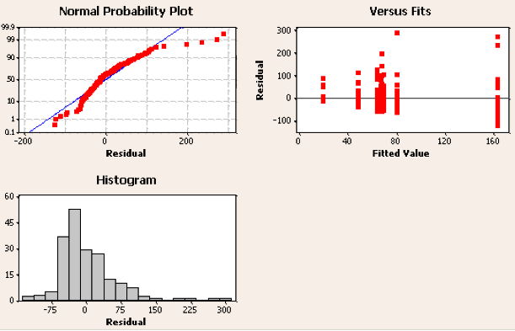

(10 pts) From the graphs above, identify three problems as potential violations of the ANOVA assumptions.