Solutions for Homework for Lesson 13

In a clinical trials study 3 drugs (A,B,and C) were administered to patients with a chronic condition. The degree of improvement was recorded as the response. Each participant was given all three drugs over the course of the study. The order of drug administration to participants was determined by randomly assigning participants to one of 6 sequences. After a drug was given, patients were assessed after 2 days for their condition, and then after a 2 week washout period, were then given the next drug in their sequence. A total of 3 periods were used to complete the study. Two participants were assigned to each sequence.

The data are in the Excel file ‘Lesson 13 Homework Data.xlsx’.

Set up the covariate coding to include adjustment for carry-over effects in an ANCOVA, and run the model as a repeated measures analysis.

To complete the assignment, just submit a single document with your name and the computer output for this analysis.

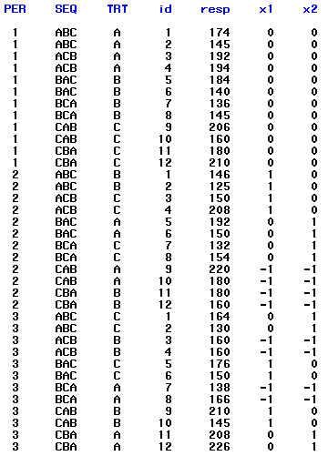

Trying various covariance structures for the repeated measures, and adding some code to each run to compile the results into a summary table:

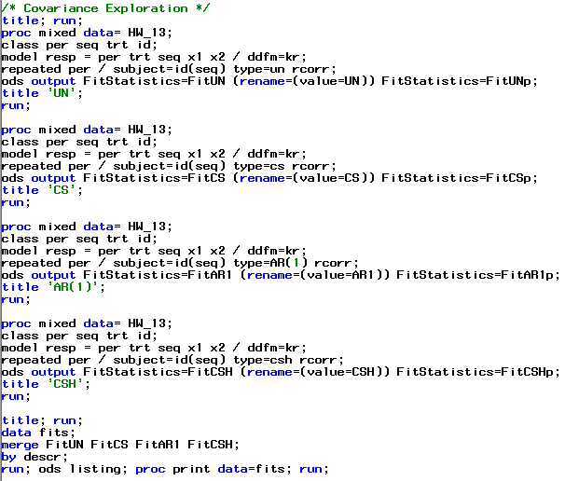

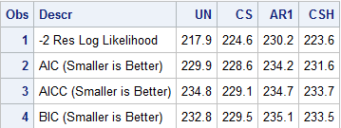

The CS structure provided the best fit and will be used for the final model.

For the ‘final’ model, using CS, we get:

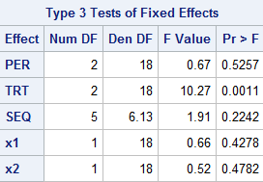

To test the significance of carry-over effects, we run the reduced model (without the carry-over covariates):

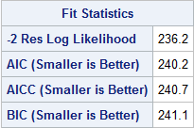

The likelihood ratio test is then:

(236.2 – 224.6) = 11.6 This exceeds the critical chi-square of 5.991 so we conclude the carry-over effect is significant.

We can generate LSmeans for a Tukey comparison, using the Full (carry-over adjusted) model:

