Solutions for Homework for Lesson 11

A study is conducted to compare two teaching methods ( A and B) and five training times (1, 3, 5, 7, or 9 hours) in a crossed design. High school students are assigned completely at random to receive the one of the method x training treatment combinations. There were 3 students randomly assigned to each method x training combination, and at the end of the training session mastery scores were recorded.

The data are in the Week 11 Lessons folder as HW11_Schools.xlsx.

**1)** (10 pts) Plot the data to show the response variable vs. hours training for each method (on one graph).

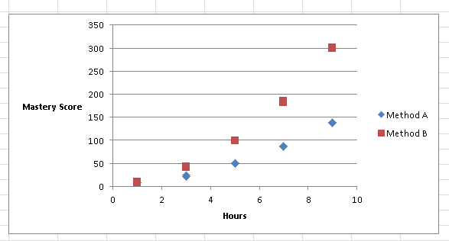

**2) (10 pts)** Run an ANOVA to compare the two methods at each level of training. Just show the output ANOVA table and appropriate mean comparisons.

*Here we are treating the hours as a categorical treatment with 5 levels in a factorial design.*

**proc** **mixed** data=hw11;

class method hours;

model mastery=method hours method*hours;

store outhw11;

**run**;

ods graphics on;

ods html style=statistical sge=on;

**proc** **plm** restore=outhw11;

lsmeans method*hours / adjust=tukey plot=meanplot cl lines;

ods exclude diffs diffplot;

**run**;

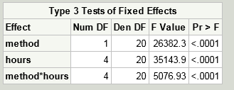

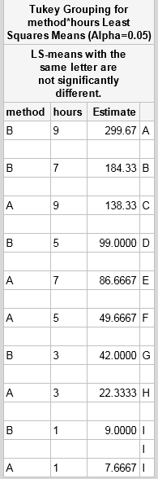

Methods differed significantly at all but the lowest level of training hours (1).

**3)** (10 pts) Use ANCOVA to characterize the effect of increasing number of training hours on mastery scores for the two teaching methods. Fit the response as a polynomial (order 2) function of training hours. Show the output and indicate what factors are significant.

*Here we are treating the hours of training as quantitative factor, entering the model as a continuous covariate (regression variable). We center the hours about its mean, and then fit a quadratic polynomial regression in x.*

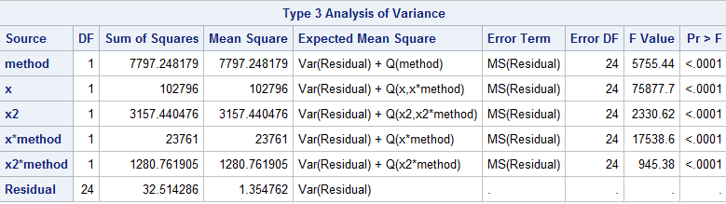

4) (10 pts) Write a 250 word summary of your results.

Method B produced greater (p><0.05) mastery skills compared to Method A in all but the lowest level of training. Methods differed significantly in the linear trend with hours, and we found a greater (p<0.05) linear increase in Method B. Method B also had greater degree of positive quadratic curvature (p<0.05) compared to Method A.