Homework for Lesson 12

A study of recover of plants in Burned vs. Unburned areas involved repeated measruements of the same plots over a 15 month period. The floral count data, in stacked format, is in the Excel file ‘Flora.xlsx’ and is also shown below.

1) Plot the data, as response vs. time for each treatment level.

To generate and plot means in SAS, I used this code:

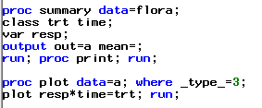

(Acceptable plots could be produced Excel, Minitab, or other software. Plotting individual ‘profile’ plots of the individual plots in each level of the burn treatment is also OK.)

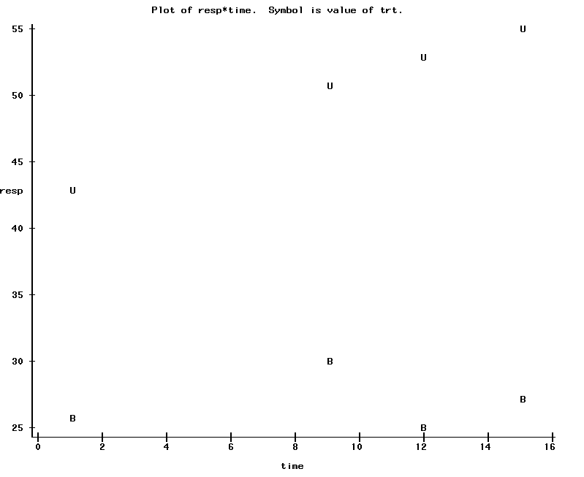

2) Run a repeated measures ANOVA, and determine which covariance structure to use (you can base your decision on AICC values). Consider the Unstructured, Compound Symmetry, and Spatial Power covariance structures. Show the process of your decision making and the Type 3 fixed effects for your final model.

*Each of the three candidate covariance structures were used and compared as below:*

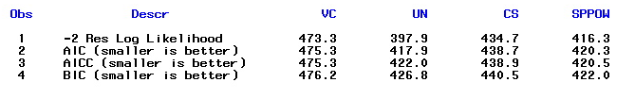

Spatial Power had the lowest AICC value.

So running the SP(Pow) covariance structure we get:

proc mixed data=flora;

class trt time plot;

model resp = trt time trt\*time / ddfm=kr;

repeated time/ subject=plot(trt) type=sp(pow)(months) rcorr;

title 'SP(POW)'; ods output FitStatistics=FitSPPOW (rename=(value=SPPOW))

run;

