Homework 2

**\*ImportantNote:** these computations should be done ‘by hand’ either with a simple calculator, or using a spreadsheet like Excel. If using a spreadsheet, be sure to show the computations on the worksheet and use adjacent cells to *label* the quantities being calculated. Use the Dropbox for HW2 to submit your assignment. The submission should be a single item, either a Word document (with Excel outputs and figures imbedded) or a pdf file with scanned work included in it. *No computer software ANOVA output will be accepted for this assignment*.

Consider the following situation: Electrical engineers have a device that tests for battery life (in minutes) by placing a battery under a controlled electrical load and measuring how long it lasts. They are interested in comparing the performance of 4 brands of batteries. They replicated the experiment 4 times by randomly assigning a battery brand to be used in the electrical load device each time they measured battery life. In other words, they made 16 ‘runs’ and randomized the order in which the battery brands were used.

The data they obtained was:

|  |  |  |  |
| --- | --- | --- | --- |
| BrandA | BrandB | BrandC | BrandD |
| 110 | 118 | 108 | 117 |
| 113 | 116 | 107 | 112 |
| 108 | 112 | 112 | 115 |
| 115 | 117 | 108 | 119 |

At the end I have attached the complete excel sheet that was used to perform the computations.

1. Draw a study diagram.

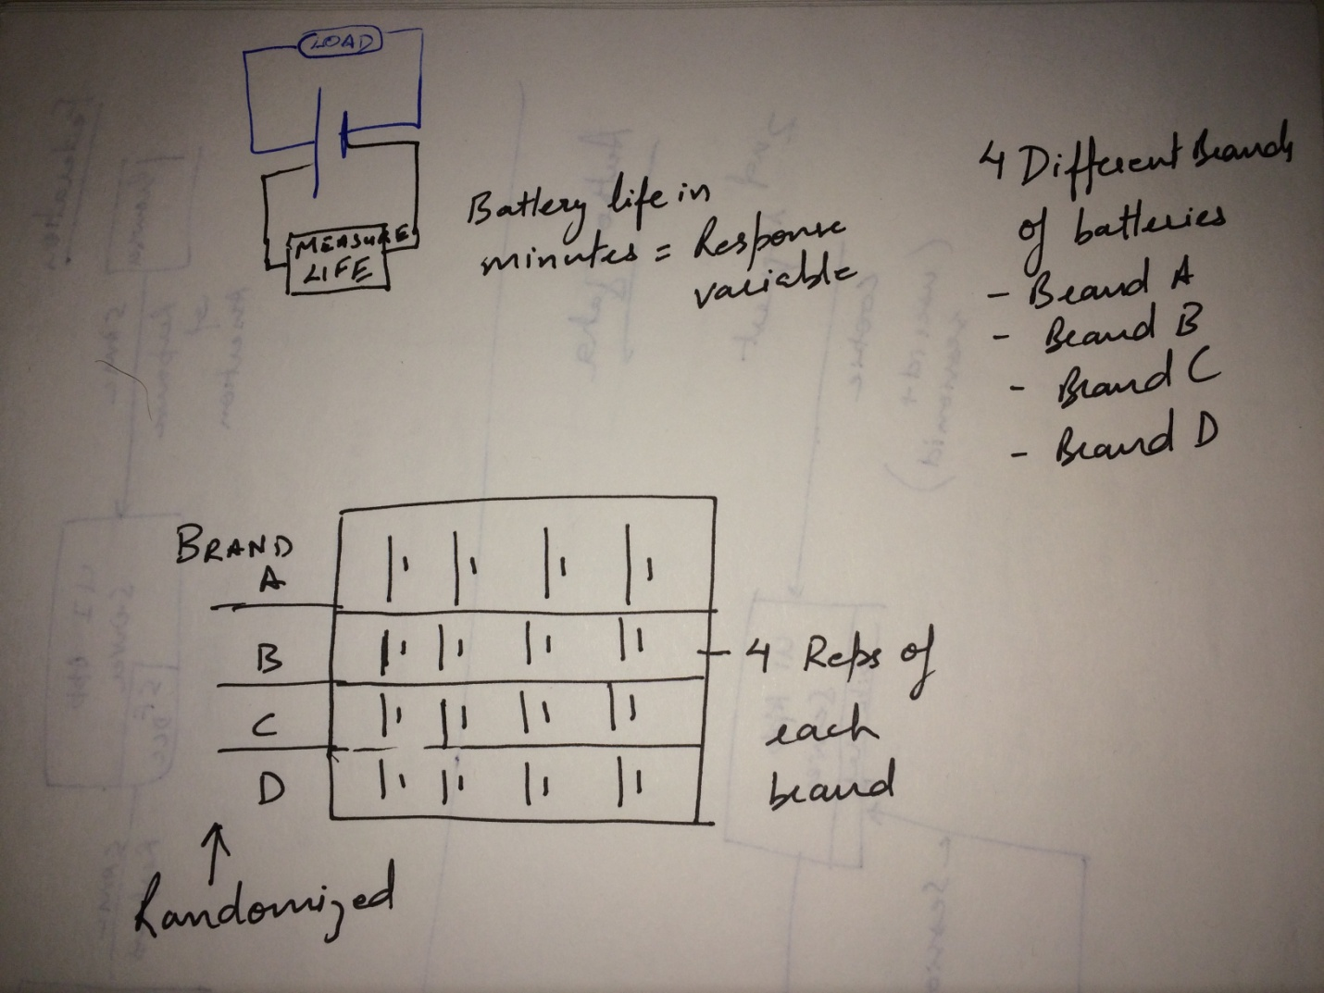

**b)** State the Null and Alternative Hypothesis

Grand mean: 26.16666667

The null hypothesis (the opposite of the alternative) states that there are no differences (or that they are all equal) among the group means.

H0:μ1=μ2= μ3=μ4

Ha: One of the means is different

**c)** Compute the means and sample standard errors for the brands.

The yellow highlighted areas have the means and sample std errors:



**d)** Compute the sums of squares for Total, Treatment, and Error, and complete the ANOVA table.

The yellow highlighted areas have the sums of squares for Total, Treatment, and Error:

|  |  |
| --- | --- |
| Treatment SS SSTrt | 141.6875 |
| Total SS =∑i∑j(Yij−Y¯..)2 | 232.9375 |
| Error SS SSerror | 91.25 |

The mean squares (MS) can now be calculated as:

MSTrt=SSTrt / dfTrt = 141.6875 / 3 = 47.229

MSerror=SSerror / dferror = 91.25 / 12 = 7.604

F=MSTrt / MSError = 47.229 / 7.604 = 6.211

ANOVA

|  |  |  |  |  |
| --- | --- | --- | --- | --- |
| Source | df | SS | MS | F |
| Treatment | *k* - 1 = 3 | 141.6875 | 47.229 | 6.211 |
| Error | 15-3=12 | 91.25 | 7.604 |  |
| Total | *N* - 1 =15 | 232.9375 |  |  |

**e)** Draw a conclusion (using α=0.05) about the Null Hypothesis, and if appropriate, construct mean comparisons using the Tukey method.

We look up the critical value of F and compare it to the value we calculated. Specifically the critical F is Fα = F(0.05, 3, 12) = 3.49

TheFcalculated > Fα so we **Reject H0** and accept the alternative HA.

 In the Tukey procedure we compute a ‘yardstick’ value based on the MSError and the number of means being compared. If any two means differ by more than the Tukeyw value, then they are significantly different.

Tukey’s w value

w = qα(p,dfError)⋅sY¯

We have

qα(p,dfError) = q.05(4, 12) = 4.20

r= number of replications = 4

sY¯ =standard error of a treatment mean = $\sqrt{\frac{MSerror}{r}}$  = $\sqrt{\frac{7.604}{4}}$ = 1.3788

Therefore w = 4.20 * 1.3788 = 5.791

For the example the tukey analysis gives:

|  |  |  |  |  |
| --- | --- | --- | --- | --- |
|  | Tukey w | 5.791 |  |  |
| Brand | B | D | A | C |
| Means | 115.75 | 115.75 | 111.5 | 108.75 |
|  | a | a | ab | b |
|  |  |  |  |  |
|  |  | Is < w | Label |  |
| B-D | 0 | Yes | a to B, D |  |
| B-A | 4.25 | Yes | a to A |  |
| B-C | 7 | No | b to C |  |
| D-C | 7 | No | nothing |  |
| A-C | 2.75 | Yes | b to A |  |

The computation for all the above questions are below:



