Homework 2 Solutions

Homework 2

**\*ImportantNote:** these computations should be done ‘by hand’ either with a simple calculator, or using a spreadsheet like Excel. If using a spreadsheet, be sure to show the computations on the worksheet and use adjacent cells to *label* the quantities being calculated. Use the Dropbox for HW2 to submit your assignment. The submission should be a single item, either a Word document (with Excel outputs and figures imbedded) or a pdf file with scanned work included in it. *No computer software ANOVA output will be accepted for this assignment*.

Consider the following situation: Electrical engineers have a device that tests for battery life (in minutes) by placing a battery under a controlled electrical load and measuring how long it lasts. They are interested in comparing the performance of 4 brands of batteries. They replicated the experiment 4 times by randomly assigning a battery brand to be used in the electrical load device each time they measured battery life. In other words, they made 16 ‘runs’ and randomized the order in which the battery brands were used.

The data they obtained was:

|  |  |  |  |
| --- | --- | --- | --- |
| BrandA | BrandB | BrandC | BrandD |
| 110 | 118 | 108 | 117 |
| 113 | 116 | 107 | 112 |
| 108 | 112 | 112 | 115 |
| 115 | 117 | 108 | 119 |

**a)** Draw a study diagram.

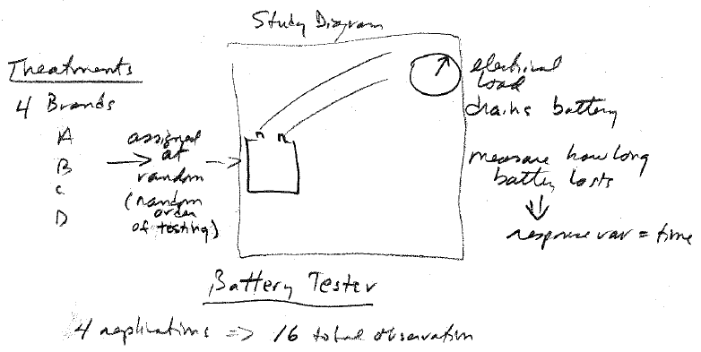

**b)** State the Null and Alternative Hypothesis

$$H_{0}:μ_{BrandA}=μ_{BrandB}=μ_{BrandC}=μ_{BrandD}$$

$$H_{A}:not all equal$$

**c)** Compute the means and sample standard errors for the brands. *(see below)*

**d)** Compute the sums of squares for Total, Treatment, and Error, and complete the ANOVA table. *See below)*

**e)** Draw a conclusion (using α=0.05) about the Null Hypothesis, and if appropriate, construct mean comparisons using the Tukey method. *Reject Ho. (Tukey comparisons below)*

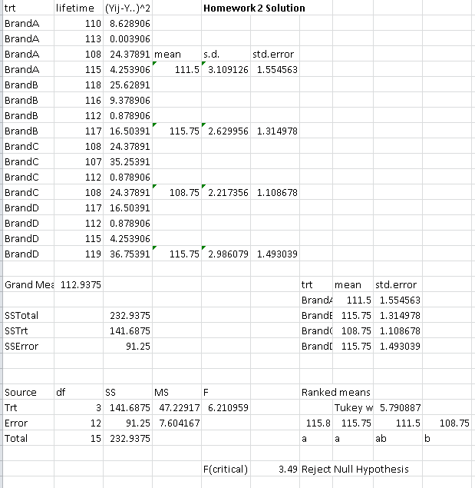

Graph (optional)

