HW4_Solutions

Please submit ONE document to the Dropbox for Homework 4. This can be a Word document (preferred) or a pdf file. **NOTE: For Question 1 and 2, which require use of statistical software, at least one analysis must be done in SAS. Both software programs will perform the analysis, and so the choice is up to you which one you apply to which question.**

**1)** Make up and describe an experiment for which these data (*given in* problem) were obtained. This can be an experiment reflecting your area of study, or be a hobby, sports, anything. You can modify the response variable by adding or subtracting a constant amount to each value, so you can adjust the response variable values to be realistic for your experiment. (Hint: Do an exploratory data analysis (EDA) and run the ANOVA before you invent the experiment. It is important to think ahead on what the results will mean).

(**Note:** *Individual answers for this problem will differ, depending on the experiment considered*)

a) (10 pts) Provide a Study Diagram for your experiment

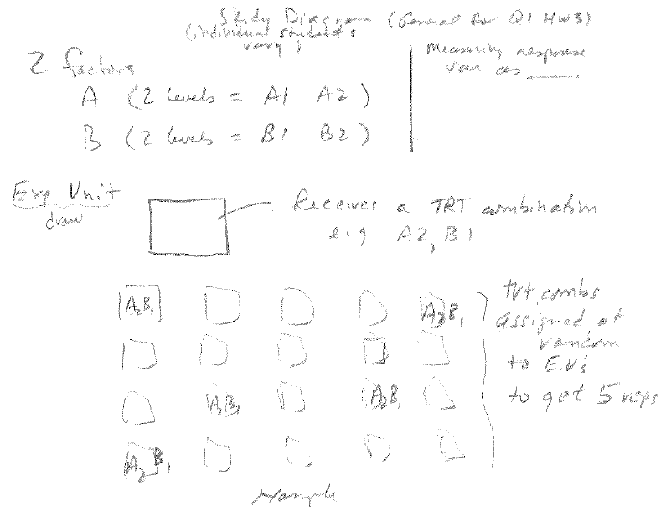

b) (10 pts) State the null and alternative hypotheses

Factor A (*whatever this factor is in the experiment*)

2) Factor B (*whatever this factor is in the experiment*)

3) Interaction

$$H_{0}:There is no interaction between Factor A and Factor B$$

$$H_{A}:A FactorA x FactorB interaction exists$$

c) (10 pts) Run an ANOVA and include any output you consider important (e.g., diagnostics)

SAS code:



*(data here)*

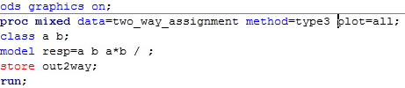

SAS output:

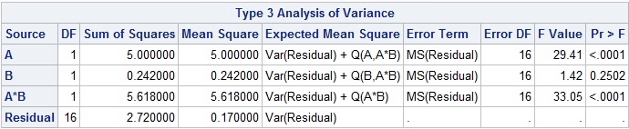

*The A*B interaction is significant. Therefore, need to perform mean comparisons and interpret the treatment combinations. Should NOT do mean comparisons or interpretation of either the Factor A or Factor B main effects because the interaction is significant.*

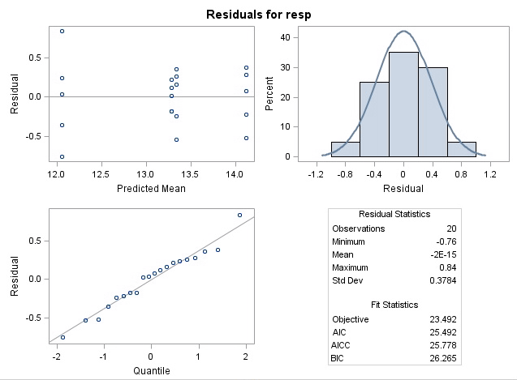

Minitab: Stat > ANOVA > General Linear Model

Minitab Output:

Analysis of Variance for resp, using Adjusted SS for Tests

Source DF Seq SS Adj SS Adj MS F P

A 1 5.0000 5.0000 5.0000 29.41 0.000

B 1 0.2420 0.2420 0.2420 1.42 0.250

A*B 1 5.6180 5.6180 5.6180 33.05 0.000

Error 16 2.7200 2.7200 0.1700

Total 19 13.5800



d) (10 pts) Do a mean comparison (where appropriate based on the ANOVA) using the Tukey adjustment.

We see from the output above that the AxB Interaction is significant. Therefore, we won’t be evaluating main effects, but will be plotting and comparing treatment combination means.

SAS:

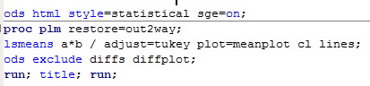

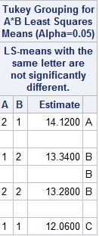

Minitab:

Grouping Information Using Tukey Method and 95.0% Confidence

A B N Mean Grouping

2 1 5 14.1 A

1 2 5 13.3 B

2 2 5 13.3 B

1 1 5 12.1 C

e) (10 pts) Produce a final graph (or graphs, if appropriate, depending on the results) to show the outcome of your experiment. The graph can be either a bar chart or means plot, but needs to include error bars and Tukey mean comparison results, and a figure caption that explains the symbols used. Provide a *brief* interpretation of the results.

SAS:

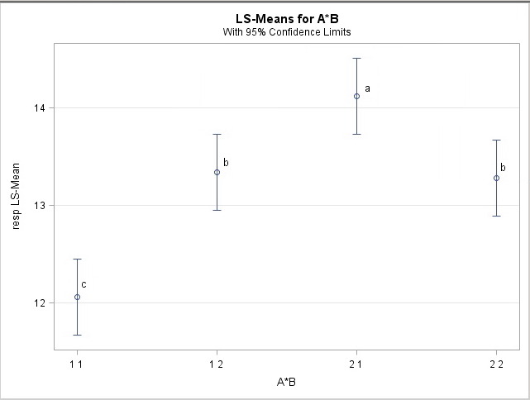

Another option: using Excel to produce a Bar chart, as shown below using the sample standard errors for error bars.

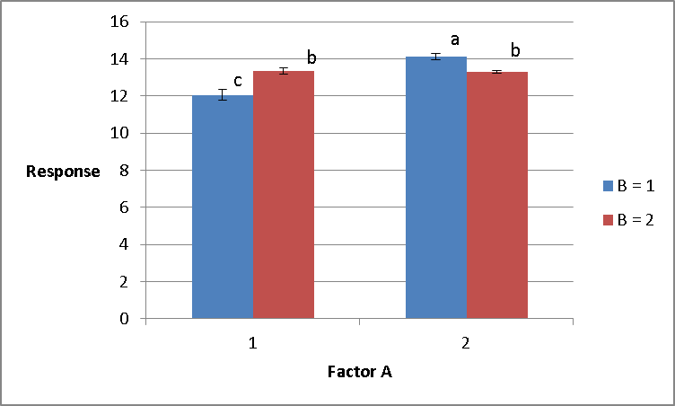

*An interval plot from Mintab will also work here, but (as in the bar chart above) error bars will not be based on experiment-wide error.*

*Interpretation: For B at level 1, Factor A at level 2 was greater (p<0.05) than Factor A at level 1. On the other hand, for B at level 2, there was no significant difference in the response due to Factor A.*

*Or*

*For Factor A at level 1, the response at B=level 2 was greater (p<0.05) than the response at B=level 1. Conversely, for Factor A at level 2, the response at B= level 1 was greater (p<0.05) than the response for B= level 2.*

**2)** Nitrogen Concentration in Wood Problem.

a) (10 pts) Provide a study diagram for this experiment.

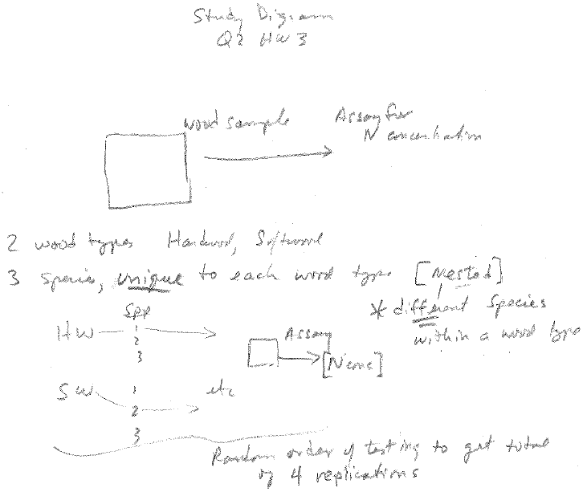

b) (10pts) Write out the statistical model for the ANOVA (You can use words instead of subscripted Greek symbols.)

Nconc = Type + Species(Type) + error

c) (20 pts) Run the ANOVA, extract relevant output and conduct appropriate mean comparisons (Tukey method) where factors are significant.

Minitab:

**General Linear Model: Nconc versus Type, Species**

Factor Type Levels Values

Type fixed 2 hardwood, softwood

Species(Type) fixed 6 ash, maple, oak, fir, pine, spruce

Analysis of Variance for Nconc, using Adjusted SS for Tests

Source DF Seq SS Adj SS Adj MS F P

Type 1 140.167 140.167 140.167 31.74 0.000

Species(Type) 4 96.833 96.833 24.208 5.48 0.005

Error 18 79.500 79.500 4.417

Total 23 316.500

S = 2.10159 R-Sq = 74.88% R-Sq(adj) = 67.90%

Grouping Information Using Tukey Method and 95.0% Confidence

Type N Mean Grouping

hardwood 12 18.7 A

softwood 12 13.8 B

Means that do not share a letter are significantly different.

Grouping Information Using Tukey Method and 95.0% Confidence

Type Species N Mean Grouping

hardwood ash 4 20.8 A

hardwood maple 4 18.8 A

softwood spruce 4 17.0 A B

hardwood oak 4 16.5 A B C

softwood fir 4 12.5 B C

softwood pine 4 12.0 C

SAS output:

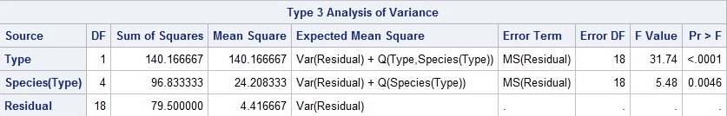

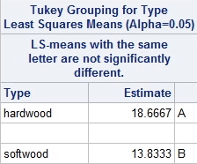

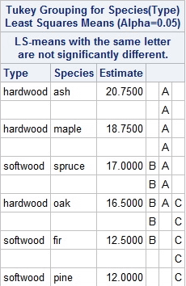

d) (10 pts) Graph significant results in bar chart or means plot form showing the means, error bars, and results of the mean comparisons. Describe the graph in a Figure Caption.

*( Graphs shown below are from SAS and Excel, but Minitab or other graphs are OK)*

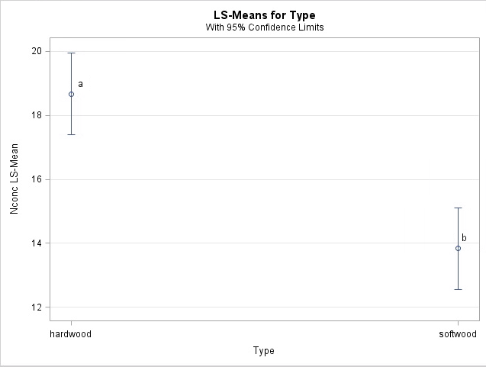

Figure caption: (Top Panel) Mean Nconcentration of hardwood and softwood types, with 95% confidence intervals. (Bottom Panel) Mean Nconcentration by species within wood type. Within each panel, means sharing the same letter do not differ significantly ( $α=0.5)$ based on Tukey mean comparisons.

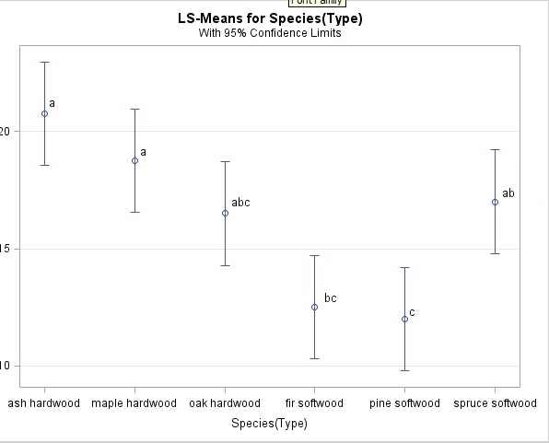

a

a

ab

abc

bc

c

A means or interval plot would also be OK here to show the results.