Homework Assignment for Lesson 7

Please submit one document file in the ANGEL dropbox.

1) (40 pts) Consider a 2 x 2 factorial treatment design administered in in a RCBD with 3 replications.

Using variables to reflect an experiment of your choice, draw out a study diagram of the experimental layout, and describe your randomization process. Please keep in mind that a study diagram is just a drawing, and can be done by hand and scanned. If you prefer using computer software drawing tools, that’s OK as well.

The study of interest is that we have a we would like to vary the amount of time the children receive instruction with one group getting 1 hour of instruction per week and another getting 4 hours per week. And, we'd like to vary the setting with one group getting the instruction in-class and the other group being pulled-outdoors.

We have 2 factors, each with 2 levels

1. A: amount of time – A1: 1 hr and A2: 4 hrs
2. B: Location of instruction – B1: in-class and B2: outdoors

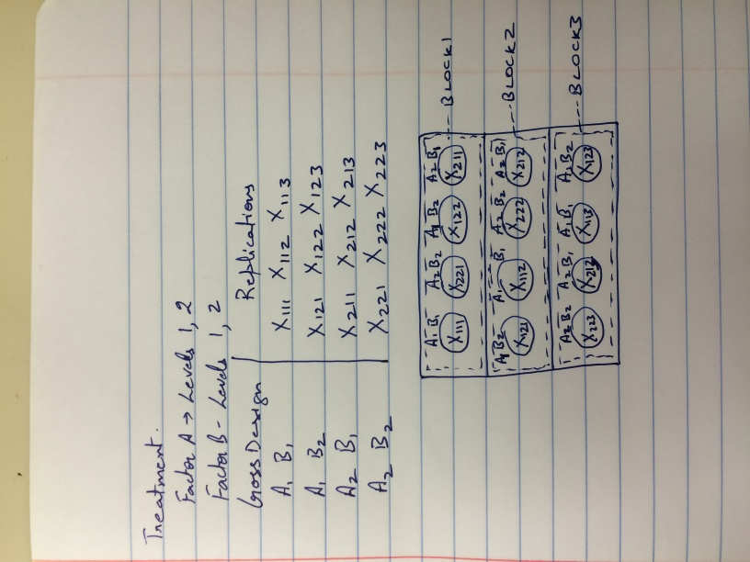

Randomization Process: We have done randomization process to form blocks. Within a block we want all the treatment levels or treatment combinations to be represented. With 3 replications, we then would have 3 blocks of 4 positions each representing the combination of factors (A1 B1, A1 B2, A2 B1, A2 B2)

Then, for each block, repeat the process. The key element is that each treatment level or treatment combination appears in each block (forming complete blocks), and were assigned at random within each block.

2) (40 pts)Consider that the data we saw in Lesson 4.1.1 (Two-Factor Factorial: Greenhouse Example) actually was run as a RCBD. The data, now including block numbers is in the file ‘Greenhouse_RCBD_data’.

Run an ANOVA considering random block effects, and compare the Fcritical, and Fcalculated with the results obtained with the CRD (ignoring blocks).

The output is as follows

|  |  |
| --- | --- |
| CRD | RCBD |
|  |  |
| F Calculated   |  |  |  | | --- | --- | --- | | **Source** | **F Value** | **Pr > F** | | **Fert** | 73.1 | <.0001 | | **Species** | 69.65 | <.0001 | | **Fert*Species** | 4.96 | 0.0051 | | F Calculated   |  |  |  | | --- | --- | --- | | **Source** | **F Value** | **Pr > F** | | **Fert** | 273.63 | <.0001 | | **Species** | 260.71 | <.0001 | | **Fert*Species** | 18.57 | <.0001 | | **block** | 22.95 | <.0001 | |
| **F critical-values for each hypothesis test at alpha = 0.05**  Fert: F0.05, 3, 40 = 2.839  Species: F0.05, 1, 40 = 4.085  Interaction: F0.05, 3, 40 = 2.839 | **F critical-values for each hypothesis test at alpha = 0.05**  Fert: F0.05, 3, 35 = 2.874  Species: F0.05, 1, 35 = 4.121  Interaction: F0.05, 3, 35 = 2.874  Block: F0.05, 5, 35 = 2.485 |

The point intended here was to show that the Fcritical doesn’t change much with the loss of a few degrees of freedom for blocks. The advantage which outweighs this loss of degrees of freedom is the huge reduction in the SS Error. The overall result is a large increase in Fcalculated for the treatments.

3) (20 pts) Randomize (describing your process) the following Standard Latin square to produce a final layout.

|  |  |  |  |
| --- | --- | --- | --- |
| A | B | C | D |
| B | C | D | A |
| C | D | A | B |
| D | A | B | C |

To randomize, first randomize the order of the rows and produce a new square.

|  |  |  |  |
| --- | --- | --- | --- |
| B | C | D | A |
| D | A | B | C |
| C | D | A | B |
| A | B | C | D |

Then randomize the order of the columns to yield the final square for the experimental layout.

|  |  |  |  |
| --- | --- | --- | --- |
| C | B | A | D |
| A | D | C | B |
| D | C | B | A |
| B | A | D | C |