Homework Assignment for Lesson 8

1) Consider a study to determine the best method for producing a particular type of canned green beans. Harvested beans are allowed to soak in a solution of herbs for either a short or long soak- time. Four crocks were available, so 2 crocks (randomly) were assigned the long soak-time treatment and two crocks were assigned the short soak-time. From each crock a jar was filled with beans and then pressure-canned in a brine solution that was made up using one of three different recipes. After a 6-week period, they were rated for taste and the data appears in the Excel file ‘diilly_beans_one.xlsx’ .

a) (10 pts) What is the treatment design?

2X3 Factorial Design – 2 factors with 1st factor at 2 levels and 2nd factor at 3 levels.

In a completely randomized design, treatment levels or combinations are assigned to experimental units at random.

b) (10 pts) What is the experimental design?

We see that the factors are crossed. This is an example of Split – Plot in a completely randomized design.

c) (20 pts) Run the ANOVA and show the output.

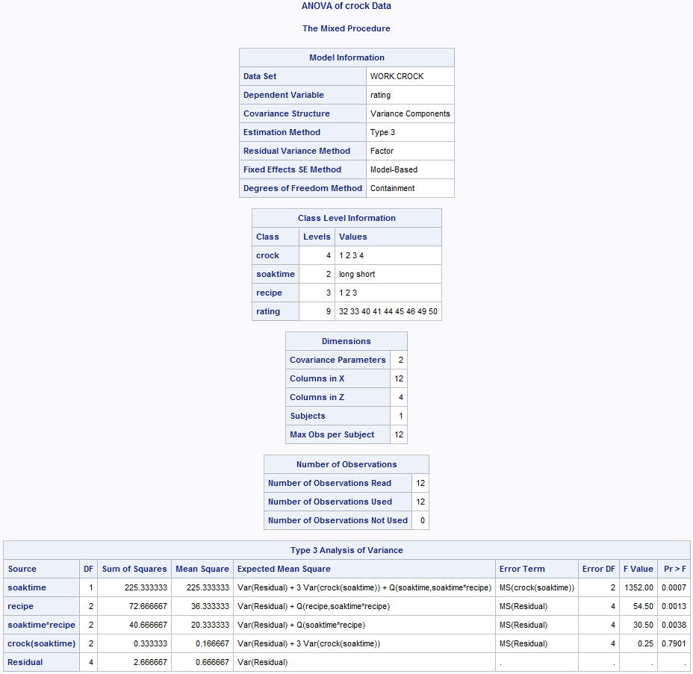

d) (10 pts) Follow-up the ANOVA with mean comparisons (where indicated by statistical significance). (You do not need to graph these results). Table output is OK.

Soaktime – mean comparison

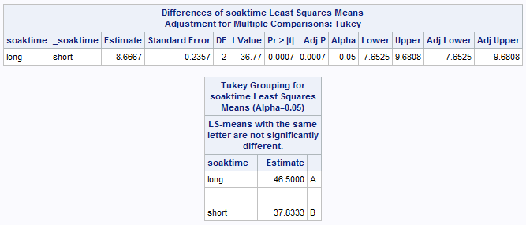

Recipe – mean comparison

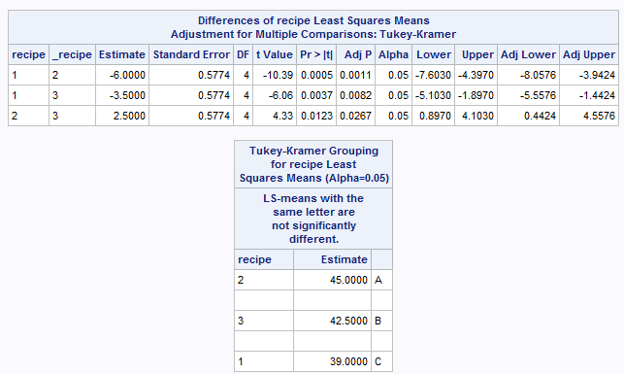

Soaktime * recipe– mean comparison

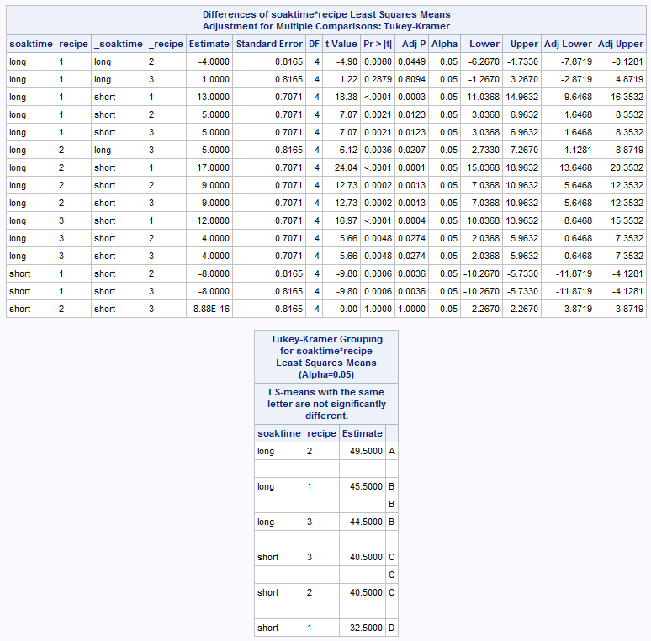

2) In an agricultural field experiment an investigator wants to evaluate 4 disease treatments on 4 varieties of wheat. The disease treatment levels and varieties were specifically chosen and of interest to the researchers. They can apply the disease treatment levels to small sub-sections of a field, but need to plant the varieties with a mechanized seeder on large acreages. They replicate their experiment in four fields by dividing each field into 4 'whole plots' which are large areas, for planting the 4 wheat varieties.  In each field, then, all 4 varieties are planted.  Then each of these large 'whole plots' in each field, planted with a variety of wheat, gets split into 4 subplots that are randomly assigned a disease treatment.

|  |  |  |  |  |  |
| --- | --- | --- | --- | --- | --- |
| **Variety** | **Field** | **D1** | **D2** | **D3** | **D4** |
| **V1** | **1** | 42.9 | 53.8 | 49.5 | 44.4 |
|  | **2** | 41.6 | 58.5 | 53.8 | 41.8 |
|  | **3** | 28.9 | 43.9 | 40.7 | 28.3 |
|  | **4** | 30.8 | 46.3 | 39.4 | 34.7 |
| **V2** | **1** | 53.3 | 57.6 | 59.8 | 64.1 |
|  | **2** | 69.6 | 69.6 | 65.8 | 57.4 |
|  | **3** | 45.4 | 42.4 | 41.4 | 44.1 |
|  | **4** | 35.1 | 51.9 | 45.4 | 51.6 |
| **V3** | **1** | 62.3 | 63.4 | 64.5 | 63.6 |
|  | **2** | 58.5 | 50.4 | 46.1 | 56.1 |
|  | **3** | 44.6 | 45 | 62.6 | 52.7 |
|  | **4** | 50.3 | 46.7 | 50.3 | 51.8 |
| **V4** | **1** | 75.4 | 70.3 | 68.8 | 71.6 |
|  | **2** | 65.6 | 67.3 | 65.3 | 69.4 |
|  | **3** | 54 | 57.6 | 45.6 | 56.6 |
|  | **4** | 52.7 | 58.5 | 51 | 47.4 |

1. (10 pts) What is the treatment design?

Since each of the 4 fields have all the treatments, this is equivalent to a RCBD design.

It has crossed treatment with 4 replications. Fields are random effects, as they would represent the population of all possible fields. In other words, we are not concerned with mean comparisons among specific fields, but are using blocks to represent the population of all possible blocks.

1. (10 pts) What is the experimental design?

We see that the factors are crossed. This is an example of Split – Plot in a RCBD design.

1. (20 pts) Run the ANOVA and show the output. (Note that the data is presented in un-stacked format and is notbeing provided in an excel file in this assignment).

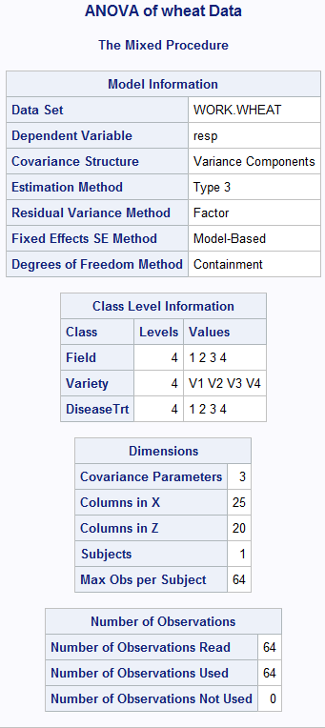

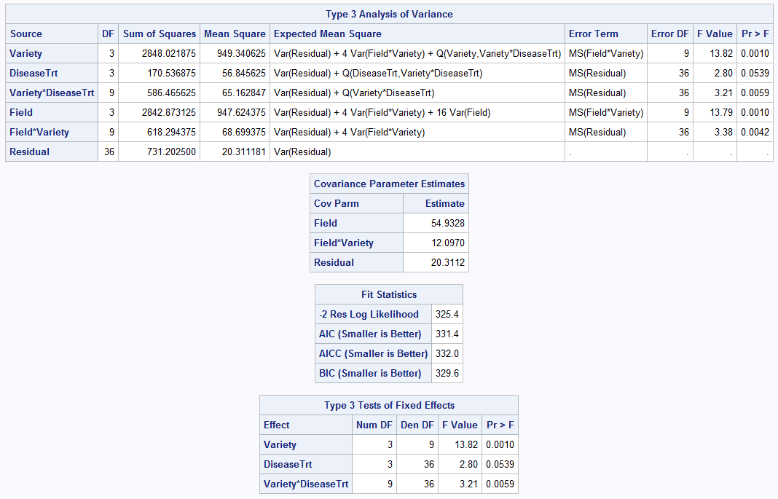

d) (10 pts) Follow-up the ANOVA with mean comparisons (where indicated by statistical significance). (You do not need to graph these results). Table output is OK.

