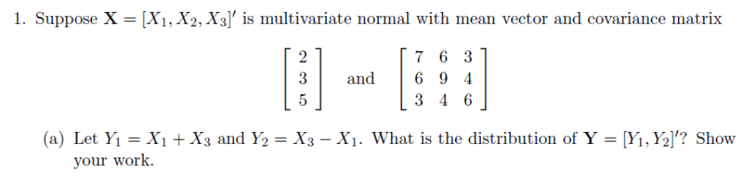
Estimated means:
Y1 = 2 + 5 = 7
Y2 = 5-2= 3

Distribution of mean of Y = =

Variances:
s²_{Y1} = 1*7 + 1*6 + 2*1*1*3 = 19
s²_{Y2} = -1*7 + 1*6 + 2*-1*1*3 = -7

cov(Y1,Y2) = 1*1* s13 + 1*-1*s²1+ 1*1*s²3 + 1*-1*s13 = 1*1* 3 + 1*-1*7 + 1*1*6 + 1*-1*3 = -1

Therefore sample covariance matrix for Y is S_{Y} =

Distribution of Y is given N()

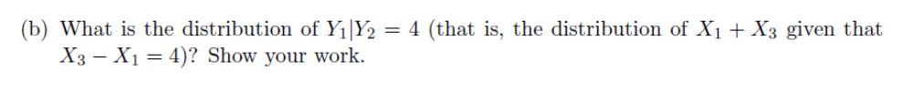
Mean = μ1 + σ12 / σ22 (x2 – μ2) = 7 + (-1 / -7) * (4-3) = 7.142857
Variance = σ₁₁− (σ₂₁² / σ₂₂) = 19 – (-1^2/-7) = 19.14286
Distribution of Y1 | Y2=4 is normally distributed with mean 7.142857 and variance 19.14286

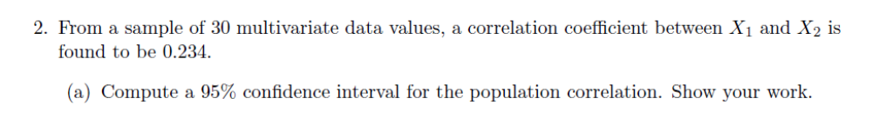
For significance of correlation coefficients, since the number of correlations tested is 1, and we want a 95% confidence level (alpha = 0.025 for 2-tailed test), the alpha-level for the Bonferroni-adjusted confidence interval is
alpha` = alpha / 1 = 0.025 / 1 = 0.025

Now given cumulative probability p = 1-0.025 = 0.975, the z value = 1.96
Between X1 and X2, r = 0.234
Step 1: Compute the Fisher transform:

= 1/2 * LN((1+0.234) / (1-0.234)) = 0.2384

Step 2: Next, compute the 95% confidence interval for the Fisher transform

Zl = 0.2384 – (1.96 / sqrt(30-3)) = -0.1388
Zl = 0.2384 + (1.96 / sqrt(30-3)) = 0.6156

Step 3: Carry out the back-transform to obtain the 95% confidence interval for ρ12. This is shown in the expression below:

= ((exp(2*-0.1388)-1) / (exp(2*-0.1388)+1), (exp(2*0.6156)-1)/(exp(2*0.6156)+1))
= -0.1379, 0.5481

This yields the interval from -0.1379, 0.5481

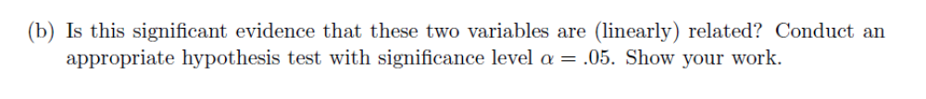
Test H0 : ρ = 0 against Ha : ρ ≠ 0 at the alpha = 0.05 level
Compute the test-statistic: 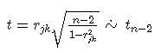

t = 0.234 * sqrt((30-2) / (1-0.234^2)) = 1.2736

Next we get a critical value of t(df, 1-α/2) = t(28, 0.975) = 2.048

Finally since 1.2736 < 2.048 we fail to reject the null hypothesis that X1 and X2 are uncorrelated at the α < 0.05 level.
Our conclusion here is that: X1 and X2 are uncorrelated (1.2736; d.f. = 28; p > 0.05)



Here since we have a multivariate setting, we are going to assume that the data vectors 1, 2,..., n are independently sampled from a multivariate normal distribution with mean vector μ and variance-covariance matrix Σ.
Then, in this case, the sample mean vector, x¯, is distributed as multivariate normal with mean vector μ and variance-covariance matrix 1/n Σ. In statistical notation we write:
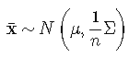

We are not able to comment on the applicability of the law of large numbers since we are not given the number of parameters of the dataset.
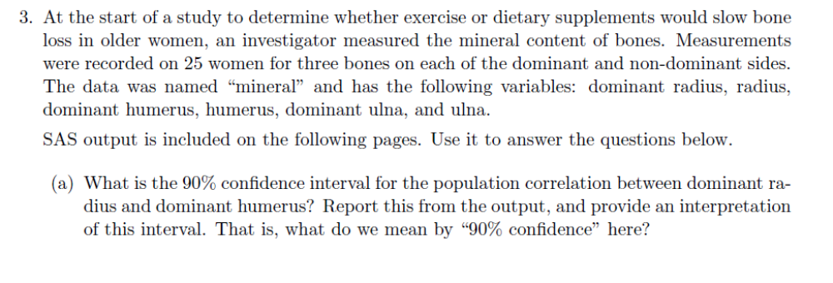
The 90% CI for the population correlation is given by:
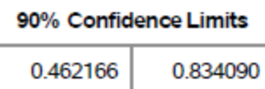

The interpretation is that we can conclude that we are 90% confident that the interval (0.462166, 0.834090) contains the correlation between dominant radius and dominant humerus scores.

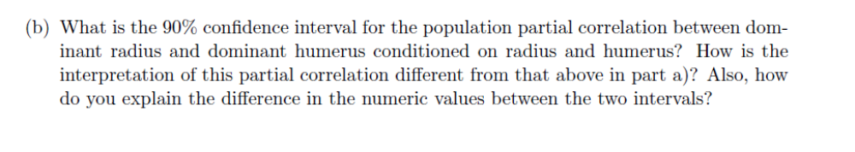
The 90% CI for the population correlation is given by:
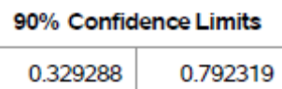

The interpretation is that we can conclude that we are 90% confident that the interval (0.329288, 0.792319) contains the partial correlation between dominant radius and dominant humerus conditioned on radius and humerus scores.

We find that the correlation goes from 0.69146 (limits of 0.462166, 0.834090) to a partial correlation of 0.61057 (with limits of 0.329288, 0.792319)
Comparing thvalues, we can see that the partial correlation is not much smaller than the ordinary correlation. This suggests that little of the relationship between dominant radius and dominant humerus can be explained by scores of radius and humerus. Further we also see that there is a small decrease where the Partial correlations are closer to zero than ordinary correlations. This would suggest that the relationship between the variables of interest dominant radius and dominant humerus might be explained to a small extent by their common relationships to the explanatory variables upon which we are conditioning i.e. radius and humerus.
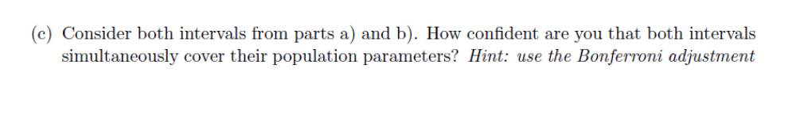
Here we have a family of 2 confidence intervals and the error rates for the individual intervals are 0.1 each. The Bonferroni Inequality states that the family wide-error rate is less than or equal to the sum of α1, α2

Here since the number of correlations tested is 2, and the alpha-level for the Bonferroni-adjusted confidence interval is alpha` = alpha` * 2 = 0.05 * 2 = 0.1
Since this is for 2-tailed test we have a overall confidence of only 1 – 0.1*2 = 0.8 or 80%

