- For the split plot ANOVA model:

Source | DF | Type III SS | Mean Square | F Value | Pr > F
treat | 1 | 365.7656250 | 365.7656250 | 6.65 | 0.0219
person(treat)  Error(a) | 14 | 770.2187500 | 55.0156250
time | 3 | 413.7968750 | 137.9322917 | 23.68 | <.0001
treat*time | 3 | 394.2968750 | 131.4322917 | 22.56 | <.0001
Error(b) | 42 | 244.656250 | 5.825149
Total | 63 | 2188.734375

The interaction between treatments and time, or:

H0:(ατ)ik=0 for all i=1,2,…,a; k=1,2,…,t

Here we need to look at the treatment by interaction term whose F-value is reported at 22.56. We want to compare this to an F-distribution with (a - 1)(t - 1) = 3 and (N - a)(t - 1) = 14*3 = 42 degrees of freedom. The numerator d.f. of 3 is tied to the source variation due to the interaction, while the denominator d.f. is tied to the source of variation due to error(b).
We can reject Ho at level alpha; if
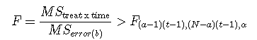
Result: We can conclude that the effect of treatment depends on time (F = 22.56; d. f. = 3, 42; p <.0001).

- We see that the interaction is significant. However let's suppose that we had not found a significant interaction. Let's do this so that you can see what it would look like to consider the effects of treatments.

Consider testing the null hypothesis that there are no treatment effects, or

H0:α1=α2=⋯=αa=0
To test this null hypothesis, we compute the F-ratio between the Mean Square for Treatments and Mean Square for Error (a). We then reject our Ho at level &alpha; if
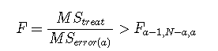
Here, the numerator degrees of freedom is equal to the number of degrees of freedom a - 1 = 1 for treatment, while the denominator degrees of freedom is equal to the number of degrees of freedom N - a = 14 for Error(a).

Result: We can conclude that the treatments significantly affect the heart rate over the t = 4 sampling times (F = 6.65; d. f. = 1,14; p = 0.0219).

- The histograms are:

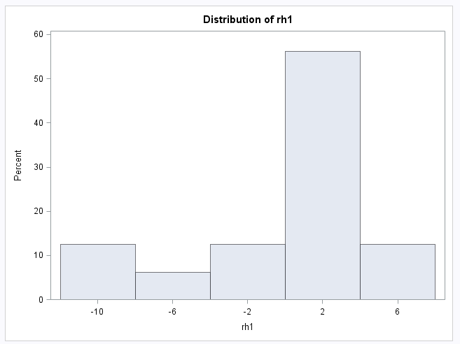
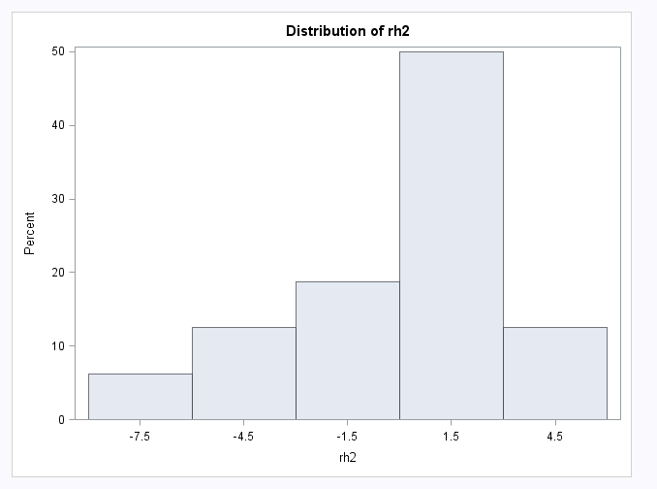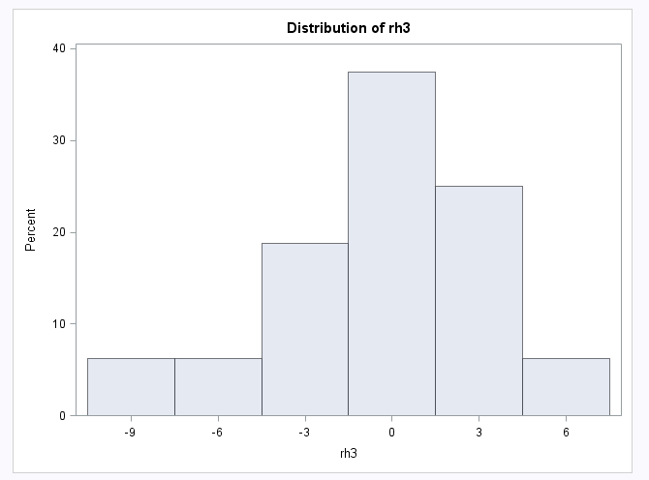
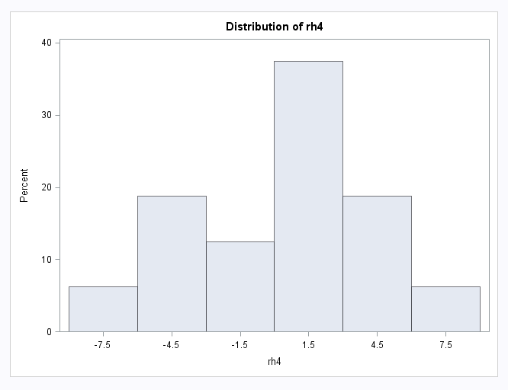

All the histograms cast doubt on the assumption of normality. While residuals for h3 appear approximately normally distributed the residuals for the remaining variables appear further away from normality.

- For the assumption of equal variance, we have:
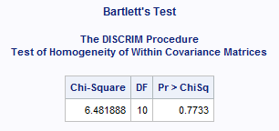
We find no statistically significant evidence against the null hypothesis that the variance-covariance matrices are homogeneous (L' = 6.482; d.f. = 10; p = 0.7733).

- Provide a profile plot for the data with time along the horizontal axis. Comment on the evidence for interaction between time and drug type. Also comment on the evidence for a drug effect on heart rate.

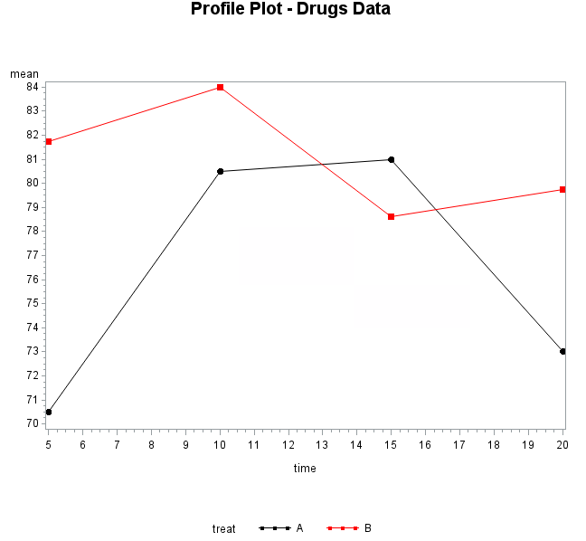
When we are testing for interaction we are testing the hypothesis that these lines segments are parallel to one another. However from the plot we see that the lines intersect each other and based on that we can say that there might be significant interaction between the treatments.

- The MANOVA for interaction gives:
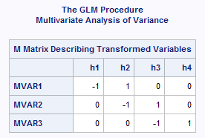
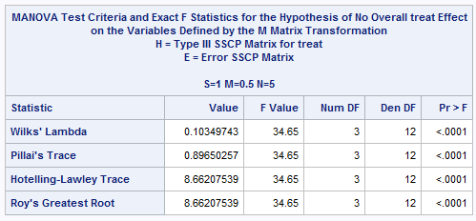

Here we get a Wilk's Lambda of 0.103 with a supporting F-value of 34.65 with 3 and 12 d.f.
Conclusion: There is enough evidence to reject null and conclude that the effect of treatments depends on time (Λ = 0.103; F = 34.65; d. f. = 3,12; p < 0.0001).
- We have from SAS:
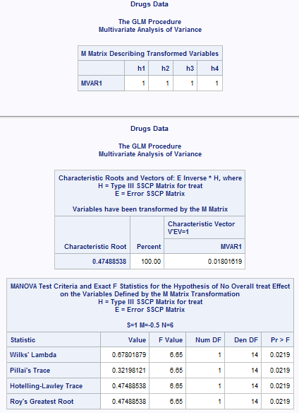
This indicates that there is a significant main effect of treatment. That is that the mean response of our four time variables differs significantly among treatments.

Conclusion: Treatments have a significant effect on the average heart rate over the first four time points (Λ = 0.678; F = 6.65; d. f. = 1, 14; p = 0.0219).

Typically when we find that there is interaction, we don’t perform main effects. We find here that the average of the heart rate over the time periods is effected by the choice of treatment. We also found earlier that there is significant interaction between time and treatment.

- While last week we looked at one-way MANOVA where we looked at the effect of the treatment, the current lesson showed how we could analyze the treatment with an added dimension of time (with repeated measures). That said the part g, collapsed the time dimension since we introduced a new variable which is equal to the sum of the observations across time for every person.

- From part f we have:
Conclusion: There is enough evidence to reject null and conclude that the effect of treatments depends on time (Λ = 0.103; F = 34.65; d. f. = 3,12; p < 0.0001).

While from part a we had:
Result: : There is enough evidence to reject null and conclude that the effect of treatment depends on time (F = 22.56; d. f. = 3, 42; p <.0001).

The outcome for part a is using the split-plot analysis where the results assume a constant correlation between any two observations from the same drug. This assumption is unlikely because, typically, when you have repeated measurements over time, the data from the same subject at two different points of time are going to be temporally correlated. In principle, observations that are collected at times that are close together are going to be more similar to one another than observations that are far apart. This correlation is accounted for in the MANOVA approach used in part f.

