



b) Single linkage:

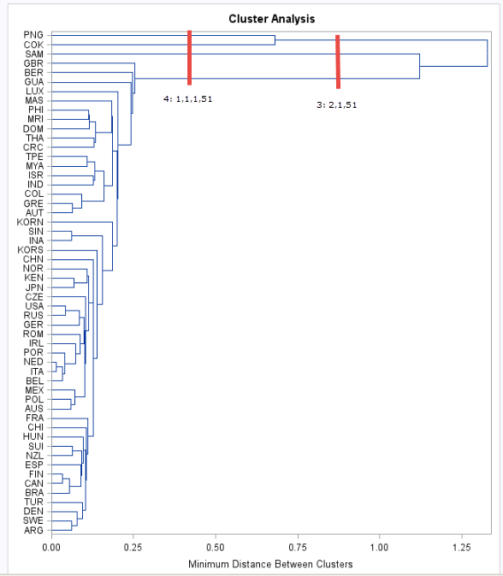

Complete linkage

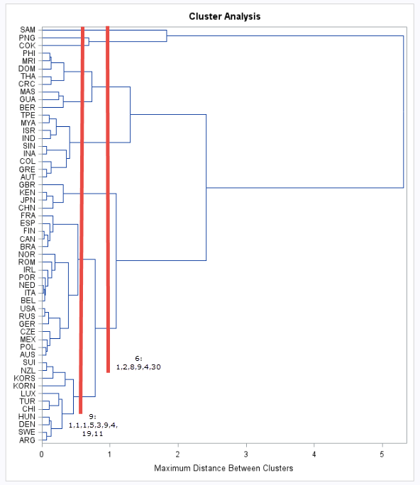

We have the following breakdown

Single: Partitioning into 4 clusters yields clusters of sizes 1,1,1,51

Single: Partitioning into 3 clusters yields clusters of sizes 2,1,51

Complete: Partitioning into 9 clusters yields clusters of sizes 1,1,1,5,3,9,4,19,11

Complete: Partitioning into 6 clusters yields clusters of sizes 1,2,8,9,4,30

From the diagrams above we can say that we get best results with Complete linkage and 6 clusters.

**c) K-means comparison**

3 clusters

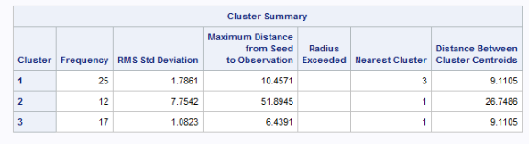

4 clusters

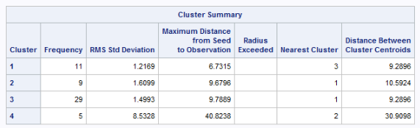

6 clusters

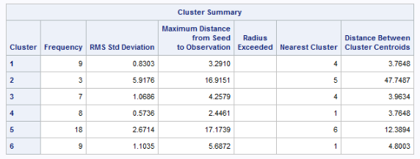

9 clusters

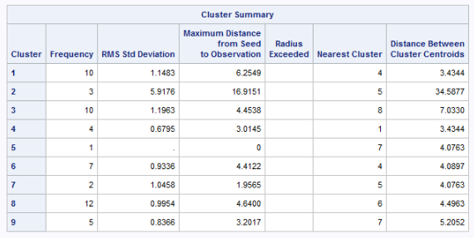

The membership for each of the above clusters is in the excel workbook (worksheet: Pivots). Below are the results summarized for Complete Linkage (6 cluster) and K-Means (6 cluster) to compare:

|  |  |
| --- | --- |
| Complete | 1- ARG, AUS, BEL, BRA, CAN, CHI, CZE, DEN, ESP, FIN, FRA, GER, HUN, IRL, ITA, KORN, KORS, LUX, MEX, NED, NOR, NZL, POL, POR, ROM, RUS, SUI, SWE, TUR, USA  2- AUT, COL, GRE, INA, IND, ISR, MYA, SIN, TPE  3- CHN, GBR, JPN, KEN,  4- BER, CRC, DOM, GUA, MAS, MRI, PHI, THA  5- COK, PNG,  6- SAM |
| K-Mean | 1- BER, CRC, DOM, GUA, IND, MAS, MRI, MYA, PHI, THA, TPE  2- ARG, AUT, CHI, COL, DEN, GRE, INA, ISR, SIN, SWE, TUR  3- AUS, BEL, CHN, GBR, GER, IRL, ITA, JPN, KEN, MEX, NED, NOR, POL, POR, ROM, RUS, USA  4- BRA, CAN, CZE, ESP, FIN, FRA, HUN, NZL, SUI  5- KORN, KORS, LUX,  6- COK, PNG, SAM |

We do see some similarities in the constitution of the two clusters. For instance cluste4 4 of Complete has lot of overlapping countries with cluster 1 of K-Means.



The table below has the steps and the clusters at each step:

|  |  |  |  |  |  |
| --- | --- | --- | --- | --- | --- |
| **Clusters** | **1** | **2** | **3** | **4** | **5** |
| **1** | 0 |  |  |  |  |
| **2** | 4 | 0 |  |  |  |
| **3** | 6 | 9 | 0 |  |  |
| **4** | 1 | 7 | 10 | 0 |  |
| **5** | 6 | 3 | 5 | 8 | 0 |
|  |  |  |  |  |  |
| **Step 1** | Merge 4 and 1 | CL41 |  |  |  |
|  |  |  |  |  |  |
| **Clusters** | **2** | **3** | **5** | **CL41** |  |
| **2** | 0 |  |  |  |  |
| **3** | 9 | 0 |  |  |  |
| **5** | 3 | 5 | 0 |  |  |
| **CL41** | 4 | 6 | 6 | 0 |  |
|  |  |  |  |  |  |
| **Step 2** | Merge 5 and 2 | CL52 |  |  |  |
|  |  |  |  |  |  |
| **Clusters** | **3** | **CL52** | **CL41** |  |  |
| **3** | 0 |  |  |  |  |
| **CL52** | 5 | 0 |  |  |  |
| **CL41** | 6 | 4 | 0 |  |  |
|  |  |  |  |  |  |
| **Step 3** | Merge CL41 and CL52 | CL4152 |  |  |  |
|  |  |  |  |  |  |
| **Clusters** | **3** | **CL4152** |  |  |  |
| **3** | 0 |  |  |  |  |
| **CL4152** | 5 | 0 |  |  |  |
|  |  |  |  |  |  |
| **Step 4** | Merge 3 and CL4152 | CL12345 |  |  |  |
|  |  |  |  |  |  |
|  | **CL12345** |  |  |  |  |
| **CL12345** | 0 |  |  |  |  |



The table below has the steps and the clusters at each step:

|  |  |  |  |  |  |
| --- | --- | --- | --- | --- | --- |
| **Clusters** | **1** | **2** | **3** | **4** | **5** |
| **1** | 0 |  |  |  |  |
| **2** | 4 | 0 |  |  |  |
| **3** | 6 | 9 | 0 |  |  |
| **4** | 1 | 7 | 10 | 0 |  |
| **5** | 6 | 3 | 5 | 8 | 0 |
|  |  |  |  |  |  |
| **Step 1** | Merge 4 and 1 | CL41 |  |  |  |
|  |  |  |  |  |  |
| **Clusters** | **2** | **3** | **5** | **CL41** |  |
| **2** | 0 |  |  |  |  |
| **3** | 9 | 0 |  |  |  |
| **5** | 3 | 5 | 0 |  |  |
| **CL41** | 7 | 10 | 8 | 0 |  |
|  |  |  |  |  |  |
| **Step 2** | Merge 5 and 2 | CL52 |  |  |  |
|  |  |  |  |  |  |
| **Clusters** | **3** | **CL52** | **CL41** |  |  |
| **3** | 0 |  |  |  |  |
| **CL52** | 9 | 0 |  |  |  |
| **CL41** | 10 | 8 | 0 |  |  |
|  |  |  |  |  |  |
| **Step 3** | Merge CL41 and CL52 | CL4152 |  |  |  |
|  |  |  |  |  |  |
| **Clusters** | **3** | **CL4152** |  |  |  |
| **3** | 0 |  |  |  |  |
| **CL4152** | 10 | 0 |  |  |  |
|  |  |  |  |  |  |
| **Step 4** | Merge 3 and CL4152 | CL12345 |  |  |  |
|  |  |  |  |  |  |
|  | **CL12345** |  |  |  |  |
| **CL12345** | 0 |  |  |  |  |