



1. We have from SAS:

|  |
| --- |
| 2-Sample Hotellings T2 - Milk Truck Cost |

| **n1** | **ybar1** |
| --- | --- |
| 36 | 12.218611 |
|  | 8.1125 |
|  | 9.5902778 |

| **s1** | | |
| --- | --- | --- |
| 23.013361 | 12.366395 | 2.906609 |
| 12.366395 | 17.544111 | 4.7730821 |
| 2.906609 | 4.7730821 | 13.963334 |

| **n2** | **ybar2** |
| --- | --- |
| 23 | 10.105652 |
|  | 10.762174 |
|  | 18.167826 |

| **s2** | | |
| --- | --- | --- |
| 4.3623166 | 0.7598872 | 2.3620992 |
| 0.7598872 | 25.851236 | 7.6857322 |
| 2.3620992 | 7.6857322 | 46.6544 |

| **spool** | | |
| --- | --- | --- |
| 15.814712 | 7.8866902 | 2.6964473 |
| 7.8866902 | 20.75037 | 5.8972629 |
| 2.6964473 | 5.8972629 | 26.580938 |

| **t2** | **f** | **df1** | **df2** | **p** |
| --- | --- | --- | --- | --- |
| 50.912787 | 16.375458 | 3 | 55 | 1.0005E-7 |

The two-sample Hotelling's T2 statistic is 50.91. The F-value is about 16.375 with 3 and 55 degrees of freedom. In this case the p-value is close to 0, here we will write this as p < 0.0001.

In this case we can reject the null hypothesis that the mean vector for the cost of transport on gasoline truck equals the mean vector for the cost of transport on diesel truck giving the evidence as usual: (T2 = 50.91; F = 16.375; d. f. = 3, 55; p < 0.0001)

**Conclusion**

The overall cost of transport on gasoline truck can be distinguished from the overall cost of transport on diesel truck on at least one of the costs components.

>>

The null hypothesis is H0 : mu1 =*mu*2, where 1 is the mean cost vector for gasoline trucks,

and 2 is the mean cost vector for diesel trucks. The alternative hypothesis, Ha, is that

these vectors differ in at least one of their three components: fuel, repair, and capital.

Hotelling’s T2 is 50.91, which corresponds to an F test statistic of 16:38 with 3 and 55

degrees of freedom. Since 16:38 > 4:16 = f3;55(:01), (p-value 0), we can reject H0

with significant evidence that at least one of the mean cost components differs between

gasoline and diesel trucks.

1. We have from the SAS output

|  |
| --- |
| Confidence Intervals - Milk Truck Cost |

| Obs | variable | truckType | _FREQ_ | n1 | xbar1 | s21 | n2 | xbar2 | s22 | f | t | sp | losim | upsim | lobon | upbon |
| --- | --- | --- | --- | --- | --- | --- | --- | --- | --- | --- | --- | --- | --- | --- | --- | --- |
| 1 | capitalC | diesel | 23 | 36 | 9.5903 | 13.9633 | 23 | 18.1678 | 46.6544 | 4.15908 | 3.06395 | 26.5809 | -13.5265 | -3.62862 | -12.7943 | -4.36080 |
| 2 | fuelCost | diesel | 23 | 36 | 12.2186 | 23.0134 | 23 | 10.1057 | 4.3623 | 4.15908 | 3.06395 | 15.8147 | -1.7043 | 5.93026 | -1.1396 | 5.36550 |
| 3 | repairCo | diesel | 23 | 36 | 8.1125 | 17.5441 | 23 | 10.7622 | 25.8512 | 4.15908 | 3.06395 | 20.7504 | -7.0223 | 1.72292 | -6.3754 | 1.07600 |

The capital costs are different between gasoline and diesel trucks.

>>

Using a Bonferroni correction for multiplicity, we can say with 99% simultaneous confidence

that the difference in mean fuel cost between gasoline and diesel trucks is within

-1.14 to 5.37, the difference in mean repair cost is within -6.38 to 1.08, and the difference

in mean capital cost is within -12.79 to -4.36.



1. We get the following output from SAS:

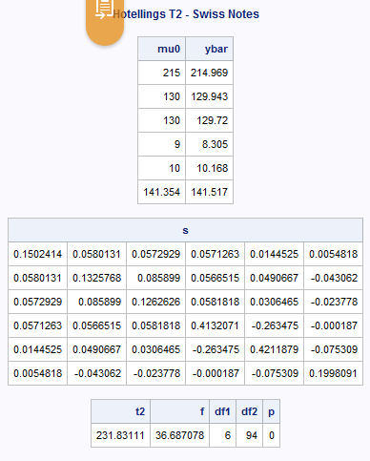

n=100, p=6

Hotelling’s T-square comes out to be: T2 = 231.83111

The F-statistic is: F = 36.687 > 2.1966= F6,94,0.05

For an 0.05 level test, the critical value is approximately 2.1966. Since 36.687 is greater that this value, we can reject the null hypothesis that the printer meets govt specifications on average.

(T2=231.83111; F=36.687 ;d.f.= 6,94;p<0.0001)

>>



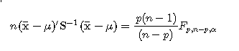

1. We have from SAS

|  |
| --- |
| Confidence Intervals - Swiss Notes |

| **variable** | **_FREQ_** | **n** | **xbar** | **s2** | **t1** | **tb** | **f** | **losim** | **upsim** | **lobon** | **upbon** |
| --- | --- | --- | --- | --- | --- | --- | --- | --- | --- | --- | --- |
| bottom | 100 | 100 | 8.305 | 0.41321 | 1.98422 | 2.69231 | 2.19660 | 8.066 | 8.544 | 8.132 | 8.478 |
| diagon | 100 | 100 | 141.517 | 0.19981 | 1.98422 | 2.69231 | 2.19660 | 141.350 | 141.684 | 141.397 | 141.637 |
| leftWi | 100 | 100 | 129.943 | 0.13258 | 1.98422 | 2.69231 | 2.19660 | 129.807 | 130.079 | 129.845 | 130.041 |
| length | 100 | 100 | 214.969 | 0.15024 | 1.98422 | 2.69231 | 2.19660 | 214.825 | 215.113 | 214.865 | 215.073 |
| rightW | 100 | 100 | 129.720 | 0.12626 | 1.98422 | 2.69231 | 2.19660 | 129.588 | 129.852 | 129.624 | 129.816 |
| topMar | 100 | 100 | 10.168 | 0.42119 | 1.98422 | 2.69231 | 2.19660 | 9.926 | 10.410 | 9.993 | 10.343 |

The following table gives the confidence intervals:

| **variable** | **mu0** | **mean** | **losim** | **upsim** |
| --- | --- | --- | --- | --- |
| bottom | 9 | 8.305 | 8.066 | 8.544 |
| diagon | 141.354 | 141.517 | 141.350 | 141.684 |
| leftWi | 130 | 129.943 | 129.807 | 130.079 |
| length | 215 | 214.969 | 214.825 | 215.113 |
| rightW | 130 | 129.72 | 129.588 | 129.852 |
| topMar | 10 | 10.168 | 9.926 | 10.410 |

Looking at these simultaneous confidence intervals we can see the following

* the upper bound of the interval for bottom falls below the govt spec
* the upper bound of the interval for rightWidth falls below the govt spec
* the remaining variables have the spec within the range

So overall the result is consistent since the first part found that printer doesn’t meets govt specifications. In the second part we found this true to bottom and rightWidth dimensions.

1. The profile plot is:

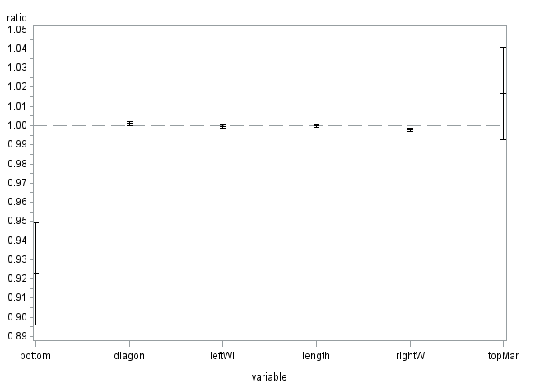

1. We have the following observations:

* the upper bound of the interval for bottom falls below the govt spec
* the upper bound of the interval for rightWidth falls below the govt spec
* the remaining variables have the spec within the range

Therefore the printer is not meeting the government specs especially for bottom and rightWidth.

>>

Overall, we have significant evidence that the printer is *not* meeting government specifications,

but the discrepancies are due to only half of the variables measured. The other

half do not significantly differ from the government specifications.



1. We get the following SAS output:

|  |
| --- |
| Paired Hotelling's T-Square |

| **Obs** | **dradius** | **radius** | **dhumerus** | **humerus** | **dulna** | **ulna** | **d1** | **d2** | **d3** |
| --- | --- | --- | --- | --- | --- | --- | --- | --- | --- |
| **1** | 1.103 | 1.052 | 2.139 | 2.238 | 0.873 | 0.872 | 0.051 | -0.099 | 0.001 |
| **2** | 0.842 | 0.859 | 1.873 | 1.741 | 0.590 | 0.744 | -0.017 | 0.132 | -0.154 |
| **3** | 0.925 | 0.873 | 1.887 | 1.809 | 0.767 | 0.713 | 0.052 | 0.078 | 0.054 |
| **4** | 0.857 | 0.744 | 1.739 | 1.547 | 0.706 | 0.674 | 0.113 | 0.192 | 0.032 |
| **5** | 0.795 | 0.809 | 1.734 | 1.715 | 0.549 | 0.654 | -0.014 | 0.019 | -0.105 |
| **6** | 0.787 | 0.779 | 1.509 | 1.474 | 0.782 | 0.571 | 0.008 | 0.035 | 0.211 |
| **7** | 0.933 | 0.880 | 1.695 | 1.656 | 0.737 | 0.803 | 0.053 | 0.039 | -0.066 |
| **8** | 0.799 | 0.851 | 1.740 | 1.777 | 0.618 | 0.682 | -0.052 | -0.037 | -0.064 |
| **9** | 0.945 | 0.876 | 1.811 | 1.759 | 0.853 | 0.777 | 0.069 | 0.052 | 0.076 |
| **10** | 0.921 | 0.906 | 1.954 | 2.009 | 0.823 | 0.765 | 0.015 | -0.055 | 0.058 |
| **11** | 0.792 | 0.825 | 1.624 | 1.657 | 0.686 | 0.668 | -0.033 | -0.033 | 0.018 |
| **12** | 0.815 | 0.751 | 2.204 | 1.846 | 0.678 | 0.546 | 0.064 | 0.358 | 0.132 |
| **13** | 0.755 | 0.724 | 1.508 | 1.458 | 0.662 | 0.595 | 0.031 | 0.050 | 0.067 |
| **14** | 0.880 | 0.866 | 1.786 | 1.811 | 0.810 | 0.819 | 0.014 | -0.025 | -0.009 |
| **15** | 0.900 | 0.838 | 1.902 | 1.606 | 0.723 | 0.677 | 0.062 | 0.296 | 0.046 |
| **16** | 0.764 | 0.757 | 1.743 | 1.794 | 0.586 | 0.541 | 0.007 | -0.051 | 0.045 |
| **17** | 0.733 | 0.748 | 1.863 | 1.869 | 0.672 | 0.752 | -0.015 | -0.006 | -0.080 |
| **18** | 0.932 | 0.898 | 2.028 | 2.032 | 0.836 | 0.805 | 0.034 | -0.004 | 0.031 |
| **19** | 0.856 | 0.786 | 1.390 | 1.324 | 0.578 | 0.610 | 0.070 | 0.066 | -0.032 |
| **20** | 0.890 | 0.950 | 2.187 | 2.087 | 0.758 | 0.718 | -0.060 | 0.100 | 0.040 |
| **21** | 0.688 | 0.532 | 1.650 | 1.378 | 0.533 | 0.482 | 0.156 | 0.272 | 0.051 |
| **22** | 0.940 | 0.850 | 2.334 | 2.225 | 0.757 | 0.731 | 0.090 | 0.109 | 0.026 |
| **23** | 0.493 | 0.616 | 1.037 | 1.268 | 0.546 | 0.615 | -0.123 | -0.231 | -0.069 |
| **24** | 0.835 | 0.752 | 1.509 | 1.422 | 0.618 | 0.664 | 0.083 | 0.087 | -0.046 |
| **25** | 0.915 | 0.936 | 1.971 | 1.869 | 0.869 | 0.868 | -0.021 | 0.102 | 0.001 |

|  |
| --- |
| Paired Hotelling's T-Square |

| **mu0** | **ybar** |
| --- | --- |
| 0 | 0.02548 |
| 0 | 0.05784 |
| 0 | 0.01056 |

| **s** | | |
| --- | --- | --- |
| 0.0036626 | 0.0048286 | 0.0015416 |
| 0.0048286 | 0.0162893 | 0.003048 |
| 0.0015416 | 0.003048 | 0.0060253 |

| **t2** | **f** | **df1** | **df2** | **p** |
| --- | --- | --- | --- | --- |
| 5.9459725 | 1.8168249 | 3 | 22 | 0.1735566 |

Here we have a test statistic, T2 = 5.9459725 approximately. The corresponding F-value of 1.8168249, with 3 and 22 degrees of freedom. The 3 corresponds with the number of bone combinations. The 22 comes from subtracting the sample size of 25 minus the 3 combinations, equaling 22. The p-value for the test is 0.174 approximately > 0.05 = alpha.

We also have Fcritical 3,22,.05 = 3.049 > 1.8168

Therefore results of our test are that we fail to reject the null hypothesis of equality of mean mineral contents between the dominant and non-dominant bones

>>

Test the equality of mean mineral contents between the dominant and non-dominant

bones at the *_* = 5% level of significance.

The null hypothesis is *H*0 : *_***d** = **0**, where *_d* is the vector of mean differences (dominant

minus non-dominant) for the three different bones. The Hotelling value is 5.94, which

corresponds to an *F* statistic of 1.82 with 3 and 22 degrees of freedom. Since the *p*-value

is 0.17, we do not have significant evidence to say that the mean mineral values differ

between dominant and non-dominant bones.

1. The output from SAS:

|  |
| --- |
| Paired Hotelling's T-Square |

| **Obs** | **variable** | **n** | **xbar** | **s2** | **f** | **t** | **losim** | **upsim** | **lobon** | **upbon** |
| --- | --- | --- | --- | --- | --- | --- | --- | --- | --- | --- |
| **1** | 1 | 25 | 0.02548 | 0.003663 | 2.62832 | 2.87509 | -0.028542 | 0.07950 | -0.009320 | 0.06028 |
| **2** | 2 | 25 | 0.05784 | 0.016289 | 2.62832 | 2.87509 | -0.056086 | 0.17177 | -0.015549 | 0.13123 |
| **3** | 3 | 25 | 0.01056 | 0.006025 | 2.62832 | 2.87509 | -0.058729 | 0.07985 | -0.034074 | 0.05519 |

The following table gives the simultaneous confidence intervals:

| **variable** | **xbar** | **mu0** | **losim** | **upsim** |
| --- | --- | --- | --- | --- |
| radius | 0.02548 | 0 | -0.028542 | 0.07950 |
| Humerus | 0.05784 | 0 | -0.056086 | 0.17177 |
| ulna | 0.01056 | 0 | -0.058729 | 0.07985 |

Looking at these simultaneous confidence intervals we can see the following

* All the variables have mu0 = 0 within the range

1. So overall the result is consistent since the first part found that we fail to reject the null hypothesis and conclude that mu = 0. In the second part we found that 0 was within the range of all the confidence intervals.

We can conclude that we have equality of mean mineral contents between the dominant and non-dominant bones.

>>

Considering that zero lies within each interval, it is not surprising that we failed reject

the zero vector as a possibility for the mean difference vector between dominant and

non-dominant mineral contents.