Stat 510 Week 14 Homework

Submit answers in a Word document or a pdf to the designated ANGEL Drop Box in the Drop Boxes folder.

1. The R command arima.sim can be used to simulate sample values from a time series process. The basic structure is

y= arima.sim (n = , list (ar=c( , , …), ma=c(, ,..)))

Give the sample size after n = , list numerical values of ar coefficients within ar = c(, ,.) and list numerical values of ma coefficients within ma = c(, ,..). If there are not any terms of a type (ar or ma), you don’t need to include that portion of the code. Be sure to get the number of left and right parentheses to be equal.

Examples:

y = arima.sim (n = 200, list (ar=c(0.9,-0.5))) ## n = 200 for an AR(2)
y = arima.sim(n = 400, list (ar = c(0.7), ma=c(0.6))) ## n = 400 for an ARMA(1,1)

The variable (object) name y is arbitrary. You can name your simulated series whatever you wish.

The default is a series with mean 0 and standard deviation = 1. To change the mean and standard deviation, follow arima.sim command with a command with the following structure:

y = mean + std-dev *y
Give specific numerical values for the mean and standard deviation. For example,

X = 120 + 6*y ## series will have mean 120 and standard deviation = 6.

A. Describe the general theoretical appearance of the ACF and PACF of a MA(2) model.

The theoretical appearance:
- ACF peaks for lag 1 and 2 and then cuts off. Only nonzero value in the theoretical ACF is for lag 1 and 2.
- PACF trails off to 0. A clearer pattern for an MA model is in the ACF. The ACF will have non-zero autocorrelations only at lags involved in the model.

B. In R, simulate n = 400 values from a MA(2) with coefficients 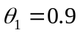 and 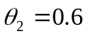. You can leave the mean and standard deviation at 0 and 1, respectively. Then, create the sample ACF and PACF of your simulated series. Give those plots and write a brief interpretation. Were the patterns what they should be? Are there any other possible interpretations?

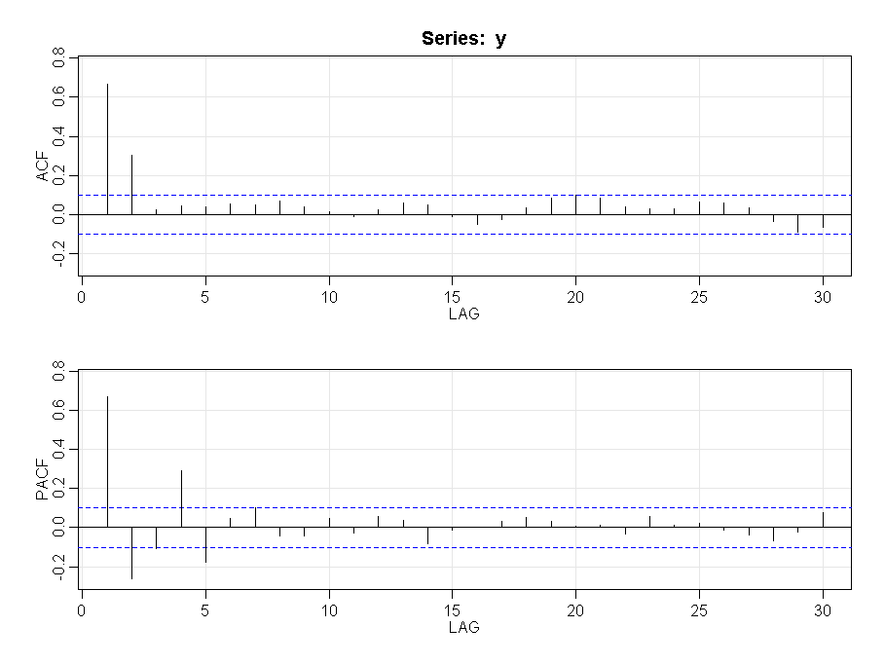
The appearance indicates:
- ACF peaks for lag 1 and 2 and then cuts off
- PACF trails off to 0.
The appearance is in alignment (broad agreement) with the expected behavior but not the exact theoretical behavior.

C. Describe the general theoretical appearance of the ACF and PACF of an AR(3) model.

The theoretical appearance:
- PACF peaks for lag 1, 2 and 3 and then cuts off
- ACF trails off to 0.

D. In R, simulate n = 400 values from an AR(3) with coefficients 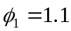 , 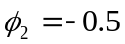, and 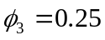You can leave the mean and standard deviation at 0 and 1, respectively. Then, create the sample ACF and PACF of your simulated series. Give those plots and write a brief interpretation. Were the patterns what they should be? Are there any other possible interpretations?

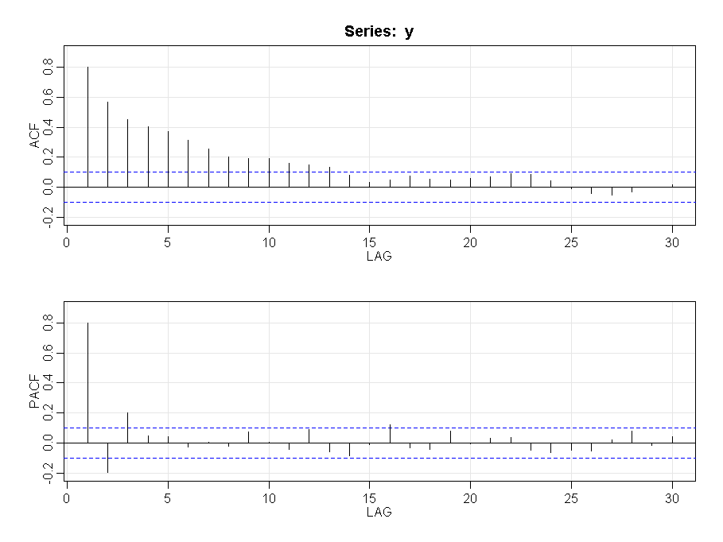
The appearance:
- PACF peaks for lag 1, 2 and 3 and then cuts off
- ACF trails off to 0.

The appearance is in alignment (broad agreement) with the expected behavior but not the exact theoretical behavior.

E. Describe the general theoretical appearance of the ACF and PACF of an ARMA(1,1) model.

The theoretical appearance:
- ARMA models (including both AR and MA terms) have ACFs and PACFs that both tail off to 0.

F. In R, simulate n = 400 values from an ARMA(1,1) with coefficients 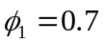 , 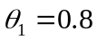You can leave the mean and standard deviation at 0 and 1, respectively. Then, create the sample ACF and PACF of your simulated series. Give those plots and write a brief interpretation. Were the patterns what they should be? Are there any other possible interpretations?

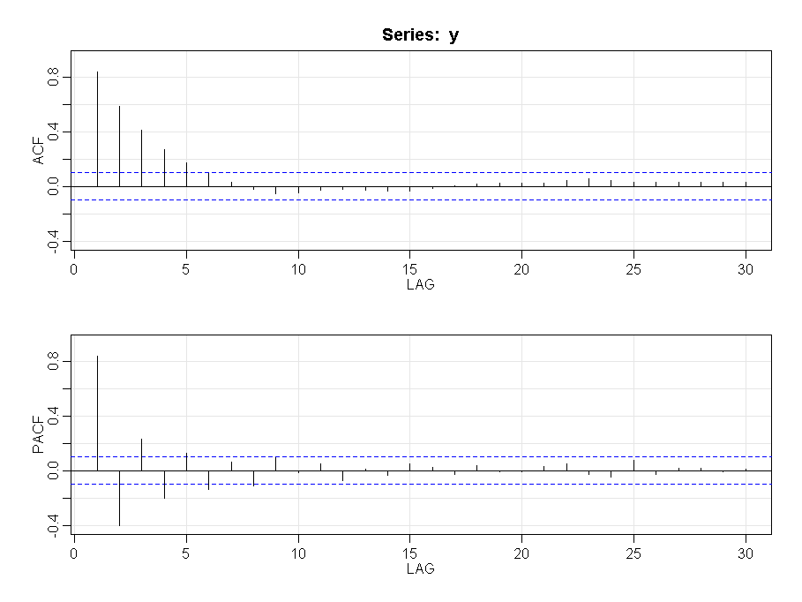
The appearance:
- ACFs and PACFs both tail off to 0. This is in alignment with the theoretical appearance.

The appearance is in alignment (broad agreement) with the expected behavior but not the exact theoretical behavior.

2. Use the metalsemploy.dat dataset from the Week 14 folder. The data are n = 132 consecutive measures of the number of people employed in metals industries in the state of Wisconsin.

A. Create a time series plot of the data. Give the plot and write a brief interpretation.

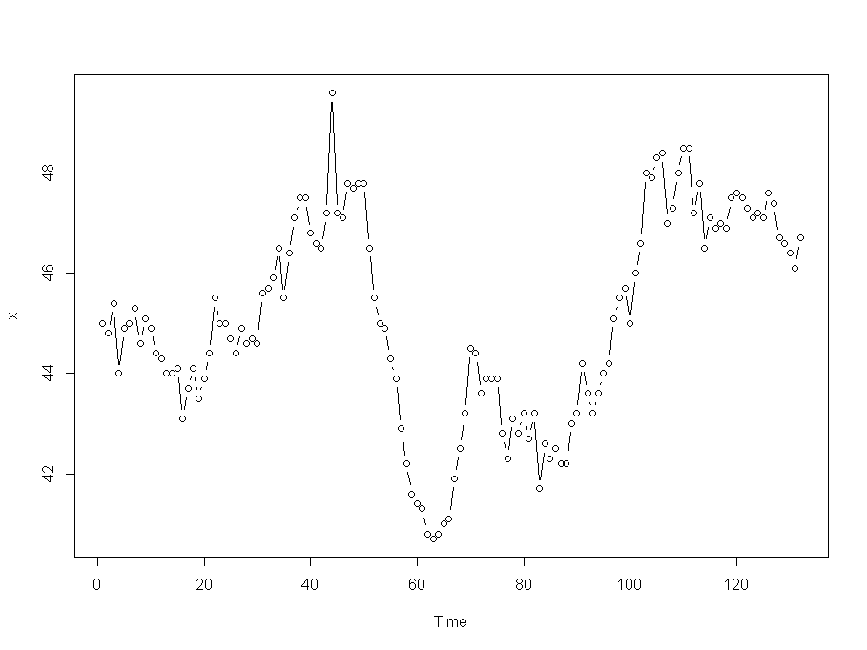
The properties are:

B. Determine the sample ACF and PACF of the series. Give the plots and write a brief interpretation.

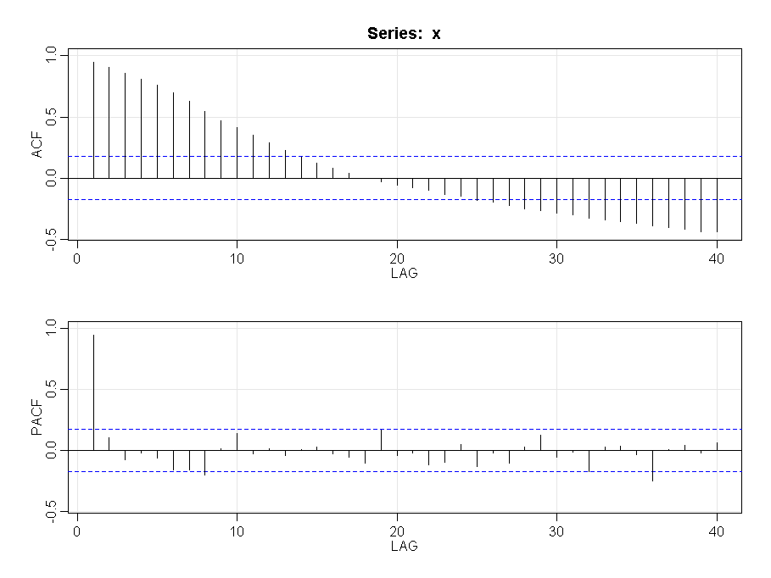
The plots indicate:
- The PACF alone has a significant value at lag 1 and then cuts off.
- The ACF seems to be high persistently. In the initial part it trails very gradually but increases gradually in the second part. This suggests that first differences may help with the model.

C. Determine the sample ACF and PACF of the first differences of the series. Give the plots and write a brief interpretation. What model is suggested?

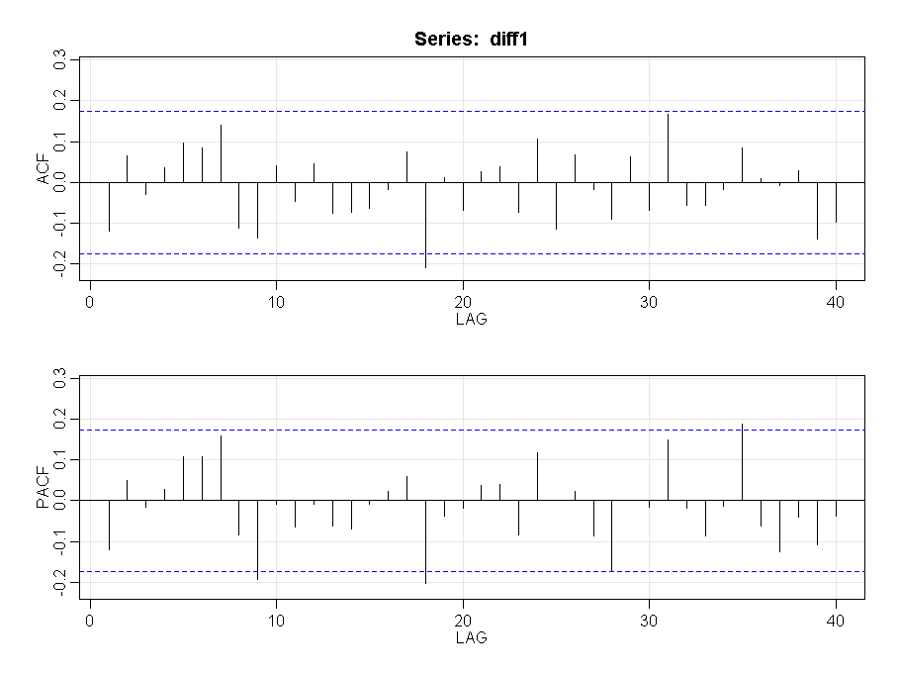
Here we see that:
- Neither ACF and PACF have any significant values. Since all the autocorrelations are non-significant, the series is random.

Here we have taken first differences and found that all the autocorrelations are non-significant, therefore the series is a random walk and there is nothing further to be done.

3. Use the buffsnow.dat dataset in the Week 14 folder. The data are n = annual values of snowfall (inches) in Buffalo, New York.

Determine an ARIMA model for these data. Give the sample ACF and PACF, a brief interpretation of these plots, output for your estimated model, and proof that the model is suitable (i.e., the diagnostic plots).

The plot of the data:
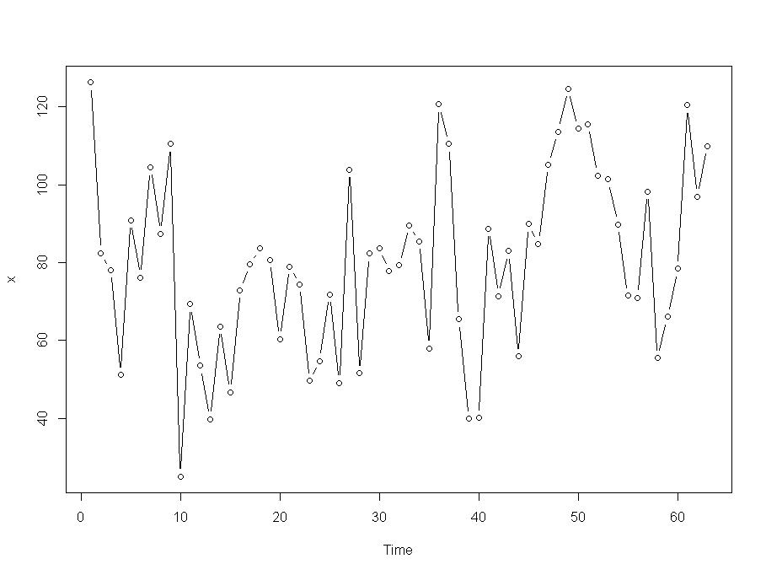

The ACF / PACF plots are:
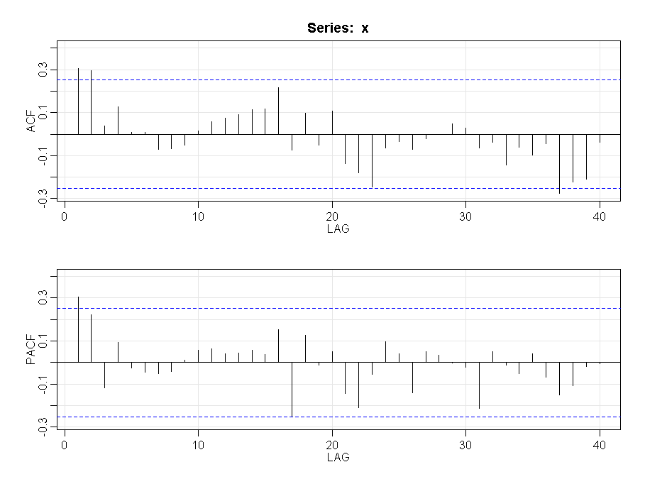
The ACF / PACF plot indicates:
- The ACF spikes for lag 1 and 2 and then cuts off. This indicates an MA(2) model.
- The PACF is significant for lag 1 and then trails off. It leads to 2 possibilities – either AR(1) or MA(2)

Based on the above we will evaluate the following models:
- MA(2), ARMA(1,1) and ARMA(1,2)

MA(2) : sarima (x, 0, 0, 2) | ARMA(1,1) : sarima (x, 1, 0, 1) | ARMA(1,2) : sarima (x, 1, 0, 2)
sigma^2 estimated as 467.6  $ttable  Estimate SE t.value p.value  ma1 0.2971 0.1267 2.3451 0.0223  ma2 0.2989 0.1136 2.6316 0.0108  xmean 80.8990 4.3118 18.7621 0.0000  $AIC  [1] 7.242747  $AICc  [1] 7.28544  $BIC  [1] 6.344801 | sigma^2 estimated as 481.2  $ttable  Estimate SE t.value p.value  ar1 0.6728 0.2001 3.3630 0.0013  ma1 -0.3747 0.2389 -1.5686 0.1220  xmean 81.4902 5.2326 15.5736 0.0000  $AIC  [1] 7.271555  $AICc  [1] 7.314248  $BIC  [1] 6.373609 | sigma^2 estimated as 467  $ttable  Estimate SE t.value p.value  ar1 -0.1768 0.6959 -0.2540 0.8004  ma1 0.4659 0.6688 0.6966 0.4888  ma2 0.3337 0.1591 2.0972 0.0403  xmean 80.8031 4.1480 19.4798 0.0000  $AIC  [1] 7.273364  $AICc  [1] 7.321818  $BIC  [1] 6.409436
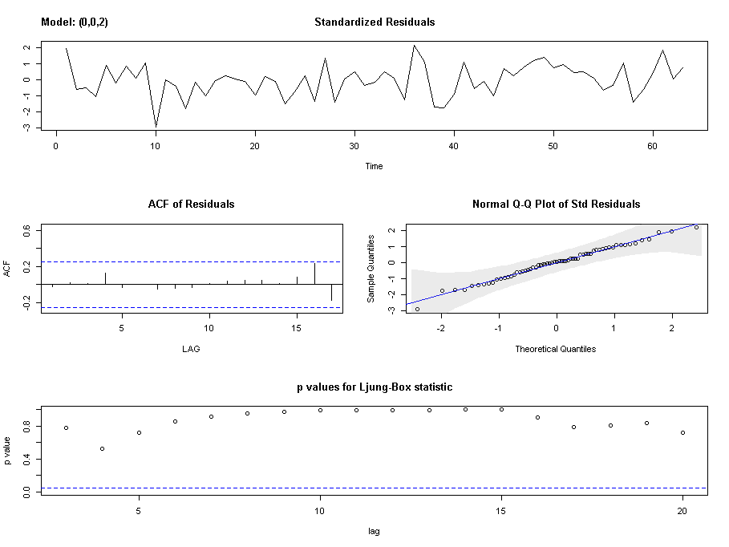 | 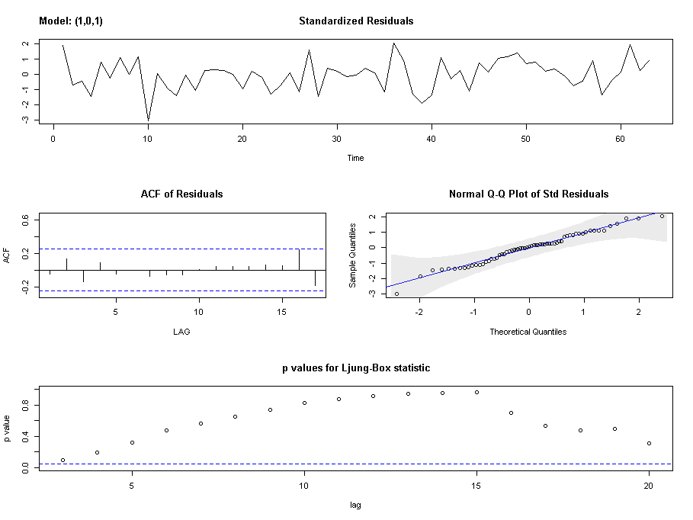 | 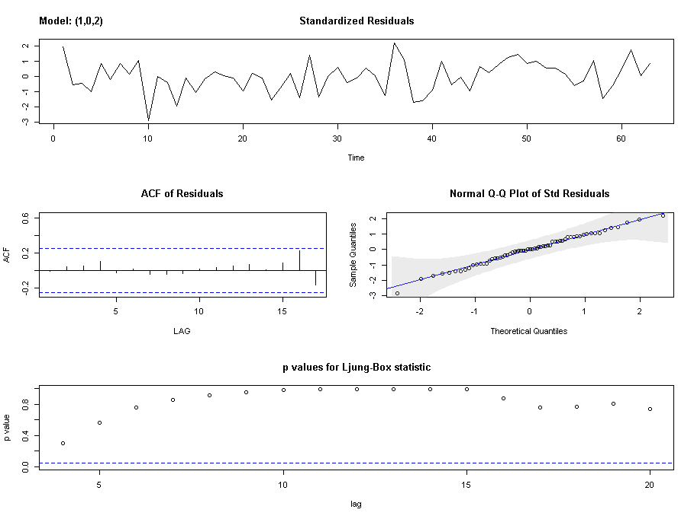

From the above table we can say that while all the models seem appropriate, MA(2) performs the best.
The output for MA(2):
sigma^2 estimated as 467.6: log likelihood = -283.16, aic = 574.32

$degrees_of_freedom
[1] 60

$ttable
Estimate SE t.value p.value
ma1 0.2971 0.1267 2.3451 0.0223
ma2 0.2989 0.1136 2.6316 0.0108
xmean 80.8990 4.3118 18.7621 0.0000

$AIC
[1] 7.242747

$AICc
[1] 7.28544

$BIC
[1] 6.344801

Diagnostic plot:

The plot indicates:
- The time series plot of the standardized residuals mostly indicates that there’s no trend in the residuals, no outliers, and in general, no changing variance across time.
- The ACF of the residuals doesn’t show significant autocorrelations – a good result.
- The Q-Q plot is a normal probability plot – The plot looks almost linear so the assumption of normally distributed residuals holds.
- The bottom plot gives p-values for the Ljung-Box-Pierce statistics for each lag up to 20. All p-values are above the dashed blue line - That’s a good result

4. The following CCF from R give cross correlations between x = annual advertising expenditures and y = annual sales for a product. Propose a possible lagged regression model (or more than one if you wish) for predicting sales. Briefly explain. Remember that in R the negative lags give the lags of the x-variable.

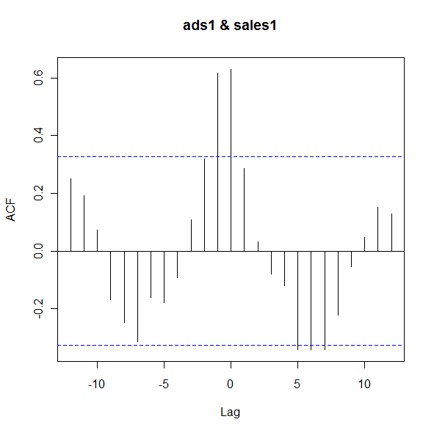
From the CCF plot we can say:
- We see clear spikes at lags 0 and 1. Thus x_{t} and x_{t-1} should be tried as predictors of y_{t}
  - Since we have y correlated to x_{t-1} we can say that x leads y
- We also observe a sinusoidal behavior indicating that we should also test Lags 1 and 2 of y i.e. yt-1, yt-2

Based on this a proposed lagged regression model will be:
y_{t}Hat = B0 + B1 x_{t} + B2 x_{t-1} + B3 y_{t-1} + B4 y_{t-2}

