**Stat 510 Week 12 Homework Solutions**

1. A. What are the weighting coefficients for a Daniell kernel with *m* = 3?

**There would be 7 equally weighted terms in the smoothing formula, therefore the weights are 1/7 = .1429.**

From R:

**kernel ("daniell", 3)**

**Daniell(3)**

**coef[-3] = 0.1429**

**coef[-2] = 0.1429**

**coef[-1] = 0.1429**

**coef[ 0] = 0.1429**

**coef[ 1] = 0.1429**

**coef[ 2] = 0.1429**

**coef[ 3] = 0.1429**

B. What are the weighting coefficients for a Daniell kernel that is convoluted (repeated) with *m* = 3 in both smoothings?

From R:

**kernel ("daniell", c(3,3))**

**Daniell(3,3)**

**coef[-6] = 0.02041**

**coef[-5] = 0.04082**

**coef[-4] = 0.06122**

**coef[-3] = 0.08163**

**coef[-2] = 0.10204**

**coef[-1] = 0.12245**

**coef[ 0] = 0.14286**

**coef[ 1] = 0.12245**

**coef[ 2] = 0.10204**

**coef[ 3] = 0.08163**

**coef[ 4] = 0.06122**

**coef[ 5] = 0.04082**

**coef[ 6] = 0.02041**

C. What are the weighting coefficients for a modified Daniell kernel with *m* = 3?

**kernel ("modified.daniell", 3)**

**mDaniell(3)**

**coef[-3] = 0.08333**

**coef[-2] = 0.16667**

**coef[-1] = 0.16667**

**coef[ 0] = 0.16667**

**coef[ 1] = 0.16667**

**coef[ 2] = 0.16667**

**coef[ 3] = 0.08333**

2. Use the dataset “week12sim.dat” from the Week 12 folder. The data are *n* = 200 values simulated from an AR(2) model (with no trend).

A. Use the spec.pgram command to determine the raw periodogram. Give the plot as the answer to this part.

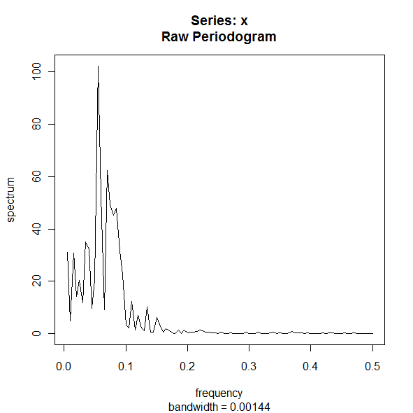

B. Smooth the periodogram using a Daniell kernel with m = 2. Give the plot as the answer to this part.

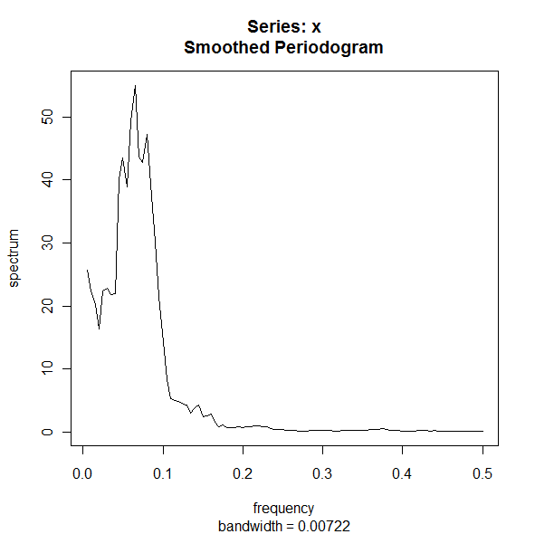

C. Smooth the periodogram using a modified Daniell kernel with m = 3 (so span length = 7). Give the plot as the answer to this part.

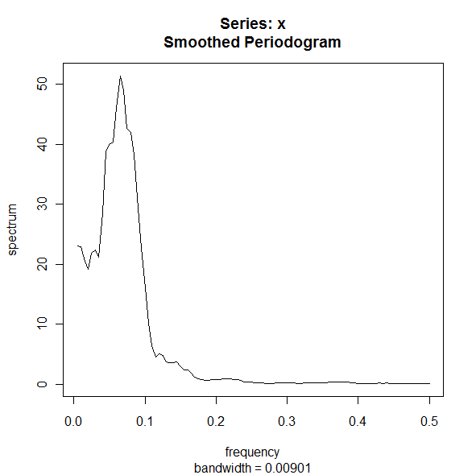

D. Smooth the periodogram using two passes of a modified Daniell kernel with m = 3 for each pass. (If you’re using the spans parameter of spec.pgram, it would be spans = c(7,7). Give the plot as the answer to this part.

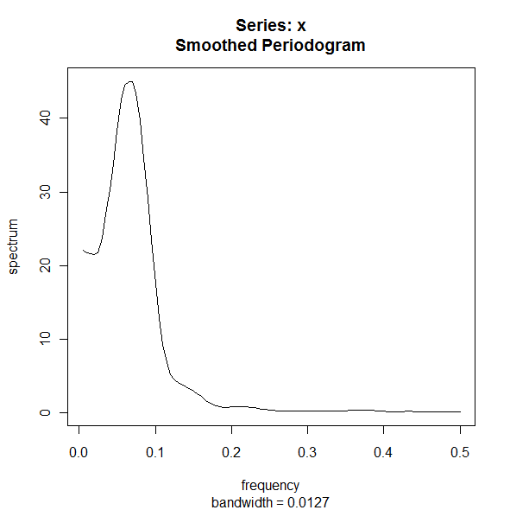

E. Using the smoothed periodogram in part D, identify the approximate frequency at which the maximum spectral density occurs. This can be estimated visually, but also can be done by assigning a name to the spec.pgram result by doing something like

specvalues = spec.pgram(……

After this command simply use the command specvalues and examine the results.

What is the frequency at which the peak occurs? What is the period associated with this frequency? Recall that period = 1/frequency.

**The max occurs at a frequency of .065. [The max is barely the max. The density value is nearly the same at .07 as it is at .065.] The period at which the max occurs is about 1/.065= 15.38, about 15 or so.**

F. Use spec.ar to determine the parametric estimate of the spectral density. Give the plot of the estimated spectral density. What AR order was used to create this estimate?

(Notice that it didn’t turn out to be the order used to simulate the data!)

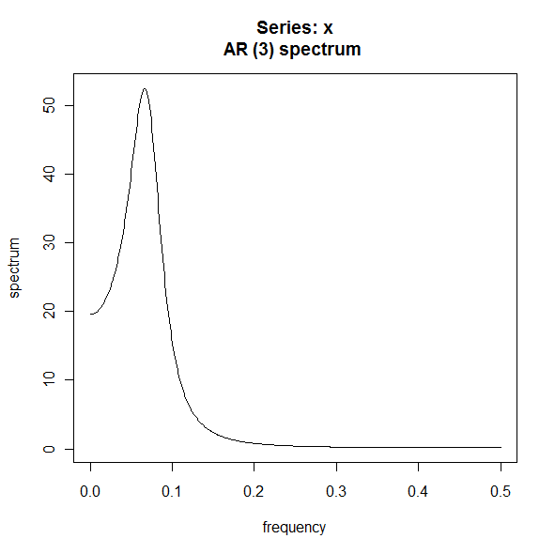

**An AR(3) was used to create this estimate. The simulated data is from an AR(2).**

G. Using the parametric estimate of the spectral density, estimate the approximate frequency at which the maximum spectral density occurs.

**max occurs at a frequency = 0.066132265 (but it was a close call)**

H. (review of ARIMA work) Determine the acf and pacf of the data series. Give the graphs and write a brief discussion of what model is suggested. You might load the astsa library and then acf2(..).



I. Use the sarima command to examine whether an AR(2) or an AR(3) is the better model for these data.

**The diagnostics look good for both an AR(2) and an AR(3) model. The information criterion are slightly higher for the AR(2) and the AR(3) term is not significant in the AR(3) model, (z = 1.79 < 1.96). The AR(2) model is better.**

3. In R, use the command

x = rnorm(250,0,1)

This will generate a series of 250 random values from a normal distribution with mean 0 and variance 1. In other words, we’ve generated a white noise series.

Use spec.ar to determine a parametric estimate of the spectral density for the simulated data.

Give the graph and write a (very) brief description of its appearance.

**The graph displays a flat line as should be observed for white noise. Due to sampling error, some simulations may also produce an AR(1) or an AR(2).**



4. Use the dataset temp.dat in the Week 12 folder. It gives n = 508 weekly values of the average temperature in Los Angeles County. Determine a nonparametric estimate of the spectral density of the series. Give the graph, describe what smoothing you used and describe the location of the peak density.

**The smoothed periodogram shows a spike at frequency 0.019531250 corresponding to a 51.2-week cycle. Because the data is weekly, a 52 week cycle is sensible. We applied a convoluted Daniell kernel with m = 3. The following graph shows a vertical line at the peak frequency of 1/52.**

