**Stat 510 Week 2 Homework**

**Submit answers in a Word document or a pdf to the designated ANGEL Drop Box in the Drop Boxes folder.**

**1.** Consider the following short time series data set:

|  |  |  |  |  |  |  |  |  |  |  |  |  |  |  |  |  |  |  |  |  |
| --- | --- | --- | --- | --- | --- | --- | --- | --- | --- | --- | --- | --- | --- | --- | --- | --- | --- | --- | --- | --- |
| *t* | 1 | 2 | 3 | 4 | 5 | 6 | 7 | 8 | 9 | 10 | 11 | 12 | 13 | 14 | 15 | 16 | 17 | 18 | 19 | 20 |
| *xt* | 13 | 2 | 5 | 20 | 2 | 4 | 12 | 8 | 7 | 19 | 7 | 1 | 20 | 5 | 12 | 18 | 12 | 20 | 8 | 5 |

Evaluate each of the following expressions (i.e., give a numerical answer):

a.  = (1-B) x13 = x13 – x12 = 20 – 1 = 19

b.  = x11 = 7

c. = x13 – x11 = 20 – 7 = 13

d.  = (1-B)2 x13 = x13 – 2*x12 + x11 = 20 – 2*1 + 7 = 25

e.  = x13 – B12 x13 = x13 – x1 = 20 – 13 = 7

f. = x13 * (1 – 0.7B +0.5 B2 – B + 0.7B2 – 0.5 B3) = x13 – 1.7 B x13 + 1.2 B2 x13 – 0.5 B3 x13 = x13 – 1.7 x12 + 1.2 x11 – 0.5 x10 = 20 – 1.7*1 + 1.2 * 7 – 0.5 * 19 = 17.2

**2.** Write out the autoregressive and moving average polynomials for the following model:

 

Hint: The key structure for this answer is (AR polynomial)xt = (MA polynomial)wt .

The model is AR(2) and MA(3)

AR(2) model can be written as: (1− ϕ1B − ϕ2B2)xt = δ+wt or as Φ(B) xt = δ+wt with an additional explanation that Φ(B) = 1− ϕ1B − ϕ2B2

A MA(3) model is defined as xt = μ+wt+θ1wt−1+θ2wt−2+θ3wt−3 and could be written as xt = μ+(1+θ1B+θ2B2+ θ3B3)wt

Since our model has both AR and MA terms we have Φ(B) (xt−μ) = Θ(B) wt

where,

Φ(B) = 1− ϕ1B − ϕ2B2 and

Θ(B) = 1+θ1B+θ2B2+ θ3B3

Substituting the values from the model we have:

Φ(B) = 1− 1.7 B – 0.7 B2 and

Θ(B) = 1 + 0.7 B + 0.4 B2 – 0.2 B3

**3**. Consider the MA(1) model  with the wt assumed to be iid N(0,).

A. Give a numerical value for the first lag autocorrelation.

The first lag autocorrelation:

θ1= 0.6, The theoretical ACF is given by ρ1 = 0.6 / (1 + 0.6^2) = 0.4412, and ρh=0 for all lags h≥2

B. Give a numerical value for the second lag autocorrelation.

ρh=0 for all lags h≥2

C. Describe the appearance of the ACF for this model.

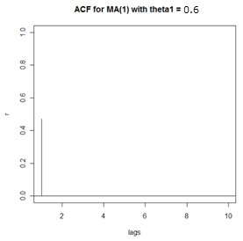

The appearance will be similar to above with significant value for lag=1 and 0 for all the other lags

D. Use R to sketch the ACF for this model. The commands are:

acfprob3=ARMAacf(ma=c(.6), lag.max=10)

plot(seq(0,10), acfprob3, xlim=c(1,10), xlab="lags", type="h")

(In the plot command, the type="h" causes projections from the value to the axis as we usually do in an ACF. The xlim option removes the unnecessary lag 0 ACF.)

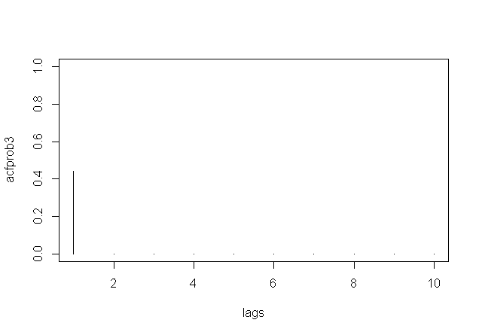

E. To get the PACF of this model, modify the command by adding the pacf option:

pacfprob3 = ARMAacf(ma=c(.6), lag.max=10, pacf=TRUE)

plot(pacfprob3, type="h")

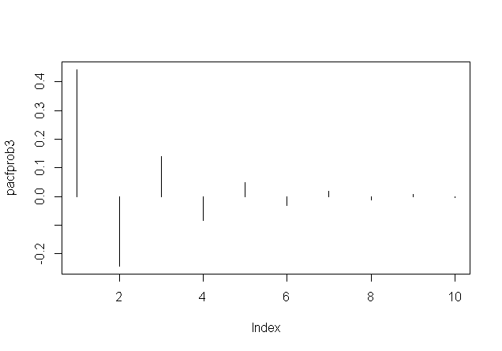

**4**. Consider the AR(1) model 

A. Give a numerical value for the first lag autocorrelation. (You might want to look back at the week 1 notes.)

The first lag autocorrelation: we will use ρh=ϕ1h

First autocorrelation = ρ1 = -0.6

B. Give a numerical value for the second lag autocorrelation.

The 2nd lag autocorrelation: we will use ρh=ϕ1h

2nd lag autocorrelation = ρ2 = (-0.6)^2 = 0.36

C. Give a numerical value for the third lag autocorrelation.

The 3rd lag autocorrelation: we will use ρh=ϕ1h

3rd lag autocorrelation = ρ3 = (-0.6)^3 = -0.216

D. Describe the appearance of the PACF for this model.

For an AR model, the theoretical PACF “shuts off” past the order of the model i.e. in theory the partial autocorrelations are equal to 0 beyond that point.

Since we have an AR(1) model, the theoretical PACF will have a significant value for lag 1 and 0 for all the other lags

E. Use R to sketch the ACF for this model. The commands are:

acfprob4=ARMAacf(ar=c(-.6), lag.max=10)

lags=0:10 #creates a variable named lags that ranges from 0 to 10.

plot(lags, acfprob4, xlim=c(1,10), type="h")

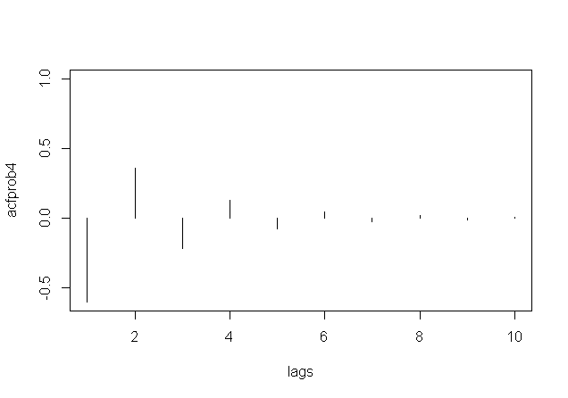

F. To get the PACF of this model, modify the command by adding the pacf option:

pacfprob4 = ARMAacf(ar=c(-.6), lag.max=10, pacf=TRUE)

plot(pacfprob4, type="h")

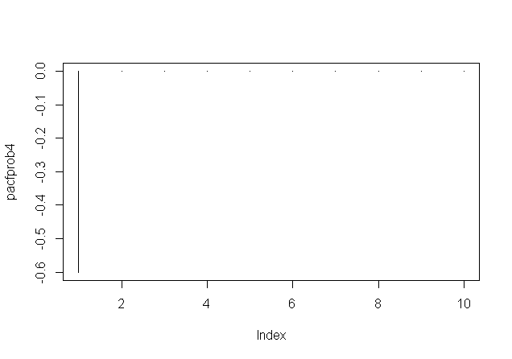

**5.** The time series for this problem is stride length measured every 30 seconds for a runner on a treadmill moving at pace of 7 minutes per mile.

Following are the ACF and PACF for the series. Briefly describe what model(s) may be suggested by these plots (and explain why).





The above plots indicate that we may have an AR(2) model. This is supported by the following points:

* PACF: Note that the first and second lag values are statistically significant, whereas partial autocorrelations for all other lags are not statistically significant. This suggests a possible AR(2) model for these data.
* ACF: We see that the ACF exponentially decreases to 0 as the lag h increases.
* An AR(2) has a sinusoidal ACF that converges to 0.

Here one can also deduce from the ACF that the MA(2) model may work but the PACF doesn’t taper towards 0 cleanly and so I preferred to select the AR(2) model.