Homework 8 Solutions

1) Consider a study to determine the best method for producing a particular type of canned green beans. Harvested beans are allowed to soak in a solution of herbs for either a short or long soak- time. Four crocks were available, so 2 crocks (randomly) were assigned the long soak-time treatment and two crocks were assigned the short soak-time. From each crock a jar was filled with beans and then pressure-canned in a brine solution that was made up using one of three different recipes. After a 6-week period, they were rated for taste and the data appears in the Excel file ‘diilly_beans_one.xlsx’ .

a) (10 pts) What is the treatment design?

*A two factor factorial with soak-time at 2 levels crossed with recipe at 3 levels.*

b) (10 pts) What is the experimental design?

*A split plot in a completely randomized design (CRD). It is a split plot because there are two different types of experimental units (EU’s) being used: the crock is the EU for the assignment of a soak-time treatment level. The experimental unit for the recipe is a jar of beans that have already received the soak-time treatment. It is a split plot in a CRD because the soak-time treatment was assigned to crocks completely at random (i.e., two of the four crocks were randomly assigned the short soak-time, and two were randomly assigned the long soak-time.*

c) (20 pts) Run the ANOVA and show the output.

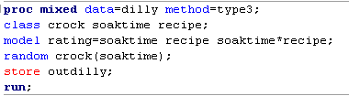

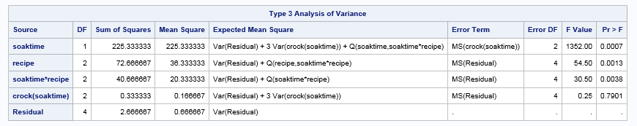

d) (10 pts) Follow-up the ANOVA with mean comparisons (where indicated by statistical significance). (You do not need to graph these results). Table output is OK.

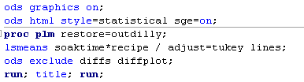

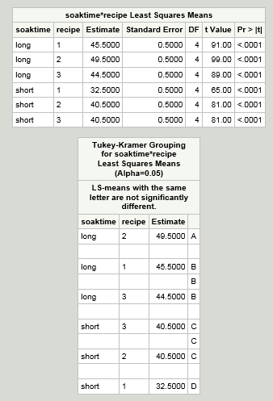

.

2) In an agricultural field experiment an investigator wants to evaluate 4 disease treatments on 4 varieties of wheat. The disease treatment levels and varieties were specifically chosen and of interest to the researchers. They can apply the disease treatment levels to small sub-sections of a field, but need to plant the varieties with a mechanized seeder on large acreages. They replicate their experiment in four fields by dividing each field into 4 'whole plots' which are large areas, for planting the 4 wheat varieties.  In each field, then, all 4 varieties are planted.  Then each of these large 'whole plots' in each field, planted with a variety of wheat, gets split into 4 subplots that are randomly assigned a disease treatment.

|  |  |  |  |  |  |
| --- | --- | --- | --- | --- | --- |
| **Variety** | **Field** | **D1** | **D2** | **D3** | **D4** |
| **V1** | **1** | 42.9 | 53.8 | 49.5 | 44.4 |
|  | **2** | 41.6 | 58.5 | 53.8 | 41.8 |
|  | **3** | 28.9 | 43.9 | 40.7 | 28.3 |
|  | **4** | 30.8 | 46.3 | 39.4 | 34.7 |
| **V2** | **1** | 53.3 | 57.6 | 59.8 | 64.1 |
|  | **2** | 69.6 | 69.6 | 65.8 | 57.4 |
|  | **3** | 45.4 | 42.4 | 41.4 | 44.1 |
|  | **4** | 35.1 | 51.9 | 45.4 | 51.6 |
| **V3** | **1** | 62.3 | 63.4 | 64.5 | 63.6 |
|  | **2** | 58.5 | 50.4 | 46.1 | 56.1 |
|  | **3** | 44.6 | 45 | 62.6 | 52.7 |
|  | **4** | 50.3 | 46.7 | 50.3 | 51.8 |
| **V4** | **1** | 75.4 | 70.3 | 68.8 | 71.6 |
|  | **2** | 65.6 | 67.3 | 65.3 | 69.4 |
|  | **3** | 54 | 57.6 | 45.6 | 56.6 |
|  | **4** | 52.7 | 58.5 | 51 | 47.4 |

a) (10 pts) What is the treatment design?

*2-factor factorial*

b) (10 pts) What is the experimental design?

*Split plot in RCBD. In this case, we have blocks (i.e., fields) that are divided into 4 areas to receive the 4 levels of the variety treatment. So the RCBD part of this split plot arises from how the main plot factor is being applied. The ramifications, however, are seen in having a different error term for F test for the main plot factor compared to the error term for the F test for the main plot factor in the split plot CRD in problem 1.*

c) (20 pts) Run the ANOVA and show the output. (Note that the data is presented in un-stacked format and is notbeing provided in an excel file in this assignment).

**proc** **mixed** data=wheat method=type3;

class variety field dis_trt;

model yield=variety dis_trt variety*dis_trt / ddfm=kr;

random field field*variety;

store out_wheat;

title 'Split Plot in RCBD';

**run**;

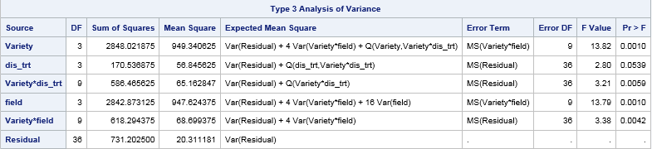

d) (10 pts) Follow-up the ANOVA with mean comparisons (where indicated by statistical significance). (You do not need to graph these results). Table output is OK.

ods graphics on;

ods html style=statistical sge=on;

**proc** **plm** restore=out_wheat;

lsmeans variety*dis_trt / adjust=tukey cl lines;

/* optional: slice variety*dis_trt / adjust=tukey cl lines; */

ods exclude diffs diffplot;

**run**; title; **run**;

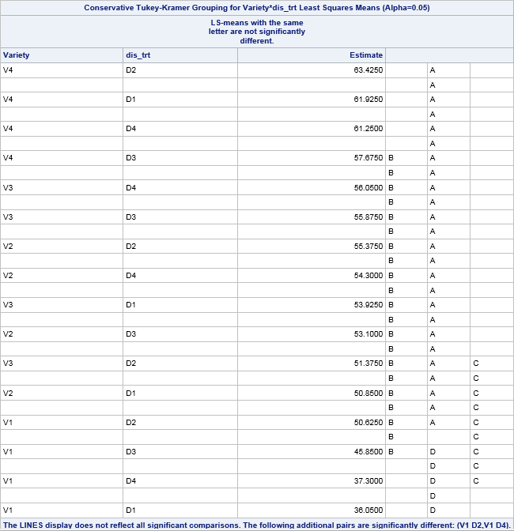

The optional statement shown in the SAS code above provides tests for ‘slices’, that is, comparing treatments means within the levels of another treatment. It sometimes helps in the interpretation of the results when there are so many treatment combinations and we have a significant interaction. The slice command here gives us:

