**System Requirements Specification**

**RF Direction Detection**

**CEC/EE 420 Fall 2020**

Team Name: RF Direction Detection Team 2

Team Members:

* Sylvie Sorese
* Ryan Clayton
* Dalton Mitchum

Contents of this Document

Introduction

* System to be Produced
* Applicable Standards

Definition, Acronyms, and Abbreviations

Product Overview

* Assumptions
* Stakeholders
* Event Table
* Use Case Diagram
* Use Case Descriptions

Specific Requirements

* Functional Requirements
* Interface Requirements
* Physical Environment Requirements
* Users and Human Factors Requirements
* Documentation Requirements
* Data Requirements
* Resource Requirements
* Security Requirements
* Quality Assurance Requirements

Supporting Material

**Section 1: Introduction**

System to be Produced:

* The design of an affordable system that detects the direction of arrival of a radio frequency (RF) propagating wave, in the ISM band, with the intention of eventually being used in a classroom setting.

Definitions, Acronyms, and Abbreviations

* Radio frequency (RF)
* Industrial, Scientific, and Medical (ISM)
* Direction of Arrival (DoA)
* Low-noise Amplifier (LNA)
* Software Defined Radio (SDR)
* Embry-Riddle Aeronautical University (ERAU)
* Institute of Electrical and Electronics Engineers (IEEE)
* Antennas and Propagation Society (AP-S)
* Continuous Time (CT)

**Section 2: Product Overview**

Assumptions:

* The team members will share responsibilities on the project. Each member wishes to gain experience with every aspect of the project, including design, documentation, and implementation.

Stakeholders:

* Dr. Eduardo Rojas, an assistant professor of Electrical and Computer Engineering at ERAU, is the project owner for the project. Dr. Rojas provided project specifications and requirements that originated from the IEEE AP-S Student Design Contest Array for DoA Detection and Visualization.
* Dr. Jianhua Liu, an associate professor of Electrical and Computer Engineering at ERAU, is the professor evaluating SCRUM process of the project.

Event Table:

|  |  |  |  |
| --- | --- | --- | --- |
| Event Name | External Stimuli | External Responses | Internal data and state |
| Receiving | Device generating the 5GHz signal | N/A | Unfiltered and non-amplified CT analog signal |
| Filtering | N/A | N/A | Filtered and non-amplified CT analog signal |
| Amplifying | N/A | N/A | Filtered and amplified CT analog signal |
| Processing | N/A | N/A | Converting analog signal to digital signal |
| Displaying | N/A | Display DoA | N/A |
| Repeating | N/A | Repeat events for a new signal | Receiving |

Case Diagram:

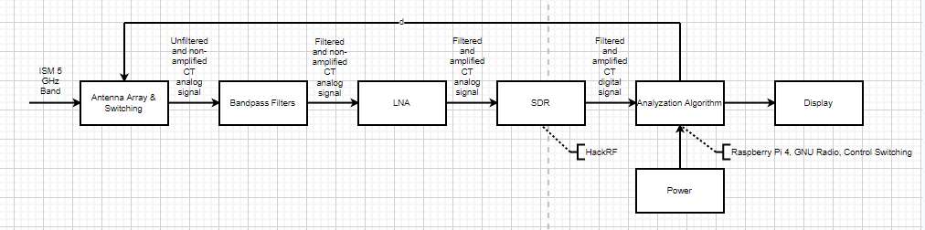

**Section 3: Specific Requirements**

* 1. Functional Requirements

1. The system shall be able to receive a 5GHz signal for interpretation using the antenna array
2. The system shall switch between which antenna is currently inputting data into the system
3. The system shall filter out noise using the bandpass filters
4. The system shall amplify the signal through the LNA
5. The system shall process signal from analog to digital through the SDR
6. The system shall analyze the signal through the algorithm ran on the computer
7. The system shall determine the DoA of the 5GHz signal
8. The system shall display the DoA of the 5GHz signal
9. The system shall display the characteristics of the 5GHz signal
10. The system shall repeat the process starting from functional requirement 1 once functional requirements 8 and 9 are met
    1. Interface Requirements
    2. Physical Environment Requirements
    3. User and Human Factors Requirements
11. The system setup shall be understood for non-specialists
12. The system instructions shall provide detailed, step-by-step instructions for teaching purposes
13. The system procedure shall be understandable for non-specialists
    1. Documentation Requirements
14. The documentation shall be understandable to those of at least a high school level of education

3.6 Data Requirements

* 1. Resource Requirements

1. The system shall require components that can be purchased from vendors only
2. The price of components to build the system shall be less than or equal $1,500
   1. Security Requirements
   2. Quality Assurance Requirements
3. The system shall be portable enough that only one individual is needed to move it

**Section 4: Supporting Material**