**System Design Document:**

RF Direction of Arrival System

Dalton Mitchum

Sylvie Sorese

Ryan Clayton

|  |  |
| --- | --- |
| Version | Date |
| V1.1 | 10/01/2020 |
| V2.0 | 10/29/2020 |
|  |  |

**Contents**

**1 Introduction**

1.1 Purpose and Scope . . . . . . . . . . . . . . . . . . . . . . . . . . . . . . . . . . . . . . . . . . . . . . . . . . . . .

1.2 Project Executive Summary . . . . . . . . . . . . . . . . . . . . . . . . . . . . . . . . . . . . . . . . . . . . . .

1.2.1 System Overview . . . . . . . . . . . . . . . . . . . . . . . . . . . . . . . . . . . . . . . . . . . . . . .

1.2.2 Design Constraints . . . . . . . . . . . . . . . . . . . . . . . . . . . . . . . . . . . . . . . . . . . . . .

1.2.3 Future Contingencies . . . . . . . . . . . . . . . . . . . . . . . . . . . . . . . . . . . . . . . . .

1.3 Document Organization . . . . . . . . . . . . . . . . . . . . . . . . . . . . . . . . . . . . . . . . . . . . . . . . .

1.4 Project References . . . . . . . . . . . . . . . . . . . . . . . . . . . . . . . . . . . . . . . . . . . . . . . . . . . . .

1.5 Glossary . . . . . . . . . . . . . . . . . . . . . . . . . . . . . . . . . . . . . . . . . . . . . . . . . . . . . . . . . . . . .

**2 System Architecture**

2.1 System Hardware Architecture . . . . . . . . . . . . . . . . . . . . . . . . . . . . . . . . . . . . . . . . . . .

2.2 System Software Architecture . . . . . . . . . . . . . . . . . . . . . . . . . . . . . . . . . . . . . . . . . . .

2.3 Internal Communications Architecture . . . . . . . . . . . . . . . . . . . . . . . . . . . . . . . . . . . . .

**3 Human-Machine Interface**

3.1 Inputs . . . . . . . . . . . . . . . . . . . . . . . . . . . . . . . . . . . . . . . . . . . . . . . . . . . . . . . . . . . . . . .

3.2 Outputs . . . . . . . . . . . . . . . . . . . . . . . . . . . . . . . . . . . . . . . . . . . . . . . . . . . . . . . . . . . . .

**4 Detailed Design**

4.1 Hardware Detailed Design . . . . . . . . . . . . . . . . . . . . . . . . . . . . . . . . . . . . . . . . . . . . . . .

4.2 Software Detailed Design . . . . . . . . . . . . . . . . . . . . . . . . . . . . . . . . . . . . . . . . . . . . . . .

4.2.1 Base Station Subsystem . . . . . . . . . . . . . . . . . . . . . . . . . . . . . . . . . . . . . . . . . .

4.2.2 Communication Subsystem . . . . . . . . . . . . . . . . . . . . . . . . . . . . . . . . . . . . . . .

4.2.3 Demodulation System . . . . . . . . . . . . . . . . . . . . . . . . . . . . . . . . . . . . . . . . . . .

4.2.4 Telemetry Subsection . . . . . . . . . . . . . . . . . . . . . . . . . . . . . . . . . . . . . . . . . . . .

4.3 Internal Communications Detailed Design . . . . . . . . . . . . . . . . . . . . . . . . . . . . . . . . . . .

**5 External Interfaces**

5.1 Interface Architecture . . . . . . . . . . . . . . . . . . . . . . . . . . . . . . . . . . . . . . . . . . . . . . . . . .

5.2 Interface Detailed Design . . . . . . . . . . . . . . . . . . . . . . . . . . . . . . . . . . . . . . . . . . . . . . .

**6 System Integrity Controls**

**1 Introduction**

**1.1 Purpose and Scope**

The purpose of the System Design Document is to describe the system requirements, system architecture, human-machine interfaces, detailed design, and external interfaces.

**1.2 Project Executive Summary**

This section provides a descriptive overview of the DoA system from a management perspective.

1.2.1 System Overview

The goal of the Radio Frequency (RF) Direction of Arrival System is to design an affordable system that detects the directions of arrival of an RF propagating wave, in the ISM band, with the intention of eventually being used in a classroom setting.

1.2.2 Design Constraints

The project is limited to two major factors, budget and components. The total cost of components shall not exceed $1,500. For the project, the components will be purchased from online vendors if possible. The goal is to avoid constructing components as much as possible so that the project can be recreated by someone else.

1.2.3 Future Contingencies

**1.3 Document Organization**

The System Design Document is constructed to provide an overall concept of the system design.

**1.4 Project References**

**1.5 Glossary**

**AP-S** – Antennas and Propagation Society

**CT** – Continuous Time

**DoA** – Direction of Arrival

**ERAU** – Embry Riddle Aeronautical University

**IEEE** – Institute of Electrical and Electronics Engineers

**ISM** – Industrial, Scientific, and Medical

**LNA** – Low-Noise Amplifier

**RF** – Radio Frequency

**SDR** – Software Defined Radio

**SPDT** – Single Pole Double Throw

**SP4T** – Single Pole 4 Throw

**2 System Architecture**

This section provides an overview of the hardware and software architecture.

**2.1 System Hardware Architecture**

Figure 1. – Block Diagram of System Overview

Figure. 2 – Basic Antenna Array and Positioning

Figure. 3 – RF Antenna Switching Layout

**2.2 System Software Architecture**

**2.3 Internal Communications Architecture**

**3 HUMAN-MACHINE INTERFACE**

**3.1 Inputs**

**3.2 Outputs**

**4 DETAILED DESIGN**

This section contains the detailed designs for the hardware and software components of the system.

**4.1 Hardware Detailed Design**

The system design of the hardware components consists of the antenna array, PCB for switching, and the SDR. The specific components used are as follows, eight Abracon APAMBJ-135 antennas, Skyworks SKY13351-378LF SPDT switch, two Peregrine PE42442 SP4T switches, a Raspberry Pi, a Walsin Technology Corporation Band Pass Filter, Analog Devices RF Amplifier, and a HackRF SDR. The antennas will be mounted on a copper base with copper deflectors attached to corner off each antenna as seen in Figure 4. Each antenna is connected to the two SP4T switches on the PCB board using coaxial cables. From the SP4T switches, the logic control pins connect to the Raspberry Pi. The SP4T switches also connect to the one SPDT switch on the PCB board through transmission lines. Figures 5 and 6 display the basic design of the switches on each PCB board.

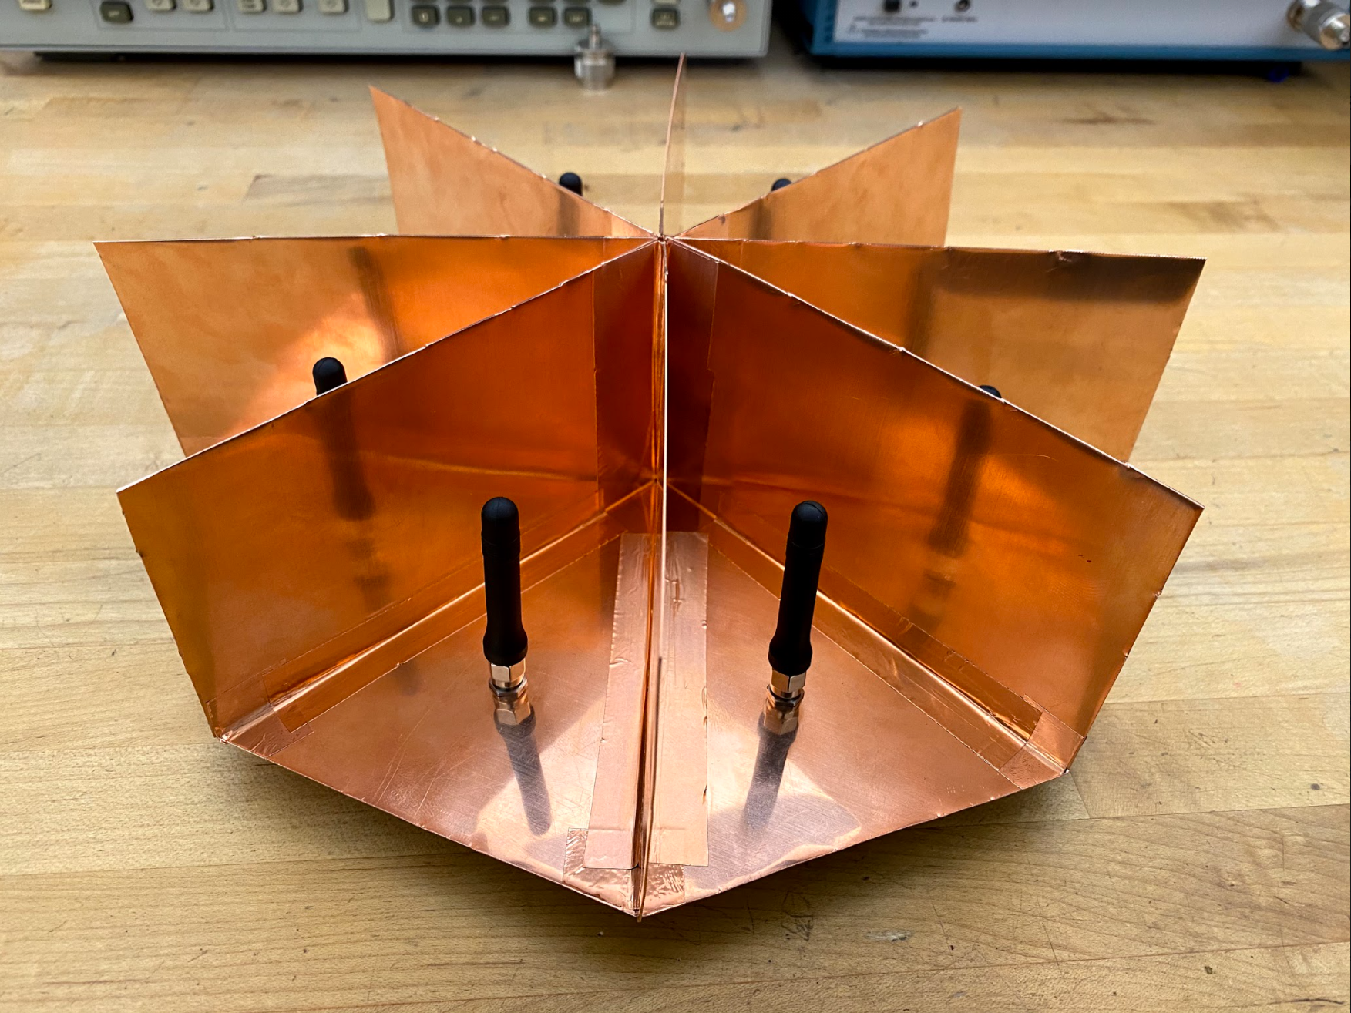

Figure 4 – Antenna Array mounted on copper base.

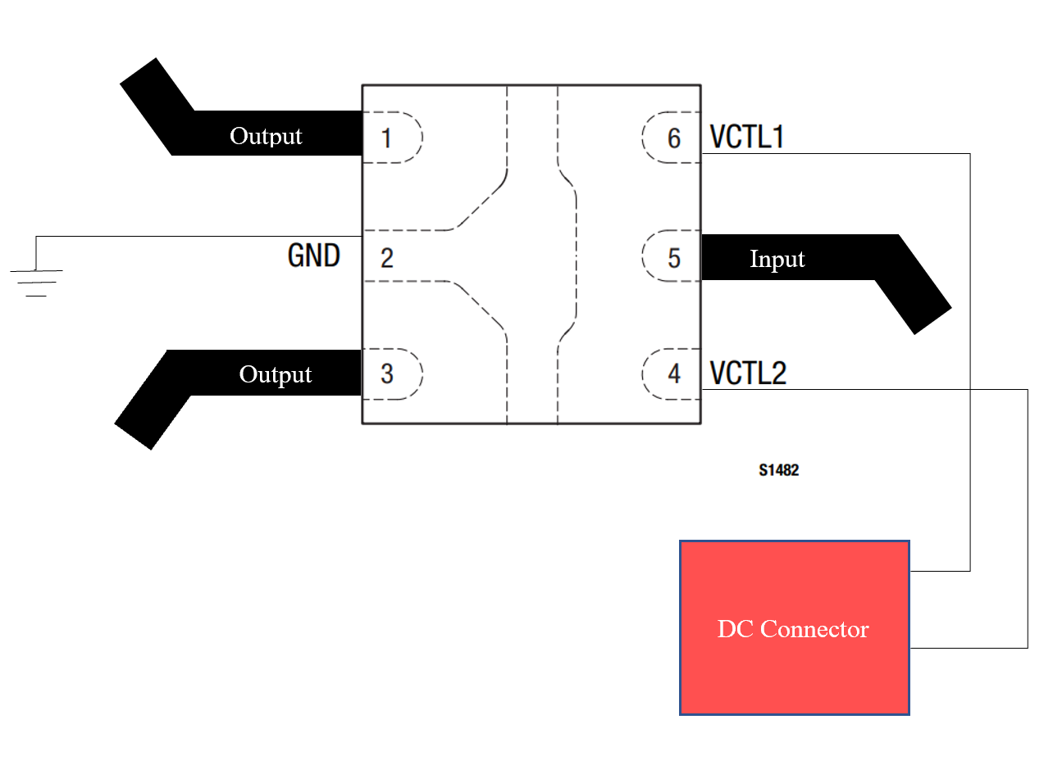

Figure 5 – SPDT switch PCB design.

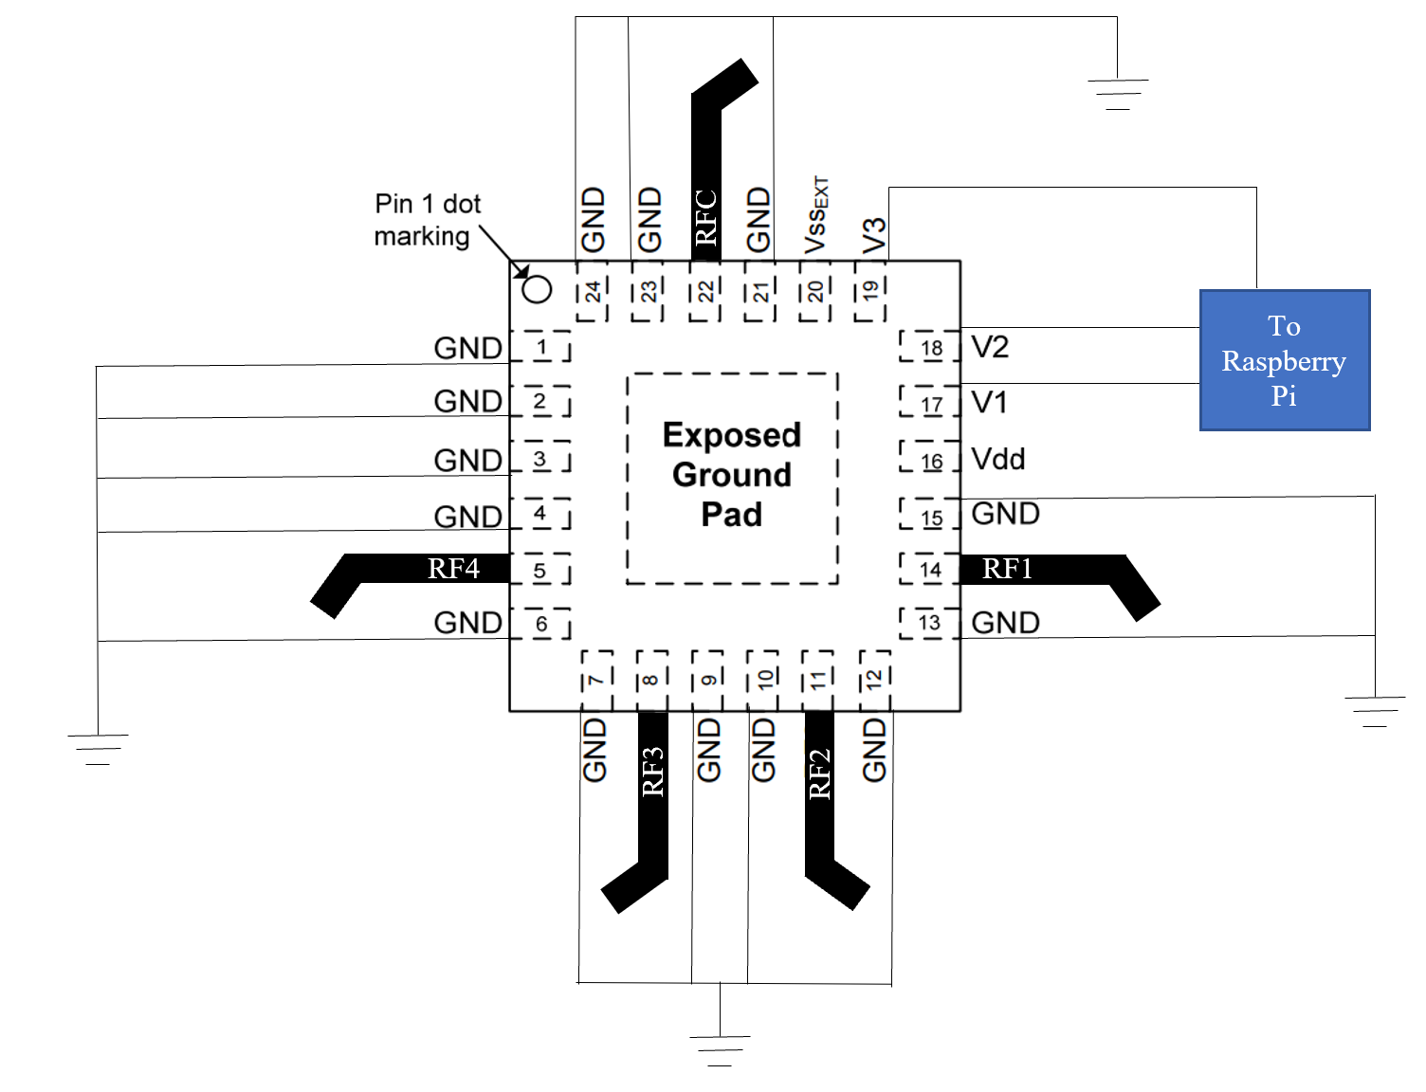

Figure 6 – SP4T switch PCB design.

**4.2 Software Detailed Design**

4.2.1 Base Station Subsystem

4.2.2 Communication Subsystem

4.2.3 Demodulation Subsystem

4.2.4 Telemetry Subsection

**4.3 Internal Communications Detailed Design**

**5 EXTERNAL INTERFACES**

**5.1 Interface Architecture**

**5.2 Interface Detailed Design**

**6 SYSTEM INTEGRITY CONTROLS**