README

Instructions for executing only my RUN.jar file

The file expects one input argument of either the path of the input file (C:/…/input.txt) or the input file itself (input.txt)

To run the jar executable,

Go to the directory where the RUN.jar is contained

An example of running it on my system is show below

java -jar Run.jar ~/pathToFile/file1.in

or

java –jar Run.jar file1.in

^^^ implies that “file1.in” is in the current working directory

To compile my java files and make a new RUN.jar do this:

1. cd into the directory with all my files (The directory should contain ‘Manifest.txt’, ‘RUN.jar’, and directory ‘program1_take2’)
2. javac program1_take2/*.java
3. jar cfvm RUN.jar Manifest.txt program1_take2/*.class
4. java -jar RUN.jar pathToFile/fileToRun.in

The output file ‘fileToRun.out’ should be generated in the current working directory.

Note to myself my Manifest.txt contains:

Main-Class: program1_take2.TestMain2

(end of file)

My Manifest.txt should contain the generic form

Main-Class: packageName.MainProgram and I need my class file MainProgram.class to be inside a folder named packageName

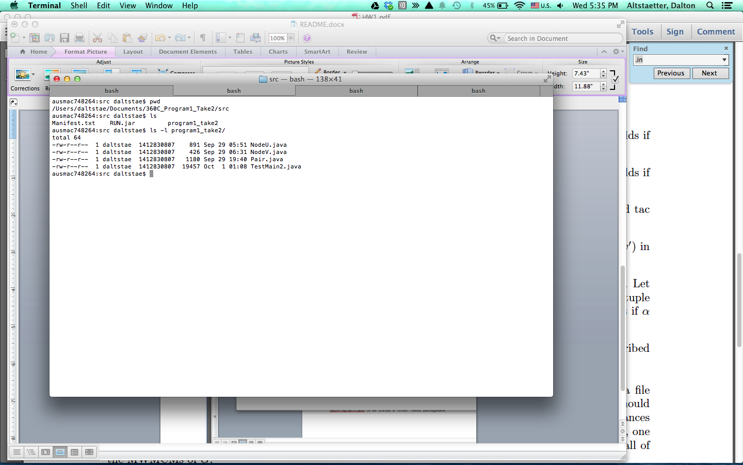

dfdfd

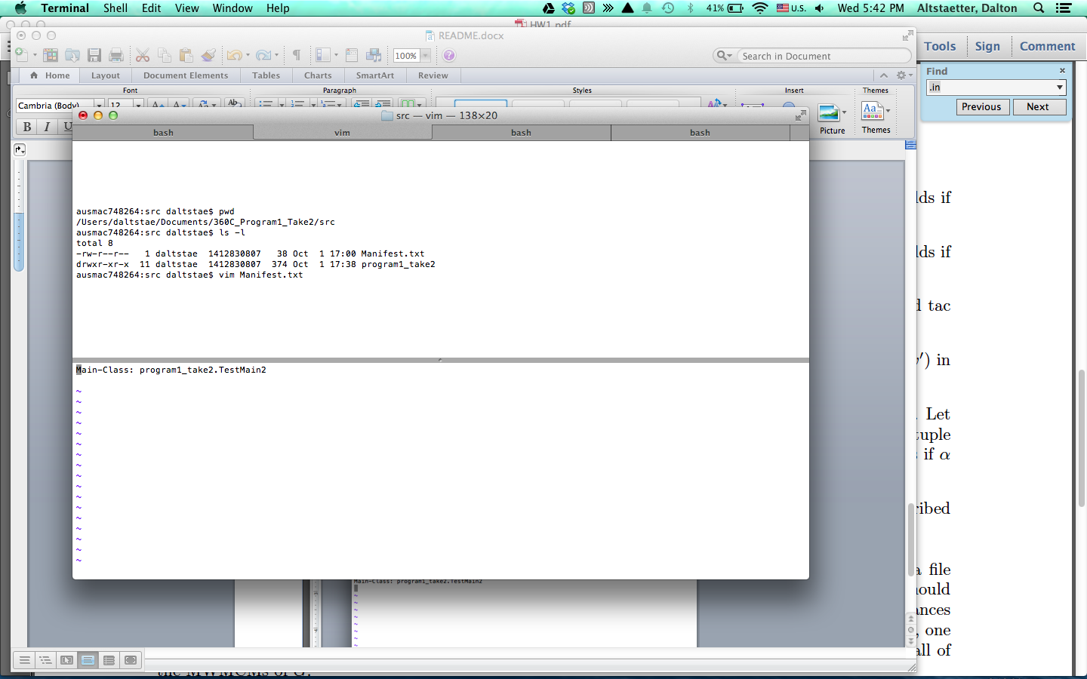

dfd

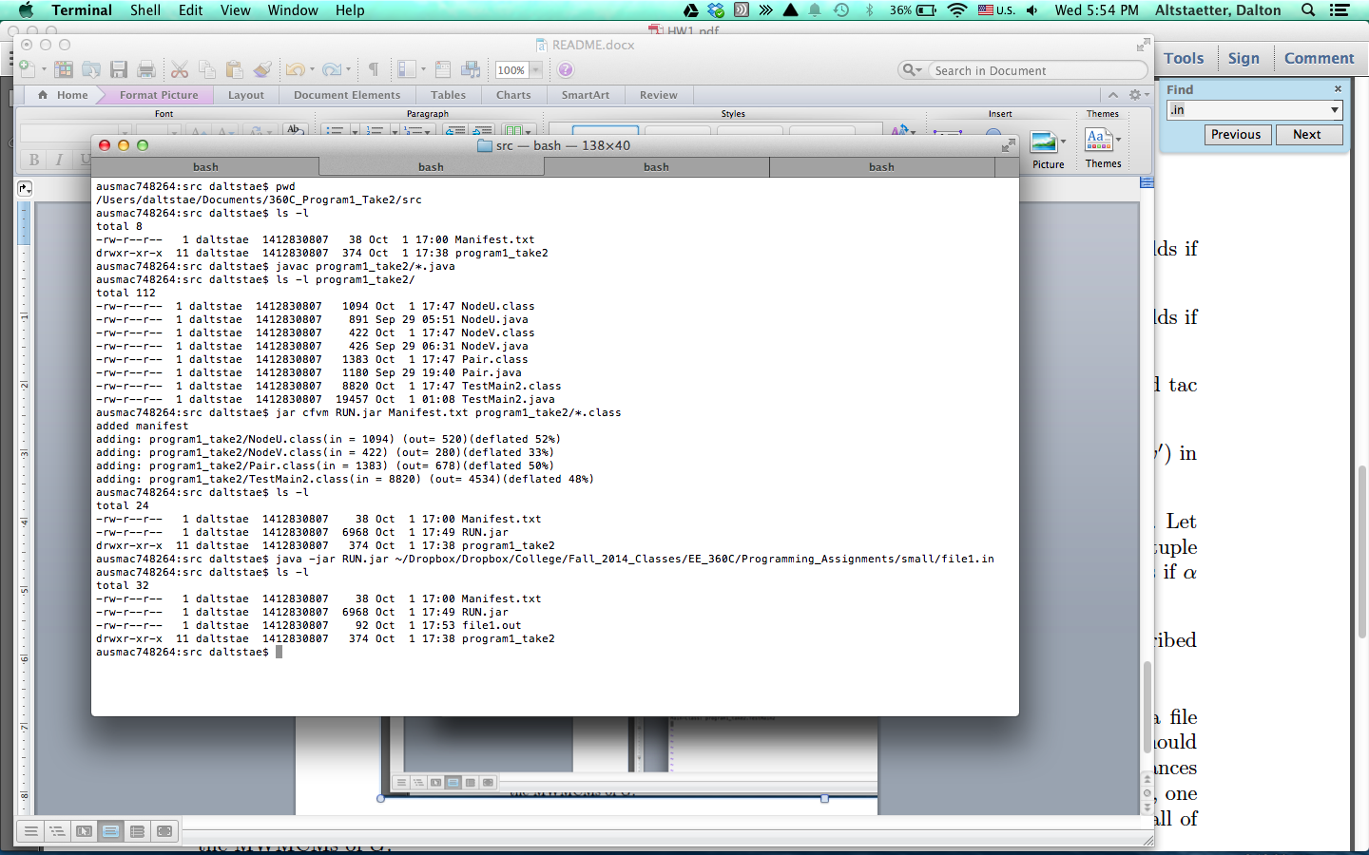

asdfasd

