LCD Assistant – Readme.docx

Here is an example of how to create a bit map.

1. First open LCDAssistant.exe (http://en.radzio.dxp.pl/bitmap_converter/)

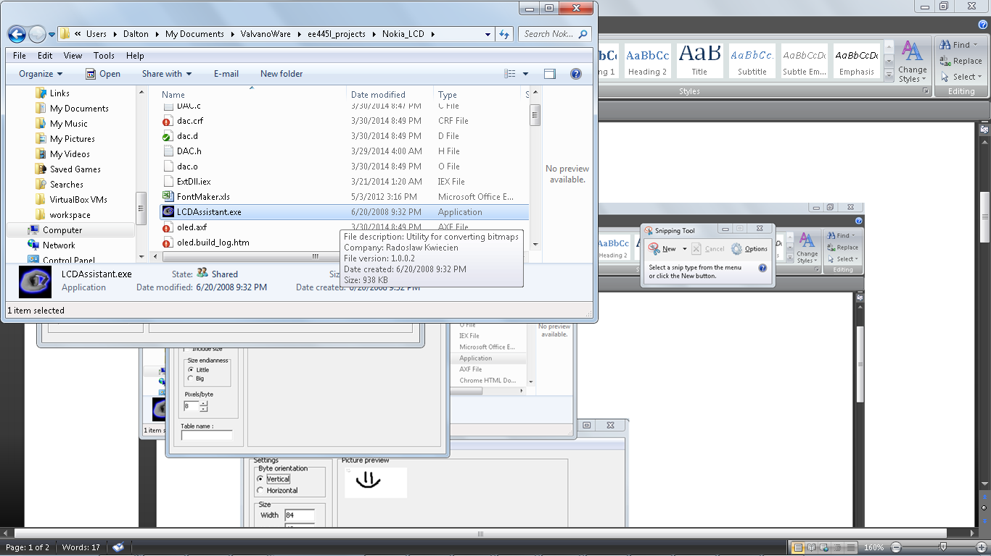

1. LCD Assistant will open and you will have some options

→ Go to File→Load image

Select the bitmap you created in paint or another utility. ( I saved my .bmp as a Mono-chrome .bmp file, but I’ve also use 16-bit color and it worked as well, but our LCD is a monochrome LCD)

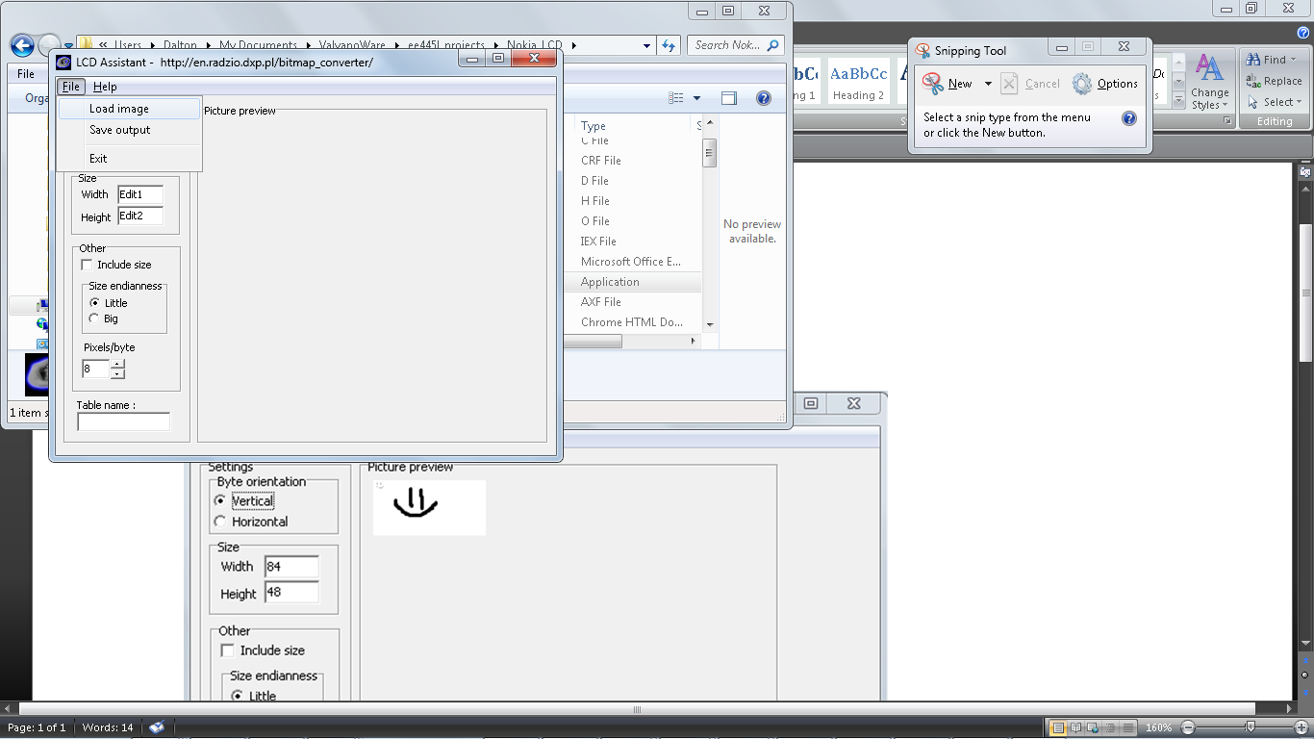

1. 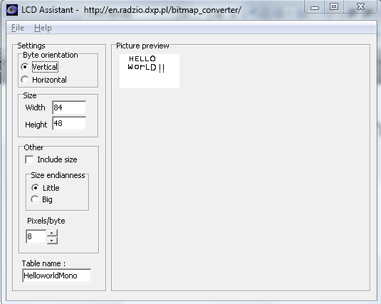It should now display a visual in “picture preview” of the bitmap you loaded. Choose the settings as shown. Vertical Byte Orientation, 84x48, Little Endian, 8 pixels/byte
2. Go to File→Save output

Choose a place to save it

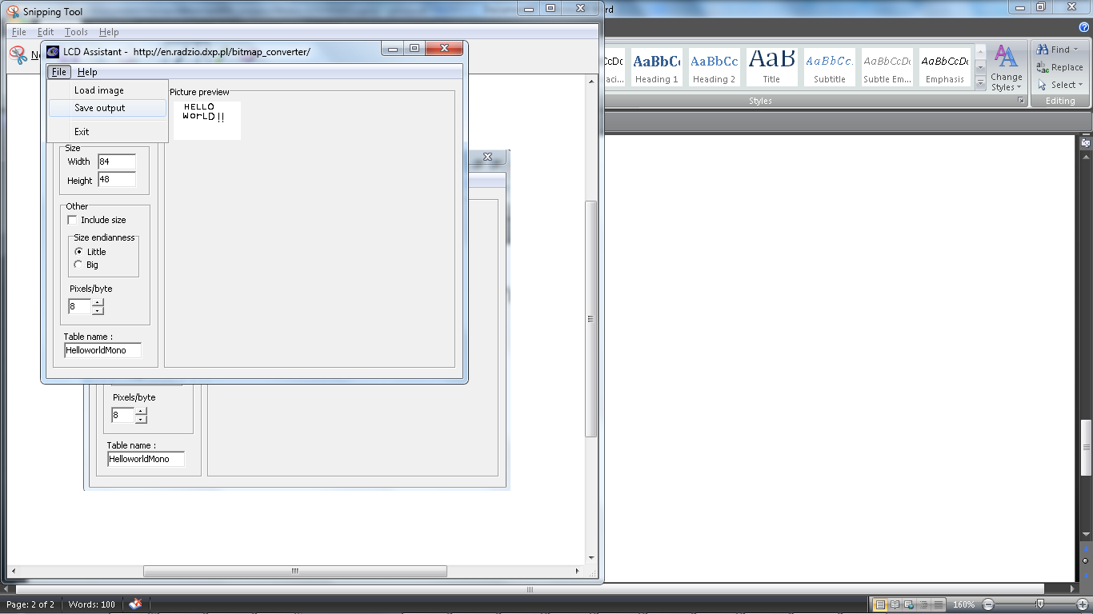

1. Open the document in a txt editor and then copy and paste the bitmap into the program

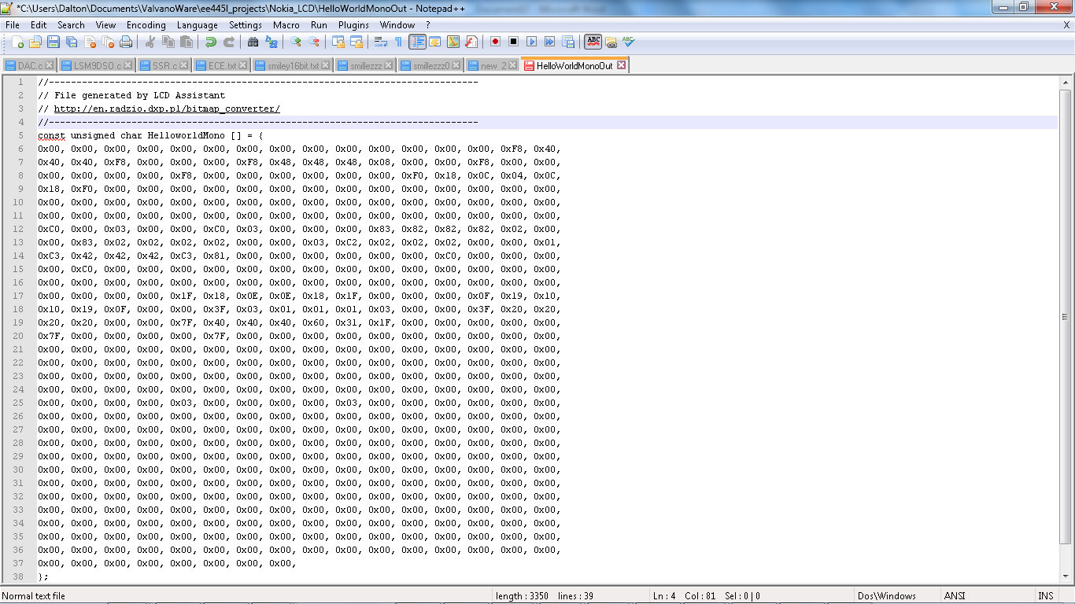

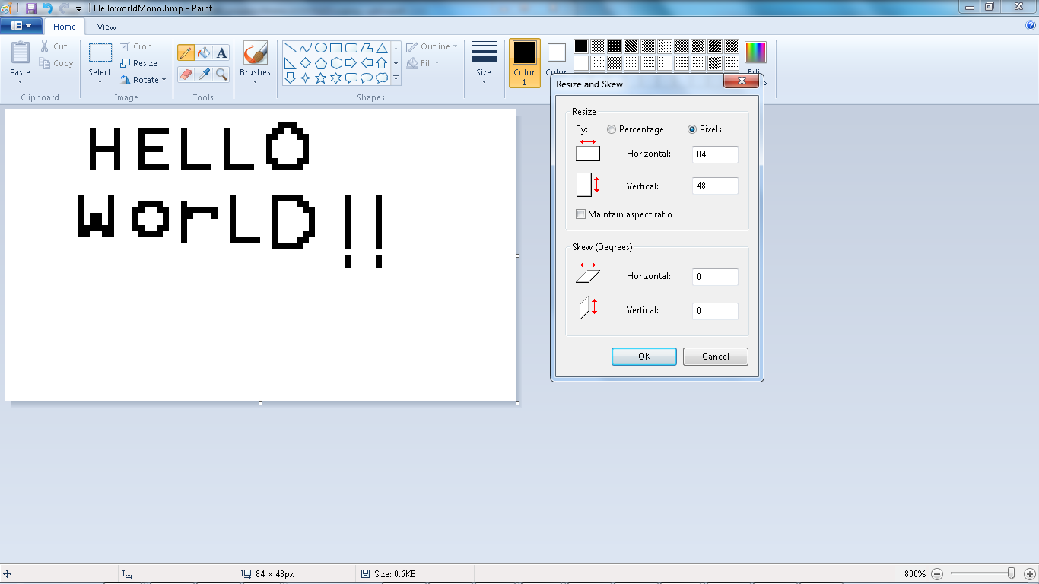

Draw it pixel by pixel with paint zoomed in at 800%

