**EE445L – Lab2: Performance Debugging**

Harley Ross and Dalton Altstaetter

2/4/14

**GOALS**

The goals of this lab were to develop software debugging techniques for performance and profiling using hardware and software, and then comparing the advantages and disadvantages of each. We also needed to learn how to pass data using the FIFO queue and become familiar with oscilloscope and the logic analyzer. We then needed to observe critical sections and get a head start on the draw functions needed for Lab 3.

**MEASUREMENT DATA**

**Part 4**

The cycle count is 61and the execution speed is 61*20ns = 1.28‌ ‌‌‌‌‌‌‌‌‌‌‌‌‌micro seconds . These pictures show the instruction used to determine execution speed.

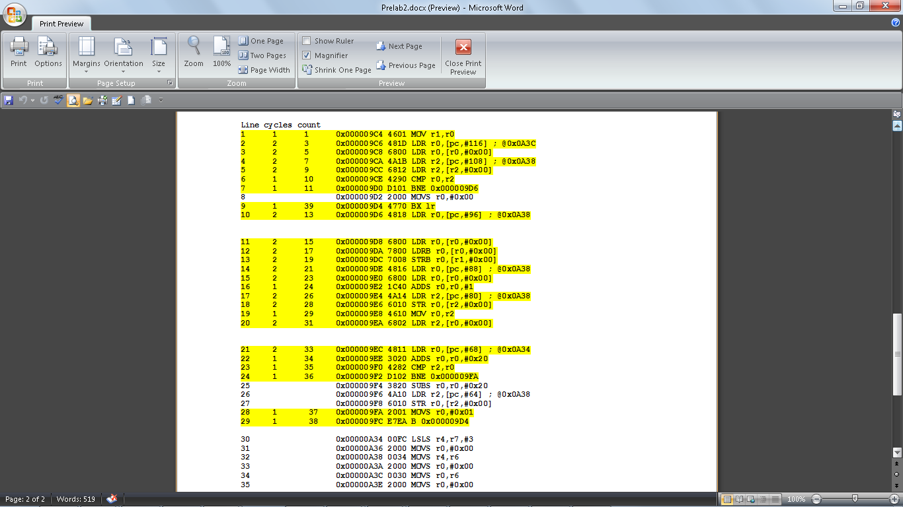**‌‌‌‌‌‌**

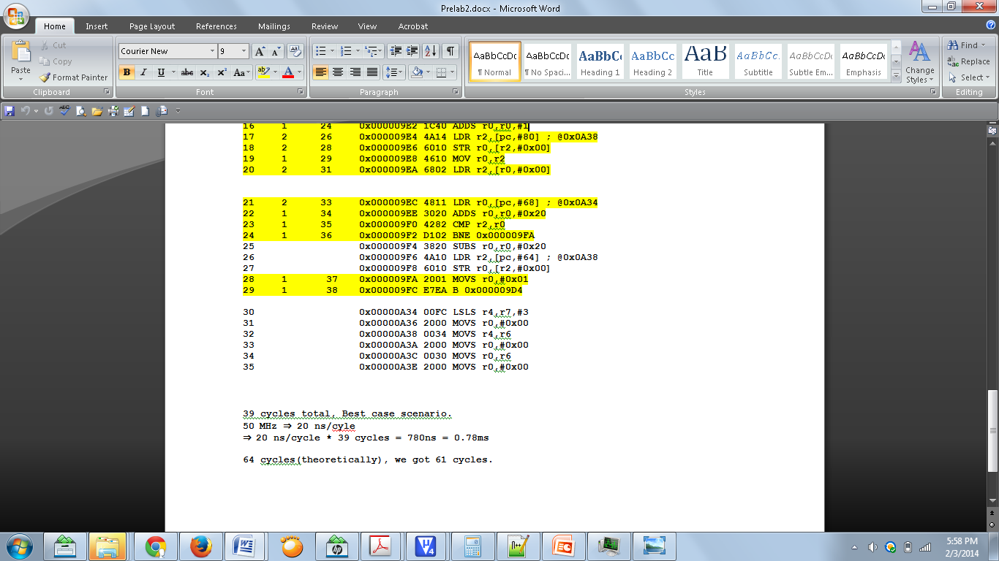

**Parts B and C**

Profiles during an interrupt where 1 is the interrupt and 2 is normal execution.

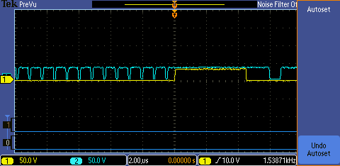

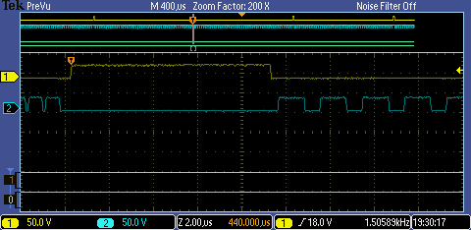

**Part D**

Execution time with no debugging methods.

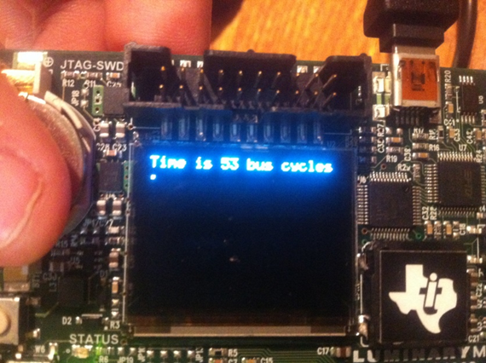

Execution time using the dump method.

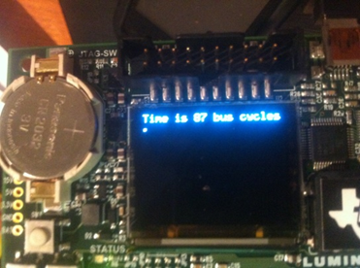

Execution time using the Printf method.

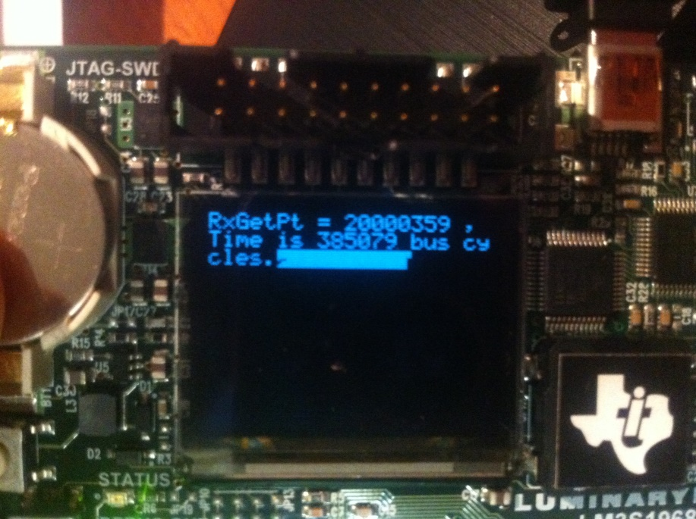

**Part E**

With the function in between

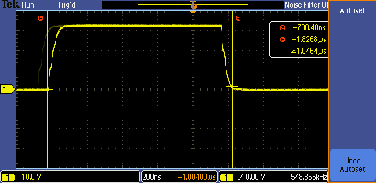

With no function in between the intrusiveness measured ~90ns

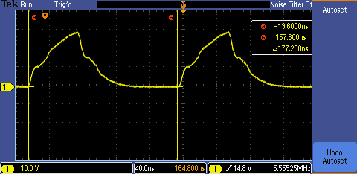

**Part F and H**

This screenshot shows there are no errors so the values are not being changed during the interrupt.

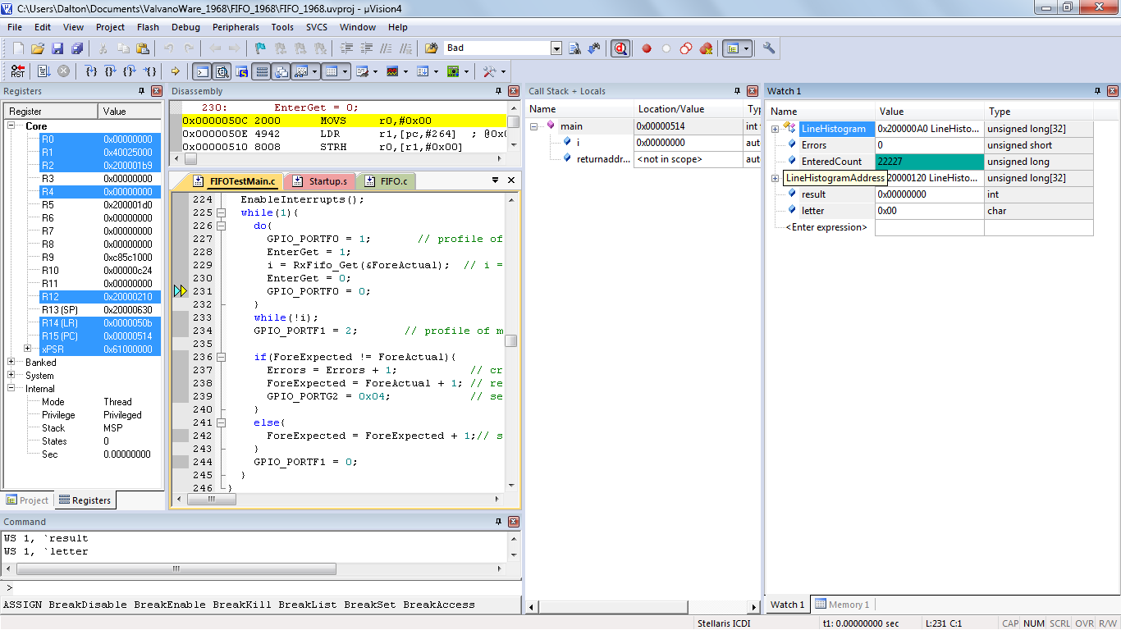

In this screenshot, store and move instructions have no interrupts when executing and these are the critical sections.

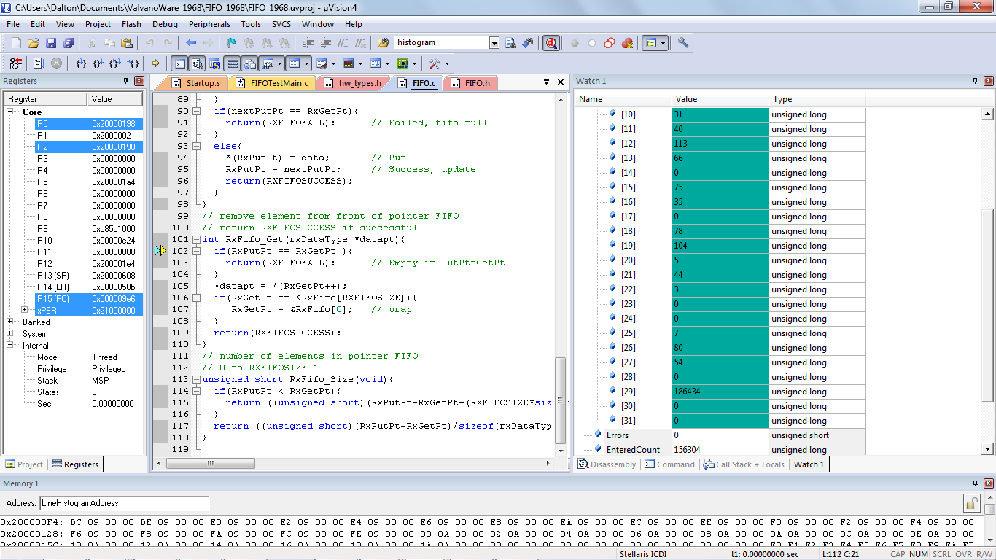

**Part G**

In this screenshot, there are a many errors because the critical sections are being interrupted.

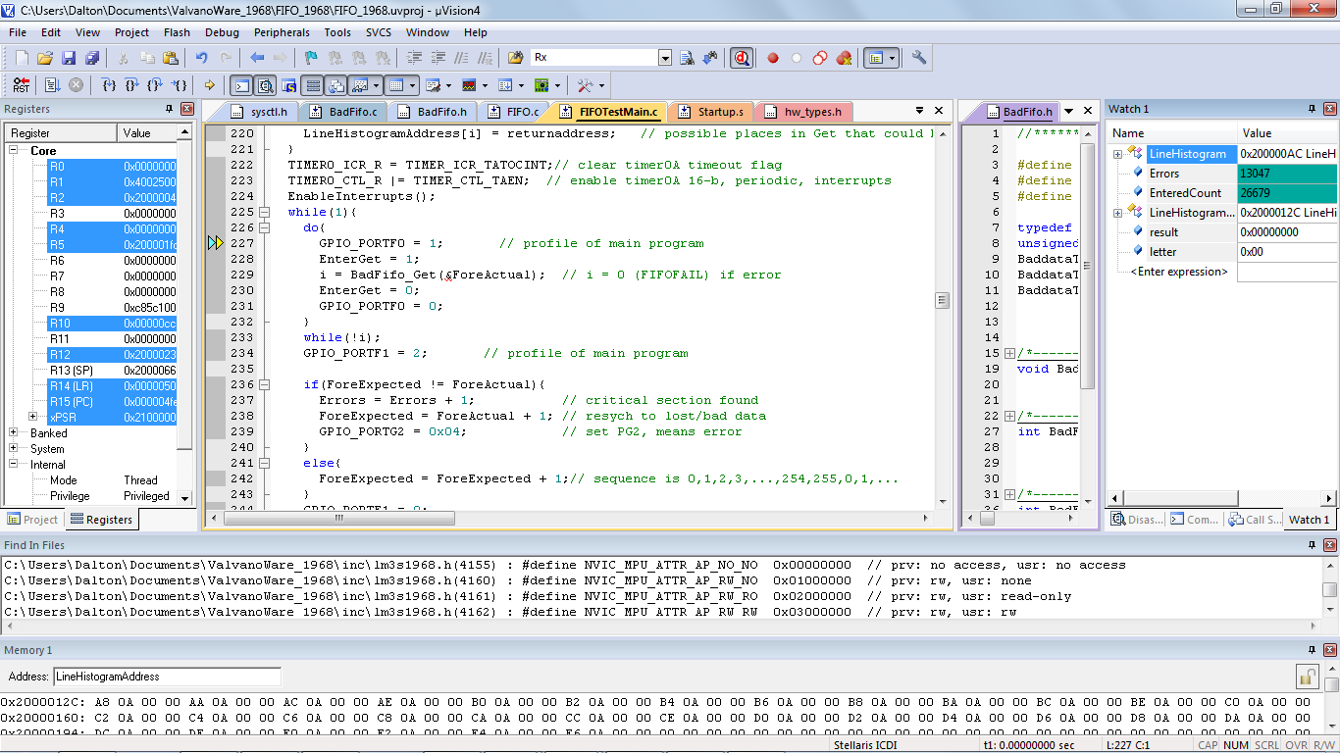

**Part H**

F3 = TXFIFOPUT, F2 = INTERRUPT, F1 = RXFIFOPUT, F0 = TXFIFOGET

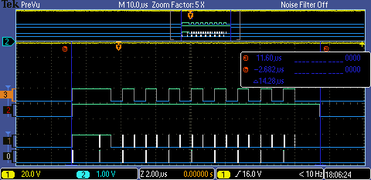

**ANALYSIS AND DISCUSION**

1. We did not get the same results when measuring the execution speed of RxFifo_Get. We got different results because the dump (87 cycles) was much less intrusive than the Printf (385,079 cycles)
2. We would use the system clock to measure execution speed because we can store the values and operate on them to determine the minimum, maximum, and average speed. The scope can’t be operated on inside the software.
3. We would use the Printf method to measure execution speed because it would negligible compared to the 20 seconds and it’s easier for the user and doesn’t require extra equipment (scope).
4. Minimally intrusive means the debugging method has a negligible effect on the system being debugged.
5. The two necessary components collected during a profile are turning the bit on and off.
6. The store and the move functions are the critical sections. You save the current enabled interrupts, then all disable interrupts during those instructions so that their values cannot be changed, then restore the enabled interrupts after the critical section has ended.

**SOURCE CODE**

**#define SCALE 4500**

**#define NUMPIXELS 300**

**#define POSITIONS 60**

**#define MINUTEHANDLENGTH 33 // length of the minute hand on OLED**

**#define HOURHANDLENGTH 24 // length of the hour hand on OLED**

**#define NULL 0**

**#define XPIVOT 55**

**#define YPIVOT 47**

**void RIT128x96x4_Line(int x1, int y1, int x2, int y2, unsigned char color)**

**{**

**int i;**

**int deltaX;**

**int deltaY;**

**int width;**

**int height;**

**int tempX;**

**int tempY;**

**// used to highlight a particular pixel of the OLED**

**const unsigned char dot[] = {0xFF};**

**width = x2-x1;**

**height = y2-y1;**

**// need to find the spacing between the two coordinates**

**// (deltaX,deltaY) and scale the input by 2500 so that we**

**// don't have dropout from integer division by dividing**

**// the interval into NUMPIXELS equal intervals**

**deltaX = (width*SCALE)/NUMPIXELS;**

**deltaY = (height*SCALE)/NUMPIXELS;**

**Output_Color(15);**

**for(i = 0; i < NUMPIXELS; i++)**

**{**

**// find the new (X,Y) scaled coordinates**

**tempX = x1*SCALE + i*deltaX;**

**tempY = y1*SCALE + i*deltaY;**

**// convert coordinates back in OLED range and print to the OLED**

**RIT128x96x4ImageDraw(&dot[0], tempX/SCALE, tempY/SCALE, 2, 1);**

**}**

**}**

**void**

**RIT128x96x4Clear(void)**

**{**

**static const unsigned char pucCommand1[] = { 0x15, 0, 63 };**

**static const unsigned char pucCommand2[] = { 0x75, 0, 127 };**

**unsigned long ulRow, ulColumn;**

**//**

**// Clear out the buffer used for sending bytes to the display.**

**//**

**\*(unsigned long *)&g_pucBuffer[0] = 0;**

**\*(unsigned long *)&g_pucBuffer[4] = 0;**

**//**

**// Set the window to fill the entire display.**

**//**

**RITWriteCommand(pucCommand1, sizeof(pucCommand1));**

**RITWriteCommand(pucCommand2, sizeof(pucCommand2));**

**RITWriteCommand(g_pucRIT128x96x4HorizontalInc,**

**sizeof(g_pucRIT128x96x4HorizontalInc));**

**//**

**// Loop through the rows**

**//**

**for(ulRow = 0; ulRow < 96; ulRow++)**

**{**

**//**

**// Loop through the columns. Each byte is two pixels,**

**// and the buffer hold 8 bytes, so 16 pixels are cleared**

**// at a time.**

**//**

**for(ulColumn = 0; ulColumn < 128; ulColumn += 8 * 2)**

**{**

**//**

**// Write 8 clearing bytes to the display, which will**

**// clear 16 pixels across.**

**//**

**RITWriteData(g_pucBuffer, sizeof(g_pucBuffer));**

**}**

**}**

**}**