**EE445L – Lab5: Music Player and Audio Amp**

Harley Ross and Dalton Altstaetter

2/18/14

**GOALS**

This objectives of the project are learning DAC conversion, learning SPI/SSI interface, design a data structure to represent music, and develop a system that plays sound.

**HARWARE DESIGN**

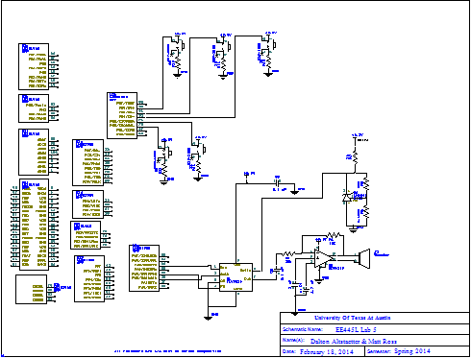

**SOFTWARE DESIGN**

**Music**

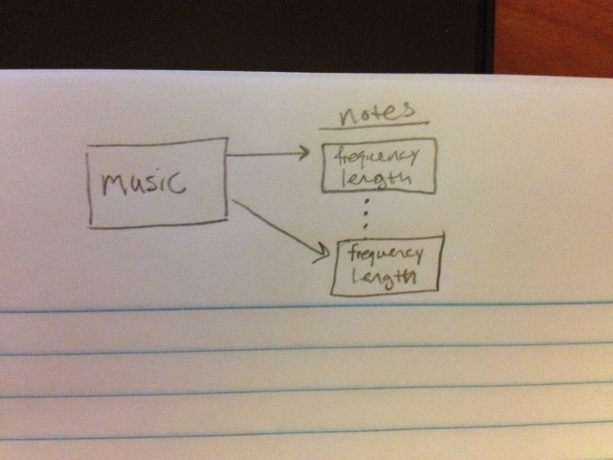

**MEASUREMENT DATA**

**Calculated Data:**

Resolution: 8.057*10^-4

Range: 3.3V

Accuracy: .02%

**DAC Response:**

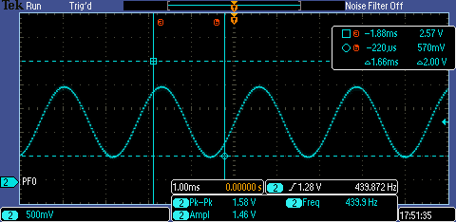

**Debugging Profile:**

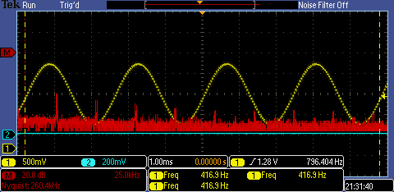

**Current required to run the system:**

Without music playing:

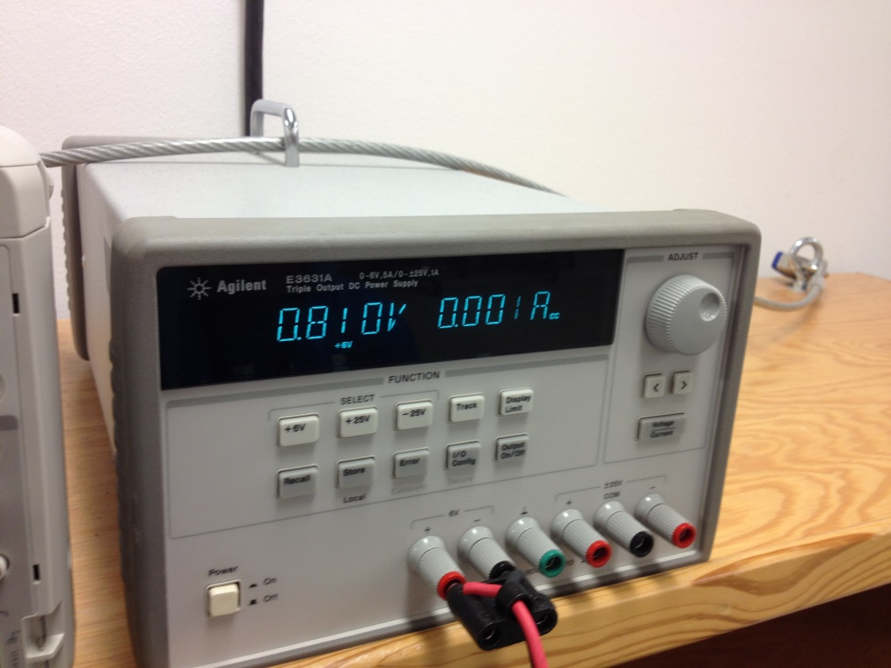

With music playing:

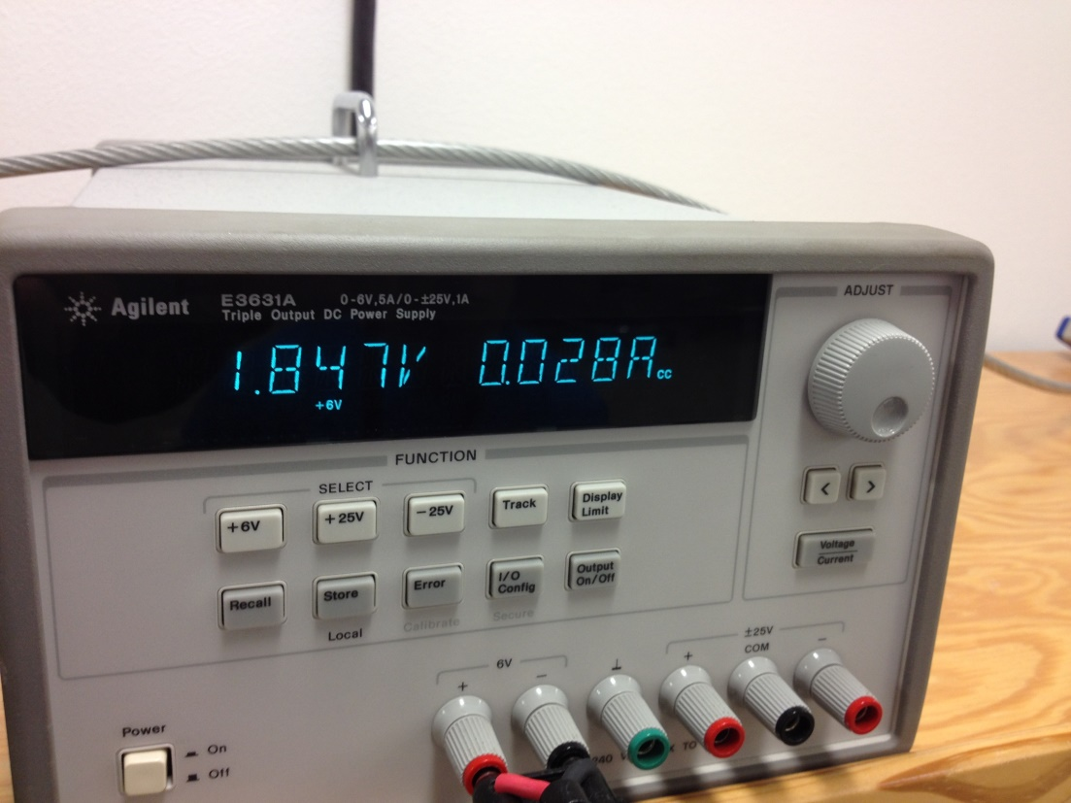

**ANALYSIS AND DISCUSION**

1. Three DAC errors are the offset error, the span error, and the gain error. The offset error are the values that produce a 0 voltage that are not 0. The span error is the difference between the precision and the offset error. The gain error is the actual span divided by the expected span.
2. The data available time should overlap the data required time so the it is latched correctly. We selected the SSI frequency so that it overlaps the required time by the DAC.
3. The frequency range of the spectrum analyzer is determined by the cursors and max sampling rate on the oscilloscope.
4. We needed more voltage given by the amplifier in order to power the speaker.

**SOURCE CODE**

Timer

// Runs on LM3S1968

// Use Timer0A in periodic mode to request interrupts at a particular

// period.

// Daniel Valvano

// September 14, 2011

/* This example accompanies the book

"Embedded Systems: Real Time Interfacing to the Arm Cortex M3",

ISBN: 978-1463590154, Jonathan Valvano, copyright (c) 2011

Program 7.5, example 7.6

Copyright 2011 by Jonathan W. Valvano, valvano@mail.utexas.edu

You may use, edit, run or distribute this file

as long as the above copyright notice remains

THIS SOFTWARE IS PROVIDED "AS IS". NO WARRANTIES, WHETHER EXPRESS, IMPLIED

OR STATUTORY, INCLUDING, BUT NOT LIMITED TO, IMPLIED WARRANTIES OF

MERCHANTABILITY AND FITNESS FOR A PARTICULAR PURPOSE APPLY TO THIS SOFTWARE.

VALVANO SHALL NOT, IN ANY CIRCUMSTANCES, BE LIABLE FOR SPECIAL, INCIDENTAL,

OR CONSEQUENTIAL DAMAGES, FOR ANY REASON WHATSOEVER.

For more information about my classes, my research, and my books, see

http://users.ece.utexas.edu/~valvano/

*/

#include "timer0A.h"

#include "Systick.h"

#include "DAC.h"

#include "lm3s1968.h"

#include "Music.h"

#define MAXVOLUME 20

#define DUMPSIZE 175

extern const unsigned short* instrumentPtr;

extern NotePtr songPtr; // this is no longer a pointer to a pointer

extern int wait0;

extern int volume;

extern int songNumber;

extern const unsigned short SinWave1[128];

void DisableInterrupts(void); // Disable interrupts

void EnableInterrupts(void); // Enable interrupts

long StartCritical (void); // previous I bit, disable interrupts

void EndCritical(long sr); // restore I bit to previous value

void WaitForInterrupt(void); // low power mode

void (*PeriodicTask)(void); // user function

void Debugging_Profile(void);

static unsigned char index = 0;

static unsigned char index2 = 0;

static unsigned char index3 = 0;

unsigned long debugArray[DUMPSIZE];

unsigned long songNote;

void Timer2A_Handler(void)

{

#ifndef CHORD

if(wait0 == -1)

{

wait0 = songPtr->duration;

}

TIMER2_ICR_R = TIMER_ICR_TATOCINT;// acknowledge timer2A timeout

if(wait0 == 0)

{

songNote++; // move to the next note if duration = 0

wait0 = songPtr[songNote].duration;

Debugging_Profile();

}

else

{wait0--;}

TIMER2_TAILR_R = 62500; // interrupt every 62.5 ms

if(songNote > ENDSONG)

{

songNote = ENDSONG;

}

#else

TIMER2_ICR_R = TIMER_ICR_TATOCINT;

TIMER2_TAILR_R = 62500;

#endif

}

void Timer0B_Handler(void)

{

TIMER0_ICR_R = TIMER_ICR_TBTOCINT;

TIMER0_TBILR_R = G;

#ifdef CHORD

DAC_Out(instrumentPtr[index]*volume/MAXVOLUME+instrumentPtr[index2]*volume/MAXVOLUME+instrumentPtr[index3]*volume/MAXVOLUME);

index3 = ((index3+1)&0x7F); // [0,127]

#endif

}

void Timer1A_Handler(void)

{

TIMER1_ICR_R = TIMER_ICR_TATOCINT;

TIMER1_TAILR_R = C; // reload value

#ifdef CHORD

DAC_Out(instrumentPtr[index]*volume/MAXVOLUME+instrumentPtr[index2]*volume/MAXVOLUME+instrumentPtr[index3]*volume/MAXVOLUME);

index2 = ((index2+1)&0x7F); // [0,127]

#endif

}

void Timer0A_Handler(void)

{

GPIO_PORTG_DATA_R ^= 0x04;

TIMER0_ICR_R = TIMER_ICR_TATOCINT;// acknowledge timer0A timeout

#ifdef CHORD

DAC_Out(instrumentPtr[index]*volume/MAXVOLUME+instrumentPtr[index2]*volume/MAXVOLUME+instrumentPtr[index3]*volume/MAXVOLUME);

TIMER0_TAILR_R = E;

index = ((index+1)&0x7F);

#else

TIMER0_TAILR_R = songPtr[songNote].frequency;

if(songPtr[songNote].frequency != REST)

{

DAC_Out(instrumentPtr[index]*volume/MAXVOLUME);

index = ((index+1)&0x7F); // index = [0,127]

}

else

{

return;

}

#endif

/*

//if(!GPIO_PORTF_DATA_R)

//{

// TIMER0_TAILR_R = 1000;

// return;

//}

//DAC_Out(SinWave1[index]);

// //DAC_Out((SinWave1[index]));/envelope[index])/16);

// //DAC_Out(Bassoon[index]);

// //DAC_Out(Horn[index]*3-1063);

//

// //DAC_Out(Flute[index]);

// //DAC_Out(Trumpet[index]);

// //DAC_Out(Oboe[index]*((index%8)/8));

// if(GPIO_PORTF_DATA_R &0x01)

// {

// DAC_Out(SinWave1[index]*6/10);

// TIMER0_TAILR_R = Ab;//200;

// }

// else if(GPIO_PORTF_DATA_R &0x02)

// {

// DAC_Out(SinWave1[index]*6/10);

// TIMER0_TAILR_R = Bb;

// }

// else if(GPIO_PORTF_DATA_R &0x04)

// {

// DAC_Out(SinWave1[index]*6/10);

// TIMER0_TAILR_R = Db;

// }

// else if(GPIO_PORTF_DATA_R &0x08)

// {

// DAC_Out(SinWave1[index]*6/10);

// TIMER0_TAILR_R = Eb;

// }

// else if(GPIO_PORTF_DATA_R &0x10)

// {// this one just dont work

// DAC_Out(SinWave1[index]*6/10);

// TIMER0_TAILR_R = D;

// }

// else if(GPIO_PORTF_DATA_R &0x20)

// {

// DAC_Out(SinWave1[index]*6/10);

// TIMER0_TAILR_R = E;

// }

// else if(GPIO_PORTF_DATA_R &0x40)

// {

// DAC_Out(SinWave1[index]*6/10);

// TIMER0_TAILR_R = F;

// }

// else if(GPIO_PORTF_DATA_R &0x80)

// {

// DAC_Out(SinWave1[index]*6/10);

// TIMER0_TAILR_R = Gb;

// }

//index = ((index+1)&0x3F); // 0-63

//index = ((index+1)&0x1F); // 0-31

*/

}

// ***************** Timer0A_Init ****************

// Activate Timer0A interrupts to run user task periodically

// Inputs: task is a pointer to a user function

// period in usec

// Outputs: none

// timer0A is for outputting the sine Wave and creating sound

void Timer0A_Init(void(*task)(void), unsigned short period)

{

SYSCTL_RCGC1_R |= SYSCTL_RCGC1_TIMER0; // 0) activate timer0

PeriodicTask = task; // user function

TIMER0_CTL_R &= ~0x00000001; // 1) disable timer0A during setup

TIMER0_CFG_R = 0x00000004; // 2) configure for 16-bit timer mode

TIMER0_TAMR_R = 0x00000002; // 3) configure for periodic mode

TIMER0_TAILR_R = period-1; // 4) reload value

TIMER0_TAPR_R = 0; // 5) 20 ns timer0A //49=>1 us timer0A

TIMER0_ICR_R = 0x00000001; // 6) clear timer0A timeout flag

TIMER0_IMR_R |= 0x00000001; // 7) arm timeout interrupt

NVIC_PRI4_R = (NVIC_PRI4_R&0x01FFFFFF)|0x40000000; // 8) priority 2

NVIC_EN0_R |= NVIC_EN0_INT19; // 9) enable interrupt 19 in NVIC

TIMER0_CTL_R |= 0x00000001; // 10) enable timer0A

// SYSCTL_RCGC1_R |= SYSCTL_RCGC1_TIMER0; // 0) activate timer0

// PeriodicTask = task; // user function

// TIMER0_CTL_R &= ~TIMER_CTL_TAEN; // 1) disable timer0A during setup

// TIMER0_CFG_R = TIMER_CFG_16_BIT; // 2) configure for 16-bit timer mode

// TIMER0_TAMR_R = TIMER_TAMR_TAMR_PERIOD; // 3) configure for periodic mode

// TIMER0_TAILR_R = period-1; // 4) reload value

// TIMER0_TAPR_R = 0; // 5) 20 ns timer0A //49=>1 us timer0A

// TIMER0_ICR_R = TIMER_ICR_TATOCINT; // 6) clear timer0A timeout flag

// TIMER0_IMR_R |= TIMER_IMR_TATOIM; // 7) arm timeout interrupt

// NVIC_PRI4_R = (NVIC_PRI4_R&0x01FFFFFF)|0x40000000; // 8) priority 2

// NVIC_EN0_R |= NVIC_EN0_INT19; // 9) enable interrupt 19 in NVIC

// TIMER0_CTL_R |= TIMER_CTL_TAEN; // 10) enable timer0A

//

}

void Timer0B_Init(void(*task)(void), unsigned short period)

{

SYSCTL_RCGC1_R |= SYSCTL_RCGC1_TIMER0; // 0) activate timer0

PeriodicTask = task; // user function

TIMER0_CTL_R &= ~TIMER_CTL_TBEN; // 1) disable timer0B during setup

TIMER0_CFG_R = TIMER_CFG_16_BIT; // 2) configure for 16-bit timer mode

TIMER0_TBMR_R = TIMER_TBMR_TBMR_PERIOD; // 3) configure for periodic mode

TIMER0_TBILR_R = period-1; // 4) reload value

TIMER0_TBPR_R = 0; // 5) 20 ns timer0A //49=>1 us timer0A

TIMER0_ICR_R = TIMER_ICR_TBTOCINT; // 6) clear timer0A timeout flag

TIMER0_IMR_R |= TIMER_IMR_TBTOIM; // 7) arm timeout interrupt

NVIC_PRI5_R = (NVIC_PRI5_R&0xFFFFFF1F)|0x00000040; // 8) priority 2

NVIC_EN0_R |= NVIC_EN0_INT20; // 9) enable interrupt 20 in NVIC

TIMER0_CTL_R |= TIMER_CTL_TBEN; // 10) enable timer0B

}

// timer1A is for the chord to play

void Timer1A_Init(void(*task)(void), unsigned short period)

{

SYSCTL_RCGC1_R |= SYSCTL_RCGC1_TIMER1; // 0) activate timer0

PeriodicTask = task; // user function

TIMER1_CTL_R &= ~0x00000001; // 1) disable timer1A during setup

TIMER1_CFG_R = 0x00000004; // 2) configure for 16-bit timer mode

TIMER1_TAMR_R = 0x00000002; // 3) configure for periodic mode

TIMER1_TAILR_R = period-1; // 4) reload value

TIMER1_TAPR_R = 0; // 5) 20 ns timer1A //49=>1 us timer0A

TIMER1_ICR_R = 0x00000001; // 6) clear timer1A timeout flag

TIMER1_IMR_R |= 0x00000001; // 7) arm timeout interrupt

NVIC_PRI5_R = (NVIC_PRI5_R&0xFFFF1FFF)|0x00004000; // 8) priority 2

NVIC_EN0_R |= NVIC_EN0_INT21; // 9) enable interrupt 19 in NVIC

TIMER1_CTL_R |= 0x00000001; // 10) enable timer1A

}

// timer2A is for the the length of the note to play

void Timer2A_Init(void(*task)(void), unsigned short period)

{

SYSCTL_RCGC1_R |= SYSCTL_RCGC1_TIMER2; // 0) activate timer2

PeriodicTask = task; // user function

TIMER2_CTL_R &= ~0x00000001; // 1) disable timer2A during setup

TIMER2_CFG_R = 0x00000004; // 2) configure for 16-bit timer mode

TIMER2_TAMR_R = 0x00000002; // 3) configure for periodic mode

TIMER2_TAILR_R = period-1; // 4) reload value

TIMER2_TAPR_R = 49; // 5) 1us timer2A

TIMER2_ICR_R = 0x00000001; // 6) clear timer2A timeout flag

TIMER2_IMR_R |= 0x00000001; // 7) arm timeout interrupt

NVIC_PRI5_R = (NVIC_PRI5_R&0x1FFFFFFF)|0x40000000; // 8) priority 2

NVIC_EN0_R |= NVIC_EN0_INT23; // 9) enable interrupt 23 in NVIC

TIMER2_CTL_R |= 0x00000001; // 10) enable timer2A

}

void Debugging_Profile(void)

{

static unsigned long ind = 0;

if(ind < DUMPSIZE)

{

debugArray[ind] = NVIC_ST_CURRENT_R;

ind++;

}

return;

}

SysTick

// SysTick.c

// Runs on LM3S1968

// Provide functions that initialize the SysTick module, wait at least a

// designated number of clock cycles, and wait approximately a multiple

// of 10 milliseconds using busy wait. After a power-on-reset, the

// LM3S1968 gets its clock from the 12 MHz internal oscillator, which

// can vary by +/- 30%. If you are using this module, you probably need

// more precise timing, so it is assumed that you are using the PLL to

// set the system clock to 50 MHz. This matters for the function

// SysTick_Wait10ms(), which will wait longer than 10 ms if the clock is

// slower.

// Daniel Valvano

// February 22, 2012

/* This example accompanies the book

"Embedded Systems: Real Time Interfacing to the Arm Cortex M3",

ISBN: 978-1463590154, Jonathan Valvano, copyright (c) 2011

Program 2.11, Section 2.6

Copyright 2011 by Jonathan W. Valvano, valvano@mail.utexas.edu

You may use, edit, run or distribute this file

as long as the above copyright notice remains

THIS SOFTWARE IS PROVIDED "AS IS". NO WARRANTIES, WHETHER EXPRESS, IMPLIED

OR STATUTORY, INCLUDING, BUT NOT LIMITED TO, IMPLIED WARRANTIES OF

MERCHANTABILITY AND FITNESS FOR A PARTICULAR PURPOSE APPLY TO THIS SOFTWARE.

VALVANO SHALL NOT, IN ANY CIRCUMSTANCES, BE LIABLE FOR SPECIAL, INCIDENTAL,

OR CONSEQUENTIAL DAMAGES, FOR ANY REASON WHATSOEVER.

For more information about my classes, my research, and my books, see

http://users.ece.utexas.edu/~valvano/

*/

#include "lm3s1968.h"

#include "SysTick.h"

void SysTick_Wait(unsigned long delay);

void SysTick_Wait10ms(unsigned long delay);

void SysTick_Init(void);

// Initialize SysTick with busy wait running at bus clock.

void SysTick_Init(void)

{

NVIC_ST_CTRL_R = 0; // disable SysTick during setup

NVIC_ST_RELOAD_R = 0x00FFFFFF; // MAX 24-bit reload value

NVIC_ST_CURRENT_R = 0; // any write to current clears it

// enable SysTick with core clock

NVIC_ST_CTRL_R = NVIC_ST_CTRL_ENABLE+NVIC_ST_CTRL_CLK_SRC;

}

// Time delay using busy wait.

// The delay parameter is in units of the core clock. (units of 20 nsec for 50 MHz clock)

void SysTick_Wait(unsigned long delay)

{

volatile unsigned long elapsedTime;

unsigned long startTime = NVIC_ST_CURRENT_R;

do{

elapsedTime = (startTime-NVIC_ST_CURRENT_R)&0x00FFFFFF;

}

while(elapsedTime <= delay);

}

// Time delay using busy wait.

// This assumes 50 MHz system clock.

void SysTick_Wait10ms(unsigned long delay)

{

unsigned long i;

for(i=0; i<delay; i++)

{

SysTick_Wait(500000); // wait 10ms (assumes 50 MHz clock)

}

}

Switches

//Switches.c

#include "Switches.h"

#include "lm3s1968.h"

#include "timer0A.h"

#include "music.h"

#define PLAYING 0

#define PAUSE 1

extern int volume;

extern unsigned long songNote;

extern const unsigned short* instrumentPtr;

extern Instruments* instrumentStruct;

extern const unsigned short* instrArray[6];

extern void DisableInterrupts(void); // Disable interrupts

extern void EnableInterrupts(void); // Enable interrupts

extern long StartCritical (void); // previous I bit, disable interrupts

extern void EndCritical(long sr); // restore I bit to previous value

unsigned long* MusicPlayOrPause(unsigned long* songIndex);

void DecreaseVolume(int* volumePtr);

void IncreaseVolume(int* volumePtr);

void Rewind(unsigned long* songIndex, unsigned long* enableSong);

void Change_Instruments(const unsigned short* instrumentsPtr);

static void Delay(unsigned long count);

unsigned long* MusicPlayOrPause(unsigned long* songIndex)

{

static unsigned long enableDisable=0;

Delay(100000);

if(GPIO_PORTB_DATA_R & 0x04)

{

if(songNote < ENDSONG)

{

if(enableDisable == PLAYING)

{

// disable Timer intrpts

NVIC_DIS0_R = NVIC_DIS0_INT19; // Timer0A

NVIC_DIS0_R = NVIC_DIS0_INT20; // Timer0B

NVIC_DIS0_R = NVIC_DIS0_INT21; // Timer1A

NVIC_DIS0_R = NVIC_DIS0_INT23; // Timer2A

enableDisable = PAUSE;

}

else

{

// enable Timer intrpts

NVIC_EN0_R = NVIC_EN0_INT19; // Timer0A

NVIC_EN0_R = NVIC_EN0_INT20; // Timer0B

NVIC_EN0_R = NVIC_EN0_INT21; // Timer1A

NVIC_EN0_R = NVIC_EN0_INT23; // Timer2A

enableDisable = PLAYING;

}

}

else

{

*songIndex = 0;

// this is just to be safe but shouldn't be necessary

if(enableDisable == PAUSE) // re-enable all interrupts

{

NVIC_EN0_R = NVIC_EN0_INT19;

NVIC_EN0_R = NVIC_EN0_INT23;

enableDisable = PLAYING;

}

}

}

Delay(5000000);

return &enableDisable;

}

void DecreaseVolume(int* volumePtr)

{

Delay(100000);

if(GPIO_PORTB_DATA_R & 0x08)

{

(*volumePtr)--;

if( *volumePtr < MIN_VOLUME)

{

*volumePtr = MIN_VOLUME;

}

}

Delay(5000000);

}

void IncreaseVolume(int* volumePtr)

{

Delay(100000);

if(GPIO_PORTB_DATA_R & 0x10)

{

#ifndef CHORD

(*volumePtr)++;

if((*volumePtr) > MAX_VOLUME)

{

(*volumePtr) = MAX_VOLUME;

}

#else // too prevent clippng on the chords

(*volumePtr)++;

if((*volumePtr) > MAX_VOLUME/3)

{

(*volumePtr) = MAX_VOLUME/3-1;

}

#endif

}

Delay(5000000);

}

void Rewind(unsigned long* songIndex,unsigned long* enableSong)

{

Delay(100000);

if(GPIO_PORTB_DATA_R & 0x20)

{

*songIndex = 0;

// enable Timer intrpts

NVIC_EN0_R = NVIC_EN0_INT19;

NVIC_EN0_R = NVIC_EN0_INT23;

}

*enableSong = 0; // used in MusicPlayOrPause

Delay(5000000);

}

void Change_Instruments(const unsigned short* instrumentsPtr)

{

static unsigned long j = 0;

Delay(10000);

if(GPIO_PORTB_DATA_R & 0x40)

{

j = (j+1)%6;

instrumentPtr = instrArray[j];

}

Delay(5000000);

}

static void Delay(unsigned long count)

{

while(count)

{

count--;

}

}

void PortC_Init(void)

{

volatile unsigned long dummyInstr;

SYSCTL_RCGC2_R |= SYSCTL_RCGC2_GPIOC; // activate PortC

dummyInstr = SYSCTL_RCGC2_R;

dummyInstr = SYSCTL_RCGC2_R;

// used for the three buttons for play,stop,rewind

GPIO_PORTC_DIR_R &= ~0xE0; // PC5,6,7 are inputs

GPIO_PORTC_DEN_R |= 0xE0; // enable digital inputs

GPIO_PORTC_AFSEL_R &= ~0xE0; // disable alt function

}

void PortF_Init(void)

{

volatile unsigned long dummyInstr;

SYSCTL_RCGC2_R |= SYSCTL_RCGC2_GPIOF; // activate PortC

dummyInstr = SYSCTL_RCGC2_R;

dummyInstr = SYSCTL_RCGC2_R;

dummyInstr = SYSCTL_RCGC2_R;

dummyInstr = SYSCTL_RCGC2_R;

// used for the three buttons for play,stop,rewind

GPIO_PORTF_DIR_R &= ~0xFF; // PC5,6,7 are inputs

GPIO_PORTF_DEN_R |= 0xFF; // enable digital inputs

GPIO_PORTF_AFSEL_R &= ~0xFF; // disable alt function

}

// used for the three buttons for play,stop,rewind

void PortB_Init(void)

{

volatile unsigned long dummyInstr;

SYSCTL_RCGC2_R |= SYSCTL_RCGC2_GPIOB; // activate PortB

dummyInstr = SYSCTL_RCGC2_R;

dummyInstr = SYSCTL_RCGC2_R;

dummyInstr = SYSCTL_RCGC2_R;

GPIO_PORTB_DIR_R &= ~0x7C; // PB2-6 inputs

GPIO_PORTB_DEN_R |= 0x7C; // enable digital inputs

GPIO_PORTB_AFSEL_R &= ~0x7C; // disable alt function

GPIO_PORTB_DATA_R = 0;

GPIO_PORTB_IS_R &= ~0x7C; // makes PB4-6 level-triggered interrupts

GPIO_PORTB_IBE_R &= ~0x7C; //sets it so it looks at GPIO_IEV

GPIO_PORTB_ICR_R = 0x7C; // clear flag4-6, do this every ISR call

GPIO_PORTB_IEV_R |= 0x7C; // interrupt triggers on HIGH level

GPIO_PORTB_IM_R |= 0x7C; // arm interrupt

NVIC_PRI0_R = NVIC_PRI0_R&0xFFFF1FFF; // PL bits 13-15 pri = 0;

NVIC_EN0_R = NVIC_EN0_INT1; // enables intrpts in PB, its a friendly operation

// NVIC_DIS0_R disables interpts for that particular port letter

}

void PortG_Init(void)

{

volatile unsigned long dummyInstr;

SYSCTL_RCGC2_R |= SYSCTL_RCGC2_GPIOG; // activate PortG

dummyInstr = SYSCTL_RCGC2_R;

dummyInstr = SYSCTL_RCGC2_R;

GPIO_PORTG_DIR_R &= ~0x04; // PG2 Output

GPIO_PORTG_DEN_R |= 0x04; // enable digital IO

GPIO_PORTG_AFSEL_R &= ~0x04; // disable alt function

}

void GPIOPortB_Handler(void)

{

//unsigned long iBits;

//iBits = StartCritical();

unsigned long* songEnableDisablePtr;

DisableInterrupts();

if(GPIO_PORTB_DATA_R & 0x04) // PB2

{ // this pauses the song

songEnableDisablePtr = MusicPlayOrPause(&songNote);

GPIO_PORTB_ICR_R = 0x04; // acknowledge interrupt

}

else if(GPIO_PORTB_DATA_R & 0x08) // PB3

{// turn down the volume

DecreaseVolume(&volume);

GPIO_PORTB_ICR_R = 0x08; // acknowledge interrupt

}

else if(GPIO_PORTB_DATA_R & 0x10) // PB4

{ // turn up the volume

IncreaseVolume(&volume);

GPIO_PORTB_ICR_R = 0x10; // acknowledge interrupt

}

else if(GPIO_PORTB_DATA_R & 0x20) // PB5

{ // start song from beginning

Rewind(&songNote,songEnableDisablePtr);

GPIO_PORTB_ICR_R = 0x20; // acknowledge interrupt

}

else if(GPIO_PORTB_DATA_R & 0x40) // PB6

{ // change instrument

Change_Instruments(instrumentPtr);

GPIO_PORTB_ICR_R = 0x40; // acknowledge interrupt

}

//EndCritical(iBits);

GPIO_PORTB_ICR_R = 0x7C; // clear all interrupt ack bits again

EnableInterrupts();

}

Periodic Timer

// PeriodicTimer0AInts.c

// Runs on LM3S1968

// Use Timer0A in periodic mode to request interrupts at a particular

// period.

// Daniel Valvano

// September 14, 2011

/* This example accompanies the book

"Embedded Systems: Real Time Interfacing to the Arm Cortex M3",

ISBN: 978-1463590154, Jonathan Valvanto, copyright (c) 2011

Program 7.5, example 7.6

Copyright 2011 by Jonathan W. Valvano, valvano@mail.utexas.edu

You may use, edit, run or distribute this file

as long as the above copyright notice remains

THIS SOFTWARE IS PROVIDED "AS IS". NO WARRANTIES, WHETHER EXPRESS, IMPLIED

OR STATUTORY, INCLUDING, BUT NOT LIMITED TO, IMPLIED WARRANTIES OF

MERCHANTABILITY AND FITNESS FOR A PARTICULAR PURPOSE APPLY TO THIS SOFTWARE.

VALVANO SHALL NOT, IN ANY CIRCUMSTANCES, BE LIABLE FOR SPECIAL, INCIDENTAL,

OR CONSEQUENTIAL DAMAGES, FOR ANY REASON WHATSOEVER.

For more information about my classes, my research, and my books, see

http://users.ece.utexas.edu/~valvano/

*/

// oscilloscope connected to PC5 for period measurement

#include "inc/hw_types.h"

#include "driverlib/sysctl.h"

#include "timer0A.h"

#include "lm3s1968.h"

#include "Music.h"

#include "DAC.h"

#include "Systick.h"

#include "Switches.h"

extern const unsigned short* instrArray[6];

extern Note* SongAlbum[5];

extern const unsigned short* instrumentPtr;

//^^^ the current output waveform sent to DAC

void DisableInterrupts(void); // Disable interrupts

void EnableInterrupts(void); // Enable interrupts

long StartCritical (void); // previous I bit, disable interrupts

void EndCritical(long sr); // restore I bit to previous value

void WaitForInterrupt(void); // low power mode

void UserTask(void);

int wait0 = -1;

//Instruments instrument;

//Instruments* instrumentStruct = &instrument;

extern NotePtr songPtr; // this is no longer a pointer to a pointer

int main(void)

{

volatile unsigned long delay;

instrumentPtr = instrArray[SINE];

songPtr = SongAlbum[0]; // this is a pointer to a pointer

DisableInterrupts();

SysCtlClockSet(SYSCTL_SYSDIV_4 | SYSCTL_USE_PLL | SYSCTL_OSC_MAIN |

SYSCTL_XTAL_8MHZ); // 50 MHz Clock

Timer0A_Init(&UserTask,200); // timer0A->DAC output

#ifdef CHORD

Timer0B_Init(&UserTask,800); // timer0B->DAC output

Timer1A_Init(&UserTask,1200); // timer1A->DAC output

#else

Timer2A_Init(&UserTask,600); // timer2A->changes note

#endif

//PortF_Init();

PortB_Init(); // used for switch interrupts

PortG_Init();

SysTick_Init(); // used for timing of debugging profile

DAC_Init();

EnableInterrupts();

while(1)

{

/*

// if(GPIO_PORTF_DATA_R &0x01)

// {

// DAC_Out(SinWave1[i]);

// SysTick_Wait(1019/2);//noteArray[NOTE_Gb]/2);

// outputs at 703 should be 740

// }

// else if(GPIO_PORTF_DATA_R &0x02)

// {

// DAC_Out(SinWave1[i]);

// SysTick_Wait(1020/2);//noteArray[NOTE_F]/2);

// outputs at 703 should be 698

// }

// else if(GPIO_PORTF_DATA_R &0x04)

// {

// DAC_Out(SinWave1[i]);

// SysTick_Wait(1075/2);//noteArray[NOTE_E]/2);

// // outputs at 624 should be 659

// // it plays an Eb, Eb =

// }

// else if(GPIO_PORTF_DATA_R &0x08)

// {

// DAC_Out(SinWave1[i]);

// SysTick_Wait(1260/2);//noteArray[NOTE_D]/2);

// // outputs at 546 should be 587

// // it plays an Eb, Eb =

// }

// else if(GPIO_PORTF_DATA_R &0x10)

// {// this one just dont work

// DAC_Out(SinWave1[i]);

// SysTick_Wait(1412/2);//noteArray[NOTE_C]/2);

// // outputs at 547 should be 523

// // it plays an Eb, Eb =

// }

// else if(GPIO_PORTF_DATA_R &0x20)

// {

// DAC_Out(SinWave1[i]);

// SysTick_Wait(1386/2);//noteArray[NOTE_B]/2);

// // outputs at 468 should be 659

// // it plays an Bb, Bb = 1582

// }

// else if(GPIO_PORTF_DATA_R &0x40)

// {

// DAC_Out(SinWave1[i]);

// SysTick_Wait(noteArray[NOTE_A]/2);

// // outputs at 468 should be 440

// // it plays an Bb, Bb = 1776

// }

// else if(GPIO_PORTF_DATA_R &0x80)

// {

// DAC_Out(SinWave1[i]);

// SysTick_Wait(1730/2);//noteArray[NOTE_G]/2);

// // outputs at 391 should be 392

// // it plays an Eb, Eb =

// }

//GPIO_PORTG_DATA_R &= ~0x04;

//GPIO_PORTC4 ^= 0x10;

//DAC_Out(SinWave[i]);

//SysTick_Wait(noteArray[NOTE_G]);

//SysTick_Wait(2000);

//DAC_Out(i*10);

// i = (i+1)%64;

// i = (i+1)&0x7F;

//

// if(i == 63)

// {

// j++;

// if (j%60 == 0)

// {

// GPIO_PORTG_DATA_R ^= 0x04;

// }

// }

*/

}

}

// This is never used and came default in the starter code

void UserTask(void)

{

//GPIO_PORTC5 ^= 0x20;

GPIO_PORTG_DATA_R ^= 0x04;

}

Music

// Music.c

#include "Music.h"

/* these are the number of clock cycles to wait before the

// next interrupt its calculated from 50e6/64/DesiredFrequency

//#define NOTE_Ab1 940 // 831

//#define NOTE_G1 996 // 784

//#define NOTE_Gb1 1056 // 740

//#define NOTE_F1 1119 // 698

//#define NOTE_E1 1186 // 659

//#define NOTE_Eb1 1256 // 622

//#define NOTE_D1 1331 // 587

//#define NOTE_Db1 1410 // 554

//#define NOTE_C1 1494 // 523

//#define NOTE_B1 1582 // 494

//#define NOTE_Bb0 1677 // 466

//#define NOTE_A0 1776 // 440

//#define NOTE_Ab0 1883 // 415

//#define NOTE_G0 1993 // 392

//#define NOTE_Gb0 2112 // 370

//#define NOTE_F0 2239 // 349

//#define NOTE_E0 2367 // 330

//#define NOTE_Eb0 2512 // 311

//#define NOTE_D0 2657 // 294

//#define NOTE_Db0 2820 // 277

//#define NOTE_C0 2982 // 262

//#define NOTE_B0 3163 // 247

// playing this sequence at difference interrupt periods

// creates different tones */

const unsigned short SinWave[64] = {

2048, 2249, 2448, 2643, 2832, 3013, 3186, 3347,

3496, 3631, 3751, 3854, 3940, 4008, 4057, 4086,

4096, 4086, 4057, 4008, 3940, 3854, 3751, 3631,

3496, 3347, 3186, 3013, 2832, 2643, 2448, 2249,

2048, 1847, 1648, 1453, 1264, 1083, 910, 749,

600, 465, 345, 242, 156, 88, 39, 10,

0, 10, 39, 88, 156, 242, 345, 465,

600, 749, 910, 1083, 1264, 1453, 1648, 1847};

const unsigned short SinWave1[128] = {

2048,

2148,

2249,

2349,

2448,

2546,

2643,

2738,

2832,

2924,

3013,

3101,

3186,

3268,

3347,

3423,

3496,

3565,

3631,

3693,

3751,

3805,

3854,

3899,

3940,

3976,

4008,

4035,

4057,

4074,

4086,

4094,

4094,

4094,

4086,

4074,

4057,

4035,

4008,

3976,

3940,

3899,

3854,

3805,

3751,

3693,

3631,

3565,

3496,

3423,

3347,

3268,

3186,

3101,

3013,

2924,

2832,

2738,

2643,

2546,

2448,

2349,

2249,

2148,

2048,

1948,

1847,

1747,

1648,

1550,

1453,

1358,

1264,

1172,

1083,

995,

910,

828,

749,

673,

600,

531,

465,

403,

345,

291,

242,

197,

156,

120,

88,

61,

39,

22,

10,

2,

0,

2,

10,

22,

39,

61,

88,

120,

156,

197,

242,

291,

345,

403,

465,

531,

600,

673,

749,

828,

910,

995,

1083,

1172,

1264,

1358,

1453,

1550,

1648,

1747,

1847,

1948,

};

const unsigned short Horn[128] = {

// 1063,1082,1119,1275,1678,1748,1275,755,661,661,703,

// 731,769,845,1039,1134,1209,1332,1465,1545,1427,1588,

// 1370,1086,708,519,448,490,566,684,802,992

2490,

2502,

2514,

2523,

2535,

2556,

2579,

2600,

2621,

2713,

2804,

2896,

2987,

3224,

3460,

3694,

3931,

3973,

4013,

4055,

4095,

3819,

3542,

3263,

2987,

2682,

2378,

2073,

1769,

1715,

1659,

1605,

1549,

1549,

1549,

1549,

1549,

1574,

1598,

1623,

1647,

1663,

1680,

1696,

1712,

1736,

1757,

1780,

1802,

1846,

1891,

1935,

1980,

2094,

2207,

2322,

2434,

2490,

2546,

2600,

2657,

2701,

2746,

2788,

2832,

2905,

2978,

3048,

3120,

3198,

3277,

3355,

3432,

3479,

3526,

3573,

3619,

3551,

3481,

3413,

3343,

3437,

3533,

3626,

3720,

3594,

3465,

3338,

3209,

3043,

2877,

2710,

2544,

2324,

2101,

1881,

1659,

1549,

1438,

1326,

1216,

1174,

1134,

1092,

1050,

1075,

1099,

1124,

1148,

1192,

1237,

1281,

1326,

1396,

1464,

1534,

1602,

1673,

1741,

1811,

1879,

1991,

2101,

2214,

2324,

2366,

2408,

2448,

};

const unsigned short Flute[128] = {

// 1007,1252,1374,1548,1698,1797,1825,1797,1675,1562,1383,

// 1219,1092,1007,913,890,833,847,810,777,744,674,

// 598,551,509,476,495,533,589,659,758,876

2260,

2396,

2536,

2672,

2809,

2879,

2946,

3016,

3083,

3182,

3278,

3377,

3473,

3559,

3642,

3727,

3810,

3866,

3922,

3976,

4032,

4048,

4064,

4079,

4095,

4079,

4064,

4048,

4032,

3965,

3895,

3828,

3758,

3696,

3633,

3568,

3505,

3404,

3305,

3204,

3103,

3011,

2919,

2827,

2735,

2663,

2594,

2522,

2450,

2403,

2356,

2307,

2260,

2208,

2154,

2102,

2049,

2035,

2024,

2010,

1997,

1966,

1934,

1901,

1869,

1878,

1885,

1894,

1901,

1880,

1860,

1838,

1818,

1800,

1782,

1761,

1743,

1726,

1708,

1687,

1669,

1631,

1591,

1553,

1512,

1470,

1427,

1384,

1342,

1315,

1290,

1263,

1236,

1214,

1189,

1167,

1142,

1124,

1106,

1086,

1068,

1079,

1091,

1099,

1111,

1133,

1153,

1176,

1196,

1227,

1259,

1290,

1322,

1362,

1400,

1441,

1479,

1535,

1591,

1645,

1701,

1768,

1833,

1901,

1966,

2040,

2114,

2185,

};

const unsigned short Trumpet[128] = {

// 1007,1088,1156,1194,1067,789,303,99,789,1510,1476,

// 1173,1067,1037,1084,1062,1011,1015,1045,1062,1011,1011,

// 1058,1113,1084,1075,1079,1105,1088,1049,1015,1045

2731,

2785,

2842,

2896,

2951,

2997,

3043,

3089,

3135,

3111,

3086,

3059,

3035,

2999,

2964,

2929,

2894,

2706,

2517,

2330,

2140,

1812,

1481,

1153,

822,

683,

545,

407,

268,

738,

1204,

1673,

2140,

2628,

3119,

3607,

4095,

4073,

4049,

4027,

4003,

3797,

3593,

3387,

3181,

3111,

3037,

2967,

2894,

2875,

2853,

2834,

2812,

2845,

2877,

2907,

2940,

2926,

2910,

2896,

2880,

2845,

2812,

2777,

2742,

2744,

2747,

2750,

2753,

2774,

2793,

2815,

2834,

2845,

2858,

2869,

2880,

2845,

2812,

2777,

2742,

2742,

2742,

2742,

2742,

2774,

2807,

2837,

2869,

2907,

2945,

2980,

3018,

2999,

2980,

2959,

2940,

2934,

2929,

2921,

2915,

2918,

2921,

2923,

2926,

2945,

2961,

2980,

2997,

2986,

2975,

2961,

2951,

2923,

2899,

2872,

2845,

2823,

2799,

2777,

2753,

2774,

2793,

2815,

2834,

2810,

2782,

2758,

};

const unsigned short Bassoon[128]={

//1068, 1169, 1175, 1161, 1130, 1113, 1102, 1076, 1032, 985, 963, 987, 1082, 1343, 1737, 1863,

//1575, 1031, 538, 309, 330, 472, 626, 807, 1038, 1270, 1420, 1461, 1375, 1201, 1005, 819, 658,

//532, 496, 594, 804, 1055, 1248, 1323, 1233, 1049, 895, 826, 826, 850, 862, 861, 899, 961, 1006,

//1023, 1046, 1092, 1177, 1224, 1186, 1133, 1098, 1102, 1109, 1076, 1027, 1003};

//

2348,

2459,

2570,

2576,

2583,

2567,

2552,

2518,

2484,

2465,

2446,

2434,

2422,

2394,

2365,

2317,

2268,

2217,

2165,

2141,

2117,

2143,

2169,

2274,

2378,

2665,

2952,

3385,

3818,

3957,

4095,

3778,

3462,

2864,

2266,

1724,

1183,

931,

679,

702,

725,

881,

1037,

1207,

1376,

1575,

1774,

2028,

2282,

2537,

2792,

2956,

3121,

3166,

3211,

3117,

3022,

2831,

2640,

2424,

2209,

2005,

1800,

1623,

1446,

1308,

1169,

1130,

1090,

1198,

1306,

1536,

1767,

2043,

2319,

2531,

2743,

2826,

2908,

2809,

2710,

2508,

2306,

2137,

1967,

1891,

1816,

1816,

1816,

1842,

1868,

1882,

1895,

1894,

1893,

1934,

1976,

2044,

2112,

2162,

2211,

2230,

2249,

2274,

2299,

2350,

2400,

2494,

2587,

2639,

2690,

2649,

2607,

2549,

2490,

2452,

2413,

2418,

2422,

2430,

2438,

2401,

2365,

2311,

2257,

2231,

2205,

2276

};

const unsigned short Oboe[128]={

//1024, 1024, 1014, 1008, 1022, 1065, 1093, 1006, 858, 711, 612, 596, 672, 806, 952, 1074, 1154, 1191,

//1202, 1216, 1236, 1255, 1272, 1302, 1318, 1299, 1238, 1140, 1022, 910, 827, 779, 758, 757, 782, 856,

//972, 1088, 1177, 1226, 1232, 1203, 1157, 1110, 1067, 1028, 993, 958, 929, 905, 892, 900, 940, 1022,

//1125, 1157, 1087, 965, 836, 783, 816, 895, 971, 1017};

3182,

3180,

3176,

3166,

3150,

3141,

3132,

3154,

3175,

3242,

3309,

3352,

3396,

3261,

3126,

2896,

2666,

2437,

2209,

2055,

1901,

1877,

1852,

1970,

2088,

2296,

2504,

2731,

2958,

3147,

3337,

3461,

3585,

3643,

3700,

3718,

3735,

3756,

3778,

3809,

3840,

3870,

3899,

3926,

3952,

3999,

4045,

4070,

4095,

4065,

4036,

3941,

3846,

3694,

3542,

3359,

3175,

3001,

2827,

2698,

2569,

2495,

2420,

2388,

2355,

2354,

2352,

2391,

2430,

2545,

2660,

2840,

3020,

3200,

3380,

3519,

3657,

3733,

3809,

3818,

3828,

3783,

3738,

3666,

3595,

3522,

3449,

3382,

3315,

3255,

3194,

3140,

3085,

3031,

2976,

2931,

2886,

2849,

2812,

2792,

2771,

2784,

2796,

2858,

2921,

3048,

3175,

3335,

3495,

3545,

3595,

3486,

3377,

3188,

2998,

2798,

2597,

2515,

2433,

2484,

2535,

2658,

2781,

2899,

3017,

3088,

3160,

3171,

};

/*

const unsigned short envelope[128] = {

10,

10,

10,

10,

10,

10,

10,

10,

9,

9,

9,

9,

9,

9,

9,

9,

7,

7,

7,

7,

7,

7,

7,

7,

6,

6,

6,

6,

6,

6,

6,

6,

5,

5,

5,

5,

5,

5,

5,

5,

5,

5,

5,

5,

5,

5,

5,

5,

4,

4,

4,

4,

4,

4,

4,

4,

4,

4,

4,

4,

4,

4,

4,

4,

4,

4,

4,

4,

4,

4,

4,

4,

4,

4,

4,

4,

4,

4,

4,

4,

4,

4,

4,

4,

4,

4,

4,

4,

4,

4,

4,

4,

4,

4,

4,

4,

4,

4,

4,

4,

4,

4,

4,

4,

4,

4,

4,

4,

4,

4,

4,

4,

4,

4,

4,

4,

4,

4,

4,

4,

4,

4,

4,

4,

4,

4,

4,

4,

};

const unsigned short duration[4] = {8000,16000,32000,64000};

//unsigned char anvelope[128] = {

// 26,

// 26,

// 27,

// 27,

// 28,

// 29,

// 30,

// 30,

// 31,

// 31,

// 32,

// 32,

// 32,

// 32,

// 32,

// 32,

// 32,

// 32,

// 32,

// 31,

// 31,

// 30,

// 30,

// 29,

// 29,

// 28,

// 28,

// 27,

// 26,

// 26,

// 25,

// 24,

// 24,

// 23,

// 22,

// 22,

// 21,

// 20,

// 20,

// 19,

// 18,

// 18,

// 17,

// 17,

// 16,

// 15,

// 15,

// 14,

// 14,

// 13,

// 13,

// 12,

// 12,

// 11,

// 11,

// 10,

// 10,

// 10,

// 9,

// 9,

// 8,

// 8,

// 8,

// 7,

// 7,

// 7,

// 7,

// 6,

// 6,

// 6,

// 5,

// 5,

// 5,

// 5,

// 5,

// 4,

// 4,

// 4,

// 4,

// 4,

// 3,

// 3,

// 3,

// 3,

// 3,

// 3,

// 3,

// 2,

// 2,

// 2,

// 2,

// 2,

// 2,

// 2,

// 2,

// 2,

// 2,

// 2,

// 1,

// 1,

// 1,

// 1,

// 1,

// 1,

// 1,

// 1,

// 1,

// 1,

// 1,

// 1,

// 1,

// 1,

// 1,

// 1,

// 1,

// 1,

// 1,

// 1,

// 1,

// 1,

// 0,

// 0,

// 0,

// 0,

// 0,

// 0,

// 0,

// , 0,

65,

66,

67,

69,

70,

72,

74,

76,

77,

78,

79,

80,

80,

81,

81,

81,

80,

80,

79,

78,

77,

76,

75,

74,

72,

71,

69,

68,

66,

64,

63,

61,

59,

58,

56,

54,

53,

51,

49,

48,

46,

44,

43,

41,

40,

38,

37,

36,

34,

33,

32,

31,

29,

28,

27,

26,

25,

24,

23,

22,

21,

20,

19,

19,

18,

17,

16,

16,

15,

14,

14,

13,

12,

12,

11,

11,

10,

10,

9,

9,

9,

8,

8,

8,

7,

7,

7,

6,

6,

6,

5,

5,

5,

5,

4,

4,

4,

4,

4,

3,

3,

3,

3,

3,

3,

3,

2,

2,

2,

2,

2,

2,

2,

2,

2,

2,

2,

1,

1,

1,

1,

1,

1,

1,

1,

1,

1,

1,

};

// t_val = 1.5*exp(-t/10)+.25*t.*exp(-t/10);

// newer one -> > plot(t,1.3*exp(-t/5)+.25*t.*exp(-t/17));

// 15.8347,

// 16.3746,

// 16.6684,

// 16.7580,

// 16.6796,

// 16.4643,

// 16.1390,

// 15.7265,

// 15.2464,

// 14.7152,

// 14.1470,

// 13.5537,

// 12.9453,

// 12.3298,

// 11.7143,

// 11.1043,

// 10.5043,

// 9.9179,

// 9.3480,

// 8.7968,

// 8.2658,

// 7.7562,

// 7.2688,

// 6.8038,

// 6.3616,

// 5.9419,

// 5.5445,

// 5.1689,

// 4.8145,

// 4.4808,

// 4.1671,

// 3.8724,*/

//void Instrument_Init(Instruments* instrument) // pted to the different instrmnts

//{

// instrument->sinePtr = &SinWave1[0];

// instrument->trumpetPtr = &Trumpet[0];

// instrument->hornPtr = &Horn[0];

// instrument->flutePtr = &Flute[0];

// instrument->bassoonPtr = &Bassoon[0];

// instrument->oboePtr = &Oboe[0];

//}

const unsigned short* instrArray[6] = {&SinWave1[0],&Horn[0],&Flute[0],

&Trumpet[0],&Bassoon[0],&Oboe[0]};

const unsigned short* instrumentPtr;

// initial defaults

int volume = 2;

int songNumber = 0;

// Rocky's "Gonna Fly Now"

Note Song0[] = {

{C,EIGHTH+SIXTEENTH},{REST,THIRTYSECOND},

{C,EIGHTH},{REST,THIRTYSECOND},

{C,SIXTEENTH},{REST,THIRTYSECOND},

{C,SIXTEENTH},{REST,THIRTYSECOND},

{C,EIGHTH},{REST,THIRTYSECOND}, // 10

{C,SIXTEENTH},{REST,THIRTYSECOND},

{C,SIXTEENTH},{REST,THIRTYSECOND},

{E,EIGHTH},{REST,THIRTYSECOND},

{C,SIXTEENTH},{REST,THIRTYSECOND},

{C,SIXTEENTH},{REST,THIRTYSECOND}, // 20

{C,QUARTER},{REST,THIRTYSECOND},

{E,EIGHTH},{REST,THIRTYSECOND},

{E,EIGHTH},{REST,THIRTYSECOND},

{E,SIXTEENTH},{REST,THIRTYSECOND},

{E,SIXTEENTH},{REST,THIRTYSECOND}, // 30

{E,EIGHTH},{REST,THIRTYSECOND},

{E,SIXTEENTH},{REST,THIRTYSECOND},

{E,SIXTEENTH},{REST,THIRTYSECOND},

{GHigh,EIGHTH},{REST,SIXTEENTH},

{E,SIXTEENTH},{REST,THIRTYSECOND}, // 40

{E,SIXTEENTH},{REST,THIRTYSECOND},

{E,QUARTER},{REST,SIXTEENTH},

{E,EIGHTH+SIXTEENTH},{REST,THIRTYSECOND},

{E,SIXTEENTH},{REST,THIRTYSECOND},

{E,SIXTEENTH},{REST,THIRTYSECOND}, // 50

{E,EIGHTH+SIXTEENTH},{REST,THIRTYSECOND},

{E,SIXTEENTH},{REST,THIRTYSECOND},

{E,SIXTEENTH},{REST,SIXTEENTH},

{E,SIXTEENTH},{REST,THIRTYSECOND},

{E,QUARTER+EIGHTH},{REST,QUARTER}, // 60 at the end of this line

{E,EIGHTH+SIXTEENTH},{REST,THIRTYSECOND},

{E,SIXTEENTH},{REST,THIRTYSECOND},

{E,SIXTEENTH},{REST,THIRTYSECOND},

{E,EIGHTH+SIXTEENTH},{REST,THIRTYSECOND},

{E,SIXTEENTH},{REST,THIRTYSECOND}, // 70

{E,HALF},{REST,QUARTER},

/* {D,SIXTEENTH},{REST,THIRTYSECOND},

// {D,EIGHTH},{REST,SIXTEENTH},

// {D,QUARTER},//{REST,THIRTYSECOND},

//

// {D,EIGHTH},{REST,THIRTYSECOND},

//// this folowing part works great

// {REST,QUARTER},

// {D,SIXTEENTH},{REST,THIRTYSECOND},

// {D,SIXTEENTH},{REST,SIXTEENTH},

//

// {D,SIXTEENTH},{REST,THIRTYSECOND},

// {D,SIXTEENTH},{REST,SIXTEENTH},

//

// {D,SIXTEENTH},{REST,THIRTYSECOND},

// {D,SIXTEENTH},{REST,SIXTEENTH},

//

// {D,SIXTEENTH},{REST,THIRTYSECOND},

// {D,HALF},{REST,SIXTEENTH},

//// ///////////////////////////////

// {D,SIXTEENTH},{REST,THIRTYSECOND},

// {D,SIXTEENTH},{REST,SIXTEENTH},

//

// {D,SIXTEENTH},{REST,THIRTYSECOND},

// {D,SIXTEENTH},{REST,SIXTEENTH},

//

// {D,SIXTEENTH},{REST,THIRTYSECOND},

// {D,HALF},{REST,SIXTEENTH},

*/

///////////////////

{E,THIRTYSECOND},{REST,SIXTEENTH},

{GHigh,EIGHTH},{REST,SIXTEENTH+THIRTYSECOND},

{AHigh,WHOLE},{REST,THREE_EIGHTHS},

{AHigh,THIRTYSECOND},{REST,SIXTEENTH}, // 80

{BHigh,EIGHTH},{REST,SIXTEENTH+THIRTYSECOND},

{E,WHOLE},{REST,THREE_EIGHTHS},

{E,THIRTYSECOND},{REST,SIXTEENTH},

{GHigh,EIGHTH},{REST,SIXTEENTH+THIRTYSECOND},

{AHigh,WHOLE},{REST,THREE_EIGHTHS}, // 90

{CHigh,THIRTYSECOND},{REST,SIXTEENTH},

{BHigh,EIGHTH},{REST,SIXTEENTH+THIRTYSECOND},//{REST,EIGHTH},

{E,WHOLE+QUARTER},{REST,HALF+THREE_EIGHTHS},

{D,SIXTEENTH},{REST,THIRTYSECOND},

{C,SIXTEENTH},{REST,THIRTYSECOND}, // 100

{D,SIXTEENTH+EIGHTH},{REST,THIRTYSECOND},

{C,SIXTEENTH},{REST,THIRTYSECOND},

{D,SIXTEENTH},{REST,THIRTYSECOND},

{E,SIXTEENTH+EIGHTH},{REST,QUARTER+EIGHTH},

{CHigh,SIXTEENTH},{REST,THIRTYSECOND}, // 110

{CHigh,SIXTEENTH},{REST,THIRTYSECOND},

{BHigh,SIXTEENTH+EIGHTH},{REST,THIRTYSECOND},

{BHigh,SIXTEENTH},{REST,THIRTYSECOND},

{AHigh,SIXTEENTH},{REST,SIXTEENTH},

{AHigh,SIXTEENTH},{REST,THIRTYSECOND}, // 120

{GHigh,HALF},{REST,THIRTYSECOND},

{CHigh,SIXTEENTH},{REST,THIRTYSECOND+EIGHTH},

{BHigh,WHOLE+QUARTER},{REST,HALF},

{A,EIGHTH},{REST,SIXTEENTH},

{A,EIGHTH},{REST,SIXTEENTH}, // 130

{C,QUARTER+EIGHTH},{REST,SIXTEENTH+THIRTYSECOND},

{B,EIGHTH},{REST,SIXTEENTH},

{B,EIGHTH},{REST,SIXTEENTH},

{D,QUARTER+EIGHTH},{REST,SIXTEENTH+THIRTYSECOND},

{C,EIGHTH},{REST,SIXTEENTH}, // 140

{C,EIGHTH},{REST,SIXTEENTH},

{E,WHOLE+QUARTER},{REST,QUARTER+EIGHTH},

{C,EIGHTH},{REST,SIXTEENTH},

{B,THREE_FOURTHS},{REST,SIXTEENTH},

{B,EIGHTH},{REST,SIXTEENTH}, // 150

{B,THREE_FOURTHS},{REST,SIXTEENTH},

{B,EIGHTH},{REST,SIXTEENTH},

{Eb,WHOLE+EIGHTH},{REST,HALF},

{Ab,SIXTEENTH},{REST,THIRTYSECOND},

{Bb,QUARTER},{REST,THIRTYSECOND}, // 160

{C,SIXTEENTH},{REST,WHOLE+WHOLE},

{Bb,HALF+EIGHTH},{REST,EIGHTH},

{Bb,HALF+EIGHTH},{REST,EIGHTH+QUARTER},

{AbHigh,SIXTEENTH},{REST,THIRTYSECOND},

{BbHigh,QUARTER},{REST,THIRTYSECOND}, // 170

{CHigh,SIXTEENTH},{REST,WHOLE},

{REST,QUARTER},{REST,QUARTER},

{REST,QUARTER},{REST,QUARTER}, // 176

};

Note Song1[] = {

{G,THIRTYSECOND},

{Ab,THIRTYSECOND},

{A,THIRTYSECOND},

{Bb,THIRTYSECOND},

{B,THIRTYSECOND},

{C,THIRTYSECOND},

{Db,THIRTYSECOND},

{D,THIRTYSECOND},

{Eb,SIXTEENTH},

{D,SIXTEENTH},

{Db,SIXTEENTH},

{C,SIXTEENTH},

{REST,QUARTER},

{F,HALF},

{REST,QUARTER},

{Gb,HALF},

{G,WHOLE},

{B,QUARTER},

{A,QUARTER},

{C,QUARTER},

{E,QUARTER},

{D,QUARTER},

{G,QUARTER}

};

// Flo-Rida "Right Round"

Note Song2[] = { {REST,QUARTER},

//{A,QUARTER},{REST,THIRTYSECOND},{A,QUARTER},{REST,THIRTYSECOND},{A,QUARTER},{REST,THIRTYSECOND},

//{C,QUARTER},{REST,THIRTYSECOND},{C,QUARTER},{REST,THIRTYSECOND},{G,QUARTER},{REST,THIRTYSECOND},

//{D,QUARTER},{REST,THIRTYSECOND},{C,EIGHTH},{REST,THIRTYSECOND},{A,EIGHTH},{REST,THIRTYSECOND},

//{A,EIGHTH},{REST,THIRTYSECOND},{A,EIGHTH},{REST,THIRTYSECOND},{D,QUARTER},{REST,THIRTYSECOND},

//{C,QUARTER},{REST,THIRTYSECOND},{REST,HALF},{REST,THIRTYSECOND},{C,QUARTER},

//{A,QUARTER},{REST,THIRTYSECOND},{A,QUARTER},{REST,THIRTYSECOND},{A,QUARTER},{REST,THIRTYSECOND},

//{C,QUARTER},{REST,THIRTYSECOND},{C,QUARTER},{REST,THIRTYSECOND},{G,QUARTER},{REST,THIRTYSECOND},

//{D,QUARTER},{REST,THIRTYSECOND},{C,EIGHTH},{REST,THIRTYSECOND},{A,EIGHTH},{REST,THIRTYSECOND},

//{A,EIGHTH},{REST,THIRTYSECOND},{A,EIGHTH},{REST,THIRTYSECOND},{D,QUARTER},{REST,THIRTYSECOND},

//{C,QUARTER},{REST,THIRTYSECOND},

//{G,EIGHTH},{REST,THIRTYSECOND},{G,EIGHTH},{REST,THIRTYSECOND},{A,QUARTER},{REST,THIRTYSECOND},

//{D,QUARTER},{REST,THIRTYSECOND},{C,QUARTER},{REST,QUARTER},

//{Ab,THIRTYSECOND},

//{A,THIRTYSECOND},

//{Bb,THIRTYSECOND},

//{B,THIRTYSECOND},

//{C,THIRTYSECOND},

//{Db,THIRTYSECOND},

//{D,THIRTYSECOND},

{REST,QUARTER},

//{Eb,SIXTEENTH},

//{D,SIXTEENTH},

//{Db,SIXTEENTH},

//{C,SIXTEENTH},

////{REST,QUARTER},

//{F,HALF},

//{REST,QUARTER},

//{Gb,HALF},

//{G,WHOLE},

//{B,QUARTER},

//{A,QUARTER},

//{C,QUARTER},

//{E,QUARTER},

//{D,QUARTER},

//{G,QUARTER}

};

Note Song3[] = {{REST,QUARTER}};

Note Song4[] = {{REST,QUARTER}};

Note* SongAlbum[5] = {Song0,Song1,Song2,Song3,Song4};

NotePtr songPtr;

DAC

// DAC.c

#include "DAC.h"

#include "lm3s1968.h"

// from the book, Sec. 7-5 pg 371

void DAC_Init(void)

{

volatile unsigned long delay;

SYSCTL_RCGC1_R |= SYSCTL_RCGC1_SSI0; // activate SSI0

SYSCTL_RCGC2_R |= SYSCTL_RCGC2_GPIOA; // activate PortA

delay = SYSCTL_RCGC2_R; // allow time to finish activating

delay = SYSCTL_RCGC2_R; // allow time to finish activating

GPIO_PORTA_AFSEL_R |= 0x2C; // enable alt func on PA2,3,5

GPIO_PORTA_DEN_R |= 0x2C; // enable digital IO on PA2,3,5

SSI0_CR1_R &= ~SSI_CR1_SSE; // disable SSI

SSI0_CR1_R &= ~SSI_CR1_MS; // master mode

SSI0_CPSR_R = (SSI0_CPSR_R & ~SSI_CPSR_CPSDVSR_M) + 2; // 3MHz

SSI0_CR0_R &= ~(SSI_CR0_SCR_M | // SCR = 0;

SSI_CR0_SPH | // SPH = 0;

SSI_CR0_SPO); // SPO = 0;

SSI0_CR0_R |= SSI_CR0_SPH; // SPH = 1;

SSI0_CR0_R = (SSI0_CR0_R&~SSI_CR0_FRF_M)+SSI_CR0_FRF_MOTO; // Freescale

SSI0_CR0_R = (SSI0_CR0_R&~SSI_CR0_DSS_M)+SSI_CR0_DSS_16; // 16-bit data

SSI0_CR1_R |= SSI_CR1_SSE; // enable SSI

return;

}

// from the book, Sec. 7-5 pg 372

// send the 16-bit data to the SSI, return a reply

unsigned short DAC_Out(unsigned short data)

{

while((SSI0_SR_R&SSI_SR_TNF) == 0) {}; // wait until room in FIFO

SSI0_DR_R = (0xC000)+(data&0x0FFF); // data out

// ^^^ sets the speed and register select bits, look at pg 11 on tlv5618 datasheet for more info why

return 0;

}