EE445L – Lab6: Introduction to PCB Design
Harley Ross and Dalton Altstaetter
2/18/14

OBJECTIVES
The objective for this lab is system level approach to embedded system design. We will implement a PCB layout, consider the mechanics, understand available parts, consider the costs, and consider the power. We will also need to figure out how to test our PCB design to make sure it is working.

HARWARE DESIGN
Battery Description

Box Description

Created Component
Mechanical PCB Drawings
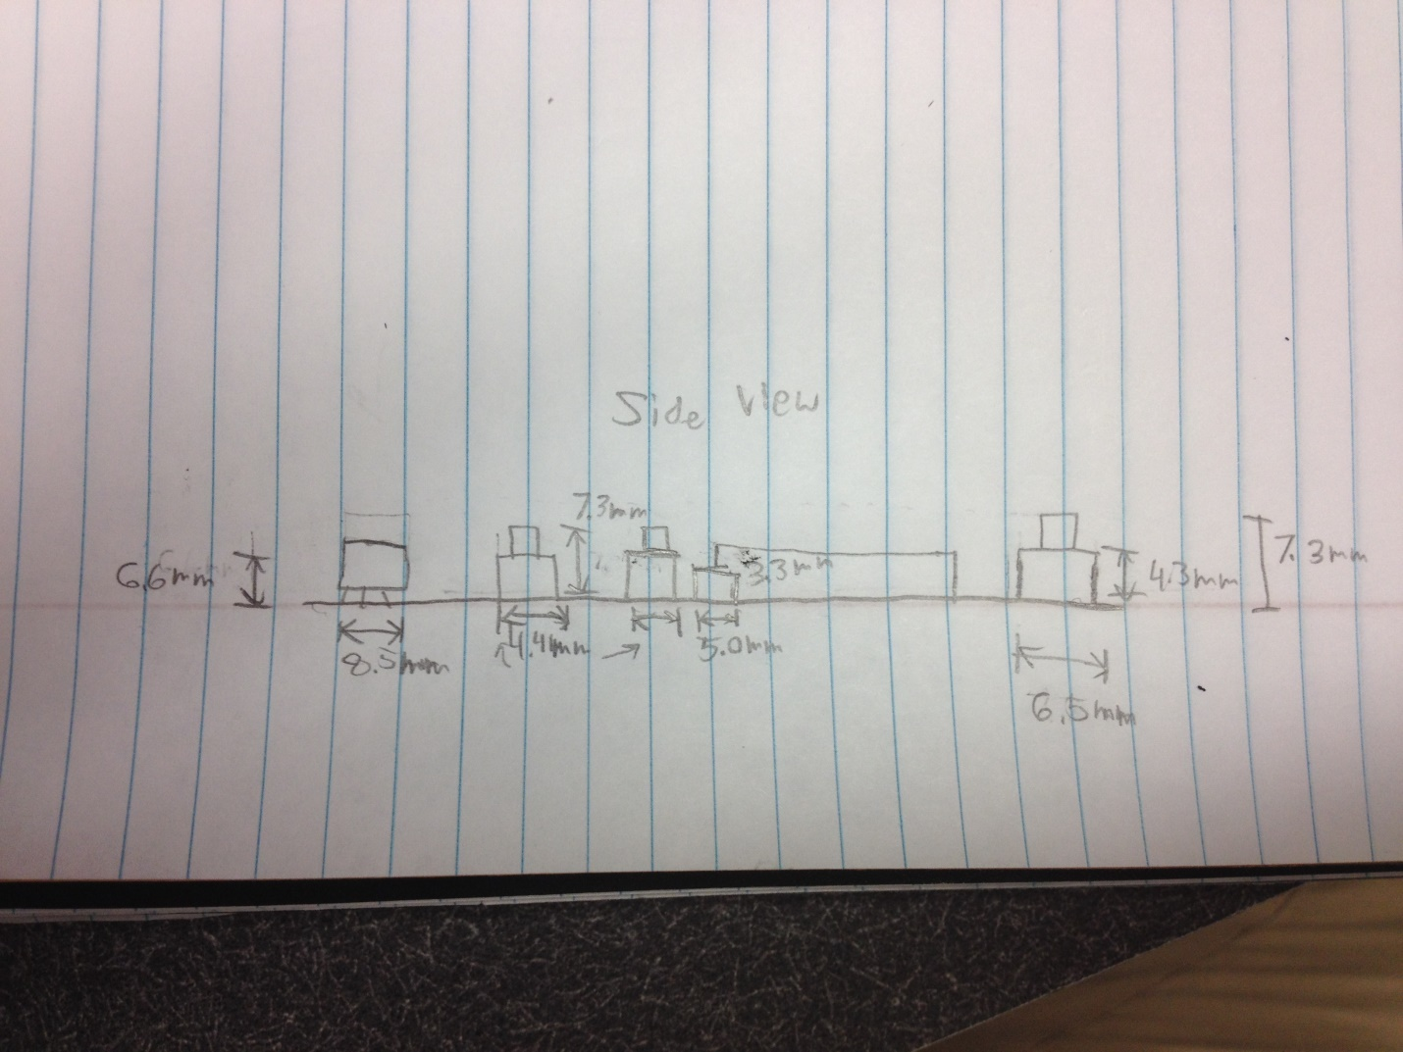

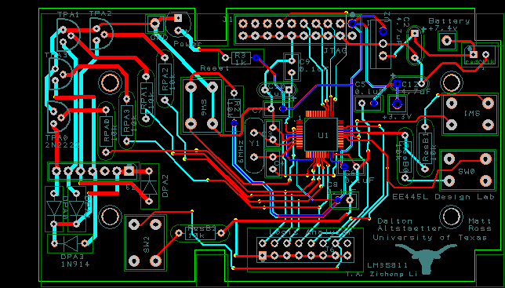

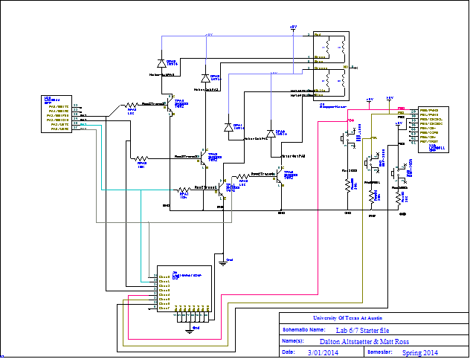
MEASUREMENT DATA

Battery = 4 * 500mA = 2000mAh

ANALYSIS AND DISCUSION
Load our lab4 code. Plug in the battery and stepper motor. Test the functionality of each switch.

