**EE445L – Lab6: Design and Layout of an Embedded System**

Harley Ross and Dalton Altstaetter

2/18/14

**OBJECTIVES**

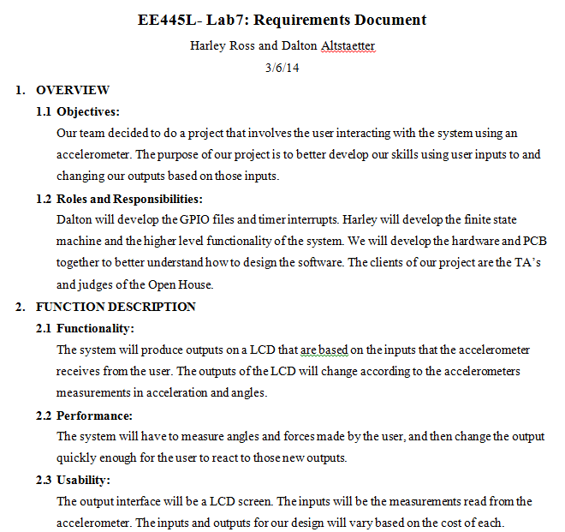

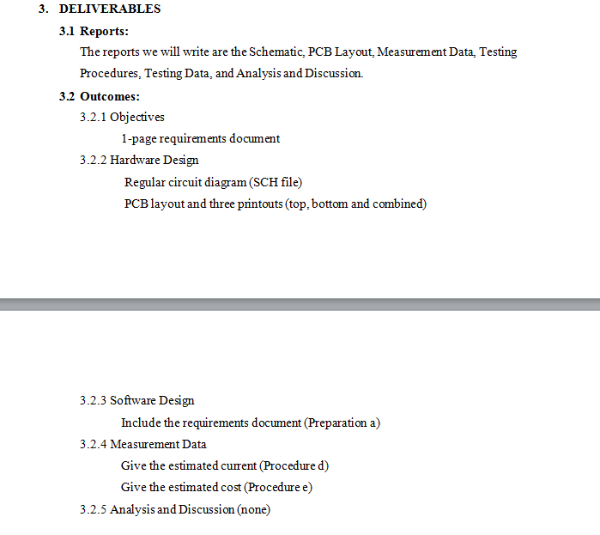

**HARWARE DESIGN**

PCB

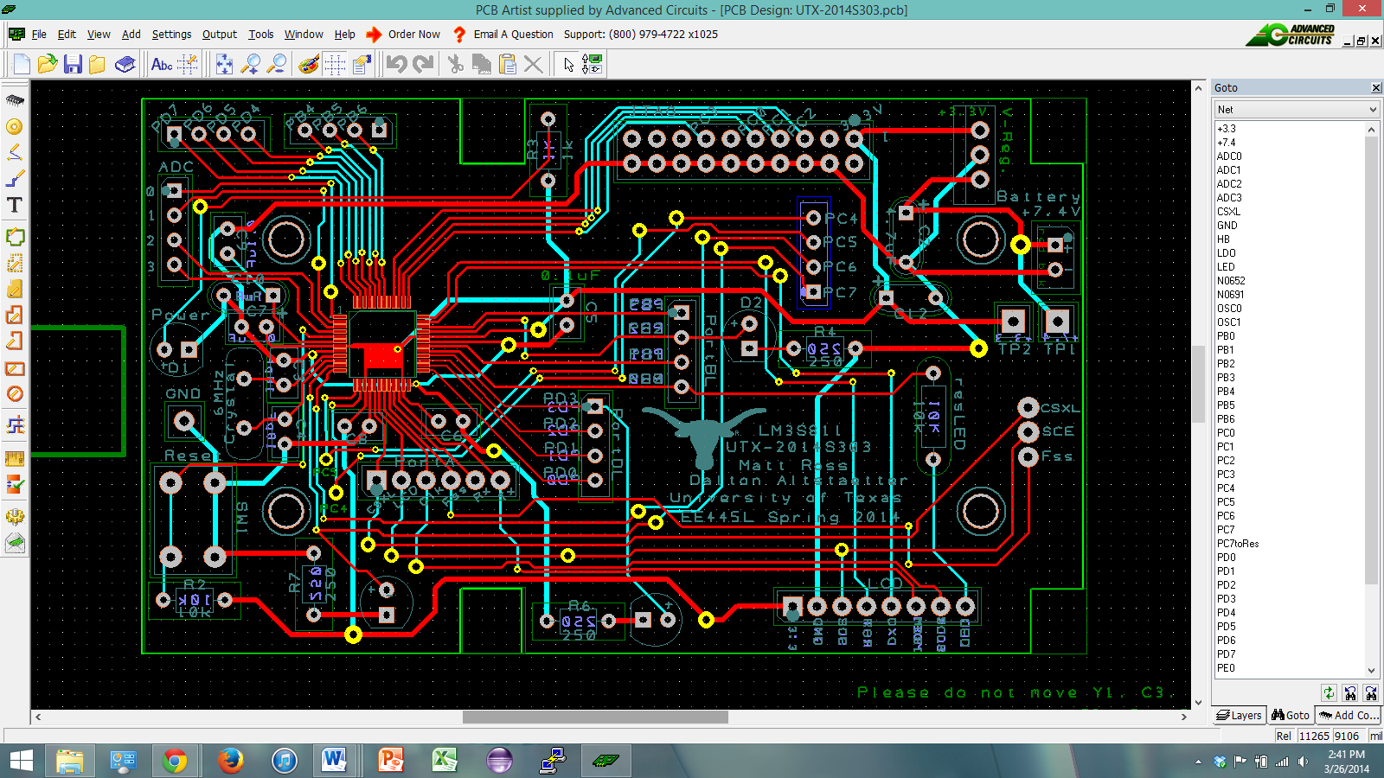

SCH

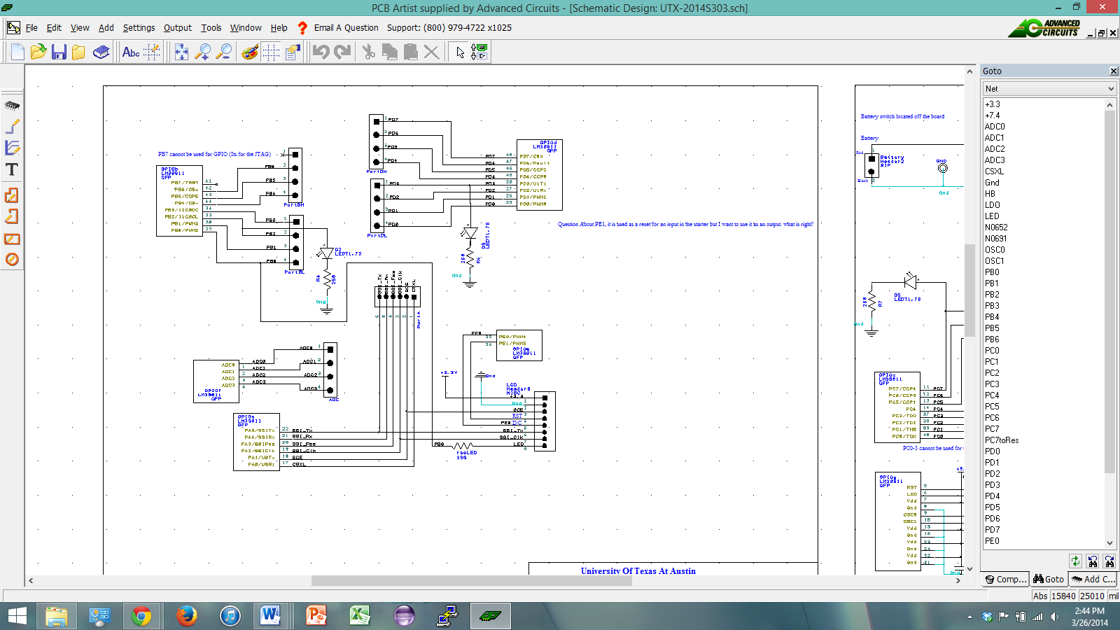

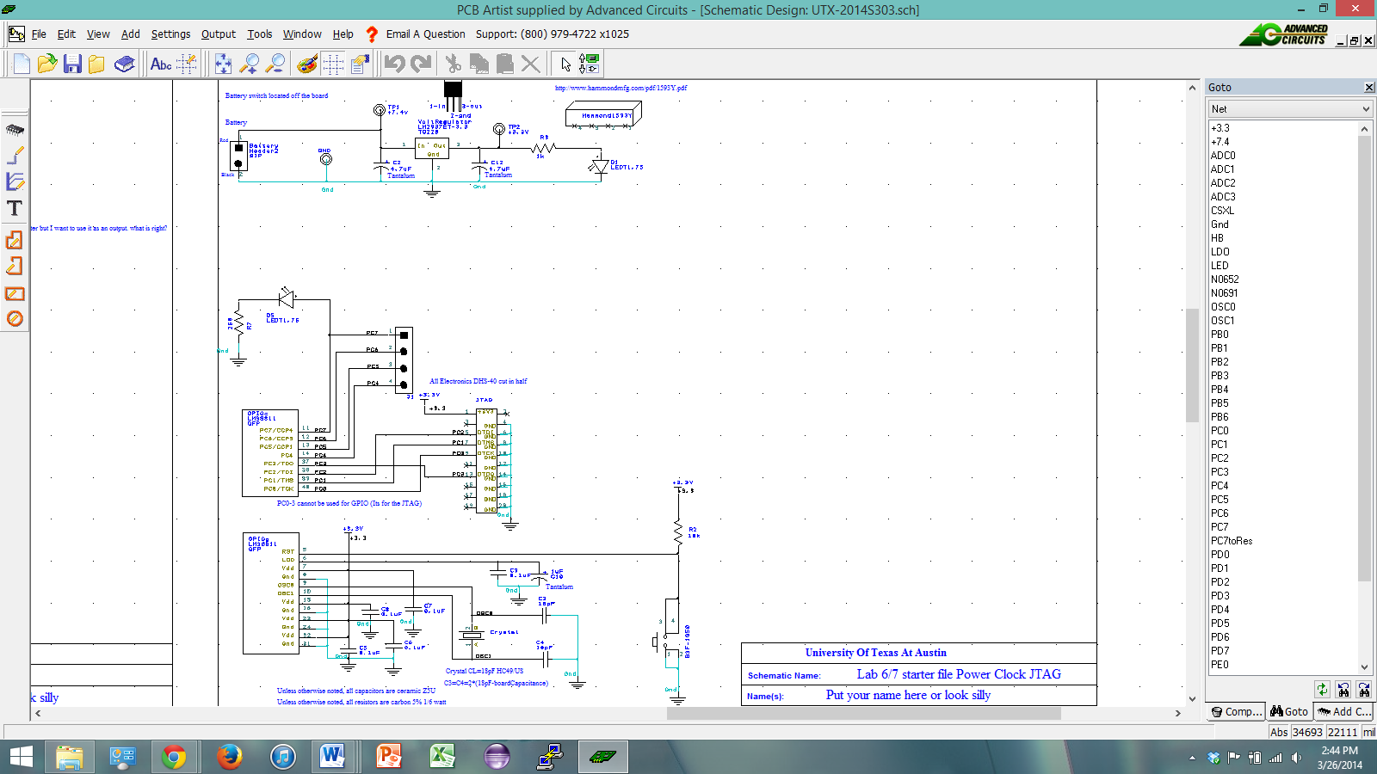

**MEASUREMENT DATA**

Estimated Current: 10 mA

Estimated Cost: $0.00