专注力学习资料 · The science of focus
正文为 PDF 提取文字，阅读顺序和公式可能需要校对；原页图片仅作参考。

原始页 2
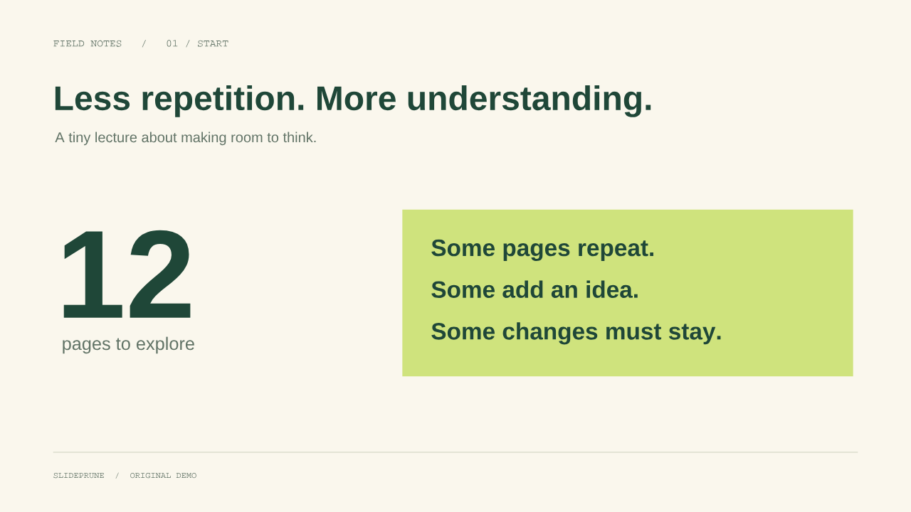
FIELD NOTES / 01 / START
Less repetition. More understanding.
A tiny lecture about making room to think.
SLIDEPRUNE / ORIGINAL DEMO
12
pages to explore
Some pages repeat.
Some add an idea.
Some changes must stay.

原始页 5
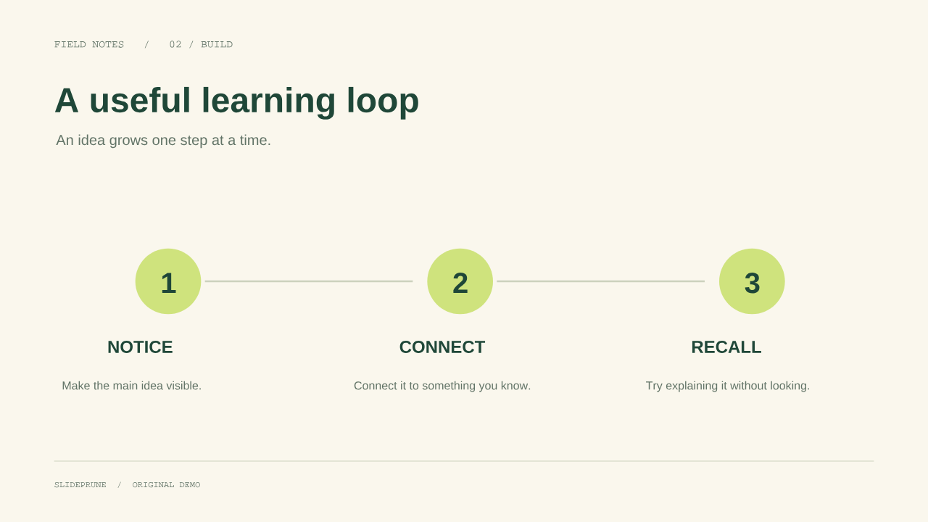
FIELD NOTES / 02 / BUILD
A useful learning loop
An idea grows one step at a time.
SLIDEPRUNE / ORIGINAL DEMO
1
NOTICE
Make the main idea visible.
2
CONNECT
Connect it to something you know.
3
RECALL
Try explaining it without looking.

原始页 6
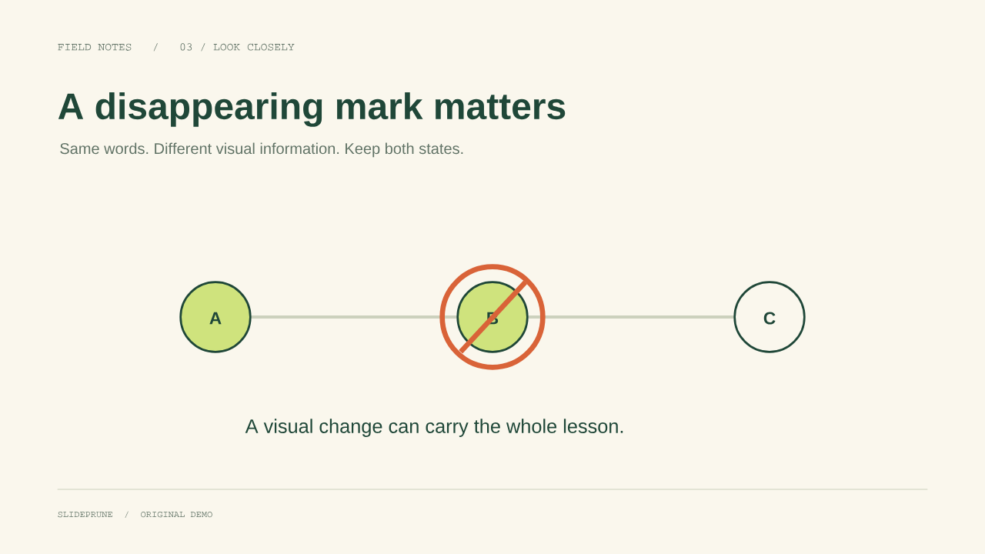
FIELD NOTES / 03 / LOOK CLOSELY
A disappearing mark matters
Same words. Different visual information. Keep both states.
SLIDEPRUNE / ORIGINAL DEMO
A B C
A visual change can carry the whole lesson.

原始页 7
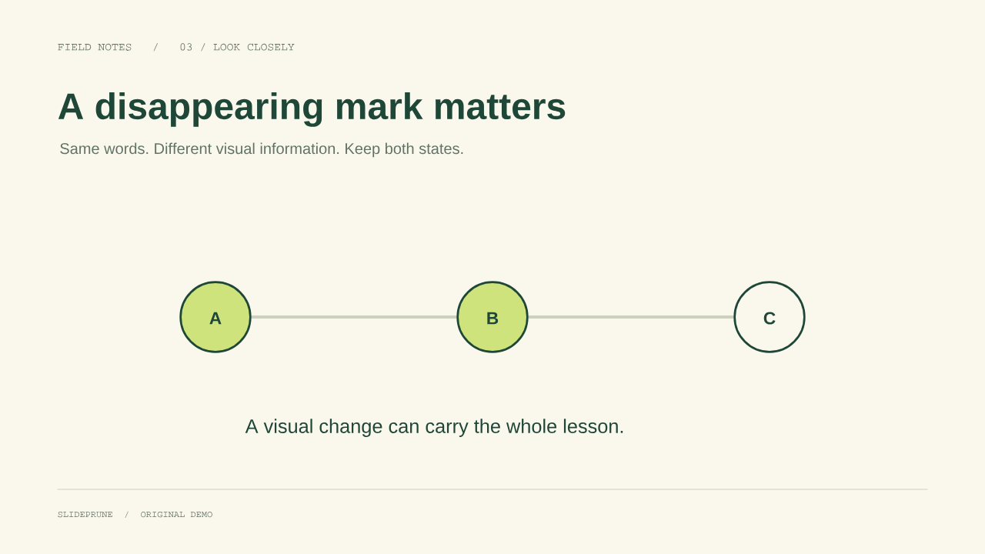
FIELD NOTES / 03 / LOOK CLOSELY
A disappearing mark matters
Same words. Different visual information. Keep both states.
SLIDEPRUNE / ORIGINAL DEMO
A B C
A visual change can carry the whole lesson.

原始页 8
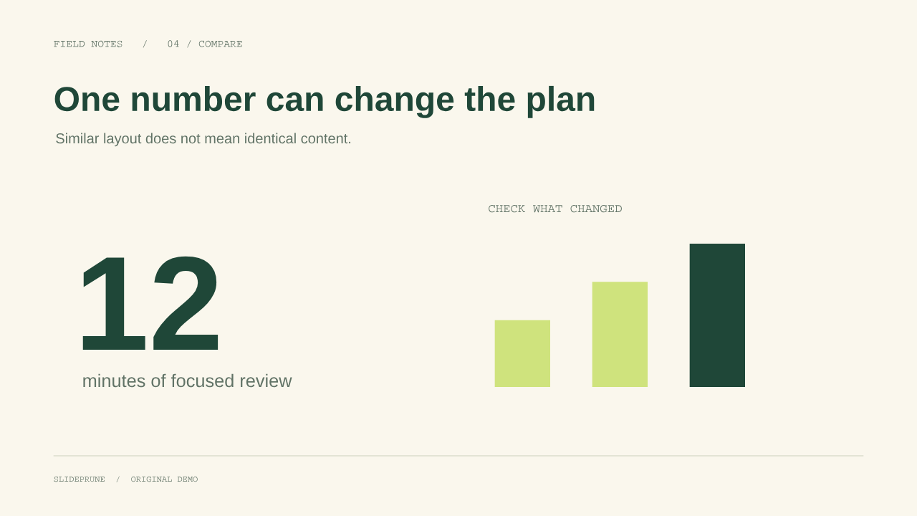
FIELD NOTES / 04 / COMPARE
One number can change the plan
Similar layout does not mean identical content.
SLIDEPRUNE / ORIGINAL DEMO
12
minutes of focused review
CHECK WHAT CHANGED

原始页 9
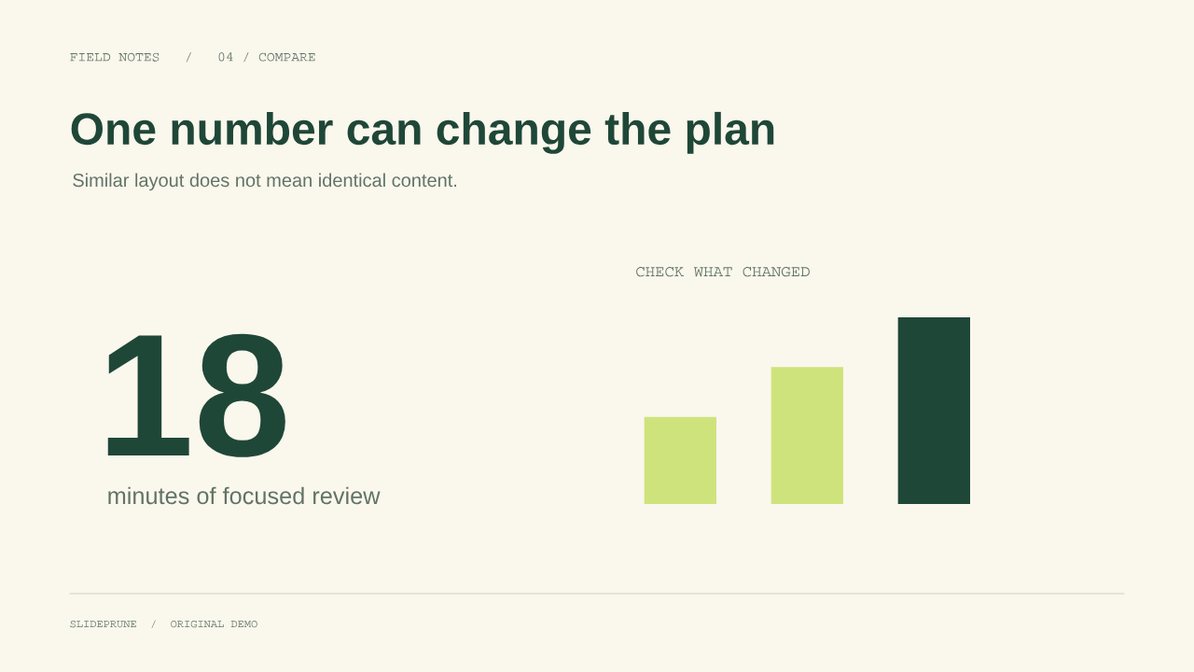
FIELD NOTES / 04 / COMPARE
One number can change the plan
Similar layout does not mean identical content.
SLIDEPRUNE / ORIGINAL DEMO
18
minutes of focused review
CHECK WHAT CHANGED

原始页 11
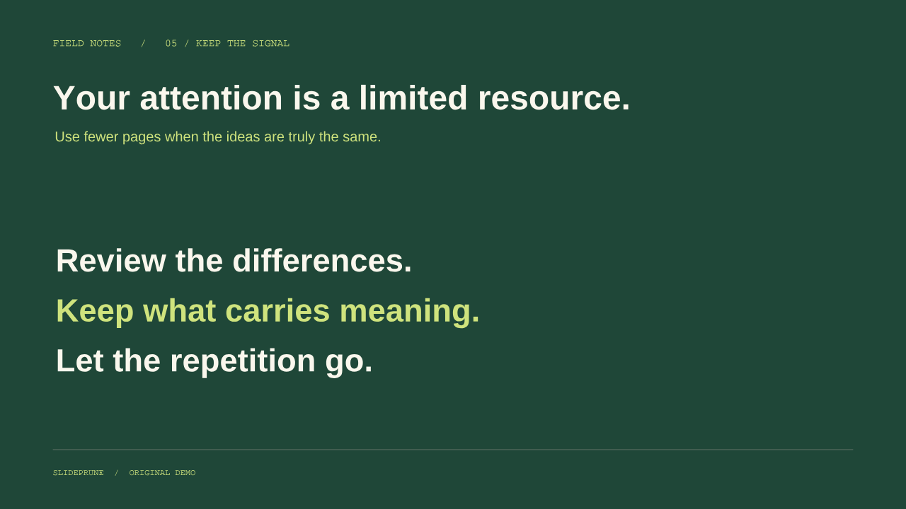
FIELD NOTES / 05 / KEEP THE SIGNAL
Your attention is a limited resource.
Use fewer pages when the ideas are truly the same.
SLIDEPRUNE / ORIGINAL DEMO
Review the differences.
Keep what carries meaning.
Let the repetition go.

原始页 12
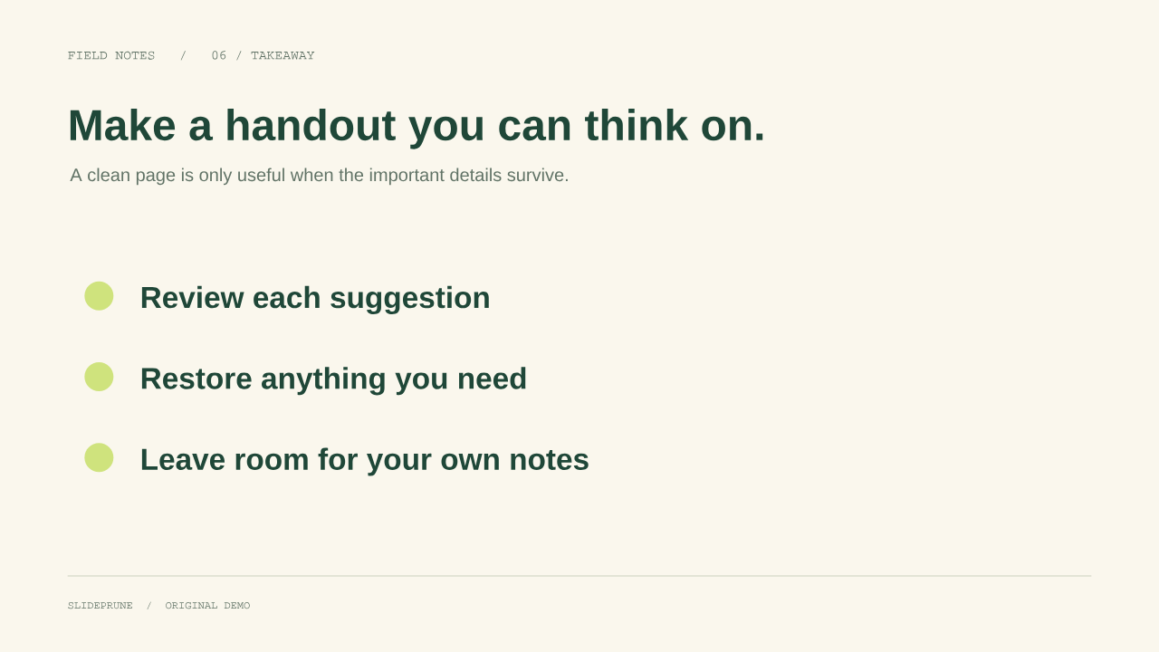
FIELD NOTES / 06 / TAKEAWAY
Make a handout you can think on.
A clean page is only useful when the important details survive.
SLIDEPRUNE / ORIGINAL DEMO
Review each suggestion
Restore anything you need
Leave room for your own notes

