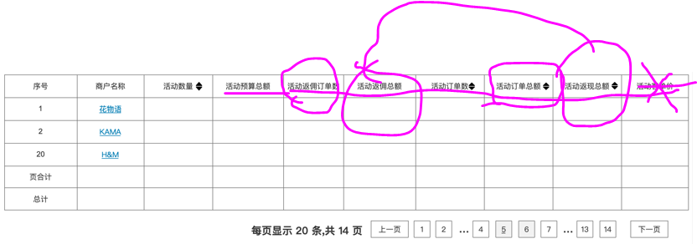sql:

FROM

marketing_cash

left join seller on mac_sellerId = sel_id

left join marketing_cash_log on mac_id = mcl_marketingCashId