关联商品：

wxh/seller/coinPurse/toSubsidyGoodsPage

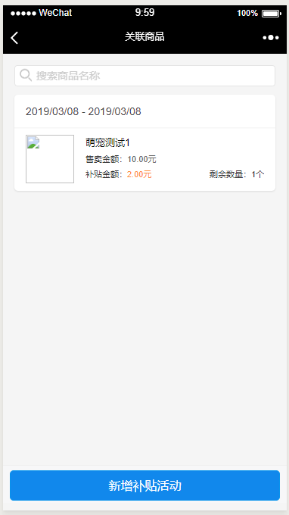

补贴详情：

wxh/seller/coinPurse/toSubsidyDetail?subsidyId=147

