User Manual for BingeWolves:



Table of Contents

**How to do a Character Search:** 3

**How to do a Mount Search:** 6

**How to do a Pet Search:** 9

# **How to do a Character Search:**

Searching for a World of Warcraft character will provide you with the current stats of that character. You can then switch to the collections of the character which will show you the total amount of achievement points, mounts, and pets that character has collected. It will also show you what pets that character currently has selected in his/her battle pet slots.

Steps to do a Character Search:

1. When you open the application, you are shown a screen with three buttons click the button that says character search to be taken to the character search screen.

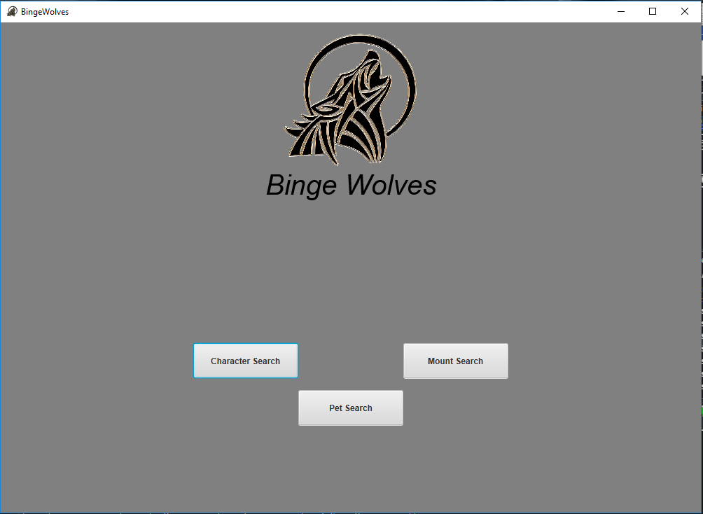

1. At the character search screen, you can now input the name of the character, their realm, and the region that character is in.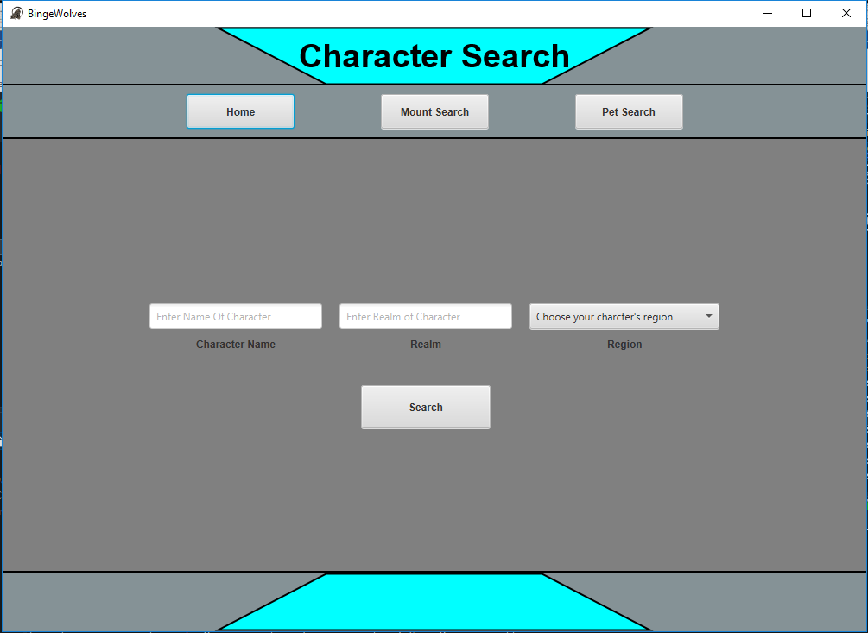

Example Input: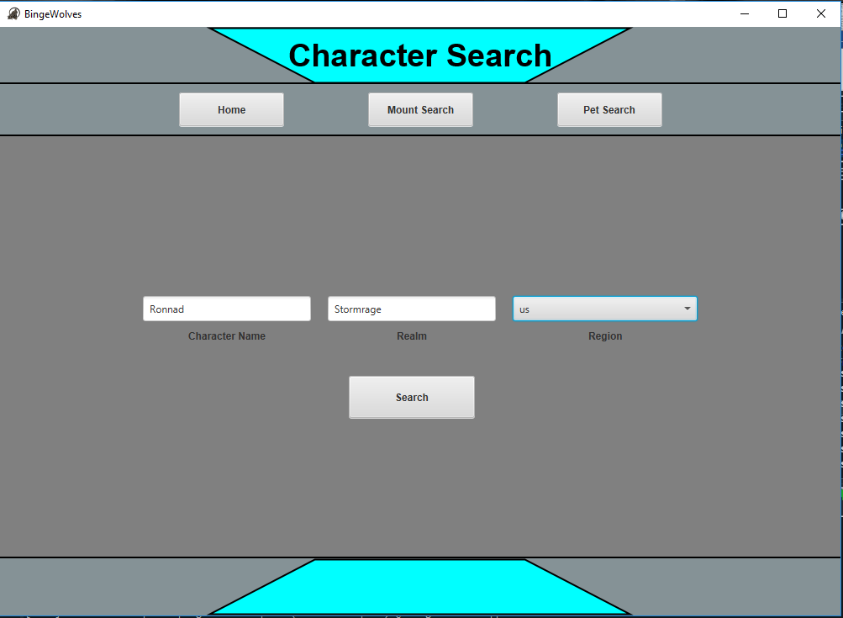

1. Now you will be able to view the stats of that character.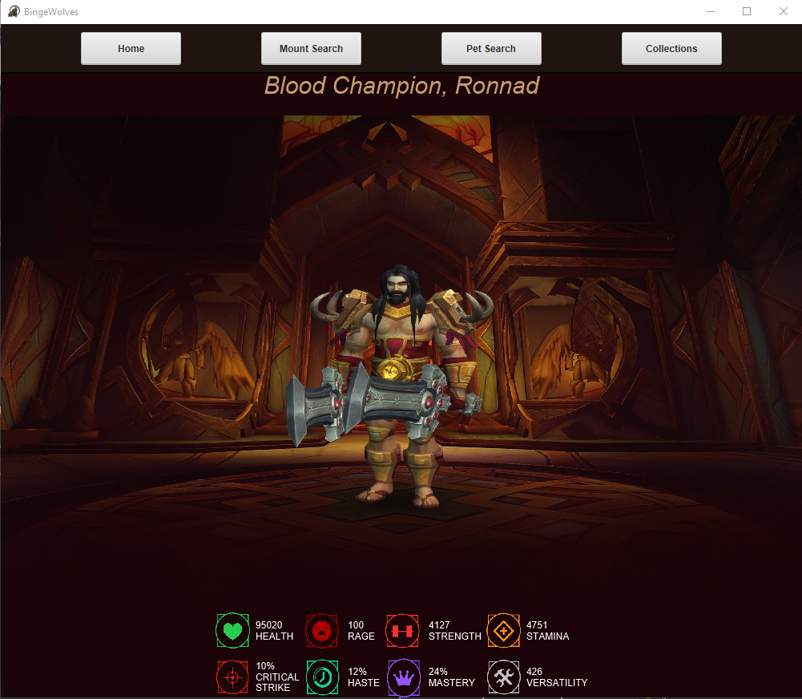
2. Once you click the collections button you will be shown the collection of that character.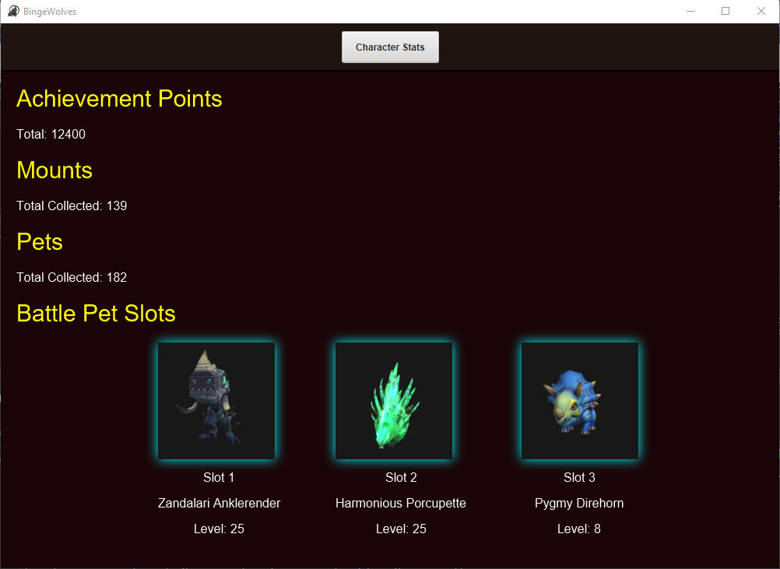

# **How to do a Mount Search:**

Searching for a mount will provide you with an image of the mount a short description of that mount and how to obtain that mount.

Steps to do a Mount Search:

1. When you open the application, you are shown a screen with three buttons click the button that says mount search to be taken to the mount search screen.
2. At the mount search screen, you will now input the name of the mount that you want to search.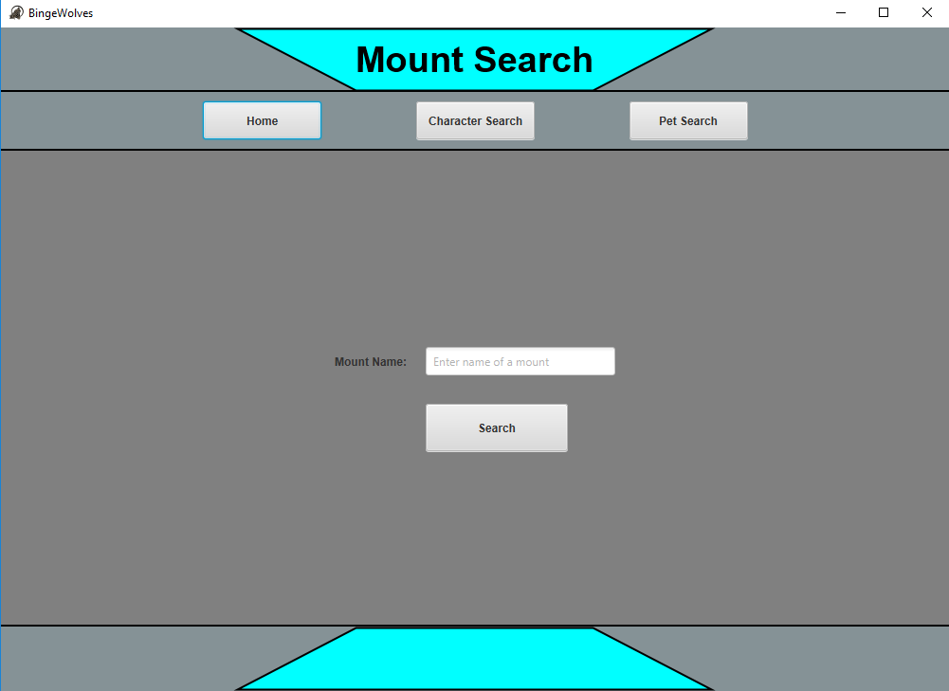

Ex. Input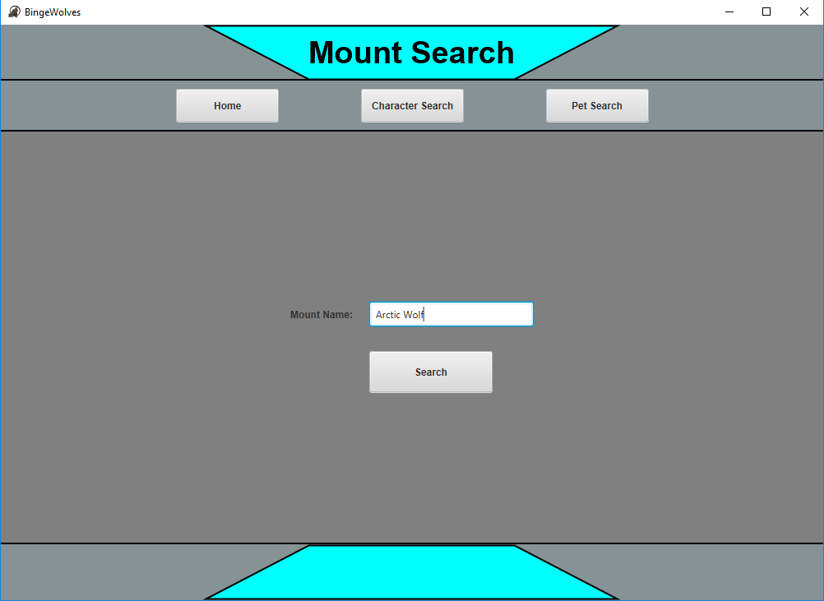

1. Now at the Mount Data Screen you can see the description and how to obtain the mount.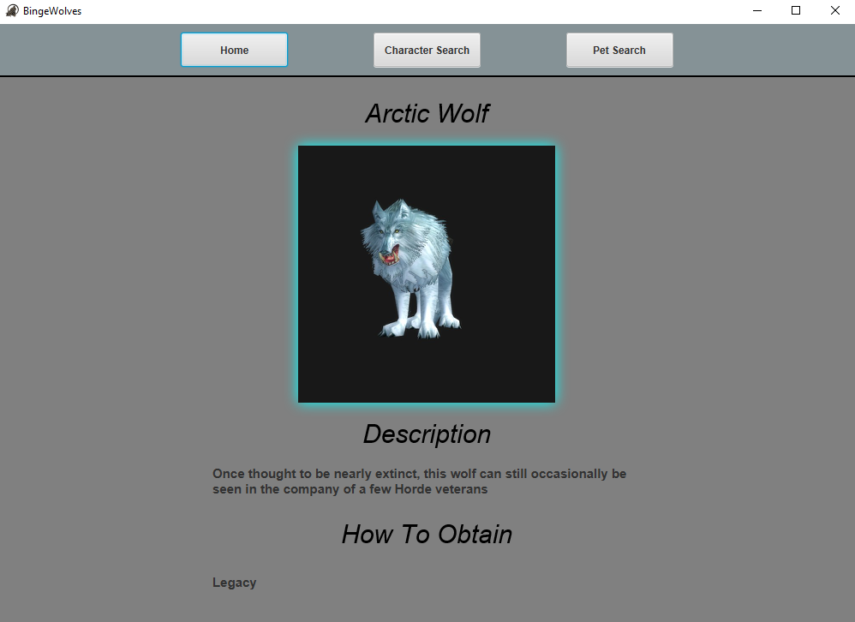

# **How to do a Pet Search:**

Searching for a pet will provide you with an image of the pet a short description of that mount, the species, and how to obtain that pet.

Steps to do a Pet Search:

1. When you open the application, you are shown a screen with three buttons click the button that says mount search to be taken to the mount search screen.
2. At the pet search screen, you will now input the name of the pet that you want to search.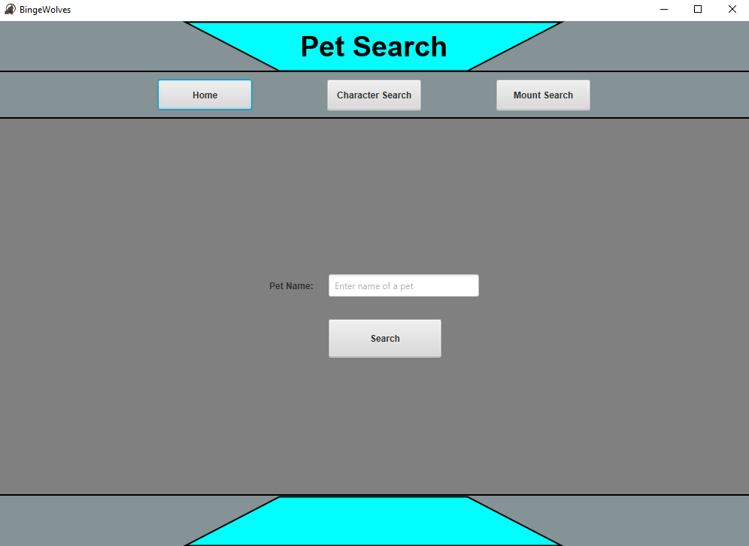

Ex. Input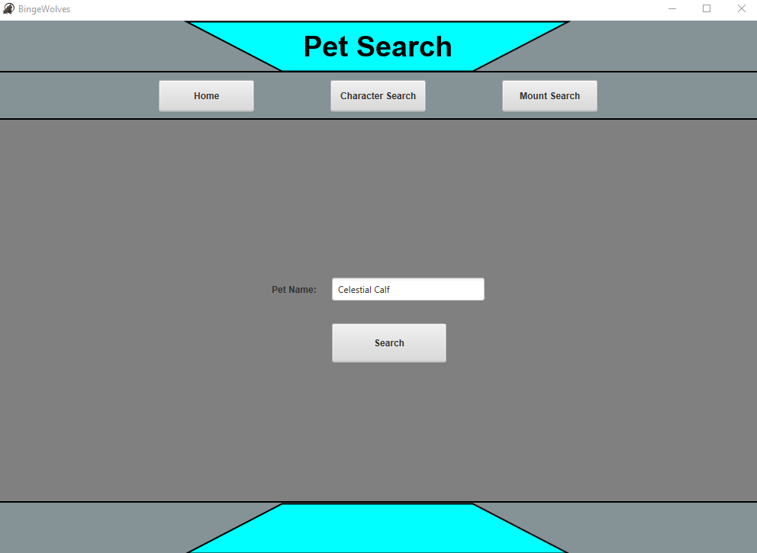

1. Now at the Pet Data Screen you can see the description, the species, and how to obtain the pet.