**Instructions for executing the tasks in LuigiDemo**

1. **Download all the files from the LuigiDemo folder from github**
2. **LUIGI Installation**

Install using pip

**pip install luigi**

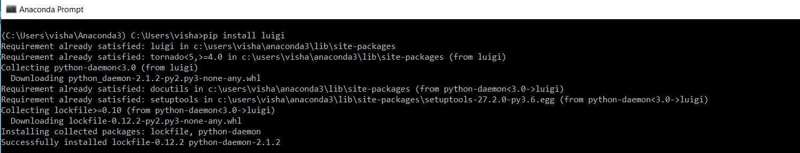

1. For running this demo, you will have to install MySQL Server because we have used that as a data source in one of the scripts **loadFromMySQL.py** . If you want to change this, then please make appropriate changes to the code.

You will also need to provide the user, password, database and port for MySQL running on your machine.

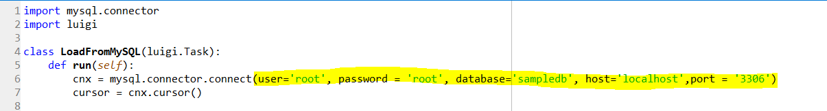

In that, create a new database called **sampledb** and run the mldb-samples-2008.09.19.sql attached below.



This will create the tables in the db.

1. Edit the targets that are returned from the output function of each Luigi Task present in the module files (.py scripts) to a path on your file system. Otherwise you will get the NoModuleFound Error



1. You will also have to install the pymysql package from pip or conda

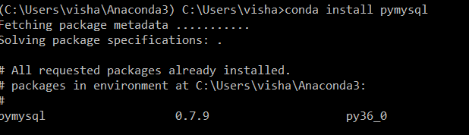

The final step is to add the path where your modules (python scripts for Luigi Tasks are present) to the PYTHONPATH environment variable. For this demo, you can set it to the path where you have kept the files downloaded from github

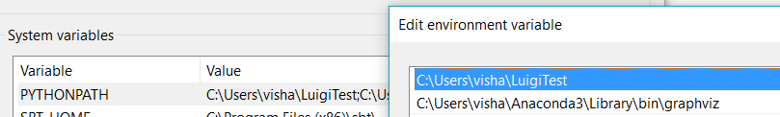

1. Start the Luigi scheduler by executing luigid in your terminal. (If this throws NoModuleFound error, then luigid is probably not installed correctly on your system. You can also try tweaking the PYTHONPATH or PATH variable so that these modules are included)

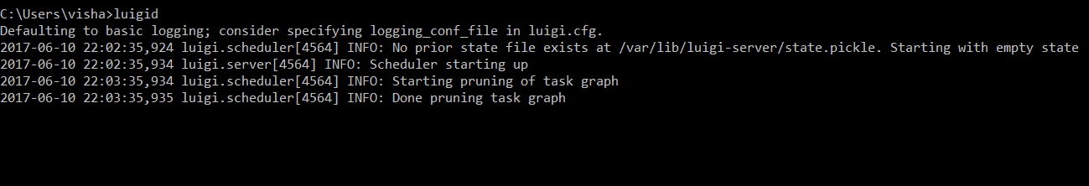

1. Invoke the following command to execute the final Task in your pipeline, Luigi will build the pipeline backwards based on what you have specified in the requires function.

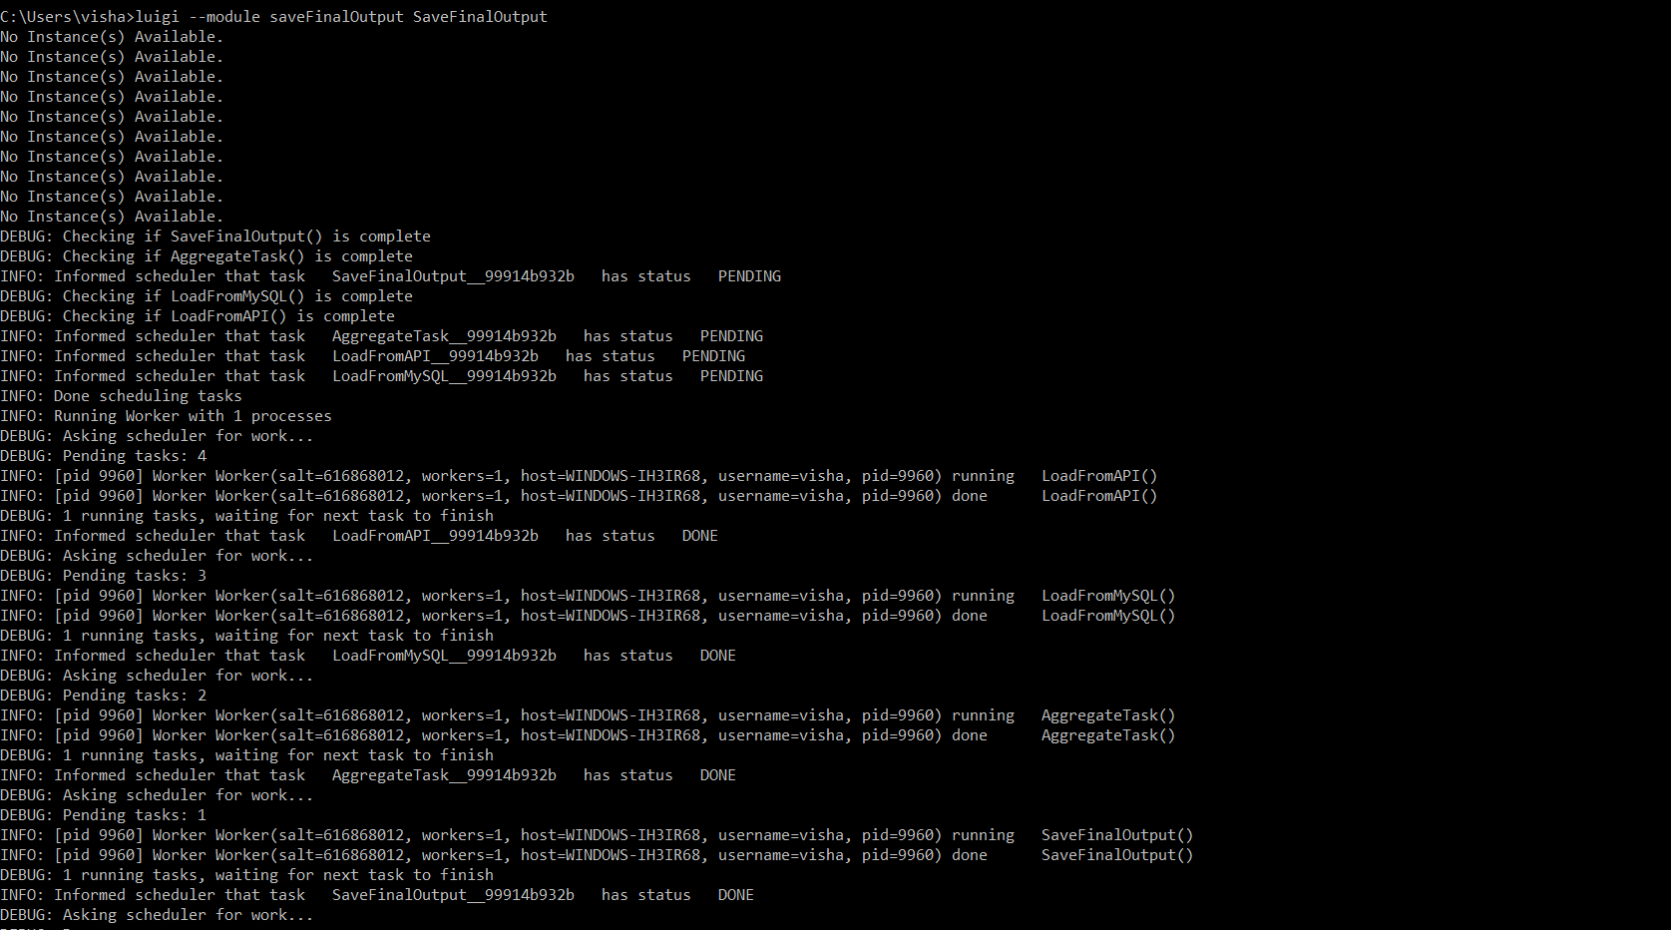

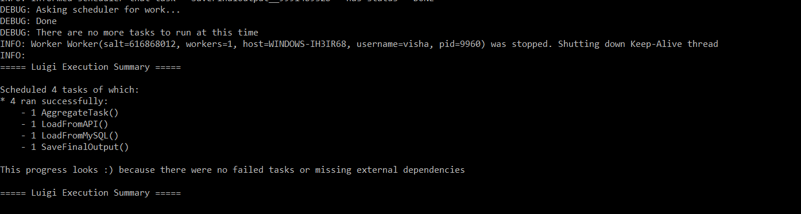

Output files will get create at the path that you specified as target

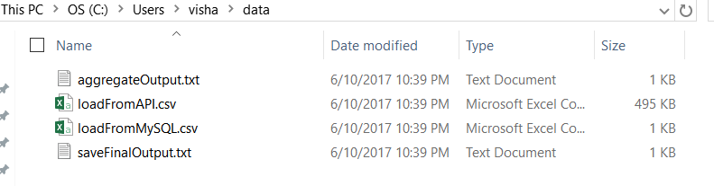

You can view the scheduled tasks and the dependency graph on the UI which is usually on the 8082 port of the running luigi scheduler daemon

