**Project Document Advance Database Management Systems Manasi Dalvi**

**Datasets**

The project contains two datasets US-pollution dataset and US-drought dataset spanning from year 2000 to 2016 and an intermediary dataset for join.

Problem statement: Find co-relation between drought type and pollutant type

**US-drought columns:**

The data contains weekly observations about the extent and severity of drought in each county of the United States.

* county: the county name
* state: the state the county is in
* NONE: percentage of the county that is not in drought
* D0: percentage of the county that is in abnormally dry conditions
* D1: percentage of the county that is in moderate drought
* D2: percentage of the county that is in severe drought
* D3: percentage of the county that is in extreme drought
* D4: percentage of the county that is in exceptional drought
* validStart: the starting date of the week that these observations represent
* validEnd: the ending date of the week that these observations represent

**US-pollution:**

* State : State of monitoring site
* County : County of monitoring site
* City : City of the monitoring site
* Date Local : Date of monitoring

The four pollutants (NO2, O3, SO2 and O3) each has 5 specific columns. For instance, for NO2:

* NO2 Units : The units measured for NO2
* NO2 Mean : The arithmetic mean of concentration of NO2 within a given day
* NO2 AQI : The calculated air quality index of NO2 within a given day
* NO2 1st Max Value : The maximum value obtained for NO2 concentration in a given day
* NO2 1st Max Hour : The hour when the maximum NO2 concentration was recorded in a given day.

**Dataset Link:**

US-Pollution data: <https://www.kaggle.com/sogun3/uspollution>

US-drought data: <https://www.kaggle.com/us-drought-monitor/united-states-droughts-by-county>

**Analysis:**

Individual analysis on pollution and drought datasets

**Pollution data set:**

1. Grouped data by state and year, month.

Performed aggregation on four pollutant columns to find out mean value per year.

Output file of pollution dataset analysis consisted of State name, Year, Month, and a single value for each year for each of the four pollutants.

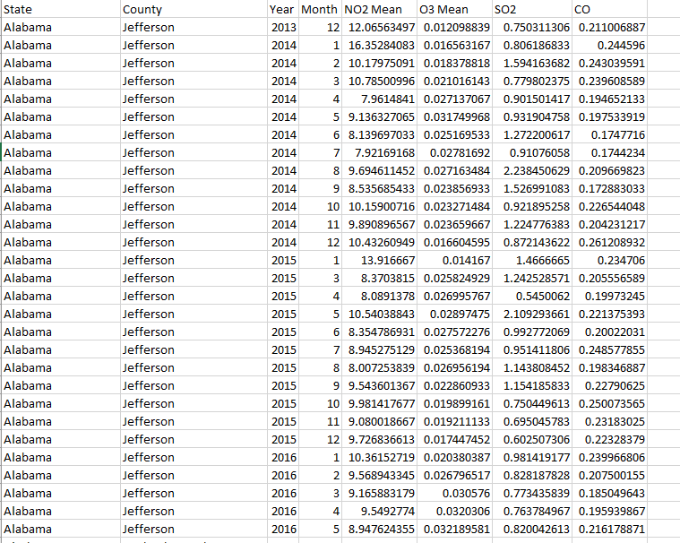

1. **Top ten polluted cites in the year 2015**

Total pollution value for all states in the year 2015 with top ten values.

Using job chaining and secondary sorting.

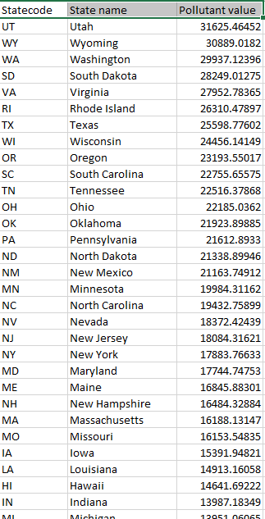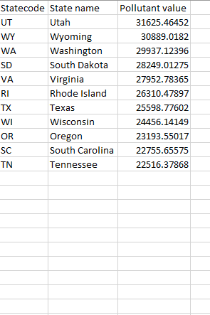

**Visualization: Top 10 Polluted cities**

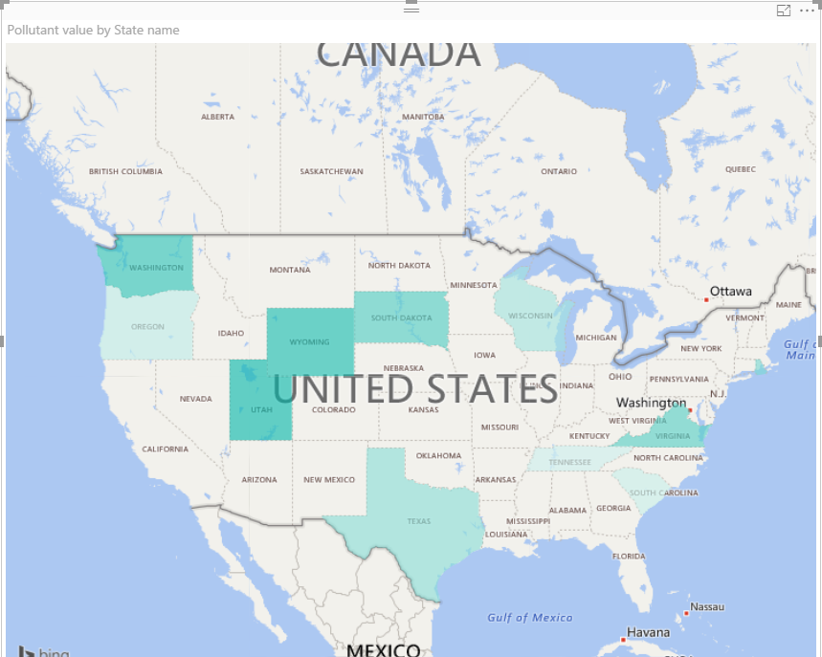

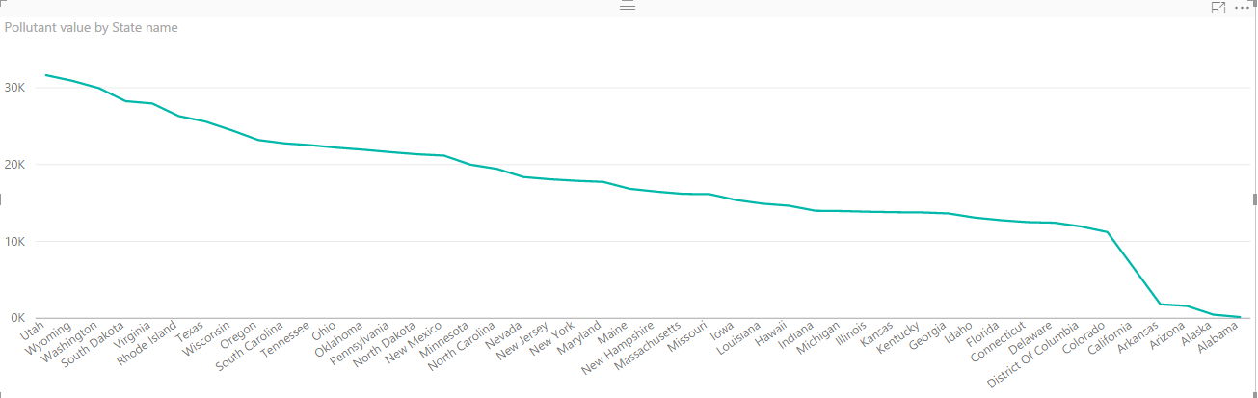

Pollution by state in descending order

**Graphs build on pollution dataset using PowerBI**

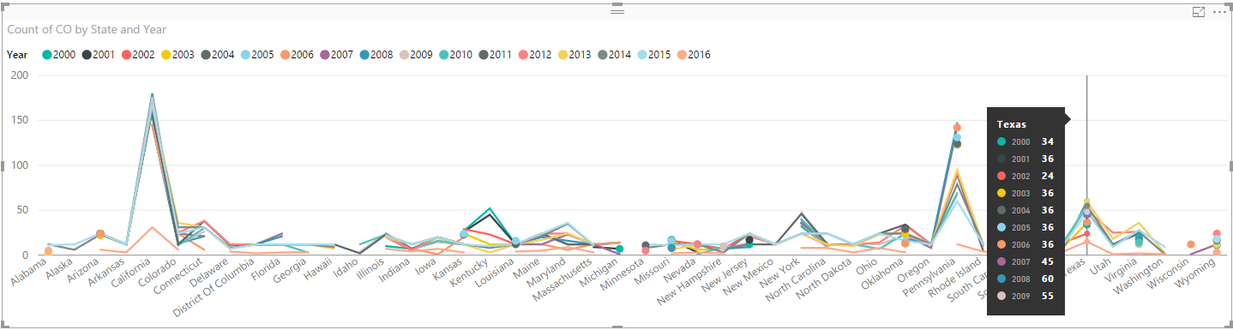

Count of CO by State and Year

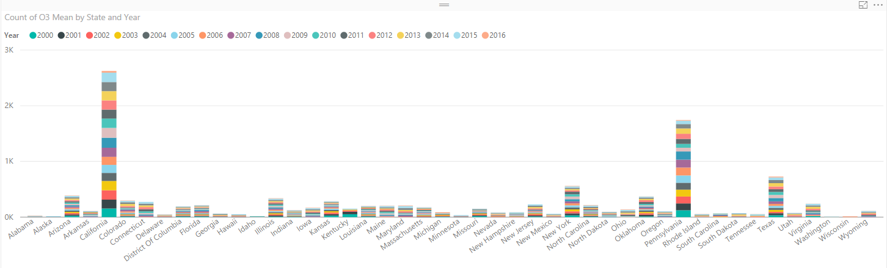

Count of O3 by State and Year

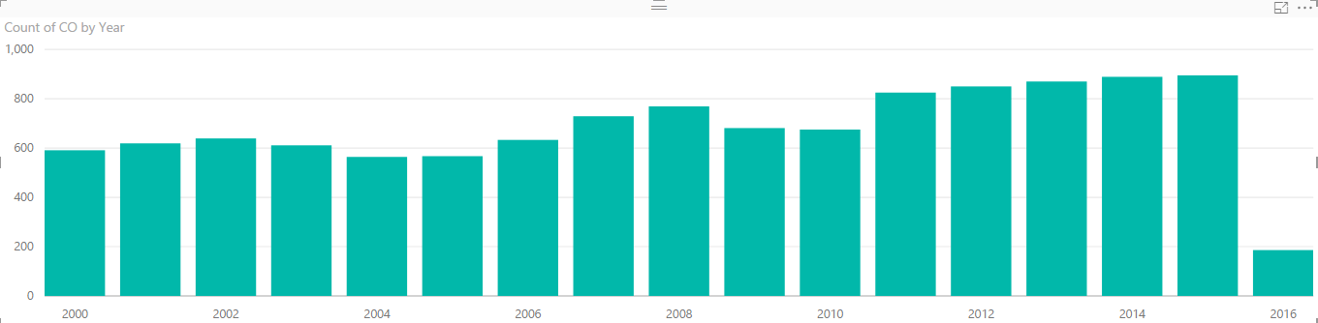

CO distribution by year

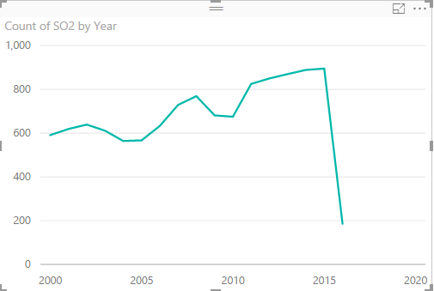

Count of SO2 by year

**Drought Dataset Analysis**

Dataset contains the percentage of area under a particular type of drought (None, D0,D1,D2,D3,D4)

Performed numerical summarization on the data to group the data by Year and Month.

The output file consisted of State code Year-Month and the average of drought for that month-year.

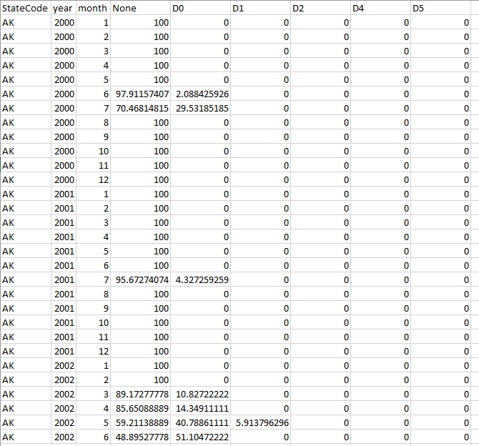

Graphs based on Drought dataset using PowerBI

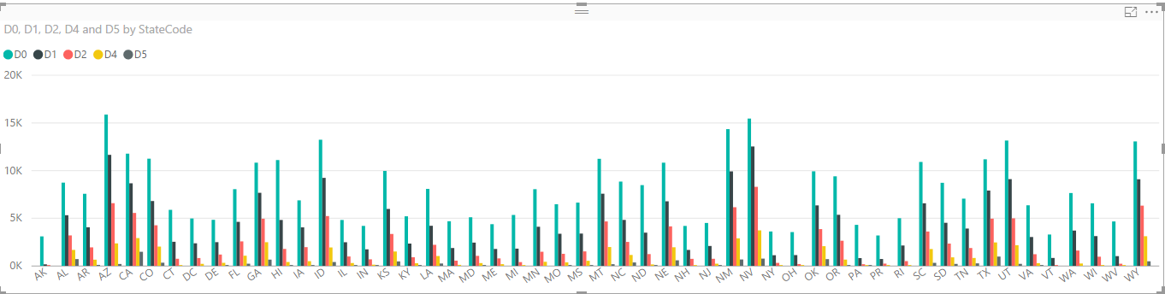Drought severity by State

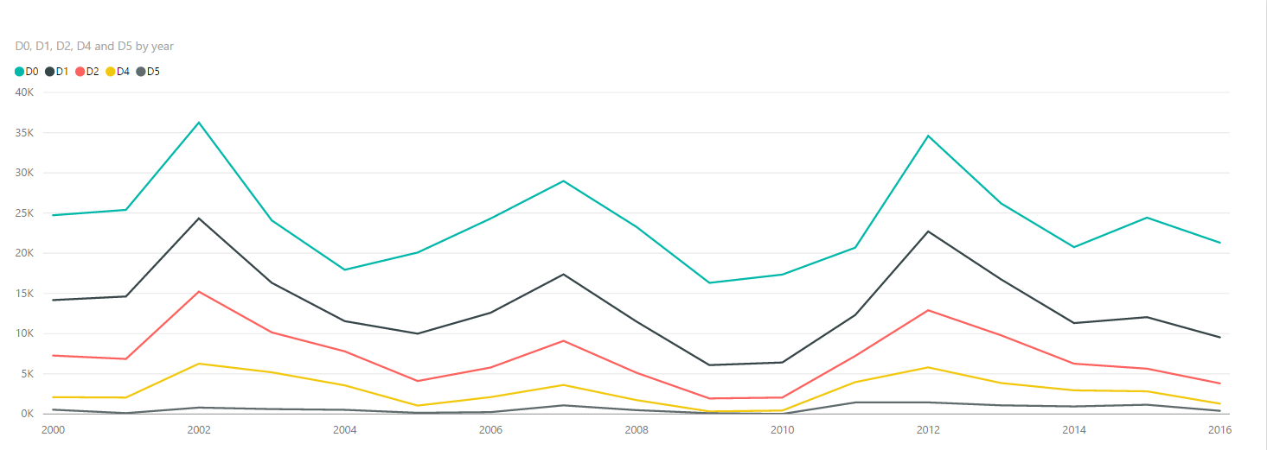

Drought severity by year

**Finding correlation between pollutant type and draught type:**

Input: Aggregate files obtained from the above analysis: pollution-aggregate, drought-aggregate

To join the two files an intermediary file statecode.csv, is used which contains the state names and codes is used.

Performed a map-side join on the statecode.csv and pollution-aggregate.csv to obtain common key column of state-code.

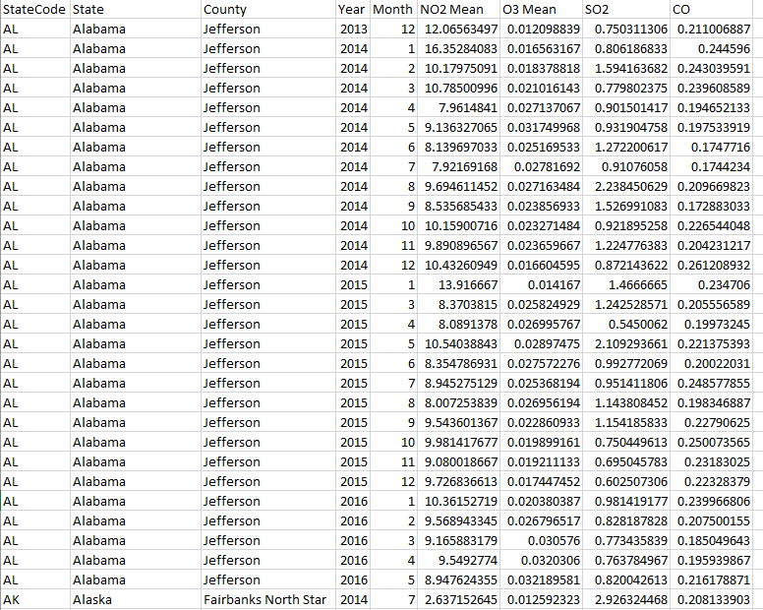

A second Map-side join was performed on Draught-aggregate file with statecodes.csv to insert state name in it.

One more aggregation was done on the draught file to find the maximum type of drought.

The final reduce side join was performed on the two data sets to obtain the final value containing

State code, state name, year, month, max pollutant, average draught type for the year.

**Final output:**

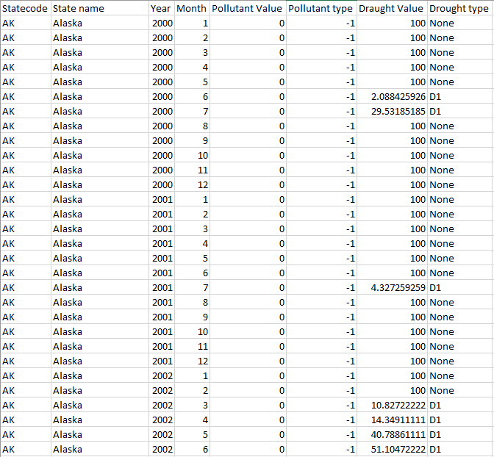

**Graphs for co-relation on final dataset:**

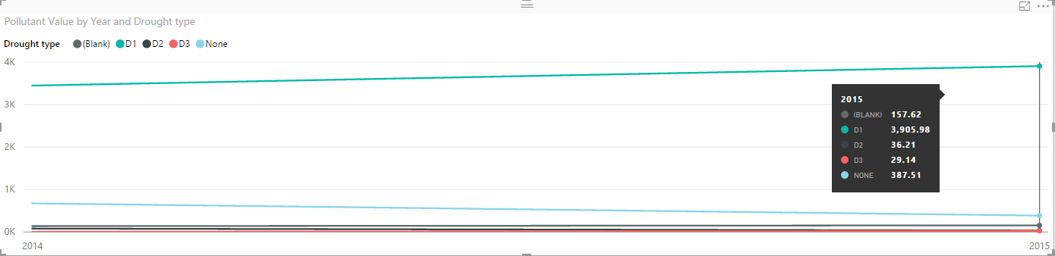

Pollutant value by year and drought type

**Appendix:**

Top ten Polluted cities

Pollution Analysis

Drought Analysis

Pollution state code join

Pollution-drought reduce side join

1. **Top Ten Polluted:**

Driver Class

/*

* To change this license header, choose License Headers in Project Properties.

* To change this template file, choose Tools | Templates

* and open the template in the editor.

*/

package totalpollutiontop10;

import java.net.URI;

import org.apache.hadoop.conf.Configuration;

import org.apache.hadoop.conf.Configured;

import org.apache.hadoop.filecache.DistributedCache;

import org.apache.hadoop.fs.Path;

import org.apache.hadoop.io.DoubleWritable;

import org.apache.hadoop.io.NullWritable;

import org.apache.hadoop.io.Text;

import org.apache.hadoop.mapred.FileInputFormat;

import org.apache.hadoop.mapred.FileOutputFormat;

import org.apache.hadoop.mapred.JobClient;

import org.apache.hadoop.mapred.JobConf;

import org.apache.hadoop.mapred.RunningJob;

import org.apache.hadoop.mapred.TextInputFormat;

import org.apache.hadoop.mapred.TextOutputFormat;

import org.apache.hadoop.mapreduce.Job;

import org.apache.hadoop.util.Tool;

import org.apache.hadoop.util.ToolRunner;

/**

*

* @author Manasi

*/

public class TotalPollutionTop10 {

public static void main(String[] args) throws Exception {

JobConf conf = new JobConf(TotalPollutionTop10.class);

conf.setJobName("totalpollution");

conf.setOutputKeyClass(Text.class);

conf.setOutputValueClass(Text.class);

conf.setMapperClass(TotalPollutionMapper.class);

conf.setReducerClass(TotalPollutionReducer.class);

conf.setInputFormat(TextInputFormat.class);

conf.setOutputFormat(TextOutputFormat.class);

FileInputFormat.setInputPaths(conf, new Path(args[0]));

FileOutputFormat.setOutputPath(conf, new Path(args[2]));

try{

DistributedCache.addCacheFile(new URI(args[1]), conf);

}

catch(Exception e){

System.out.println(e);

}

RunningJob rj = JobClient.runJob(conf);

boolean success = rj.isComplete();

if(success){

JobConf confNew = new JobConf(TotalPollutionTop10.class);

confNew.setJobName("totalpollutionsort");

confNew.setOutputKeyClass(DoubleWritable.class);

confNew.setOutputValueClass(Text.class);

confNew.setMapperClass(ReducerSorterMapper.class);

confNew.setReducerClass(ReducerSorterReducer.class);

confNew.setInputFormat(TextInputFormat.class);

confNew.setOutputFormat(TextOutputFormat.class);

FileInputFormat.setInputPaths(confNew, new Path(args[2] + "/part-00000"));

FileOutputFormat.setOutputPath(confNew, new Path(args[3]));

confNew.setOutputKeyComparatorClass(TotalPollutionComparator.class);

JobClient.runJob(confNew);

}

else{

System.out.println("First Job NOt successful");

}

}

}

Mapper1 – TotalPollutionMapper

/*

* To change this license header, choose License Headers in Project Properties.

* To change this template file, choose Tools | Templates

* and open the template in the editor.

*/

package totalpollutiontop10;

import java.io.BufferedReader;

import java.io.File;

import java.io.FileNotFoundException;

import java.io.FileReader;

import java.io.IOException;

import java.util.HashMap;

import java.util.Map;

import org.apache.hadoop.io.LongWritable;

import org.apache.hadoop.io.NullWritable;

import org.apache.hadoop.io.Text;

import org.apache.hadoop.mapred.JobConf;

import org.apache.hadoop.mapred.MapReduceBase;

import org.apache.hadoop.mapred.Mapper;

import org.apache.hadoop.mapred.OutputCollector;

import org.apache.hadoop.mapred.Reporter;

//import org.apache.hadoop.mapreduce.Reducer.Context;

/**

*

* @author Manasi

*/

public class TotalPollutionMapper extends MapReduceBase implements Mapper<LongWritable, Text, Text, Text> {

private Map<String,String> stateCodes = new HashMap<String,String>();

@Override

public void configure(JobConf job) {

// Get the cached archives/files

File f = new File("statecodenames.csv");

System.out.println("filenme = "+ f.getName());

try{

BufferedReader reader = new BufferedReader(new FileReader(f));

String line = reader.readLine();

while(line!=null){

String [] tokens = line.split(",");

stateCodes.put(tokens[1].trim().toUpperCase(), tokens[0].trim());

System.out.println("State name = "+ tokens[1].trim() +" : Value = "+stateCodes.get(tokens[1].trim().toUpperCase()));

line = reader.readLine();

}

}

catch(FileNotFoundException e){

System.out.println("File Not found -"+e);

}

catch(IOException e){

System.out.println("IO - " + e);

}

}

@Override

public void map(LongWritable key, Text value, OutputCollector<Text, Text> output,Reporter reporter)

throws IOException {

if (value.toString().length() > 0) {

//System.out.println(value);

String[] attarray = value.toString().split(",(?=(?:[^\"]*\"[^\"]*\")*[^\"]*$)", -1);

if(!attarray[0].equals("")){

String dateattarray[] = attarray[8].split("-"); //2000-01-01

String val=attarray[10]+"\t"+attarray[15]+"\t"+attarray[20]+"\t"+attarray[25];

try{

String stateCode = stateCodes.get(attarray[5].toUpperCase());

if(stateCode != null){

double NO2 = 0.0;

long valueCount=0;

double SO2 = 0.0;

double O3 = 0.0;

double CO = 0.0;

try{

NO2= Double.parseDouble(attarray[0]);

}

catch(NumberFormatException e){

NO2=0.0;

}

try{

O3= Double.parseDouble(attarray[1]);

}

catch(NumberFormatException e){

O3=0.0;

}

try{

SO2= Double.parseDouble(attarray[2]);

}

catch(NumberFormatException e){

SO2=0.0;

}try{

CO= Double.parseDouble(attarray[3]);

}

catch(NumberFormatException e){

CO=0.0;

}

double totalPollution = (NO2 + O3 + SO2 + CO)/4;

//System.out.println("Mapper Key = "+stateCode.toUpperCase() +"\t"+ attarray[5] + " - value - " + totalPollution);

output.collect(new Text(stateCode.toUpperCase() +"\t"+ attarray[5]), new Text("" + totalPollution));

}

}

catch(ArrayIndexOutOfBoundsException e){

try{

System.out.println("Error = "+ attarray[0] + ","+attarray[5]+"," + attarray[6]);

}

catch(ArrayIndexOutOfBoundsException ex){

System.out.println("Error still exists = "+attarray[0]);

}

}

//System.out.print("MApper"+c1.getCountymonthyear());

}

}

}

}

Reducer 1-TotalPollutionReducer

package totalpollutiontop10;

import java.io.IOException;

import java.util.Iterator;

//import org.apache.hadoop.io.NullWritable;

import org.apache.hadoop.io.Text;

import org.apache.hadoop.mapred.MapReduceBase;

import org.apache.hadoop.mapred.OutputCollector;

import org.apache.hadoop.mapred.Reducer;

import org.apache.hadoop.mapred.Reporter;

public class TotalPollutionReducer extends MapReduceBase implements

Reducer<Text, Text, Text, Text > {

@Override

public void reduce(Text key, Iterator<Text> values, OutputCollector<Text, Text> output, Reporter report) throws IOException {

double pollution = 0.0;

long valueCount=0;

//System.out.print("REducer"+key.toString()+"value"+values);

while(values.hasNext()) {

Text value = values.next();

System.out.print("REducer"+key.toString()+"value"+value.toString());

String v=value.toString();

try{

pollution+= Double.parseDouble(v.trim());

}

catch(NumberFormatException e){

pollution+=0.0;

}

valueCount++;

}

if(valueCount!= 0){

pollution /= valueCount;

}

String keypart[] = key.toString().split("\t");

String stateCode = keypart[0];

String stateName = keypart[1];

output.collect(new Text(stateCode+"\t"+stateName), new Text("" + pollution));

}

}

Mapper 2:

package totalpollutiontop10;

import java.io.IOException;

import org.apache.hadoop.io.DoubleWritable;

import org.apache.hadoop.io.LongWritable;

import org.apache.hadoop.io.Text;

import org.apache.hadoop.io.WritableComparable;

import org.apache.hadoop.io.WritableComparator;

import org.apache.hadoop.mapred.MapReduceBase;

import org.apache.hadoop.mapred.Mapper;

import org.apache.hadoop.mapred.OutputCollector;

import org.apache.hadoop.mapred.Reporter;

/**

*

* @author manasi dalvi

*/

public class ReducerSorterMapper extends MapReduceBase implements

Mapper<LongWritable,/*Input key Type */

Text, /*Input value Type*/

DoubleWritable , /*Output key Type*/

Text> /*Output value Type*/

{

@Override

public void map(LongWritable key, Text value, OutputCollector<DoubleWritable, Text> output,Reporter reporter)

throws IOException {

String line[] = value.toString().split("\t");

double val = Double.parseDouble(line[2].trim());

//System.out.println("Value = " + "" + val + "\nvalue = "+line[0] + "\t" + line[1]);

output.collect(new DoubleWritable(val),new Text(line[0] + "\t" + line[1]));

}

}

Reducer 2: ReducerSorterReducer

package totalpollutiontop10;

import java.io.IOException;

import java.util.Iterator;

import org.apache.hadoop.io.DoubleWritable;

import org.apache.hadoop.io.LongWritable;

import org.apache.hadoop.io.Text;

import org.apache.hadoop.mapred.MapReduceBase;

import org.apache.hadoop.mapred.OutputCollector;

import org.apache.hadoop.mapred.Reducer;

import org.apache.hadoop.mapred.Reporter;

public class ReducerSorterReducer extends MapReduceBase implements

Reducer<DoubleWritable, Text, Text, Text> {

public static long counter = 0;

@Override

public void reduce(DoubleWritable key, Iterator<Text> values,

OutputCollector<Text, Text> output, Reporter reporter)

throws IOException {

while (values.hasNext()) {

String parts[] = values.next().toString().split("\t");

String stateCode = parts[0];

String stateName = parts[1];

//System.out.println("Reducer : "+stateCode + "\t"+stateName + " : Value = "+ key.get());

if(counter <= 10){

output.collect(new Text(stateCode+"\t"+stateName), new Text(""+ key.get()));

counter++;

}

else{

return;

}

}

}

}

**Comparator:** TotalPollutionComparator

package totalpollutiontop10;

import org.apache.hadoop.io.DoubleWritable;

import org.apache.hadoop.io.LongWritable;

import org.apache.hadoop.io.WritableComparable;

import org.apache.hadoop.io.WritableComparator;

public class TotalPollutionComparator extends WritableComparator {

protected TotalPollutionComparator() {

super(DoubleWritable.class, true);

}

@SuppressWarnings("rawtypes")

@Override

public int compare(WritableComparable w1, WritableComparable w2) {

DoubleWritable key1 = (DoubleWritable) w1;

DoubleWritable key2 = (DoubleWritable) w2;

return -1 * key1.compareTo(key2);

}

}

**Composite Key**

package totalpollutiontop10;

import java.io.DataInput;

import java.io.DataOutput;

import java.io.IOException;

import org.apache.hadoop.io.Writable;

import org.apache.hadoop.io.WritableComparable;

import org.apache.hadoop.io.WritableUtils;

public class CompositeKey implements Writable,

WritableComparable<CompositeKey>{

private String state;

// private String county;

private String countymonthyear;

public CompositeKey(){

}

public CompositeKey(String state, String countymonthyear){

this.state=state;

// this.county=county;

this.countymonthyear=countymonthyear;

}

@Override

public String toString() {

return (new StringBuilder().append(state).append("\t")

.append("\t").append(countymonthyear)).toString();

}

public void readFields(DataInput dataInput) throws IOException {

state = WritableUtils.readString(dataInput);

countymonthyear = WritableUtils.readString(dataInput);

}

public void write(DataOutput dataOutput) throws IOException {

WritableUtils.writeString(dataOutput, state);

//WritableUtils.writeString(dataOutput, county);

WritableUtils.writeString(dataOutput, countymonthyear);

}

public int compareTo(CompositeKey objKeyPair) {

if (objKeyPair == null)

return 0;

int intcnt = state.compareTo(objKeyPair.state);

return intcnt;

}

public String getState() {

return state;

}

public void setState(String state) {

this.state = state;

}

public String getCountymonthyear() {

return countymonthyear;

}

public void setCountymonthyear(String countymonthyear) {

this.countymonthyear = countymonthyear;

}

}

1. **Pollution Analysis:**

Driver Class:

/*

* To change this license header, choose License Headers in Project Properties.

* To change this template file, choose Tools | Templates

* and open the template in the editor.

*/

package pollutionanalysisone;

import org.apache.hadoop.conf.Configuration;

import org.apache.hadoop.conf.Configured;

import org.apache.hadoop.fs.Path;

import org.apache.hadoop.io.NullWritable;

import org.apache.hadoop.io.Text;

import org.apache.hadoop.mapred.FileInputFormat;

import org.apache.hadoop.mapred.FileOutputFormat;

import org.apache.hadoop.mapred.JobClient;

import org.apache.hadoop.mapred.JobConf;

import org.apache.hadoop.mapred.TextInputFormat;

import org.apache.hadoop.mapred.TextOutputFormat;

import org.apache.hadoop.mapreduce.Job;

import org.apache.hadoop.util.Tool;

import org.apache.hadoop.util.ToolRunner;

/**

*

* @author Manasi

*/

public class PollutionAnalysisOne extends Configured implements Tool {

@Override

public int run(String[] strings) throws Exception {

if (strings.length != 2) {

System.out.printf("Two parameters are required for SecondarySortBasicDriver- <input dir> <output dir>\n");

return -1;

}

JobConf conf = new JobConf(PollutionAnalysisOne.class);

Job job = Job.getInstance(conf, "PollutionAnalysisOne");

conf.setJobName("PollutionAnalysisOne");

conf.setNumReduceTasks(1);

conf.setNumMapTasks(3);

conf.setOutputKeyClass(CompositeKey.class);

conf.setOutputValueClass(Text.class);

conf.setMapperClass(SecondarySortMapper.class);

conf.setReducerClass(SecondarySortReducer.class);

conf.setPartitionerClass(Partitioner.class);

conf.setInputFormat(TextInputFormat.class);

conf.setOutputFormat(TextOutputFormat.class);

FileInputFormat.setInputPaths(conf, new Path(strings[0]));

FileOutputFormat.setOutputPath(conf, new Path(strings[1]));

JobClient.runJob(conf);

//return (job.waitForCompletion(true) ? 0 : 1) == 0?true:false;

boolean success = job.waitForCompletion(true);

return success ? 0 : 1;

}

public static void main(String[] args) throws Exception {

int exitCode = ToolRunner.run(new Configuration(),

new PollutionAnalysisOne(), args);

System.exit(exitCode);

}

}

**Mapper Class**

/*

* To change this license header, choose License Headers in Project Properties.

* To change this template file, choose Tools | Templates

* and open the template in the editor.

*/

package pollutionanalysisone;

import java.io.IOException;

import org.apache.hadoop.io.LongWritable;

import org.apache.hadoop.io.NullWritable;

import org.apache.hadoop.io.Text;

import org.apache.hadoop.mapred.MapReduceBase;

import org.apache.hadoop.mapred.Mapper;

import org.apache.hadoop.mapred.OutputCollector;

import org.apache.hadoop.mapred.Reporter;

//import org.apache.hadoop.mapreduce.Reducer.Context;

/**

*

* @author Manasi

*/

public class SecondarySortMapper extends MapReduceBase implements Mapper<LongWritable, Text, CompositeKey, Text> {

@Override

public void map(LongWritable key, Text value, OutputCollector<CompositeKey, Text> output,Reporter reporter)

throws IOException {

// if (value.toString().length() > 0) { //System.out.println(value); String attarray[] = value.toString().split(","); if(!attarray[0].equals("")){ String dateattarray[] = attarray[8].split("-"); //2000-01-01 context.write( new CompositeKey( attarray[5], (attarray[6] + "\t" + dateattarray[0] + "\t" + dateattarray[1])), NullWritable.get()); } }

if (value.toString().length() > 0) {

//System.out.println(value);

String[] attarray = value.toString().split(",(?=(?:[^\"]*\"[^\"]*\")*[^\"]*$)", -1);

//String attarray[] = value.toString().split(",");

if(!attarray[0].equals("")){

String dateattarray[] = attarray[8].split("-"); //2000-01-01

String val=attarray[10]+"\t"+attarray[15]+"\t"+attarray[20]+"\t"+attarray[25];

//CompositeKey c1=new CompositeKey(attarray[5],dateattarray[0] + "\t" + dateattarray[1]);

try{

CompositeKey c1=new CompositeKey(attarray[5]+"\t"+attarray[6]+"\t"+dateattarray[0] + "\t" + dateattarray[1],"");

output.collect(c1, new Text(val));

}

catch(ArrayIndexOutOfBoundsException e){

try{

System.out.println("Error = "+ attarray[0] + ","+attarray[5]+"," + attarray[6]);

}

catch(ArrayIndexOutOfBoundsException ex){

System.out.println("Error still exists = "+attarray[0]);

}

}

//System.out.print("MApper"+c1.getCountymonthyear());

}

}

}

}

**Reducer Class**

package pollutionanalysisone;

import java.io.IOException;

import java.util.Iterator;

//import org.apache.hadoop.io.NullWritable;

import org.apache.hadoop.io.Text;

import org.apache.hadoop.mapred.MapReduceBase;

import org.apache.hadoop.mapred.OutputCollector;

import pollutionanalysisone.CompositeKey;

import org.apache.hadoop.mapred.Reducer;

import org.apache.hadoop.mapred.Reporter;

public class SecondarySortReducer extends MapReduceBase implements

Reducer<CompositeKey, Text, CompositeKey, Text > {

@Override

public void reduce(CompositeKey key, Iterator<Text> values, OutputCollector<CompositeKey, Text> output, Reporter report) throws IOException {

double NO2 = 0.0;

long valueCount=0;

double SO2 = 0.0;

double O3 = 0.0;

double CO = 0.0;

//System.out.print("REducer"+key.toString()+"value"+values);

while(values.hasNext()) {

//System.out.print("REducer"+key.toString()+"value"+value.toString());

Text value = values.next();

String v[]=value.toString().split("\t");

try{

NO2+= Double.parseDouble(v[0]);

}

catch(NumberFormatException e){

NO2+=0.0;

}

try{

O3+= Double.parseDouble(v[1]);

}

catch(NumberFormatException e){

O3+=0.0;

}

try{

SO2+= Double.parseDouble(v[2]);

}

catch(NumberFormatException e){

SO2+=0.0;

}try{

CO+= Double.parseDouble(v[3]);

}

catch(NumberFormatException e){

CO+=0.0;

}

valueCount++;

}

NO2 /= valueCount;

O3 /= valueCount;

SO2 /= valueCount;

CO /= valueCount;

output.collect(key, new Text(NO2+"\t"+O3+"\t"+SO2+"\t"+CO));

}

}

**Composite Key class**

/*

* To change this license header, choose License Headers in Project Properties.

* To change this template file, choose Tools | Templates

* and open the template in the editor.

*/

package pollutionanalysisone;

/**

*

* @author Manasi

*/

import java.io.DataInput;

import java.io.DataOutput;

import java.io.IOException;

import org.apache.hadoop.io.Writable;

import org.apache.hadoop.io.WritableComparable;

import org.apache.hadoop.io.WritableUtils;

public class CompositeKey implements Writable,

WritableComparable<CompositeKey>{

private String state;

// private String county;

private String countymonthyear;

public CompositeKey(){

}

public CompositeKey(String state, String countymonthyear){

this.state=state;

// this.county=county;

this.countymonthyear=countymonthyear;

}

// CompositeKey(String toString, String string) {

// // throw new UnsupportedOperationException("Not supported yet."); //To change body of generated methods, choose Tools | Templates.

// }

//

@Override

public String toString() {

return (new StringBuilder().append(state).append("\t")

.append("\t").append(countymonthyear)).toString();

}

// public String toString() {

// return (new StringBuilder().append(deptNo).append("\t")

// .append(lNameEmpIDPair)).toString();

// }

public void readFields(DataInput dataInput) throws IOException {

state = WritableUtils.readString(dataInput);

countymonthyear = WritableUtils.readString(dataInput);

// monthyear = WritableUtils.readString(dataInput);

}

public void write(DataOutput dataOutput) throws IOException {

WritableUtils.writeString(dataOutput, state);

//WritableUtils.writeString(dataOutput, county);

WritableUtils.writeString(dataOutput, countymonthyear);

}

public int compareTo(CompositeKey objKeyPair) {

// TODO:

/*

* Note: This code will work as it stands; but when CompositeKeyWritable

* is used as key in a map-reduce program, it is de-serialized into an

* object for comapareTo() method to be invoked;

*

* To do: To optimize for speed, implement a raw comparator - will

* support comparison of serialized representations

*/

/*

int result = state.compareTo(objKeyPair.state);

// int finalresult;

if (0 == result) {

result = countymonthyear.compareTo(objKeyPair.countymonthyear);

}

return result;

*/

if (objKeyPair == null)

return 0;

int intcnt = state.compareTo(objKeyPair.state);

//int retVal = intcnt == 0 ? countymonthyear.compareTo(objKeyPair.countymonthyear) : intcnt;

//System.out.println("comparetoResult "+retVal);

return intcnt;

}

public String getState() {

return state;

}

public void setState(String state) {

this.state = state;

}

public String getCountymonthyear() {

return countymonthyear;

}

public void setCountymonthyear(String countymonthyear) {

this.countymonthyear = countymonthyear;

}

// @Override

// public void write(DataOutput d) throws IOException {

// throw new UnsupportedOperationException("Not supported yet."); //To change body of generated methods, choose Tools | Templates.

// }

//

// @Override

// public void readFields(DataInput di) throws IOException {

// throw new UnsupportedOperationException("Not supported yet."); //To change body of generated methods, choose Tools | Templates.

// }

//

}

**Partitioner class**

/*

* To change this license header, choose License Headers in Project Properties.

* To change this template file, choose Tools | Templates

* and open the template in the editor.

*/

package pollutionanalysisone;

//import org.apache.hadoop.io.NullWritable;

import org.apache.hadoop.io.Text;

import org.apache.hadoop.mapred.MapReduceBase;

/**

*

* @author Manasi

*/

public class Partitioner extends MapReduceBase implements

org.apache.hadoop.mapred.Partitioner<CompositeKey, Text> {

@Override

public int getPartition(CompositeKey key, Text value,

int numReduceTasks) {

return (key.getState().hashCode() % numReduceTasks);

}{

}

}

1. **Drought analysis**

**Driver Class**

/*

* To change this license header, choose License Headers in Project Properties.

* To change this template file, choose Tools | Templates

* and open the template in the editor.

*/

package draughtanalysis;

import org.apache.hadoop.conf.Configuration;

import org.apache.hadoop.conf.Configured;

import org.apache.hadoop.fs.Path;

import org.apache.hadoop.io.Text;

import org.apache.hadoop.mapred.FileInputFormat;

import org.apache.hadoop.mapred.FileOutputFormat;

import org.apache.hadoop.mapred.JobClient;

import org.apache.hadoop.mapred.JobConf;

import org.apache.hadoop.mapred.TextInputFormat;

import org.apache.hadoop.mapred.TextOutputFormat;

import org.apache.hadoop.mapreduce.Job;

import org.apache.hadoop.util.Tool;

import org.apache.hadoop.util.ToolRunner;

/**

*

* @author manasi

*/

public class DraughtAnalysis extends Configured implements Tool{

@Override

public int run(String[] strings) throws Exception {

if (strings.length != 2) {

System.out.printf("Two parameters are required for SecondarySortBasicDriver- <input dir> <output dir>\n");

return -1;

}

JobConf conf = new JobConf(DraughtAnalysis.class);

Job job = Job.getInstance(conf, "DraughtAnalysis");

conf.setJobName("DraughtAnalysis");

conf.setNumReduceTasks(1);

conf.setNumMapTasks(3);

conf.setOutputKeyClass(DraughtCompositeKey.class);

conf.setOutputValueClass(Text.class);

conf.setMapperClass(DraughtMapper.class);

conf.setReducerClass(DraughtReducer.class);

conf.setPartitionerClass(DraughtPartitioner.class);

conf.setInputFormat(TextInputFormat.class);

conf.setOutputFormat(TextOutputFormat.class);

FileInputFormat.setInputPaths(conf, new Path(strings[0]));

FileOutputFormat.setOutputPath(conf, new Path(strings[1]));

JobClient.runJob(conf);

boolean success = job.waitForCompletion(true);

return success ? 0 : 1;

}

public static void main(String[] args) throws Exception {

int exitCode = ToolRunner.run(new Configuration(),

new DraughtAnalysis(), args);

System.exit(exitCode);

}

}

**Mapper Class**

/*

* To change this license header, choose License Headers in Project Properties.

* To change this template file, choose Tools | Templates

* and open the template in the editor.

*/

package draughtanalysis;

import java.io.IOException;

import org.apache.hadoop.io.LongWritable;

import org.apache.hadoop.io.Text;

import org.apache.hadoop.mapred.MapReduceBase;

import org.apache.hadoop.mapred.Mapper;

import org.apache.hadoop.mapred.OutputCollector;

import org.apache.hadoop.mapred.Reporter;

/**

*

* @author manasi

*/

public class DraughtMapper extends MapReduceBase implements Mapper<LongWritable,Text,DraughtCompositeKey,Text>{

@Override

public void map(LongWritable k1, Text v1, OutputCollector<DraughtCompositeKey, Text> oc, Reporter rprtr) throws IOException {

if(v1.toString().length()>0){

String []darray=v1.toString().split(",(?=(?:[^\"]*\"[^\"]*\")*[^\"]*$)", -1);

if(!darray[0].equalsIgnoreCase("releaseDate")){

String dateattarray[] = darray[10].split("-"); //2000-01-01

String val=darray[4]+"\t"+darray[5]+"\t"+darray[6]+"\t"+darray[7]+"\t"+darray[8]+"\t"+darray[9];

try{

DraughtCompositeKey c=new DraughtCompositeKey(darray[3]+"\t"+dateattarray[0] + "\t" + dateattarray[1],"");

oc.collect(c, new Text(val));

}

catch(ArrayIndexOutOfBoundsException e){

try{

System.out.println("Error = "+ darray[3]);

}

catch(ArrayIndexOutOfBoundsException ex){

System.out.println("Error still exists = "+darray[0]);

}

}

}

}

}

}

**Reducer Class**

/*

* To change this license header, choose License Headers in Project Properties.

* To change this template file, choose Tools | Templates

* and open the template in the editor.

*/

package draughtanalysis;

import java.io.IOException;

import java.util.Iterator;

import org.apache.hadoop.io.Text;

import org.apache.hadoop.mapred.MapReduceBase;

import org.apache.hadoop.mapred.OutputCollector;

import org.apache.hadoop.mapred.Reducer;

import org.apache.hadoop.mapred.Reporter;

/**

*

* @author manasi

*/

public class DraughtReducer extends MapReduceBase implements

Reducer<DraughtCompositeKey, Text, DraughtCompositeKey, Text > {

@Override

public void reduce(DraughtCompositeKey k2, Iterator<Text> itrtr, OutputCollector<DraughtCompositeKey, Text> oc, Reporter rprtr) throws IOException {

// throw new UnsupportedOperationException("Not supported yet."); //To change body of generated methods, choose Tools | Templates.

double none = 0.0;

double d0 = 0.0;

double d1 = 0.0;

double d2 = 0.0;

double d3 = 0.0;

double d4 = 0.0;

long valueCount=0;

while(itrtr.hasNext()){

Text value = itrtr.next();

String v[]=value.toString().split("\t");

try{

none+= Double.parseDouble(v[0]);

}

catch(NumberFormatException e){

none+=0.0;

}

try{

d0+= Double.parseDouble(v[1]);

}

catch(NumberFormatException e){

d0+=0.0;

}

try{

d1+= Double.parseDouble(v[2]);

}

catch(NumberFormatException e){

d1+=0.0;

}try{

d2+= Double.parseDouble(v[3]);

}

catch(NumberFormatException e){

d2+=0.0;

}try{

d3+= Double.parseDouble(v[4]);

}

catch(NumberFormatException e){

d3+=0.0;

}try{

d4+= Double.parseDouble(v[5]);

}

catch(NumberFormatException e){

d4+=0.0;

}

valueCount++;

}

none /= valueCount;

d0 /= valueCount;

d1 /= valueCount;

d2 /= valueCount;

d3 /= valueCount;

d4 /= valueCount;

oc.collect(k2, new Text(none+"\t"+d0+"\t"+d1+"\t"+d2+"\t"+d3+"\t"+d4));

}

}

**Partitioner**

/*

* To change this license header, choose License Headers in Project Properties.

* To change this template file, choose Tools | Templates

* and open the template in the editor.

*/

package draughtanalysis;

import org.apache.hadoop.io.Text;

import org.apache.hadoop.mapred.MapReduceBase;

/**

*

* @author manasi

*/

public class DraughtPartitioner extends MapReduceBase implements

org.apache.hadoop.mapred.Partitioner<DraughtCompositeKey, Text> {

@Override

public int getPartition(DraughtCompositeKey k2, Text v2, int i) {

return (k2.getState().hashCode() % i);

}

// throw new UnsupportedOperationException("Not supported yet."); //To change body of generated methods, choose Tools | Templates.

}

**Composite key**

/*

* To change this license header, choose License Headers in Project Properties.

* To change this template file, choose Tools | Templates

* and open the template in the editor.

*/

package draughtanalysis;

import java.io.DataInput;

import java.io.DataOutput;

import java.io.IOException;

import org.apache.hadoop.io.Writable;

import org.apache.hadoop.io.WritableComparable;

import org.apache.hadoop.io.WritableUtils;

/**

*

* @author manasi

*/

class DraughtCompositeKey implements Writable,

WritableComparable<DraughtCompositeKey> {

private String state;

private String monthyear;

public DraughtCompositeKey() {

}

DraughtCompositeKey(String state, String monthyear) {

//throw new UnsupportedOperationException("Not supported yet."); //To change body of generated methods, choose Tools | Templates.

this.state = state;

this.monthyear = monthyear;

}

@Override

public String toString() {

return (new StringBuilder().append(state).append("\t")

.append("\t").append(monthyear)).toString();

}

@Override

public void write(DataOutput d) throws IOException {

// throw new UnsupportedOperationException("Not supported yet."); //To change body of generated methods, choose Tools | Templates.

WritableUtils.writeString(d, state);

WritableUtils.writeString(d, monthyear);

}

@Override

public void readFields(DataInput di) throws IOException {

//throw new UnsupportedOperationException("Not supported yet."); //To change body of generated methods, choose Tools | Templates.

state = WritableUtils.readString(di);

monthyear = WritableUtils.readString(di);

}

@Override

public int compareTo(DraughtCompositeKey o) {

//throw new UnsupportedOperationException("Not supported yet."); //To change body of generated methods, choose Tools | Templates.

if (o == null) {

return 0;

}

int intcnt = state.compareTo(o.state);

int retVal = intcnt == 0 ? monthyear.compareTo(o.monthyear) : intcnt;

//int retVal = intcnt == 0 ? monthyear.compareTo(objKeyPair.countymonthyear) : intcnt;

//System.out.println("comparetoResult "+retVal);

return retVal;

}

public String getState() {

return state;

}

public void setState(String state) {

this.state = state;

}

public String getMonthyear() {

return monthyear;

}

public void setMonthyear(String monthyear) {

this.monthyear = monthyear;

}

}

1. **Pollution**- **State-code** **csv** **mapside** **join**

package pollutionstatecodes;

import java.io.BufferedReader;

import java.io.FileReader;

import java.util.*;

import java.io.IOException;

import java.io.IOException;

import java.net.URI;

import org.apache.hadoop.fs.Path;

import org.apache.hadoop.conf.*;

import org.apache.hadoop.filecache.DistributedCache;

import org.apache.hadoop.io.*;

import org.apache.hadoop.mapred.*;

import org.apache.hadoop.mapreduce.lib.map.WrappedMapper;

import org.apache.hadoop.mapreduce.Mapper.Context;

import org.apache.hadoop.mapreduce.Job;

import org.apache.hadoop.util.*;

import java.io.File;

import java.io.FileNotFoundException;

public class PollutionStateCodes

{

//Mapper class

public static class E_EMapper extends MapReduceBase implements

Mapper<LongWritable ,/*Input key Type */

Text, /*Input value Type*/

Text, /*Output key Type*/

Text> /*Output value Type*/

{

private Map<String,String> stateCodes = new HashMap<String,String>();

@Override

public void configure(JobConf job) {

// Get the cached archives/files

File f = new File("statecodenames.csv");

//Path[] files = DistributedCache.getLocalCacheArchives(job.);

//System.out.println("length of files = "+ files.length);

//for(Path p : files){

System.out.println("filenme = "+ f.getName());

//if(p.getName().equals("statecodenames.csv")){

try{

BufferedReader reader = new BufferedReader(new FileReader(f));

String line = reader.readLine();

while(line!=null){

String [] tokens = line.split(",");

stateCodes.put(tokens[1].trim().toUpperCase(), tokens[0].trim());

//System.out.println("State name = "+ tokens[1].trim() +" : Value = "+stateCodes.get(tokens[1].trim()));

line = reader.readLine();

}

}

catch(FileNotFoundException e){

System.out.println("File Not found -"+e);

}

catch(IOException e){

System.out.println("IO - " + e);

}

}

//Map function

public void map(LongWritable key, Text value,

OutputCollector<Text, Text> output,

Reporter reporter) throws IOException

{

String line = value.toString();

//System.out.print(line);

//String lasttoken = null;

String mapFileToken[] = line.split("\t");

String opVal = "";

String stateName = "";

String stateCode = "";

if(line != null){

if(mapFileToken[0].equals("")){

opVal = line;

stateCode="";

}

else{

stateName = mapFileToken[0].trim();

stateCode = stateCodes.get(stateName.toUpperCase());

//tokens[1] = stateCode;

opVal = StringUtils.join(",", mapFileToken);

}

}

if(stateCode != null)

output.collect(new Text(stateCode), new Text(line));

else{

System.out.println("Statename == "+stateName);

System.out.println("stateCode =" + stateCodes.get(stateName));

}

}

}

//Main function

public static void main(String args[])throws Exception

{

JobConf conf = new JobConf(PollutionStateCodes.class);

conf.setJobName("Mapside Join");

conf.setNumReduceTasks(0);

conf.setNumMapTasks(1);

conf.setOutputKeyClass(Text.class);

conf.setOutputValueClass(Text.class);

conf.setMapperClass(E_EMapper.class);

//conf.setCombinerClass(E_EReduce.class);

//conf.setReducerClass(E_EReduce.class);

conf.setInputFormat(TextInputFormat.class);

conf.setOutputFormat(TextOutputFormat.class);

FileInputFormat.setInputPaths(conf, new Path(args[0]));

FileOutputFormat.setOutputPath(conf, new Path(args[2]));

try{

DistributedCache.addCacheFile(new URI(args[1]), conf);

}

catch(Exception e){

System.out.println(e);

}

JobClient.runJob(conf);

}

}

1. **Reduce side join**

/*

* To change this license header, choose License Headers in Project Properties.

* To change this template file, choose Tools | Templates

* and open the template in the editor.

*/

Driver Class

package reducejoinpollutionstate;

import java.io.BufferedReader;

import java.io.File;

import java.io.FileNotFoundException;

import java.io.FileReader;

import java.util.*;

import java.io.IOException;

import java.io.IOException;

import java.net.URI;

import org.apache.hadoop.fs.Path;

import org.apache.hadoop.conf.*;

import org.apache.hadoop.filecache.DistributedCache;

import org.apache.hadoop.io.*;

import org.apache.hadoop.mapred.*;

import org.apache.hadoop.mapred.lib.MultipleInputs;

import org.apache.hadoop.mapreduce.lib.map.WrappedMapper;

import org.apache.hadoop.mapreduce.Mapper.Context;

import org.apache.hadoop.mapreduce.Job;

import org.apache.hadoop.util.*;

public class ReduceJoinPollutionState {

//Main function

public static void main(String args[]) throws Exception {

JobConf conf = new JobConf(ReduceJoinPollutionState.class);

conf.setJobName("Reduce Side Join");

conf.setNumReduceTasks(1);

conf.setNumMapTasks(2);

conf.setOutputKeyClass(Text.class);

conf.setOutputValueClass(Text.class);

conf.setMapperClass(PollutionMapper.class);

//conf.setCombinerClass(E_EReduce.class);

conf.setReducerClass(E_EReduce.class);

conf.setInputFormat(TextInputFormat.class);

conf.setOutputFormat(TextOutputFormat.class);

//FileInputFormat.setInputPaths(conf, new Path(args[1]));

MultipleInputs.addInputPath(conf, new Path(args[0]), TextInputFormat.class, DroughtMapper.class);

MultipleInputs.addInputPath(conf, new Path(args[1]), TextInputFormat.class, PollutionMapper.class);

FileOutputFormat.setOutputPath(conf, new Path(args[3]));

try{

DistributedCache.addCacheFile(new URI(args[2]), conf);

}

catch(Exception e){

System.out.println(e);

}

JobClient.runJob(conf);

}

}

**DroughtMapper**

/*

* To change this license header, choose License Headers in Project Properties.

* To change this template file, choose Tools | Templates

* and open the template in the editor.

*/

package reducejoinpollutionstate;

import java.io.BufferedReader;

import java.io.File;

import java.io.FileNotFoundException;

import java.io.FileReader;

import java.io.IOException;

import java.util.HashMap;

import java.util.Map;

import org.apache.hadoop.io.LongWritable;

import org.apache.hadoop.io.Text;

import org.apache.hadoop.mapred.JobConf;

import org.apache.hadoop.mapred.MapReduceBase;

import org.apache.hadoop.mapred.Mapper;

import org.apache.hadoop.mapred.OutputCollector;

import org.apache.hadoop.mapred.Reporter;

/**

*

* @author manasi

*/

public class DroughtMapper extends MapReduceBase implements

Mapper<LongWritable,/*Input key Type */ Text, /*Input value Type*/ Text, /*Output key Type*/ Text> /*Output value Type*/ {

private Map<String, String> stateCodes = new HashMap<String, String>();

//@Override

public void configure(JobConf job) {

// Get the cached archives/files

File f = new File("statecodenames.csv");

try {

BufferedReader reader = new BufferedReader(new FileReader(f));

String line = reader.readLine();

while (line != null) {

String[] tokens = line.split(",");

stateCodes.put(tokens[0].trim().toUpperCase(), tokens[1].trim());

//System.out.println("State code = " + tokens[0].trim() + " : Value = " + stateCodes.get(tokens[0].trim()));

line = reader.readLine();

}

} catch (FileNotFoundException e) {

System.out.println("File Not found -" + e);

} catch (IOException e) {

System.out.println("IO - " + e);

}

}

//Map function

public void map(LongWritable key, Text value,

OutputCollector<Text, Text> output,

Reporter reporter) throws IOException {

String line = value.toString();

String mapFileToken[] = value.toString().split("\t");

// String opVal = "";

if (line != null) {

String stateName = "";

String stateCode = mapFileToken[0];

if (mapFileToken[0].equals("")) {

//opVal = line;

stateCode = "";

} else {

stateCode = mapFileToken[0].trim();

stateName = stateCodes.get(stateCode.toUpperCase());

if (stateName!=null && stateCode != null) {

String droughtkey = mapFileToken[0] + "\t" + stateName + "\t" + mapFileToken[1] + "\t" + mapFileToken[2];

double[] droughtValues = new double[6];

int j = 5;

for (int i = 0; i < 6; i++) {

try {

droughtValues[i] = Double.parseDouble(mapFileToken[j]);

j++;

} catch (NumberFormatException e) {

droughtValues[i] = 0.0;

}

}

double maxdrought = 0.0;

int maxdroughtindex = 0;

if (droughtValues[0] < 100.0) {

//maxdroughtindex = 1;

int i = 1;

while (i < 6) {

if (droughtValues[i] >= maxdrought) {

maxdroughtindex = i;

maxdrought = droughtValues[i];

}

i++;

}

} else {

maxdrought = droughtValues[0];

maxdroughtindex = 0;

}

String drtype = maxdroughtindex == 0 ? "None" : "D" + (maxdroughtindex);

//System.out.println("Draought mapper key = "+droughtkey+"\nVaue = " + "draught\t" + maxdrought + "\t" + drtype);

output.collect(new Text(droughtkey), new Text("draught\t" + maxdrought + "\t" + drtype));

}

else {

System.out.println("StateCode == " + stateCode);

System.out.println("StateName =" + stateCodes.get(stateCode));

}

//

}

}

}

}

**PollutionMapper**

/*

* To change this license header, choose License Headers in Project Properties.

* To change this template file, choose Tools | Templates

* and open the template in the editor.

*/

package reducejoinpollutionstate;

import java.io.BufferedReader;

import java.io.File;

import java.io.FileNotFoundException;

import java.io.FileReader;

import java.io.IOException;

import java.util.HashMap;

import java.util.Map;

import org.apache.hadoop.io.LongWritable;

import org.apache.hadoop.io.Text;

import org.apache.hadoop.mapred.JobConf;

import org.apache.hadoop.mapred.MapReduceBase;

import org.apache.hadoop.mapred.Mapper;

import org.apache.hadoop.mapred.OutputCollector;

import org.apache.hadoop.mapred.Reporter;

/**

*

* @author manasi

*/

//Mapper class

public class PollutionMapper extends MapReduceBase implements

Mapper<LongWritable,/*Input key Type */ Text, /*Input value Type*/ Text, /*Output key Type*/ Text> /*Output value Type*/ {

//key --- code state year value -----no,so,co,o3

//Map function

public void map(LongWritable key, Text value,

OutputCollector<Text, Text> output,

Reporter reporter) throws IOException {

String line = value.toString();

String tokens[] = line.split("\t");

// String linePart[] = tokens[1].split(",");

String keyCode = tokens[0] + "\t" + tokens[1]+ "\t" + tokens[3] + "\t" + tokens[4];

//System.out.println("key = " + keyCode);

//System.out.println("value = " + "poll\t" + tokens[7] + "\t" + tokens[8] + "\t" + tokens[9] + "\t" + tokens[10]);

output.collect(new Text(keyCode), new Text("poll\t" + tokens[7] + "\t" + tokens[8] + "\t" + tokens[9] + "\t" + tokens[10 ]));

}

}

**Reducer class**

/*

* To change this license header, choose License Headers in Project Properties.

* To change this template file, choose Tools | Templates

* and open the template in the editor.

*/

package reducejoinpollutionstate;

import java.io.IOException;

import java.util.Iterator;

import org.apache.hadoop.io.Text;

import org.apache.hadoop.mapred.MapReduceBase;

import org.apache.hadoop.mapred.OutputCollector;

import org.apache.hadoop.mapred.Reducer;

import org.apache.hadoop.mapred.Reporter;

/**

*

* @author manasi

*/

public class E_EReduce extends MapReduceBase implements

Reducer< Text, Text, Text, Text > {

//Reduce function

public void reduce(Text key, Iterator<Text> values,

OutputCollector<Text, Text> output, Reporter reporter) throws IOException {

double maxPollutant = 0.0;

long count = 0;

int type = -1;

String pollutantType = "";

Double maxdrought = 0.0;

String drtype = "";

String droughtType = "";

String droughtValue = "";

double pollutants[] = new double[4];

//System.out.println("key = "+ key.toString());

while (values.hasNext()) {

//output.collect(key, new Text("KEY = " + key.toString() + " \nvalues = " + values.next().toString()));

String parts[] = values.next().toString().split(("\t"));

// double pollutants[] = new double[4];

if (parts[0].equals("poll")) {

count++;

for (int i = 0; i < 4; i++) {

try {

pollutants[i] += Double.parseDouble(parts[i + 1]);

} catch (NumberFormatException e) {

pollutants[i] = 0.0;

}

}

} else if (parts[0].equals("draught")) {

try {

maxdrought = Double.parseDouble(parts[1]);

} catch (Exception e) {

maxdrought = -1.0;

}

drtype = parts[2];

}

}

for (int i = 0; i < 4; i++) {

if(count!=0){

pollutants[i] /= count;

}

if (pollutants[i] >= maxPollutant) {

maxPollutant = pollutants[i];

type = i;

}

}

if(maxPollutant == 0.0){

type = -1;

}

if(type==0) {

pollutantType = "NO2";

}

else if(type==1) {

pollutantType = "O3";

}

else if(type==2) {

pollutantType = "SO2";

}

else if(type==3) {

pollutantType = "CO";

}

else{

pollutantType = "-1";

}

output.collect(key, new Text(maxPollutant + "\t" + pollutantType + "\t" + maxdrought + "\t" + drtype));

}

}