**☐ Deliverable: Link to a three-minute solution demo video**

<https://vimeo.com/941389173?share=copy>

**☐ Deliverable: Describe how IBM watsonx product(s) would be used**

**Data Gathering and Preparation:**

* **IBM Maximo Asset Management:** Maximo can centralize sensor data collection and management.
* **IBM Cloud Object Storage:** This service provides a secure and scalable platform to store camera footage and sensor data.
* **IBM Watson Knowledge Catalog:** Catalog data assets (camera footage, sensor data, historical datasets) within Watson Knowledge Catalog for easy discovery and organization.

**Machine Vision (Camera Data):**

* **IBM Watson Machine Learning with AutoAI:** This service streamlines the machine vision model development process. You can upload your video footage, and AutoAI will guide you through data preparation, feature engineering, model training, and deployment.

**Sensor Data and Feature Engineering:**

* **IBM Watson Studio:** This integrated development environment provides tools for data cleaning, transformation, and feature engineering on sensor data to prepare it for modeling.

**Predictive Modeling:**

* **IBM Watson Machine Learning (Classic):** This service offers a comprehensive toolkit for building and training custom machine learning models. Can leverage pre-built algorithms or code your own models to suit your specific prediction needs.
* **IBM Watson OpenScale:** Once the model is trained, OpenScale helps monitor its performance, identify biases, and ensure fairness in your predictions.

**Deployment:**

* **IBM Cloud Foundry:** This platform allows deployment of a trained model as a web service, making it accessible to integrate with applications or trigger actions based on predictions.

**Additional Considerations:**

* **IBM Maximo Visual Inspection:** The project involves visual anomaly detection using camera data and Maximo Visual Inspection offers pre-trained models and tools for streamlining the process.

**Implementation Steps:**

1. **Data Collection and Storage:** Set up Maximo or other means to gather sensor data and store it securely in IBM Cloud Object Storage. Catalog your data in Watson Knowledge Catalog.
2. **Machine Vision Model Development:** Use Watson Machine Learning with AutoAI to train a model on your camera footage. AutoAI will guide you through data preparation, model selection, training, and evaluation.
3. **Sensor Data Preprocessing:** Utilize Watson Studio to clean, transform, and engineer features from your sensor data to prepare it for integration with your machine learning model.
4. **Predictive Modeling:** Choose between AutoAI's suggested models or build a custom model in Watson Machine Learning (Classic) that leverages both camera-derived features and sensor data for prediction.
5. **Model Monitoring:** Deploy your trained model using Cloud Foundry and monitor its performance with Watson OpenScale to ensure accuracy and fairness.

*This is the tentative plan we have come up with and more details will be added as we start implementing this.*

**☐ Deliverable: Describe data sources and other technology to be used**

The following datasets will be used:

1. [New York City Stormwater Flood Maps](https://experience.arcgis.com/experience/6f4cc60710dc433585790cd2b4b5dd0e) - Citywide Geographic Information System (GIS) layer that shows areas of potential flooding under the Moderate Stormwater Flood with Current Sea Levels scenario.
2. [NYC Stormwater Flood Map - Moderate Flood with 2050 Sea Level Rise](https://data.cityofnewyork.us/City-Government/NYC-Stormwater-Flood-Map-Moderate-Flood-with-2050-/5rzh-cyqd/about_data) - Citywide Geographic Information System (GIS) layer that shows areas of potential flooding under the Moderate Stormwater Flood with 2050 Sea Level Rise scenario.
3. [Topography Data (DEM): High-resolution Digital Elevation Models (DEM)](https://data.cityofnewyork.us/City-Government/1-foot-Digital-Elevation-Model-DEM-/dpc8-z3jc/about_data) A bare-earth, hydro-flattened, digital-elevation surface model derived from 2010 Light Detection and Ranging (LiDAR) data. Surface models are raster representations derived by interpolating the LiDAR point data to produce a seamless gridded elevation data set. A Digital Elevation Model (DEM) is a surface model generated from the LiDAR returns that correspond to the ground with all buildings, trees and other above ground features removed. The cell values represent the elevation of the ground relative to sea level. The DEM was generated by interpolating the LiDAR ground points to create a 1-foot resolution seamless surface. Cell values correspond to the ground elevation value (feet) above sea level. A proprietary approach to surface model generation was developed that reduced spurious elevation values in areas where there were no LiDAR returns, primarily beneath buildings and over water. This was combined with a detailed manual QA/QC process, with emphasis on accurate representation of docks and bare earth within 2000ft of the water bodies surrounding each of the five boroughs.
4. [Street flooding in NYC dataset](https://data.cityofnewyork.us/Social-Services/Street-flooding-map/euy6-dafe) – a Dataset which contains the data of the streetwise frequency of flooding that are updated on a daily basis.
5. [New York City Climate Projections: Temperature and Precipitation](https://data.cityofnewyork.us/Environment/New-York-City-Climate-Projections-Temperature-and-/hmdk-eidg/about_data) Temperature and precipitation projections for NYC reported by the New York City Panel on Climate Change (NPCC).  
     
   The New York City Panel on Climate Change (NPCC) started in 2009 and was codified in Local Law 42 of 2012 with a mandate to provide an authoritative and actionable source of scientific information on future climate change and its potential impacts.
6. [Population Density Analysis](https://data.cityofnewyork.us/City-Government/New-York-City-Population-By-Neighborhood-Tabulatio/swpk-hqdp/about_data)  - Population Numbers By New York City Neighborhood Tabulation Areas
7. Dataset generated by sensor + camera – Data streamed to the backend database from the sensors and cameras that have been installed underground.

We will be using lidar sensors to map the level blockages in the drain as compared to the floor level to understand how serious a blockage is present at that moment.

The cameras will give us data on the nature of the blockages, whether the materials that are stuck are plastic or not and will give us additional data on the severity of blockages on a mesh or a flat surface.

These will be IoT devices and will communicate with a gateway using MQTT and WebRTC. The data will be filtered and sent to the backend database, and we will use IBMs Watsonxai to train a model to give us the necessary results.

**☐ Deliverable: Solution architecture diagram**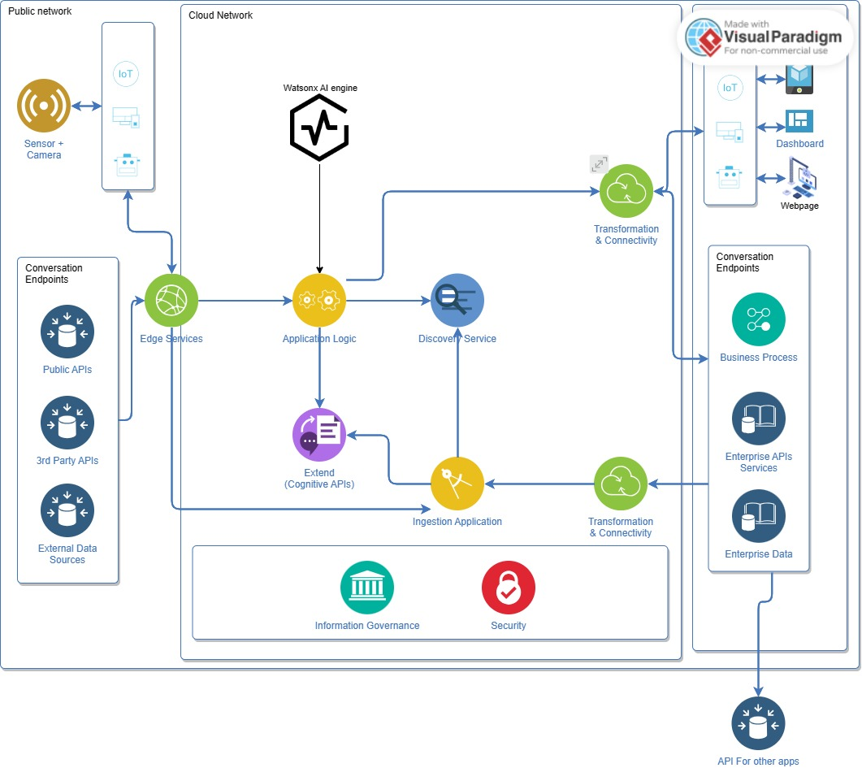

The solution diagram represents how the architecture of the AI model would function, starting from the user, who will access the model using a device, the message would then be carried forward using edge services which is connected to public APIs, 3rd party APIs and external data sources, these edge services would then take the message to the application logic in the cloud network and would be translated using IBM Watson technology, this data would then be transformed to the enterprise network and would then be processed using business processes, enterprise API services and enterprise data and the processed collection of data points would then be sent back to the user. The cloud network would also handle security and information governance.

**☐ Deliverable: Description of the issue you're hoping to solve**  
The world is facing increased flooding due to climate change-induced erratic weather patterns and rising sea levels. Outdated drainage systems worsen the problem by struggling to manage heavier rainfall, posing challenges in protecting citizens and infrastructure. Efforts are needed to mitigate storm impacts and address drainage blockages effectively. We intend to solve the issue of blocked drains with affordable and efficient methods.

**☐ Deliverable: Description of how your solution can help solve the problem**

Affordable Continuous sensor monitoring + AI to facilitate predictive maintenance and timely debris clearance to reduce the risk of floods.

**☐ Deliverable: Long description of your idea**

The world has been facing the issue of climate change which is showing itself in different ways around the world. Flash floods are now a common thing in most cities in the world with the most recent one happening in Dubai not so long ago. It disrupts life, causes damage to public and private property and could also cause a loss of life. The drainage systems in most of the old cities were built at a time when the population was not as much as it is today. Hence, these systems are not capable of handling the waste of today’s population and fail during natural calamities such as storms. In addition, today we have plastics, e-waste, and other biowaste that goes into these drains and often causes blockages inside them. Hence, our drains overflow and the system that was built to tackle the issue of handling water during storms now fails.

We are proposing a solution where we first monitor the blockages in the drains using a combination of sensors and cameras. They will be connected to gateways located in the drains and relay this data through public networks to a central database. The gateways will have some level of intelligence and filter the data before sending it to the servers to reduce load and make the solution cost effective. The data that is sent to the servers will be used to train a model which uses this data along with the data from external databases such as:

1. [New York City Stormwater Flood Maps](https://experience.arcgis.com/experience/6f4cc60710dc433585790cd2b4b5dd0e)
2. [NYC Stormwater Flood Map - Moderate Flood with 2050 Sea Level Rise](https://data.cityofnewyork.us/City-Government/NYC-Stormwater-Flood-Map-Moderate-Flood-with-2050-/5rzh-cyqd/about_data)
3. [Topography Data (DEM): High-resolution Digital Elevation Models (DEM)](https://data.cityofnewyork.us/City-Government/1-foot-Digital-Elevation-Model-DEM-/dpc8-z3jc/about_data)
4. [Street flooding in NYC dataset](https://data.cityofnewyork.us/Social-Services/Street-flooding-map/euy6-dafe)
5. [New York City Climate Projections: Temperature and Precipitation](https://data.cityofnewyork.us/Environment/New-York-City-Climate-Projections-Temperature-and-/hmdk-eidg/about_data)
6. [Population Density Analysis](https://data.cityofnewyork.us/City-Government/New-York-City-Population-By-Neighborhood-Tabulatio/swpk-hqdp/about_data)

Using these datasets, we intend to notify the authorities on potential areas of flooding, areas which are on the red line and need immediate cleaning using a dashboard. This will largely help the authorities with resource management as they will have accurate stats as to which drains need cleaning for a particular given time and only the necessary resources could be sent there. In addition, the necessary equipment and manpower needed for that task can be provided as well. Using the historic data, we will accurately predict when each zone needs cleaning in the future and can plan the necessary activities in a better way.

In addition, we also intend to use this data to integrate with home renting and buying apps to alert citizens to the potential issues they could face in the future in that particular area. Along with that, we also could use this data to affect insurance pricing in potential flooding areas. By doing this, we ensure that the community is well informed and protected in a better way while also sustaining the project by raising revenue for it. The user dashboard will be inspired from the SIMs city game, and we will alert the officials about a particular zone that needs attention along with showing the citizens the data in an easy-to-understand manner .