Shiffman Calendar User Guide

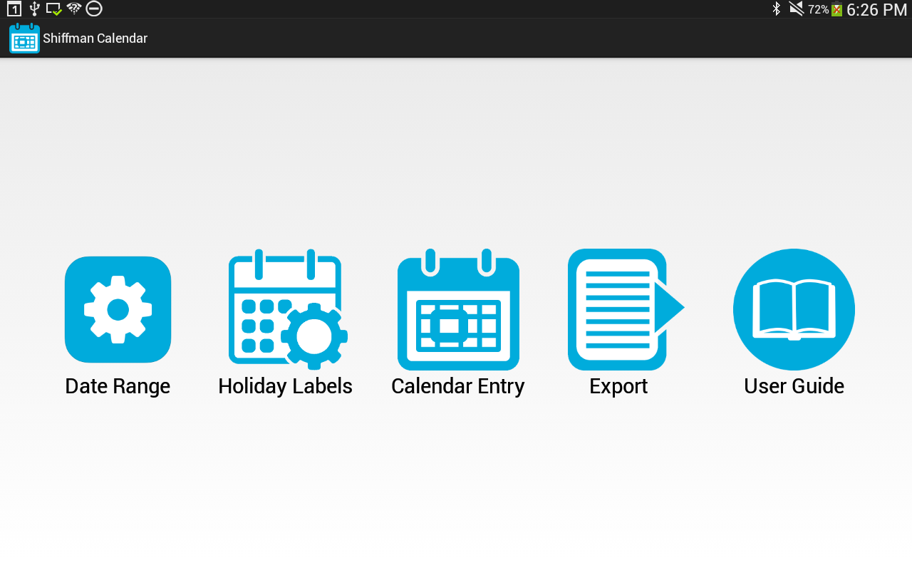

Table of Contents

Launching the application 3

Device Configuration 3

Configuration Guide 5

Date Range Configuration 5

Holiday Configuration 6

Calendar Data Collection User Guide 10

Enter Data 10

Review Data 13

Exporting Data Guide 17

# Launching the application

To launch the application, open the application menu by clicking the ***Apps*** icon near the bottom of the screen. Click on the ***Shiffman Calendar*** icon in the application menu. This should be located on the second page of icons. See Figure 1.

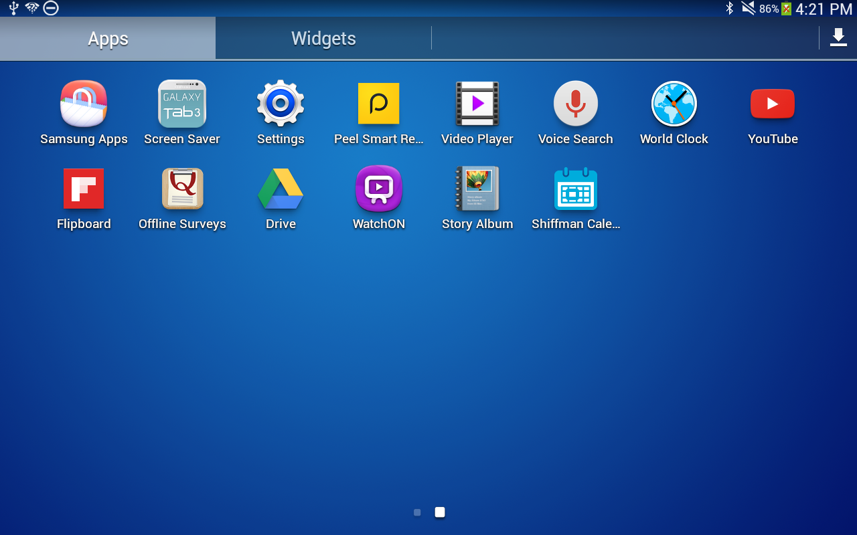

Figure Shiffman Calendar is the blue calendar icon in the bottom right corner.

## Device Configuration

1. The first time the application is run after installation, a dialog will pop up asking you to enter a unique device identifier. This identifier is used in the file names of all files exported by the application so files can easily be traced back to the devices that generated them. See Figure 2.

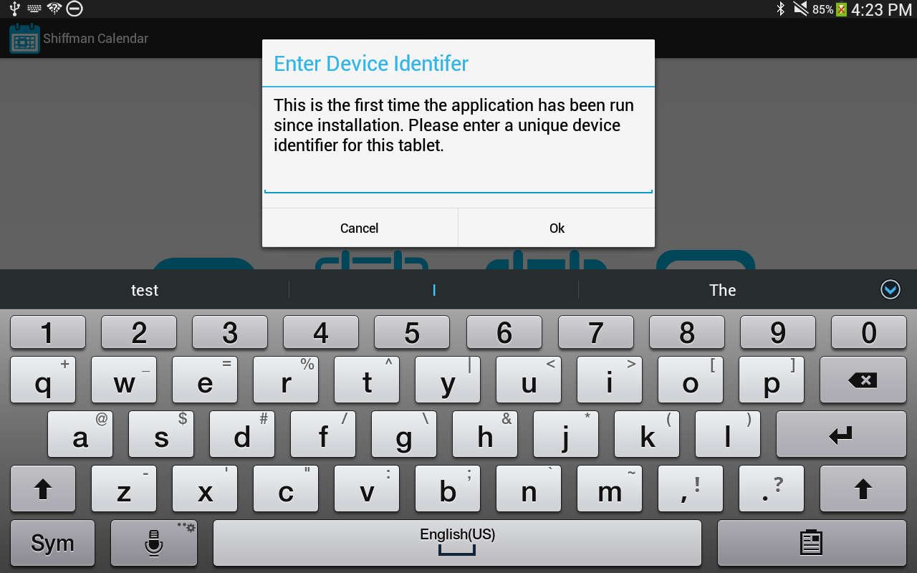

Figure 2 Enter device identifier on first launch.

1. The next time you run the application, you will not be asked to do this step.

# Configuration Guide

There are three types of configuration for a participant. First is device configuration. This is only done the first time the application is run after installation. Second is the participant configuration that must be run for each participant before they can enter data. Third is the holiday configuration that only needs to be done as the data entry range changes.

## Date Range Configuration

1. Launch the participant configuration by clicking the ***Date Range*** icon



Figure Main launcher view.

1. Select the study phase and select the start and end dates for the data entry range. See Figure 4.

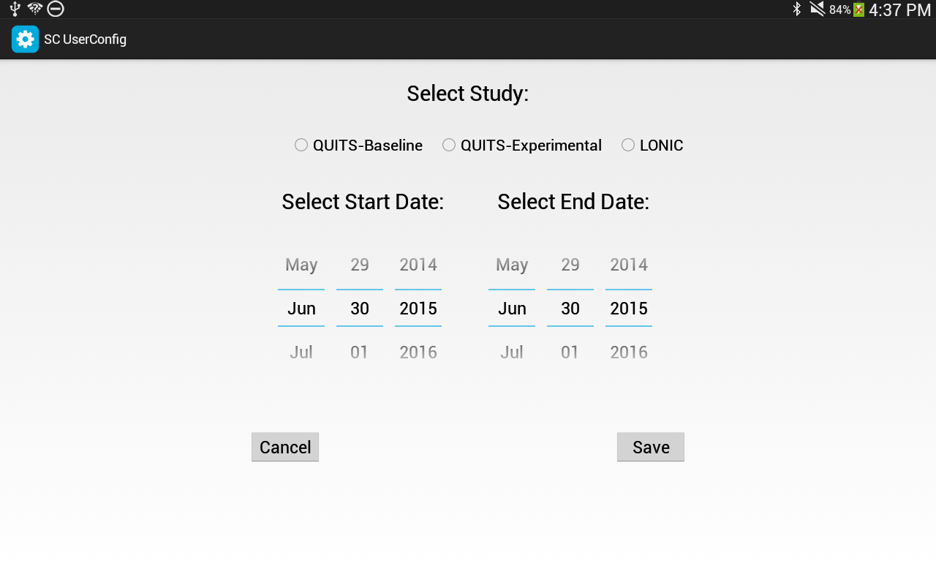

Figure Select the study version and the date range in the configuration form.

1. Click the save button. You must enter all the configuration data for the save to succeed. The start date must be equal to or before the end date.
2. You will see a confirmation dialog that you must affirmatively reply to in order to save.

## Holiday Configuration

1. Launch the holiday configuration by clicking the ***Holiday Labels*** icon



1. This must be done after a participant configuration has been entered since it relies on the date range entered to decide which month(s) to display.
2. The “Clear All” button on the top left will erase all previously entered holiday labels.
3. To enter a new label: 1) type the holiday name in the text field above the calendar, 2) select the date on the calendar to apply the label to, and 3) click the “Save” button in the top right. The label will be applied to the date as blue text. See Figure 5, Figure 6, and Figure 7.

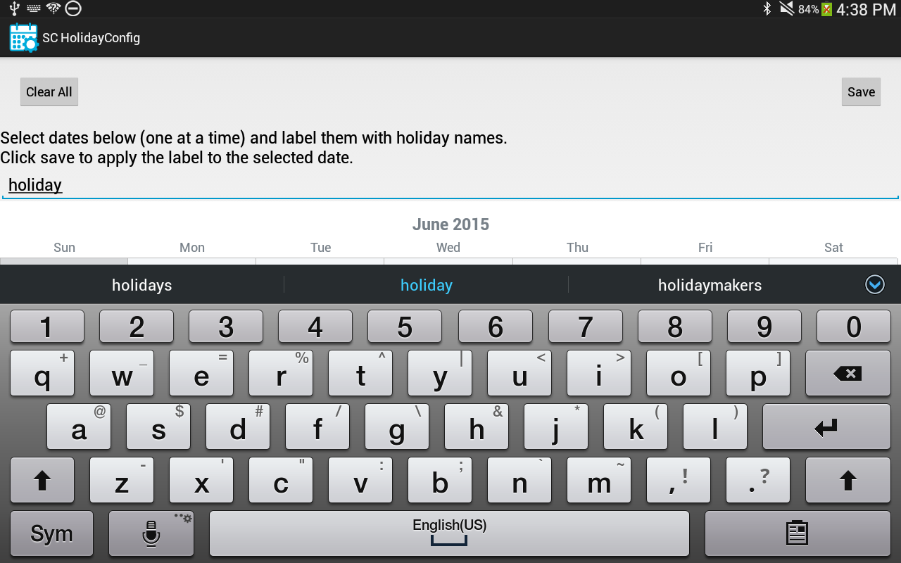

Figure Enter holiday label text.

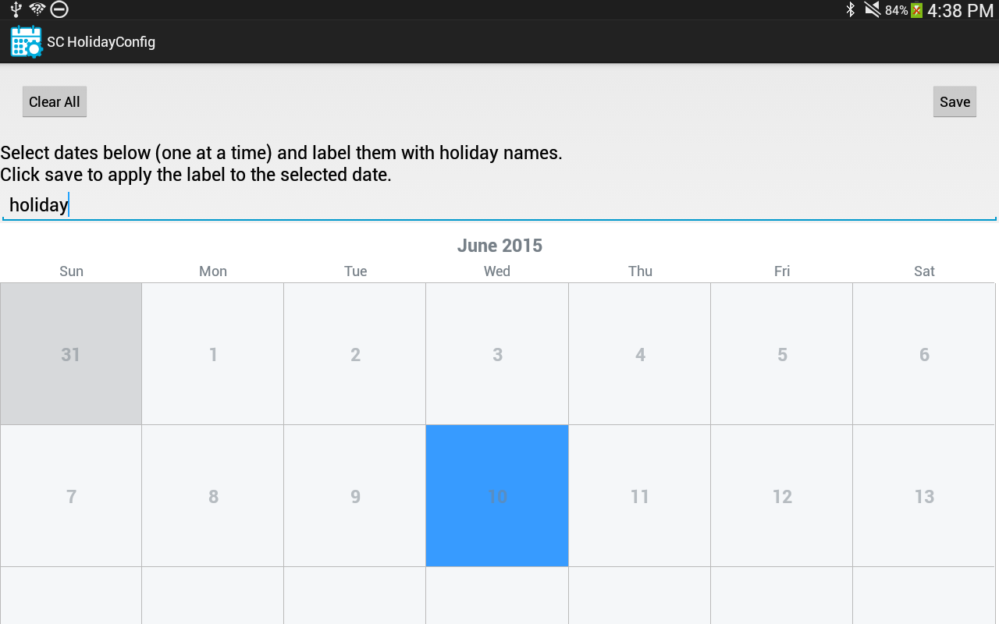

Figure Select a date on the calendar.

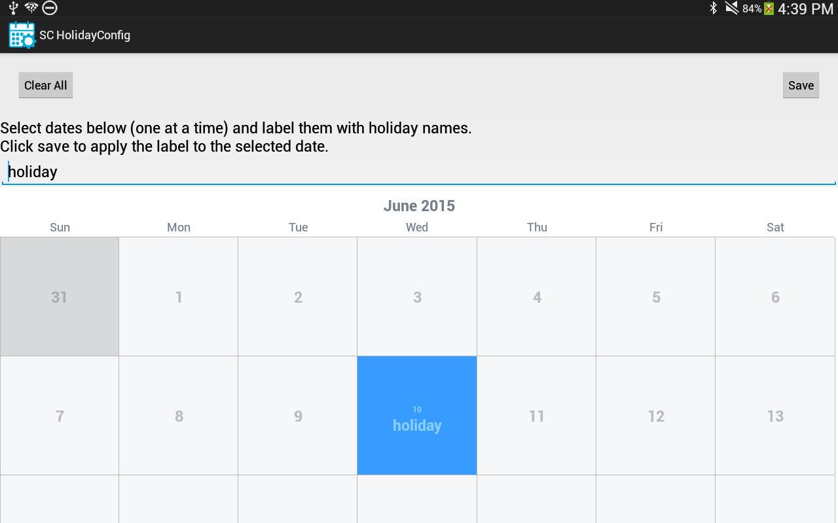

Figure Click the Save button to apply the label to the date.

1. To edit an existing label: 1) Leave the text field blank, 2) select the date with a label, 3) the existing label will be entered automatically in the text field where you can edit or delete it, 4) Click save.

# Calendar Data Collection User Guide

1. Launch the data entry application by clicking the ***Calendar Entry*** icon.



## Enter Data

1. The calendar displayed shows one or two calendar pages. You may have to scroll up and down to see the entire display. See Figure 8.

**NOTE: Before giving the device to a participant, click on the View Data Summary button to make sure there is no data that has not had a participant ID applied to.**

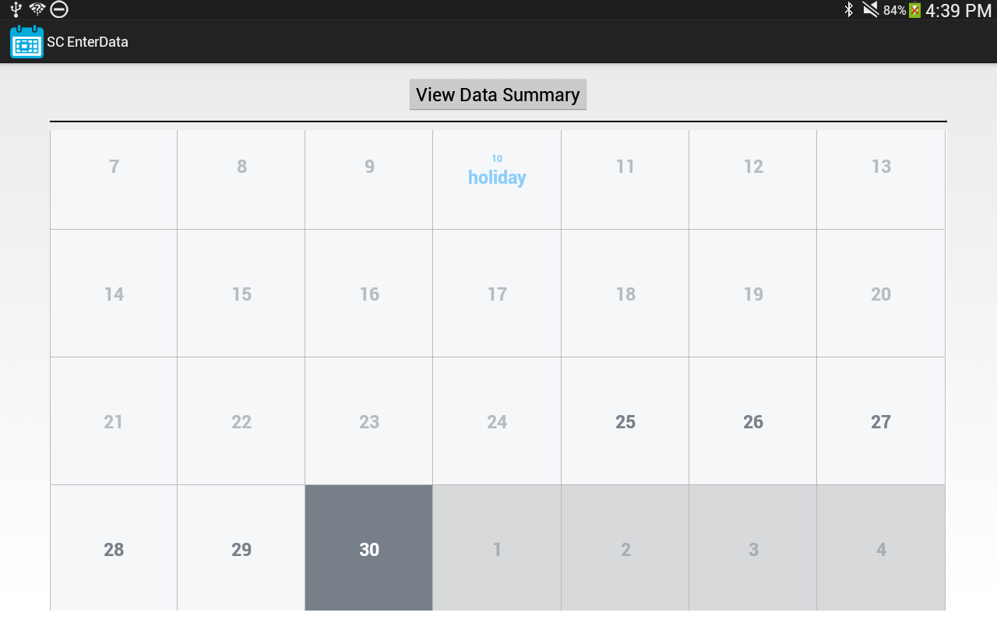

Figure Calendar Entry view before any data has been entered.

1. The days that have been configured for data entry are all numbered with dark gray numbers. All days outside of the configured data entry range are numbered with light gray numbers. The current date has a dark gray background. Clicking on a light grayed calendar date will pop up a message telling you that you it is not a valid date. Holiday prompts may be added to the calendar to prime participants. These will show up as light blue text in the date cell.
2. Click on a dark gray numbered date to launch the data entry form for that date.
3. Enter data for all the fields in the entry form and click save to close. See Figure 9.

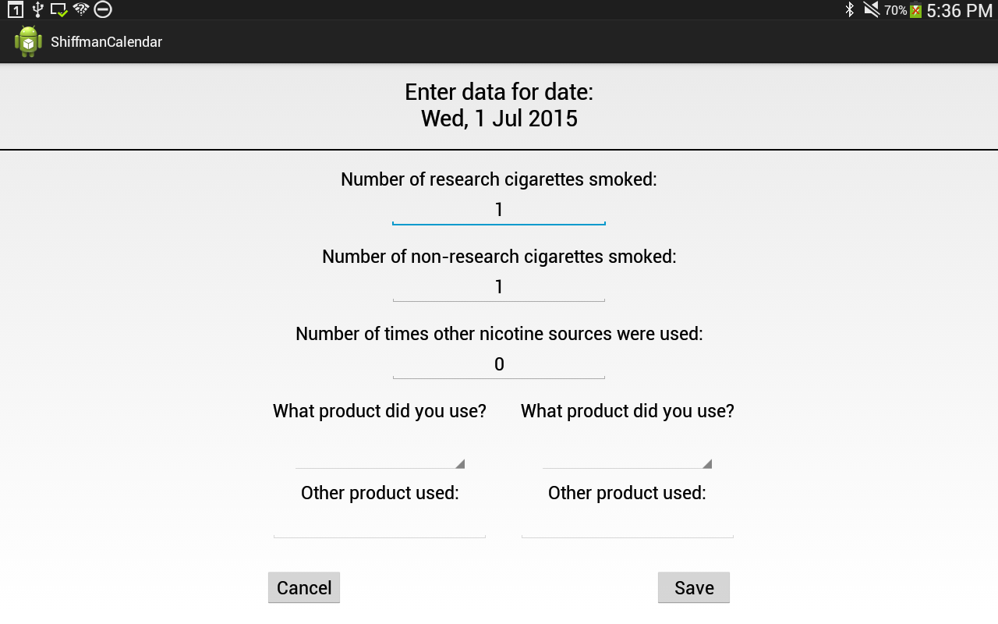

Figure Enter data for a selected date. In this case, data is being entered for the LONIC study.

1. All calendar dates that have had data entered for them will be colored green (except the last selected date which is always blue). See Figure 10.

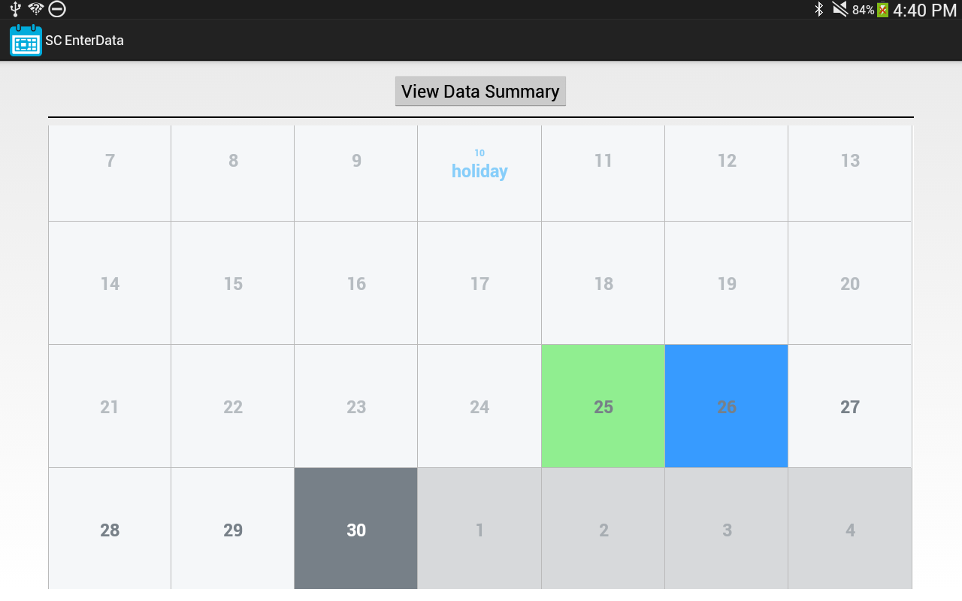

Figure Dates for which data has already been entered have a green background.

1. Clicking on a date, which is already green, will bring up the data entry form with the fields pre-populated with the data already entered. If you edit any of the data, click the “Save” button to overwrite it. Otherwise click cancel to exit without modifying anything.

## Review Data

1. After all of the data has been entered, you can click the “View Data Summary” button to bring up a list of the data entered for validation purposes. See Figure 11.

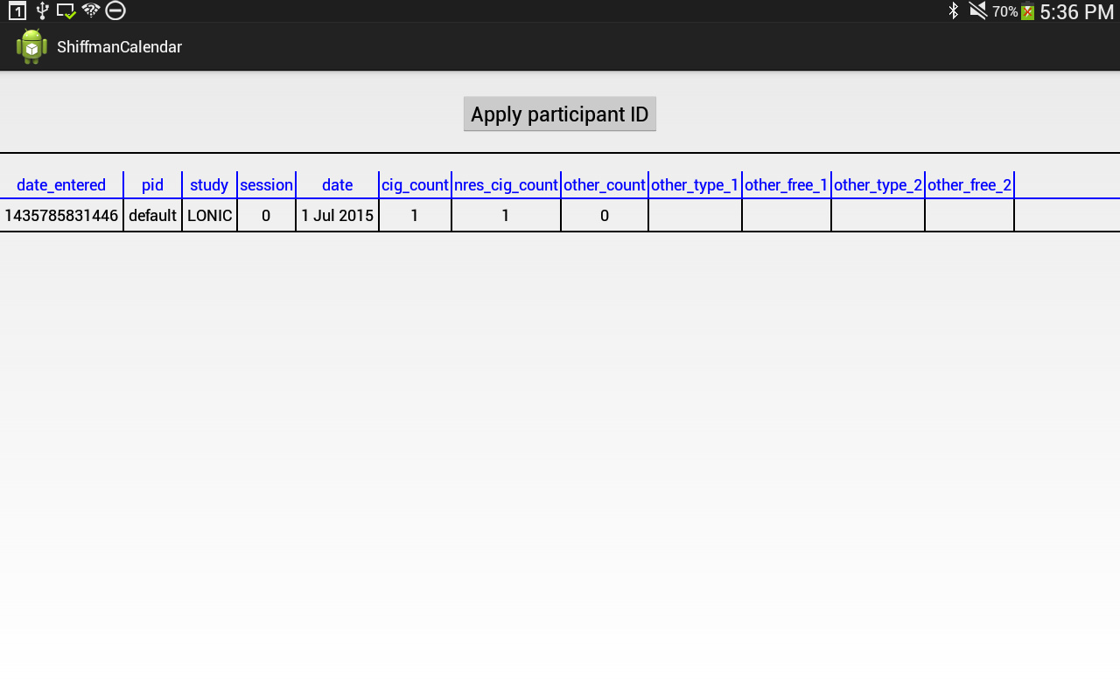

Figure The table summarizes the data that has been entered, sorted by the "date" field. This example shows one entered row of data for the LONIC study.

1. If the data disqualifies the person from participating in the study, you should click the ***Apply participant ID*** button and enter the participant ID **9999**. See steps 10 – 14 below for details on the applying a participant ID to data.
2. If the data looks good, you need to apply a participant ID and session number to the data entered. To do this click on the ***Apply participant ID*** button. This will launch a form to enter the ID and session number information.
3. Both participant ID and session number must be entered twice to reduce the chance of entry error. See Figure 12.

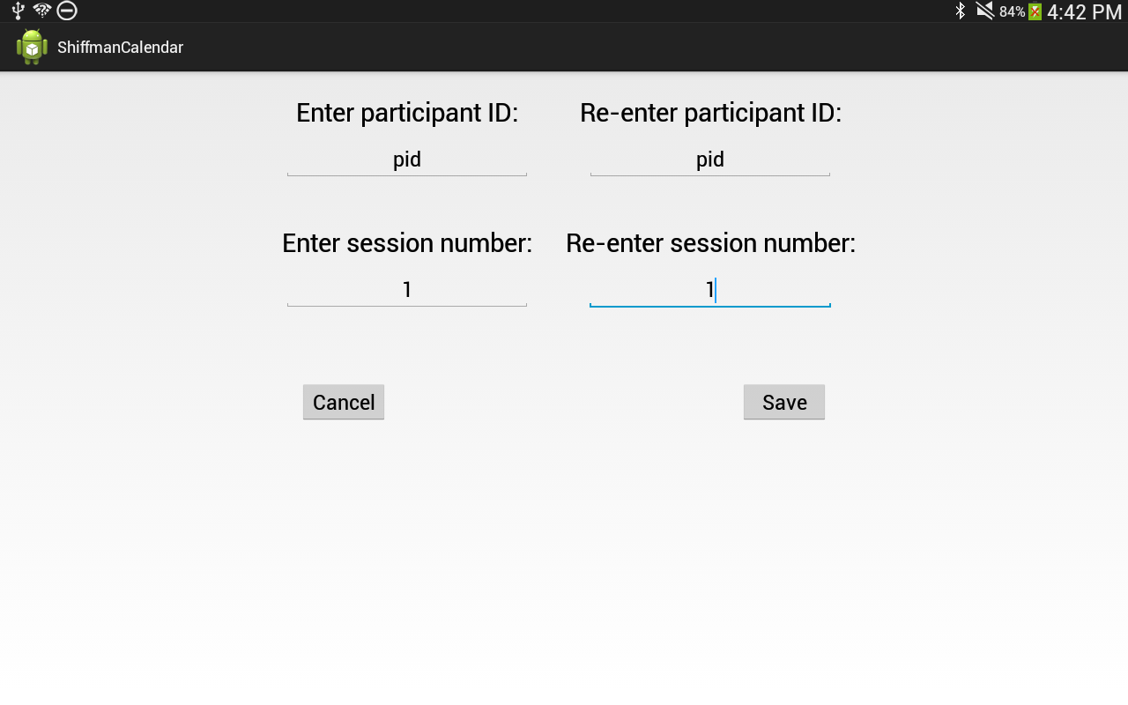

Figure Form for entering participant ID and session number. Both fields must be entered twice to prevent entry errors.

1. Clicking the save button will pop up a dialog asking for confirmation. If there is already data in the database matching the current set of participant ID, session number and study name you will get a message telling you this instead. You will not be allowed to use this set of values to save new data. See Figure 13.

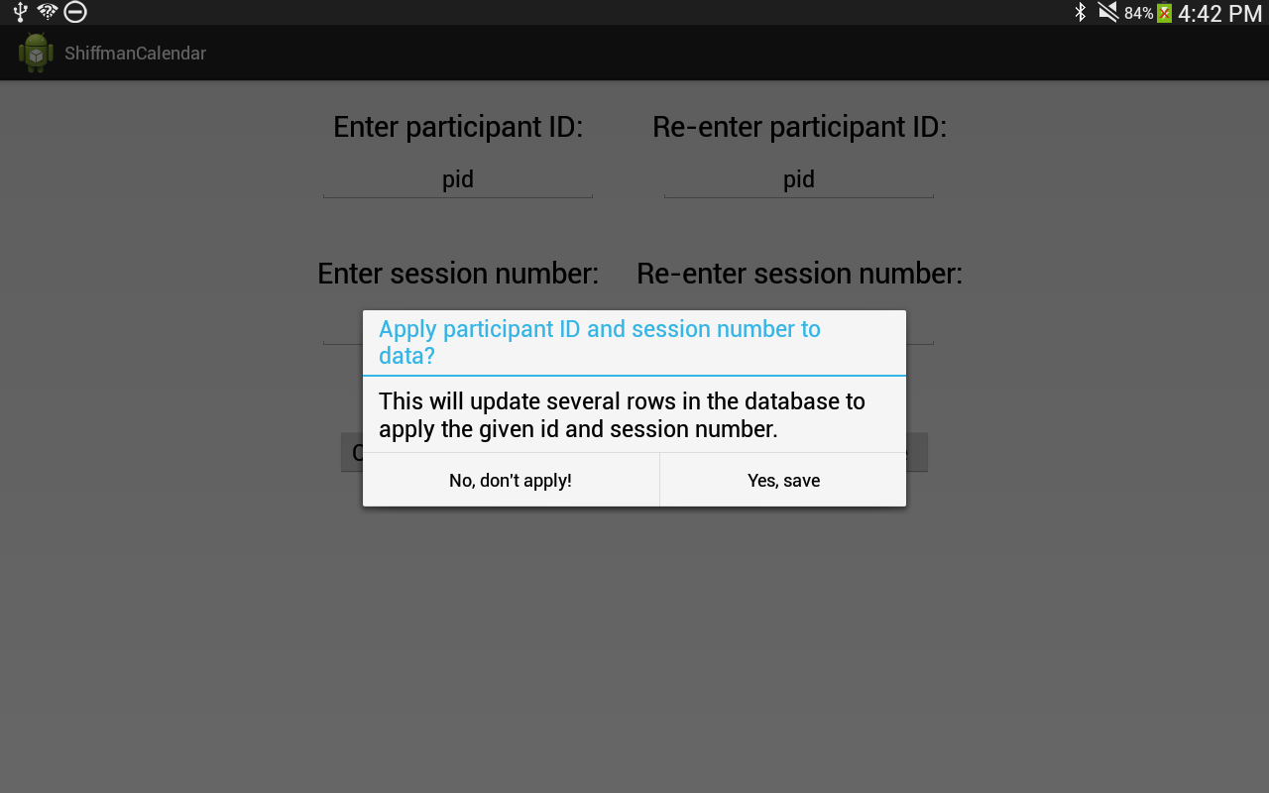

Figure Applying participant ID and session number confirmation dialog.

1. Confirming the save results in a pop up appearing telling you how many database entries were updated with the new participant ID and session number values. See Figure 14.

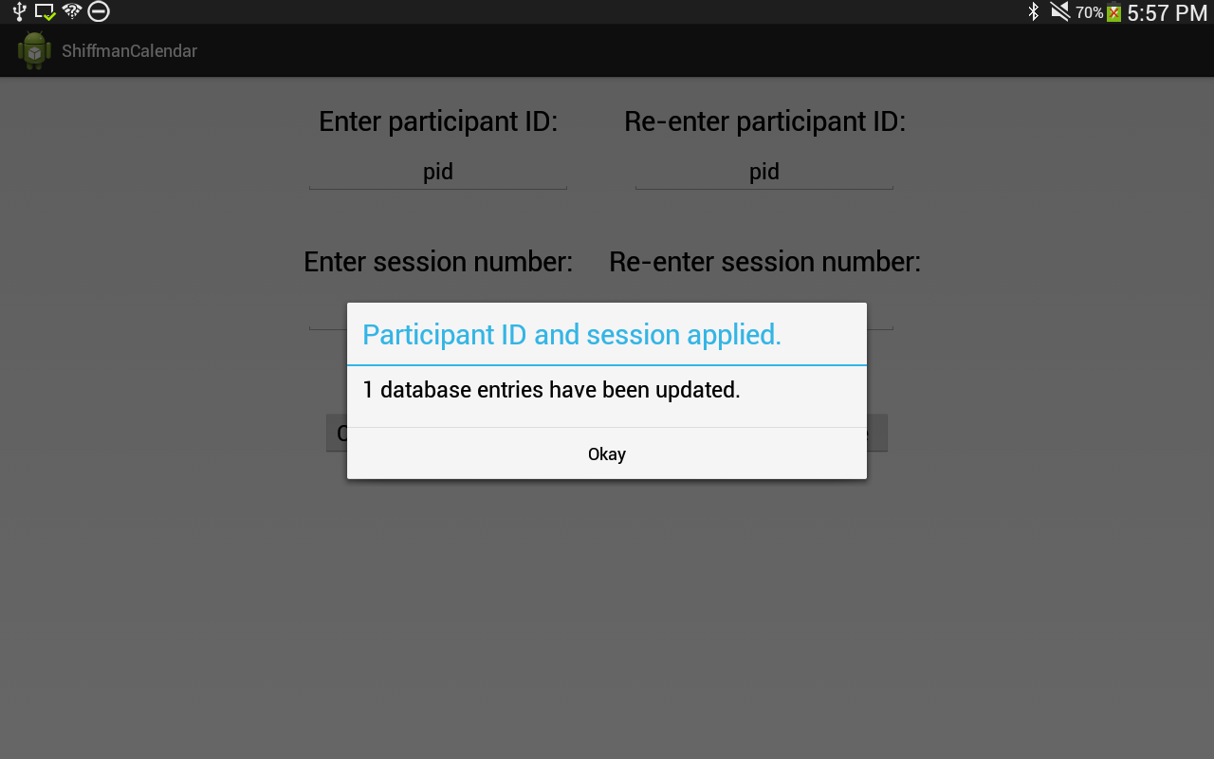

Figure Applying participant ID and session number feedback dialog.

1. After applying the participant ID and session number you will be returned to the data summary table. The data will be updated to reflect the new participant ID and session number entered. See Figure 15.

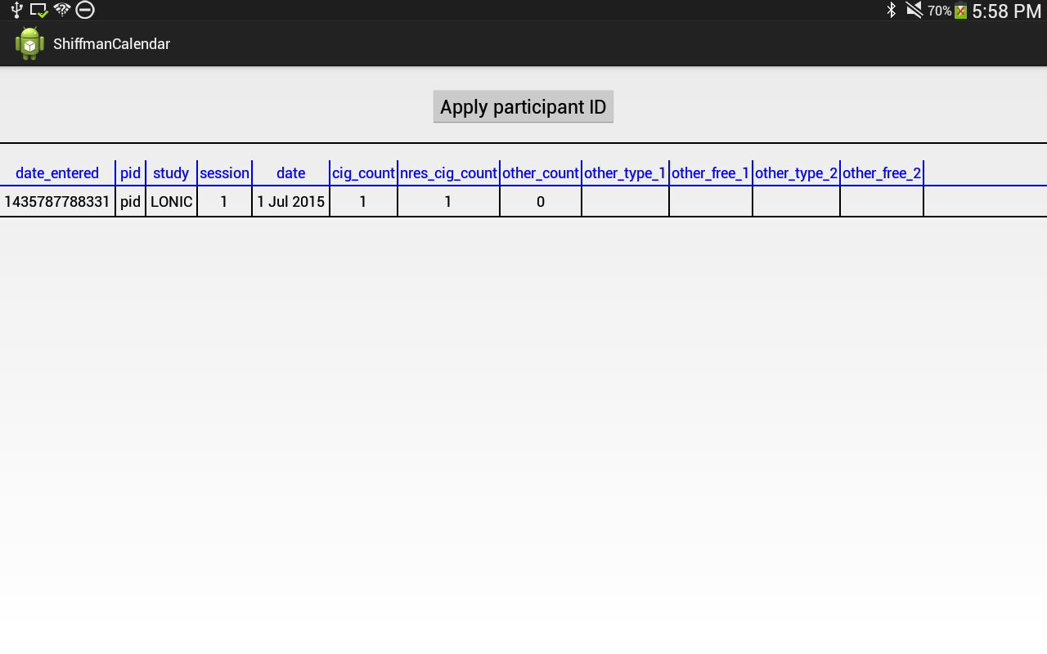

Figure The summarized data reflects the applied participant ID and session number.

# Exporting Data Guide

1. Launching the data export functionality by clicking on the ***Export*** icon.



Figure Export application.

1. Select a date from the dropdown box from which to start the export. All data that was entered on or later that date will be exported to a file. See Figure 17.

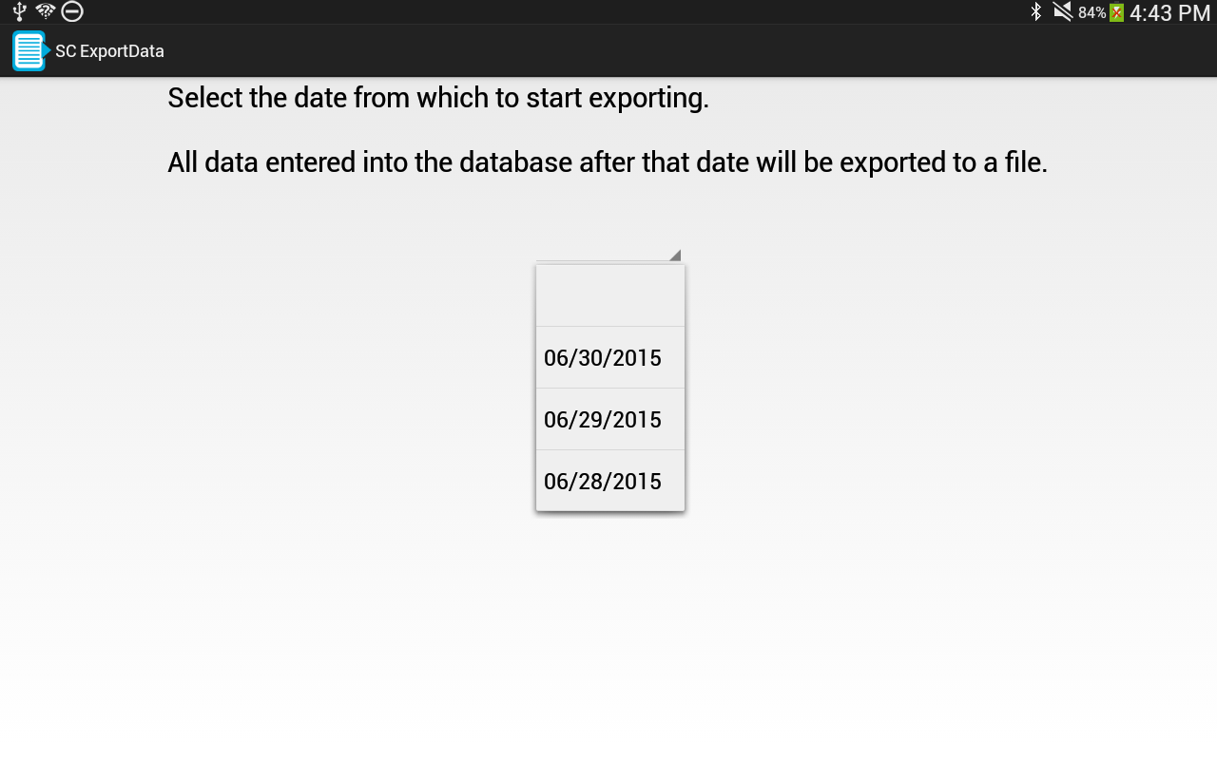

Figure Select a data entry date to begin exporting from. All dates listed in the dropdown are dates on which participants entered data into a calendar.

1. Click save to begin the export. A pop up a dialog box will appear. This should say the export was successful and tell you the location and name of the exported file. The name of the file is based on the device ID, the date range when the data was entered and the date and time that the export occurred. See Figure 18.

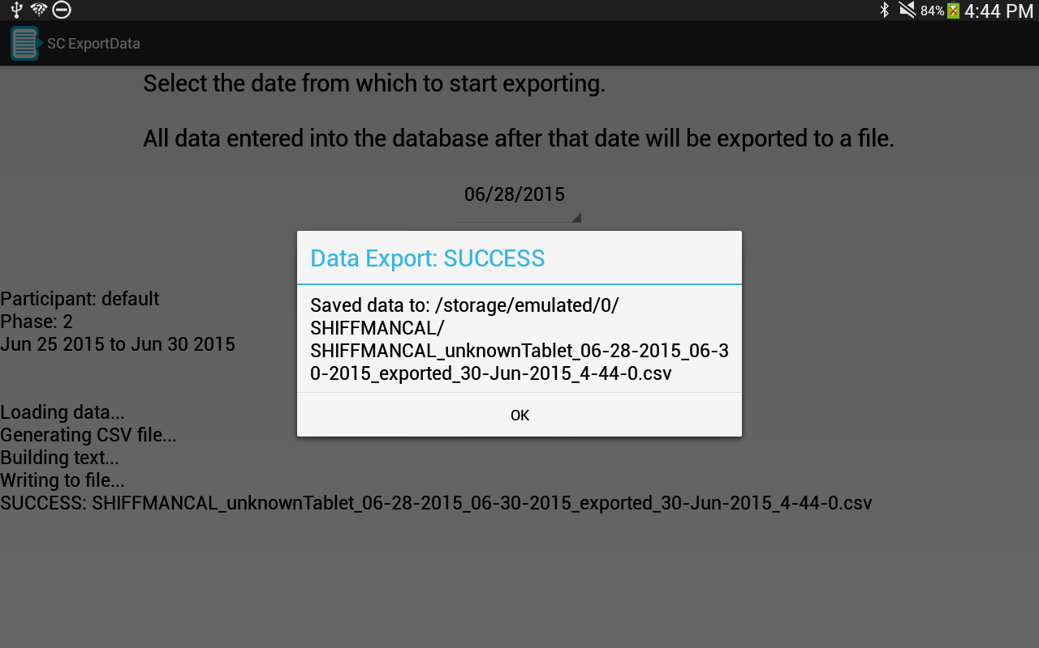

Figure Export success dialog.

1. It is possible for the export to fail and the dialog box may tell you this. The most likely cause of failure is if the tablet is plugged into a computer and its storage volume is mounted on the computer. If this is the case, unplug the tablet and try to export the file again.
2. Exporting multiple times will generate multiple identical files, differing only in the timestamp in the filename.