diSanOpps Tool
  - Note on framework and model

Introduction
An understanding of the costs and benefits involved in developing and maintaining a proper sanitation system is essential for creating awareness about the economic impact of sanitation and convincing authorities to invest in universal coverage. Various studies were conducted to estimate the costs and benefits of improved water and sanitation facilities at the global and country levels. However, there are no city-level studies that would help the policymakers and other stakeholders understand the benefits of diverting their investment into improving and expanding sanitation facilities.
The SanOpps Project focuses on tackling this by developing an innovative tool that will evaluate the costs and benefits that arise out of investing in sanitation projects in various parts of the world. SanOpps tool will be user-friendly and hosted in the form of a website or a mobile application that makes sanitation costs and return on investments clear and makes nuanced information easy to absorb through visualizations.

Objective
This tool aims to help investors at the city level understand the long-term economic and health benefits that arise from proper sanitation and encourage them to prioritize sanitation investments.

Framework
The user of the tool needs to enter basin information pertaining to the town. The model projects the population for the next 5 years based on the demographic data provided. The fifth year becomes the base year. By this, it is assumed that all the infrastructure will be deployed and the capital investment will be done. The model calculates the costs and benefits required for providing access to water, access to sanitation and cost of training and awareness raising for the projected population of base year. The life cycle cost analysis is done for 30 years from the base year.
The development of the model has four parts to it:
- Costs Calculation
- Benefits Calculation
- Life Cycle Costs Assessment
- Visualizations
This report will discuss the first three stages of the model development in detail.

Model
The cost and benefits were calculated in Microsoft Excel which would later be used for the development of the code and eventually a dashboard.

Costs calculation
- The cost parameters taken into consideration are broadly divided into:
  - Access to water
  - Access to toilet
  - Access to sewered sanitation
  - Access to non-sewered sanitation
  - Training and Campaigns
The process of cost calculation and the assumptions made for each parameter are discussed below.
- Access to water: The cost required to provide Functional Household Tap Connections (FHTC) to every household by the target year (2030) is calculated using user inputs for the current number of households with piped water supply. It is assumed that 100% of the projected households will have access to piped water, and the cost per FHTC is INR 5,000. Based on the current number of households with FHTC and the projected number of households, the model will compute the total required cost.
- Access to toilets: Under access to toilets, the focus is given to providing toilet facilities to slum and floating populations. The figure below illustrates the definition of various sanitation facilities.
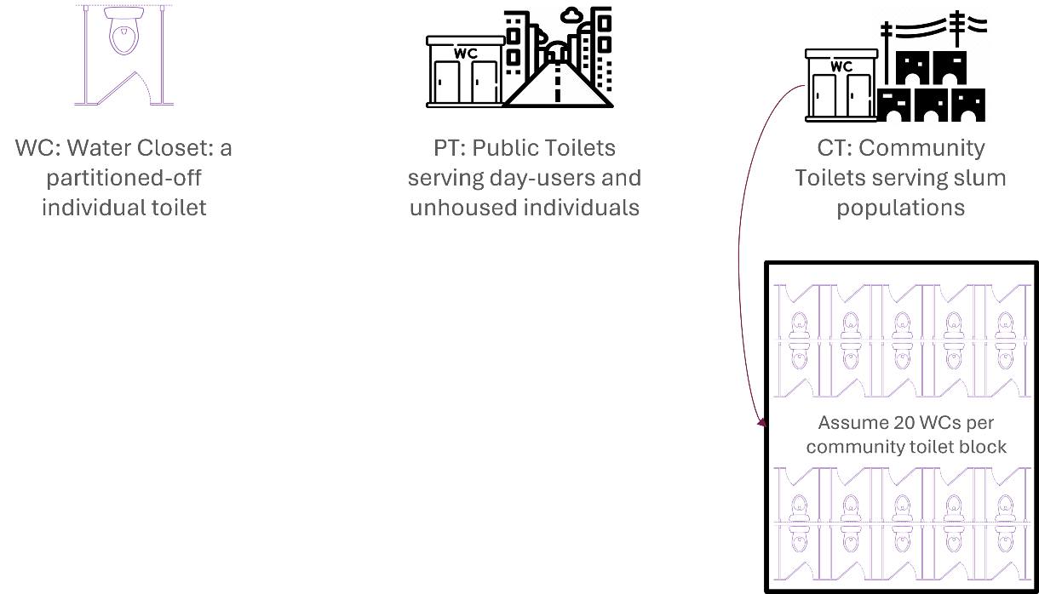
  - It is assumed that the slum population decrease by 10% in the target year due to the National Public Housing Schemes and Slum Rehabilitation Program and that the entire projected slum population relies on Community Toilets (CT). It is also assumed that the entire floating population relies on Public Toilets (PT). The required number of CT and PT are calculated based on the projected slum and floating population.
  - The number of people per Water Closet (WC) is set at 30, following the guidelines of Swachh Bharat Mission 2.0. Based on the available data on existing toilet blocks, we have assumed an average of 20 WCs per community toilet block. Using this assumption, the current number of WCs is calculated.
  - The required number of WCs is calculated based on the projected slum and floating population and the current number of WCs. The construction cost of a WC for CTs is assumed to be INR 98,000. Using this and the required number of WCs, the construction costs for CT are calculated.
  - It is assumed that the operational and maintenance (O&M) costs of CTs and PTs are recovered from the users. O&M cost is usually taken care of because PTs have the pay per use model in India. For other countries, a percentage factor of capex (1-2%) can be applied.
- Access to sewered sanitation: It is assumed that the percentage of the population connected to the sewer network remains unchanged between the current year and the target year. Using the existing length of the sewer line in the city and the population connected to the sewer network, the sewer length per person is computed. This is then used to calculate the length of the sewer network for the projected population.
  - The cost of laying the sewer network is assumed to be INR 4,000,000 per kilometer. With this and the required length of the sewer network for the projected population, the capital cost for the sewer network is computed. The operational and maintenance cost is assumed to be INR 9 per kilometer per year which is multiplied by the projected sewer length to obtain the total O&M costs.
  - Cost of sewage treatment is calculated based on the water consumption per capita per day and the capacity of the existing sewage treatment plants (STPs). It is assumed that 80% of the water consumed per person is equivalent to the amount of sewage generated per person. Using this and the projected population, the total amount of sewage generated and the gap in the treatment capacity is calculated. The cost for the treatment is assumed to be INR 30,000,000 per MLD (Million liters per day). The annual maintenance cost of STP per MLD of wastewater is assumed to be INR 800,000.
- Access to non-sewered sanitation: It is assumed that households not connected to a sewer network will use septic tanks. Based on this, and the projected population change, we calculate the projected number of households needing Fecal Sludge and Septage Management (FSSM). Septic tanks are expected to be desludged every 10 years, with 3 kilolitres (KL) of septage emptied per household.
  - Using the total number of households and the desludging frequency, we estimate how many households with septic tanks will need desludging in any given year. Assuming 300 working days in a year and 3 KL of septage emptied per household, the amount of septage to be emptied and treated per day is calculated. The daily amount of septage that needs to be emptied and treated is calculated.
  - Following this, to calculate the costs of treatment, the user will be asked if there are co-treatment facilities at the existing STPs. If the answer is YES, the cost of co-treatment will be calculated in the existing or proposed STPs. If the answer is NO, the cost of treatment at a fecal sludge treatment plant (FSTP) will be computed.
  - The cost of co-treatment is assumed to be 100,000 INR per KL. Using the amount of septage to be treated per day and the cost of co-treatment, the total cost of treatment per day is calculated.
  - In case there are no co-treatment facilities and the city is not planning to have one, the cost of FSTP will be calculated. Here, the user has to provide if there are any existing FSTPs. If yes, based on the existing capacity of the FSTPs, the gap in the treatment capacity and the cost of treating the same will be calculated.
  - If the answer is no, the cost of treatment of the entire septage will be calculated. The septage treatment cost in the FSTPs is assumed to be 350,000 INR per KL. Using this the cost of treatment of the total septage is calculated. The annual O&M costs are assumed to be 50,000 INR per KLD.
- Training and Campaigns: The annual cost of capacity building per person is assumed to be INR 10,000. The total number of workers in the ULB for the capacity-building programs is assumed to be 0.1% of the total population per year. The cost for the same is calculated by the model. Meanwhile, the annual cost of the public awareness campaign is assumed to be INR 25 per person and is calculated for the entire projected population of the city.

Benefits calculation
- The benefit parameters taken into consideration are broadly classified into
  - Healthcare costs
  - Productive time lost (time off work/ time to access water and sanitation)
  - Revenue generated
  - Value of life
The process of benefit calculation and the assumptions made for each parameter are discussed below.
- Healthcare benefits: This includes savings in medical treatment costs and savings in hospital commute costs.
  - Savings in medical treatment costs are calculated based on the number of disease incidences due to diarrhea and other water-borne diseases and the unit cost of treatment. The unit cost for treatment is assumed to be INR 3000. Based on this, the model will calculate the cost savings when the disease incidences are averted. The benefit in savings in treatment cost per person will be calculated using the total projected population.
  - It is assumed that all the incidences are considered as outpatients and that it requires one visit per case. Based on the literature, the cost for the commute per visit is assumed to be INR 50. The model will compute the total cost savings in hospital commute costs and the cost savings per person using the number of incidences which will be equal to the number of visits.
- Productive time lost: This includes productive time lost due to diseases and lack of access to water and sanitation
  - Based on the literature, it is assumed that the days off work per diarrheal incidence is five days. Data on the percentage of the population in working age is collected and used as the percentage of the working population. Using GDP per capita as the proxy for the income, the hourly monetary income is calculated (8 work hours per day, 40 work hours per week, and 52 work weeks per year).
  - The value of productive time lost for the working age group is assumed to be 30% (WHO/HSE/WSH/12.01) of the hourly monetary income. Using this the opportunity cost of time for working age is calculated. The opportunity cost of time and the number of days off of work are used to calculate the productive time losses from diseases. The same is calculated for the projected population.
  - For the non-working age group, the same calculation is done assuming the productive time lost to be 15% of the hourly monetary income (WHO/HSE/WSH/12.01).
  - The time savings from having access to tap water and access to toilets is calculated. For time saved from traveling to collect water, it is assumed that a household spends one hour a day collecting water from outside sources and the hourly monetary income is assumed to be lost due to this. Using the GDP per capita as the proxy for monetary income and the number of households not having FHTC, the economic benefit of water collection time saved is computed by the model.
  - The time savings from providing access to toilets for slum and floating populations is estimated at 0.5 hours per day, with 30% of the hourly income assumed to be lost due to the lack of access. Using GDP per capita as a proxy for income, the economic loss is then calculated.
- Revenue generated: This includes revenue generated from the reuse of treated wastewater and an increase in tourism due to improved sanitation.
  - In the case of the reuse of treated wastewater, it is assumed that 20% of the wastewater generated is reused, based on government policy in India, which mandates utilizing at least 20% of treated wastewater for reuse. It is also assumed that the price of treated wastewater is 15 INR/KL or m³. The price of treated wastewater for non-potable uses in India ranges from 12-19 INR per INR was taken as an average value. Based on this, the annual benefit arising out of reusing treated wastewater is calculated.
  - The price of treated wastewater varies based on its quality. For high-quality treated wastewater, the cost typically ranges from 25 to 30 INR per KL. Additional treatment costs should be considered for this. However, as we are assuming we are reusing the water for non-potable purposes, additional treatment are not necessary.
  - It is well known that improved sanitation practices bring in more tourists. Literature shows the loss in GDP ranges from 5-15% due to poor sanitation in various countries, for example 6% GDP loss in India in 2006. We have assumed 10% could be the increase with reference to these articles, but this value could be adjusted with further expert review or new literature sources. In 2023, tourism contributed to 9.1% of India’s GDP. Using this, the per capita GDP contribution is calculated which is then used to calculate the increase in GDP per capita.
- Value of life: The value of life is calculated using the human capital approach. We are assuming the number of years lost for the working and non-working age groups as 19 years and 22 years respectively based on the literature. Using this and the GDP per capita as the proxy for the income lost, the economic value of lives lost is computed by the model.

Life cycle cost assessment
Sanitation infrastructure, including sewer networks and sewage treatment plants, typically has a lifespan of 30 to 40 years. To fully understand the total investment, operational, and maintenance costs over this period, a Life Cycle Cost Assessment (LCCA) is performed. In our case, we assume that the infrastructure will last for 30 years from the base year. Below are the key components of the cost and benefit analysis:

Cost components
- Capital Expenditure (CapEx): This includes the one-time costs associated with planning, supervision, hardware, and construction. For this analysis, it is assumed that all capital expenditures are incurred by the base year.
- Operational & maintenance Expenditure (OpEx): These are recurring costs required for the regular operation of the infrastructure, including labor, energy, chemicals, and other ongoing expenses. It is assumed that operational costs will be recovered from users through tariffs or service charges.

Benefit components
- The benefits are expected to begin from the base year and are calculated on an annual basis.

Final assumptions
- An inflation rate of 4% and a discount rate of 6% are assumed for this analysis. Costs and benefits are projected annually, and the Benefit-Cost Ratio (BCR) is calculated for every decade.
- To account for the time value of money, the compounded costs and benefits are discounted to their Net Present Value (NPV) using the 6% discount rate. This discounted NPV is then used to determine the final BCR.

Functional Household Tap Connection - A tap connection to a household for providing drinking water in adequate quantity of prescribed quality on a regular basis (Jal Jeevan Mission, India)
Community Toilet (CT) - Toilet facilities that are shared by a group of households within a community, especially in areas where individual household toilets are not feasible (Joint Monitoring Program)
Public Toilet (PT) - Public toilets are sanitation facilities that are open for public use and not limited to specific households or groups (Joint Monitoring Program)
Water Closet (WC) - Refers to a single toilet that is flushed with water and is usually connected to a sewer system or a septic tank.
​​https://documents1.worldbank.org/curated/en/820131468041640929/pdf/681590WSP0Box30UBLIC00WSP0esi0india.pdf https://www.unicef.org/india/media/1221/file/Potential-Impact-of-Sanitation.pdf https://papers.ssrn.com/sol3/papers.cfm?abstract_id=1149071

