1. Tuning “level”

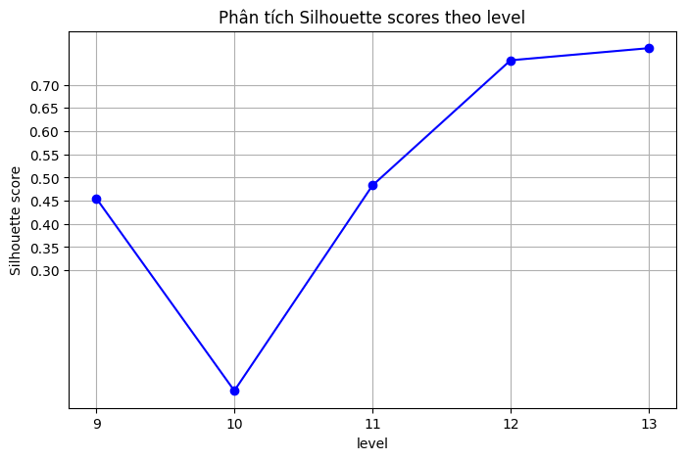

1. Tuning “amount_threshold”

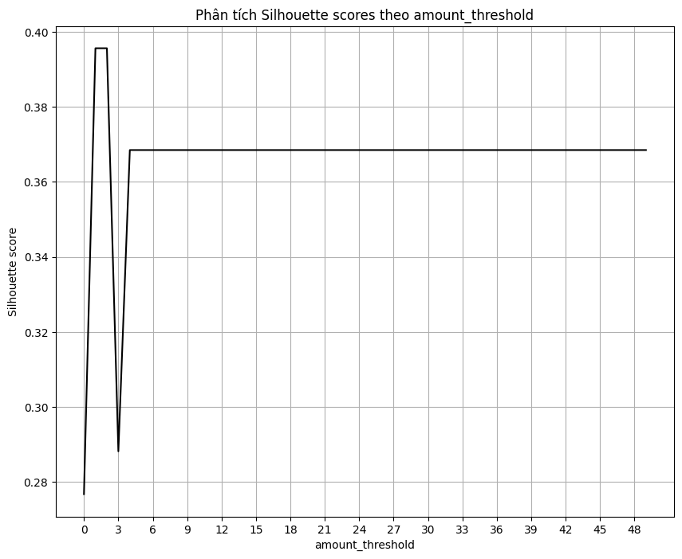

1. Tuning “density_threshold”

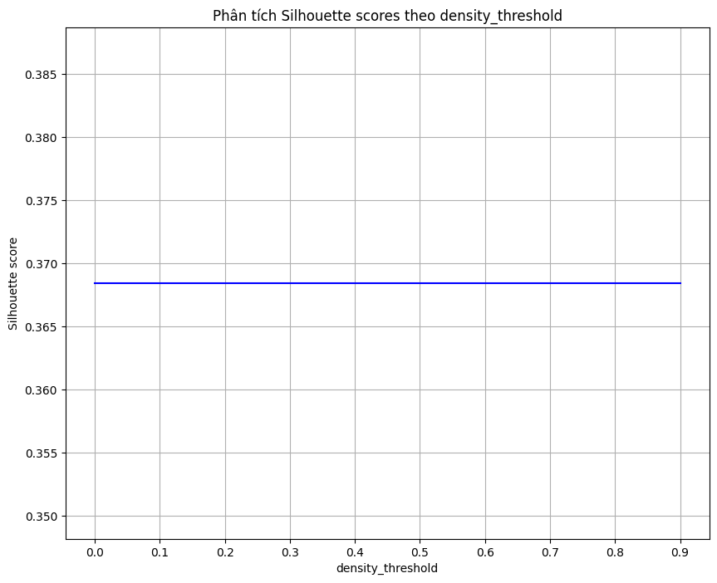

1. Chọn giá trị

default: level = 11

after tuning: level = 10, amount_threshold = 2

| levels | amount_threhold | Silouette_score |
| --- | --- | --- |
| 10 | default |  |
| 11 | default | 0.48289 |
| 10 | 31 | 0.05 |
| 11 | 31 | 0.1198 |
| 10 | 2 | 0.110 |
| 11 | 2 | 0.30866 |

10 - default:

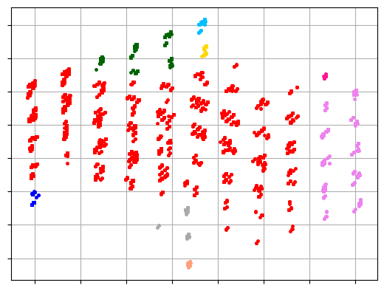

11 - default:

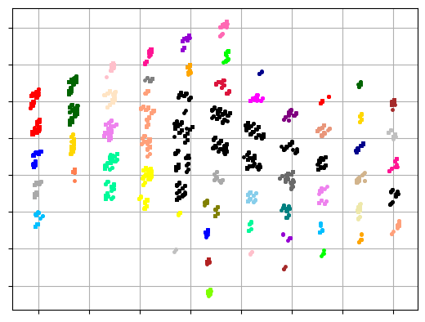

10 - 31:

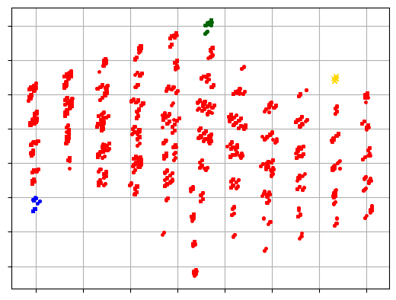

11 - 31:

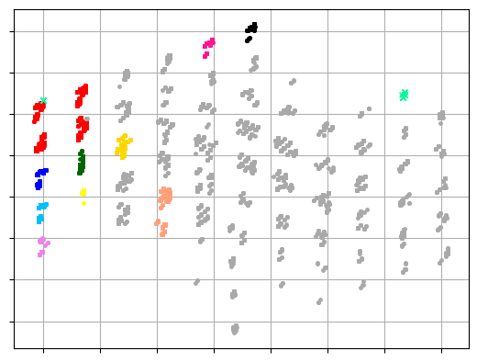

10 - 2:

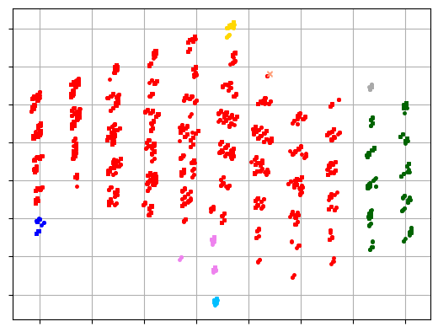

11 - 2:

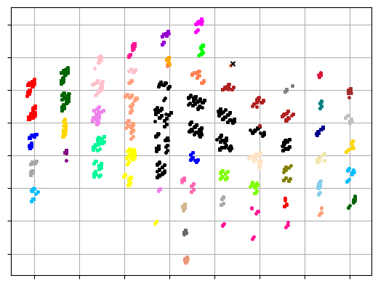

1. Time Measurement

