Assignment 1 — Mini Project
Console Record-Management Application
Course: MCA Semester I
Subject: Python Programming & Relational Database
Submitted by: [Your Name]
Roll No / PRN: [Your Roll Number]
GitHub Repository: [Your Repository URL]

1. Introduction
This report documents the design, implementation, and testing of a Console Record-Management Application developed in Python. The application is a menu-driven Student Record Management System that allows a user to add, view, search, update, and delete student records from the command line. The project was undertaken to consolidate and demonstrate practical understanding of core Python programming concepts covered in the course, including data types, control flow, functions, exception handling, and file input/output, combined into a single working system rather than practiced in isolation.

2. Objective
The objective of this mini project is to design and implement a fully functional, menu-driven console application in Python that:
- Manages a collection of records using appropriate data structures.
- Provides Create, Read, Update, and Delete (CRUD) operations through a text-based menu.
- Organises logic into reusable functions rather than a single monolithic script.
- Validates user input and handles runtime/file errors gracefully using exception handling.
- Persists data between program executions using file input/output.

3. Requirement Analysis
Based on the assignment brief, the application needed to satisfy the following functional requirements:
Requirement | Description
Menu-driven interface | Present the user with a numbered list of operations on every iteration.
Add record | Collect and validate details of a new record and store it.
View records | Display all currently stored records in a readable, tabular format.
Search record | Locate one or more records by ID or by name.
Update record | Modify one or more fields of an existing record, identified by ID.
Delete record | Remove a record identified by ID, after user confirmation.
Persistence | Store records in a file so that data survives program restarts.
Error handling | Gracefully handle invalid input, missing files, and unexpected errors.

4. System Design

4.1 Data Model
Each student record is represented as a Python dictionary with the following fields:
Field | Type | Description
id | int | Unique identifier, generated automatically as (max existing ID + 1).
name | str | Full name of the student.
age | int | Age of the student (validated to be between 1 and 120).
course | str | Programme/course the student is enrolled in.
email | str | Contact email, validated against a regular expression.
phone | str | Contact phone number, validated to be 7-15 digits.

All records are held in memory as a Python list of dictionaries during execution, and the entire list is serialised to / deserialised from a JSON file (data/records.json) using Python's built-in json module. JSON was chosen because it maps naturally onto Python's list/dictionary structures, is human-readable for debugging, and requires no external dependencies.

4.2 Application Architecture
The application follows a simple layered structure within a single module:
- File I/O layer: ensure_data_file_exists(), load_records(), save_records() — responsible for all disk access.
- Validation layer: get_non_empty_string(), get_valid_age(), get_valid_email(), get_valid_phone() — responsible for collecting and validating user input.
- Business logic / CRUD layer: add_record(), view_records(), search_record(), update_record(), delete_record(), find_record_by_id(), generate_new_id().
- Presentation / control layer: display_menu() and main() — responsible for the menu loop and dispatching user choices to the correct function.
This separation keeps each function focused on a single responsibility, makes the code easier to test and extend (e.g. swapping JSON storage for a relational database later), and satisfies the requirement to implement the application using functions rather than one large block of code.

4.3 Menu Flow
On startup, the application ensures the data directory/file exist and loads any previously saved records into memory. It then enters an infinite loop that displays the main menu, reads the user's choice, and dispatches to the corresponding function. The loop continues until the user selects option 6 (Exit), at which point the program terminates gracefully. Every menu iteration is wrapped in exception handling so that an unexpected error in any one operation does not crash the whole application.
1. Add Record
2. View All Records
3. Search Record
4. Update Record
5. Delete Record
6. Exit

5. Implementation Details

5.1 Data Types and Variables
The application uses Python's built-in data types purposefully: int for IDs and age, str for names/course/email/phone, list for the in-memory record collection, and dict for each individual record. This mirrors how a relational table row (dict) within a table (list) would be represented before being persisted to storage.

5.2 Conditional Statements and Loops
Conditional statements (if / elif / else) are used throughout for menu dispatch and validation checks (e.g. verifying an age is within a realistic range, or that a search keyword matches a name). while loops are used to keep re-prompting the user until valid input is supplied, and to keep the main menu active until the user chooses to exit. for loops are used to iterate over the record list when searching, displaying, or generating a new unique ID.

5.3 Functions
All logic is decomposed into small, well-named functions, each documented with a docstring describing its purpose. This avoids code duplication (for example, table-formatting logic is written once and reused by both View and Search), and makes the program easier to read, test, and maintain.

5.4 Exception Handling
try / except blocks are used at every point where a runtime failure is possible:
- Converting text input to an integer (age, ID) — catches ValueError.
- Reading and writing the JSON data file — catches FileNotFoundError, json.JSONDecodeError, and OSError.
- The main menu loop itself is wrapped in a broad except Exception clause as a final safety net, ensuring the application never terminates with an unhandled traceback.
- A KeyboardInterrupt handler allows the user to exit cleanly with Ctrl+C.

5.5 File I/O
The json module is used to persist the record list to data/records.json. Records are saved immediately after every successful add, update, or delete operation, so that no data is lost even if the application is closed unexpectedly afterward. On startup, the file (and its containing folder) is created automatically if it does not already exist, and a corrupted or unreadable file is handled gracefully by falling back to an empty record set rather than crashing.

5.6 Input Validation Rules
Field | Validation Rule
Name / Course | Must not be empty (re-prompted until non-blank text is entered).
Age | Must be a whole number between 1 and 120.
Email | Must match the pattern name@domain.tld (checked with a regular expression).
Phone | Must contain only digits, between 7 and 15 characters long.

6. Source Code Overview
The complete, runnable source code is provided in record_manager.py in the accompanying GitHub repository. A representative excerpt of the menu-driven main loop is shown below; the full listing includes all CRUD and validation functions described in Section 5.
def main():
ensure_data_file_exists()
records = load_records()
while True:
display_menu()
try:
choice = input("Enter your choice (1-6): ").strip()
if choice == "1":
add_record(records)
elif choice == "2":
view_records(records)
elif choice == "3":
search_record(records)
elif choice == "4":
update_record(records)
elif choice == "5":
delete_record(records)
elif choice == "6":
print("Exiting application. Goodbye!")
break
else:
print("[INVALID CHOICE] Please enter a number between 1 and 6.")
except KeyboardInterrupt:
print("\n[INTERRUPTED] Program terminated by user.")
break
except Exception as e:
print(f"[UNEXPECTED ERROR] {e}")

7. Testing
The application was tested manually by running it end-to-end and exercising every menu option, including both valid and invalid inputs, to confirm correct behaviour and that no operation crashes the program.
Test Case | Input | Expected Result | Result
Add valid record | Name, age=21, course, valid email/phone | Record saved with new auto-generated ID | Pass
Add with invalid age | Age = 'abc' | Re-prompt until a valid whole number is entered | Pass
Add with invalid email | Email = 'not-an-email' | Re-prompt until a valid email format is entered | Pass
View records (empty) | No records exist | "No records found." message shown | Pass
Search by ID (found) | Existing ID | Matching record displayed | Pass
Search by ID (not found) | Non-existent ID | "No matching records found." message shown | Pass
Search by name (partial) | Substring of a name | All matching records displayed | Pass
Update record, blank fields | Blank input for some fields | Only non-blank fields updated; others unchanged | Pass
Delete record, confirm | 'y' at confirmation prompt | Record removed and file updated | Pass
Delete record, cancel | 'n' at confirmation prompt | Record retained, deletion cancelled | Pass
Restart application | Close and reopen program | Previously saved records are still present | Pass
Invalid menu choice | e.g. '9' | "[INVALID CHOICE]" message shown, menu redisplayed | Pass

7.1 Sample Execution Screenshot
The screenshot below demonstrates a real terminal session: two records are added, the full record list is displayed, and the application exits cleanly, with data written to data/records.json.
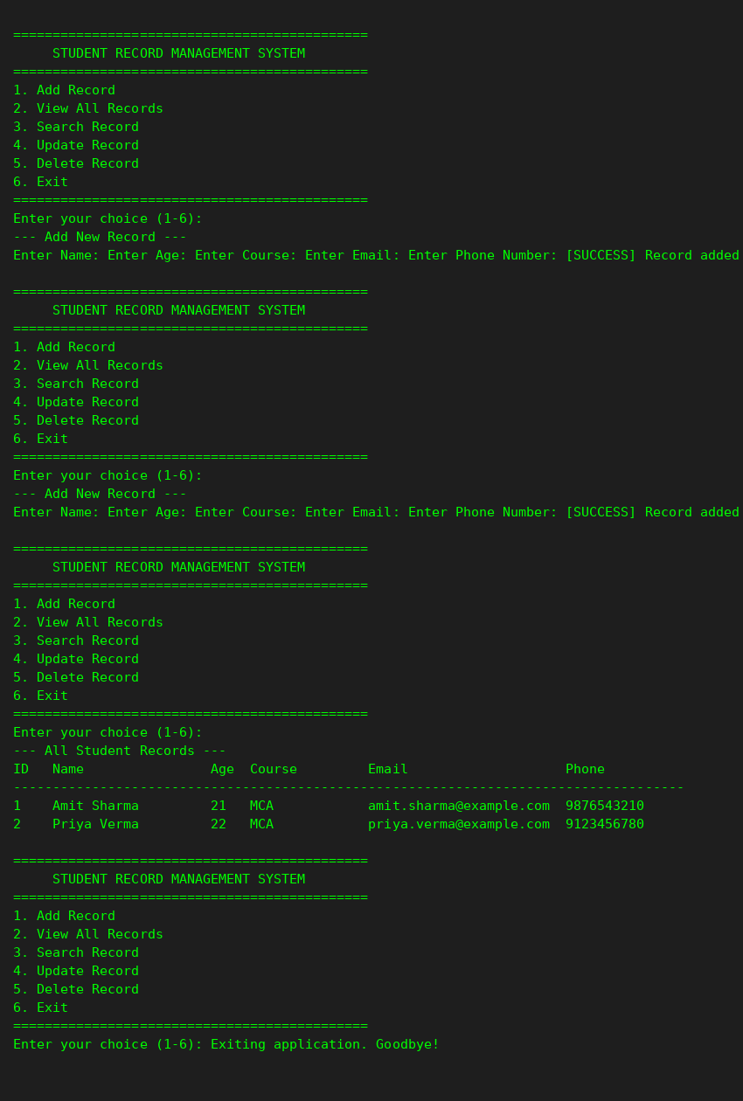

8. Challenges and Learnings
- Designing validation loops that re-prompt on bad input without duplicating code across every field led to extracting reusable helper functions (get_valid_age, get_valid_email, etc.).
- Handling a missing or corrupted data file required distinguishing between different exception types (FileNotFoundError vs json.JSONDecodeError) so the application could recover appropriately in each case.
- Keeping the update function usable required allowing blank input to mean 'keep current value', which needed careful conditional handling per field.

9. Conclusion
This mini project successfully implements a complete, working, menu-driven Console Record-Management Application in Python. It integrates data types and variables, conditional statements and loops, functions, exception handling, and file I/O into a single cohesive system, fulfilling all requirements of Assignment 1. The modular design also provides a natural foundation for future extension, such as replacing JSON file storage with a relational database (e.g. SQLite/MySQL) as covered later in the course.

10. References
- Python Software Foundation, Python 3 Documentation — https://docs.python.org/3/
- Python json module documentation — https://docs.python.org/3/library/json.html
- Course lecture material: MCA Semester I — Python Programming & Relational Database.

