**2.Problem Statement:** **Create a script that demonstrate the use of basic linux commands such as ls,cd,mkdir etc to manage files and directories and various operations**

**1. What command is used to list the files and directories in the current directory?**

Ls -command lists all files and directories in the current working directory.

**2. How do you create a new directory in Linux?**

mkdir directory_name - is used to create a new directory. Replace directory_name with the desired name of your directory**.**

**3. Which command is used to change the current directory?**

cd directory_name - changes the current directory to the specified one. Use cd .. to move up one directory level.

**4. How can you display the contents of a text file in the terminal?**

cat filename - is used to display the contents of a text file. Replace filename with the name of the file.

**5. How do you copy a file from one location to another?**

cp source_file destination_directory - copies a file from the source location to the destination. Replace source_file with the file you want to copy and destination_directory with the target directory.

**6. Which command is used to move or rename a file?**

mv old_name new_name - is used to move or rename a file or directory. Replace old_name with the current name and new_name with the new name or new location.

**7. How do you delete a file in Linux?**

rm filename - removes a file. Replace filename with the name of the file you want to delete.

**8. What command is used to find out your current working directory?**

Pwd - prints the current working directory path.

**9. How do you display the first few lines of a file?**

head filename - shows the first 10 lines of a file by default. You can specify the number of lines using -n (e.g., head -n 5 filename).

**10. Question: How can you check the disk usage of files and directories?**

du

The `du` command estimates the disk space used by files and directories. Use `du -h` for a human-readable format**.**

**11. Which command shows the current user’s login name?**

Who am i

**12.How do you create an empty file in Linux?**

touch filename

**13.How can you delete a directory and all its contents?**

rm -r directory_name

**14.. Question: What command is used to count the number of lines, words, and characters in a file?**

wc filename

**15.. Question: How do you display the current date and time?**

date

**16.Which command shows the last few lines of a file?**

tail filename

**17.How do you search for a specific pattern in a file?**

grep "pattern" filename

**18.Which command will show the amount of free and used memory in the system?**

**free**

**19. What command would you use to compress a file using gzip?**

gzip filename

**20. Which command is used to display your IP address?**

ifconfig

**ls,mkdir,cd,touch,cp,mv,rm,pwd:**

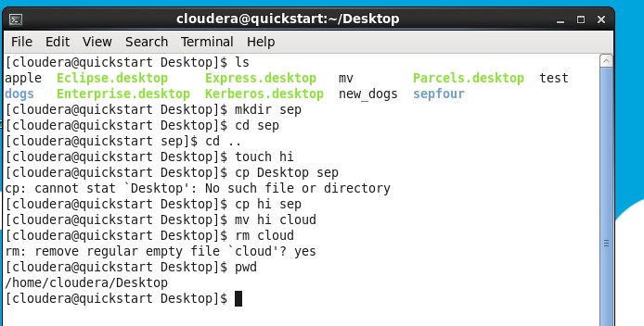

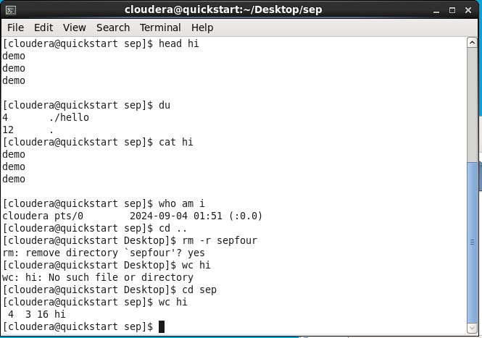**Head,du,cat,who am I,wc:**

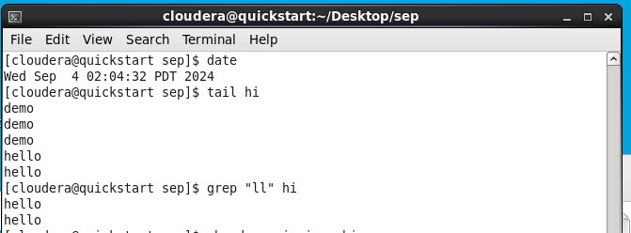**date,tail,grep,free,top:**

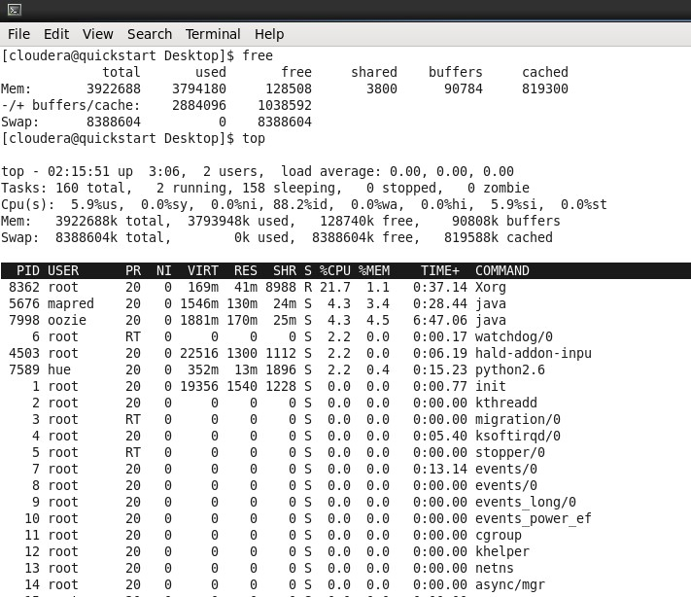

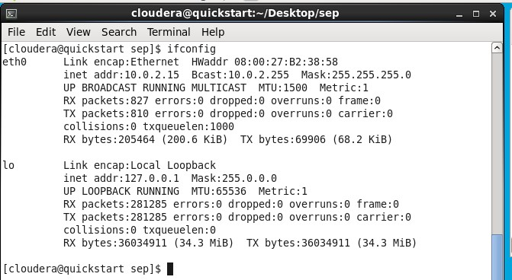**Ifconfig,df -h,uname -a,printenv:**

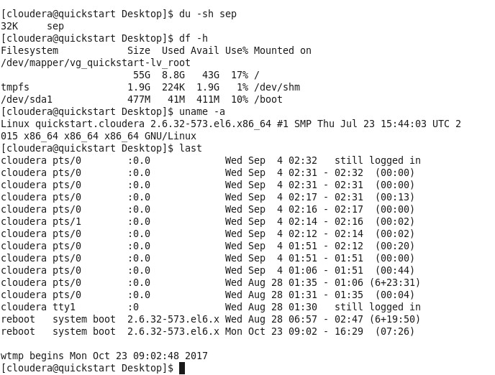

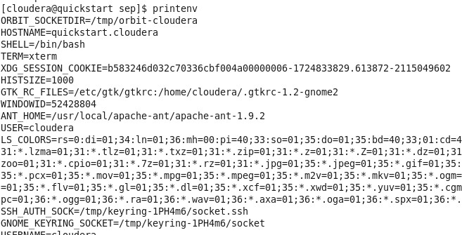

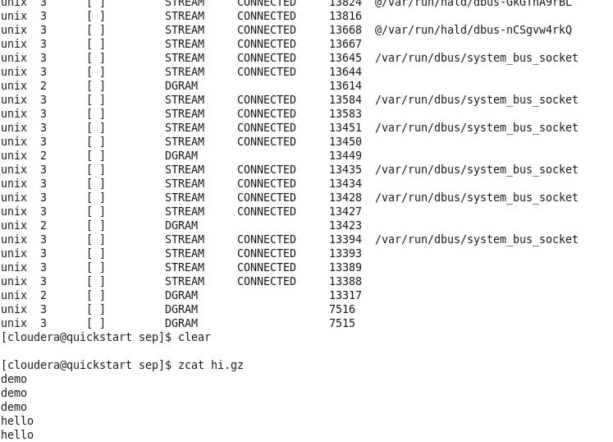**Clear,zcat,passwd,diff,history:**

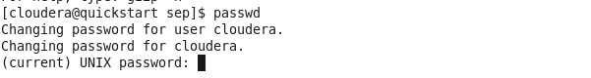

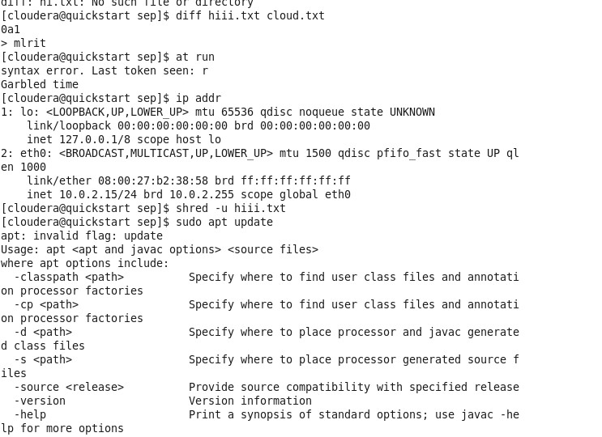

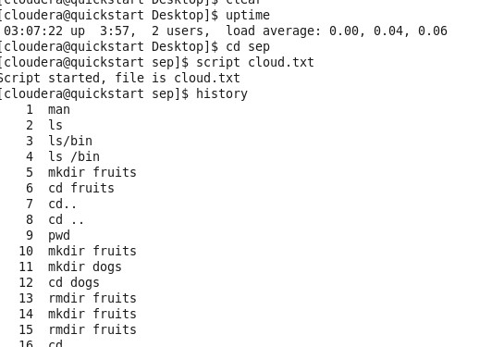

**3.Problem Statement:** **Write a script that demonstrate the basic HDFS shell commands**

**1. How do you list all files and directories in a specific HDFS directory?**

hdfs dfs -ls /path/to/directory

**2. Which command is used to display the contents of a file in HDFS?**

hdfs dfs -cat /path/to/file

**3. How can you create a new directory in HDFS?**

hdfs dfs -mkdir /path/to/new_directory

**4. What command is used to copy files from the local file system to HDFS?**

hdfs dfs -put local_file /path/to/hdfs_directory

**5. How do you retrieve a file from HDFS to the local file system?**

hdfs dfs -get /path/to/hdfs_file /local/destination_directory

**6. Which command can be used to remove a file or directory in HDFS?**

hdfs dfs -rm /path/to/hdfs_file_or_directory

**7. How do you delete a non-empty directory in HDFS?**

hdfs dfs -rm -r /path/to/non_empty_directory

**8. What command is used to check the disk usage of a directory in HDFS?**

hdfs dfs -du -h /path/to/directory

**9. How do you move or rename a file in HDFS?**

hdfs dfs -mv /path/to/source /path/to/destination

**10. Which command will display the last part of a file in HDFS?**

hdfs dfs -tail /path/to/file

**11. How do you merge multiple files into a single file in HDFS?**

hdfs dfs -getmerge /path/to/source_directory /path/to/destination_file

**12. What command is used to change the owner of a file or directory in HDFS?**

hdfs dfs -chown new_owner:new_group /path/to/file_or_directory

**13. Question: How do you change the permissions of a file in HDFS?**

hdfs dfs -chmod 755 /path/to/file_or_directory

**14. Which command will change the group ownership of a file or directory in HDFS?**

hdfs dfs -chgrp new_group /path/to/file_or_directory

**15. How can you set the replication factor for a file in HDFS?**

hdfs dfs -setrep -w replication_factor /path/to/file

**16. What command is used to display the status of a file or directory in HDFS?**

hdfs dfs -stat /path/to/file_or_directory

**17. How do you copy files from one HDFS location to another?**

hdfs dfs -cp /source/path /destination/path

**18. Which command is used to count the number of directories, files, and bytes in HDFS?**

hdfs dfs -count /path/to/directory

**19. Question: How do you check the checksum of a file in HDFS?**

hdfs dfs -checksum /path/to/file

**20. Question: Which command is used to display the HDFS usage summary?**

hdfs dfsadmin -report

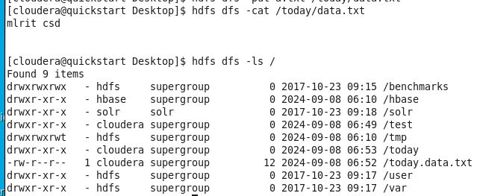**cat , ls :**

**Du,rm:**





**Mkdir ,cp,cat:**

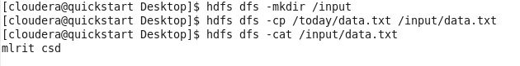

**Get,count,checksum,:**

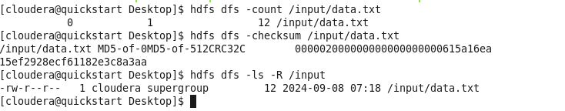

**Stat,tail,mv:**





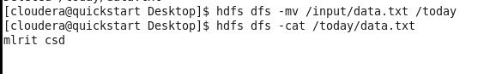

**H,getconf:**

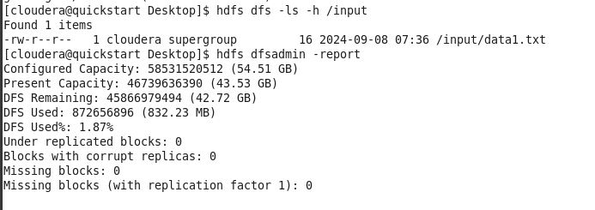



**spaceQuota:**

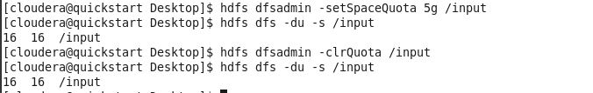

**Safemod:**

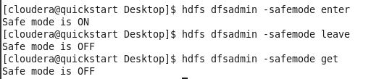

**Snapshot:**

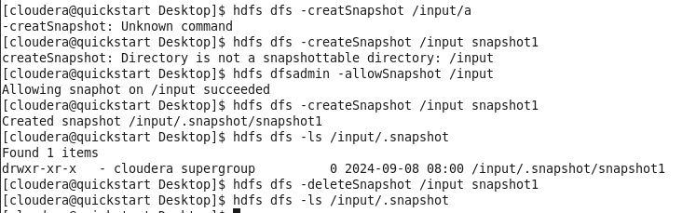

**-rm:**



**-help:**

