**OBJECT ORIENTED ANALYSIS AND DESIGN(OOAD)**

**(PROFESSIONAL ELECTIVE-II)**

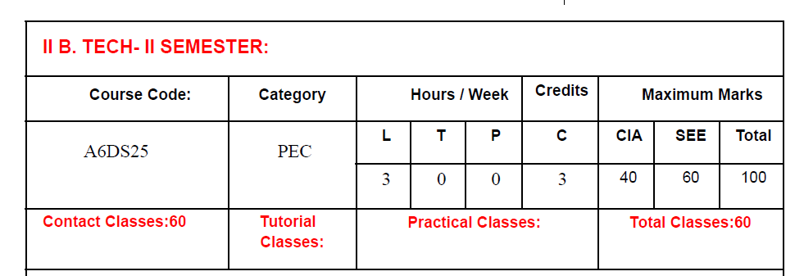

**COURSE OBJECTIVES**

1. To Introduce various designing techniques and methods for object oriented

2. Performance analysis with real time system

3. Demonstrate a familiarity with object-oriented data and system.

4. To give clear idea on implementing design with UML diagram like state diagram, activity

diagram, use case diagram etc

5. To inculcate necessary skills to handle complexity in software design

**COURSE OUTCOMES**

**At the end of the course, student will be able to:**

1. Describe Object Oriented Analysis and Design concepts and apply them to solve problems

2. Prepare Object Oriented Analysis and Design documents for a given problem using Unified Modelling Language

3. Ability to analyze and model software specifications.

4. Ability to abstract object-based views for generic software systems.

5. Ability to deliver robust software components.

**UNIT-I Classes :8**

What is modelling? Object Oriented Thinking, History of UML Building Blocks of UML, Introduction to OMG standards MDA, XMI, UML 2.0. RUP emphasizing Inception, Elaboration, Construction, Transition Phases. 4+1 Architecture, UML Meta model.

Abstraction, the three models, Object and class concepts Basic Class diagrams, Need, purpose & application of UML diagrams, Link and association concepts, Generalization & Inheritance, Navigation of class models.

**UNIT-II Classes-9**

State Modelling: Events, States, Transitions and Conditions, State diagrams, State diagram behaviour. Need, purpose Advanced object and class concepts, Use Case Modelling: Actor Identification, Actor Classification, Actor Generalization, Use Cases Identification, Communication, Uses/Include and Extend Associations, writing a Formal Use Cases, Use Case realizations. Need, purpose

**UNIT-III Classes:8**

Activity Diagram: Activity and Actions, Initial and Final Activity, Activity Edge, Decision and Merge Points, Fork and Join, Input and Output Pins, Activity Group, Activity Partitions, Constraints on Action, Swim Lanes. Sequence Diagram: Context, Objects and Roles, Links, Object Life Line, Message or stimulus, Activation/Focus of Control, Modelling Interactions.

**UNIT-IV Classes:8**

Collaboration Diagram: Objects and Links, Messages and stimuli, Active Objects, Communication Diagram,Iteration Expression, Parallel Execution, Guard Expression, Timing Diagram. Design Using UML Activity Diagram ,Introduction to Patterns General Responsibility Assignment Software Patterns (GRASP) : Introduction, Creator , Information Expert, Low coupling, Controller, High Cohesion, Polymorphism , Pure fabrication, Indirection, Protected Variations. Gang of Four (GoF): Introduction, Categories of Patterns (Creational, Structural and Behavioral Patterns), Singleton, Adapter, State, and Strategy.

**UNIT-V Classes:8**

Component Diagram, Interfaces and ports, Deployment diagrams, Need, purpose & application of above diagrams two, three tier architecture, Concept of Forward Engineering and Reverse Engineering of UML Diagrams Development stages, Development life cycle, devising a system concepts, Elaborating a concept. Preparing problem statements, Overview of analysis, Domain class models, Domain state model, Domain Interaction model.

**Text Books:**

1. Blaha ,Rumbaugh:”Object Oriented Modeling and Design with UML”(2/e) Pearson Education

**Reference Books:**

1. Dathan, Ramnath: “Object Oriented Analysis, Design &Implementation,”OUP.

2. McRobb& Farmer: “Object Oriented System Analysis &Design”McGraw Hill.

3. Booch, Rumbaugh& Jacobson: “The UML User guide”Pearson Education.

4. Whitten & Bentley: “System Analysis & Design Methods”TataMcGraw Hill.

5. Booch: “Object Oriented Analysis & Design with Applications”,Pearson Education.

**6.** Visual modelling with Rational Rose and UML by Terry Quatrani, by Addison-Wesley

Professional