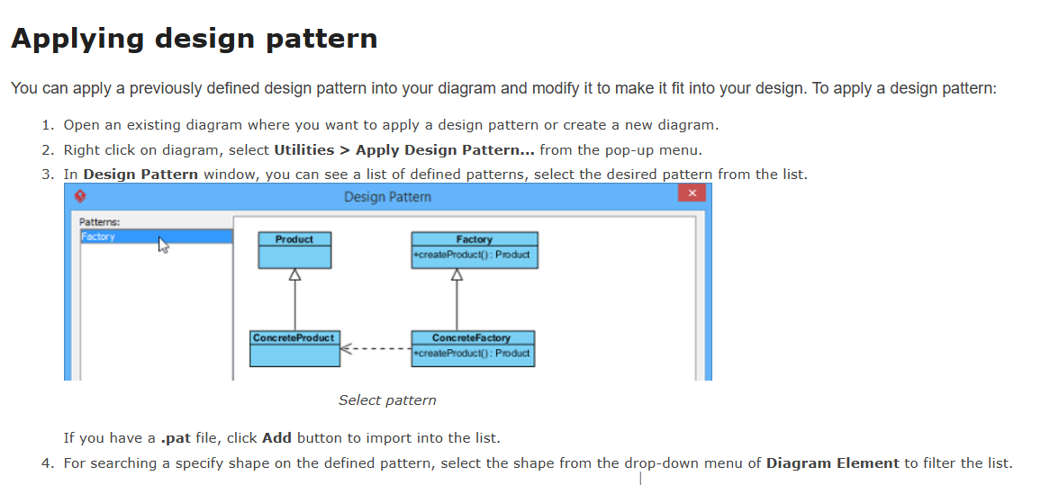

1. You can also click on the shape or select a diagram element from the **Diagram Element** combo box to filter the list.
2. Finally, click **OK** button. The pattern will be applied to the diagram.