**Create line charts in Power BI**

This tutorial uses the Sales and Marketing Sample to create a line chart that displays sales by category.

1. Download the [sample PBIX file](https://download.microsoft.com/download/9/7/6/9767913A-29DB-40CF-8944-9AC2BC940C53/Sales%20and%20Marketing%20Sample%20PBIX.pbix) to your desktop.
2. In Power BI Desktop, select **File** > **Open report**.
3. Browse to and select the **Sales and Marketing Sample PBIX** file, and then select **Open**.
4. The **Sales and Marketing Sample PBIX** file opens in report view.
5. At the bottom, select the green plus symbol https://learn.microsoft.com/en-us/power-bi/visuals/media/power-bi-line-charts/power-bi-plus-green-tab.png to add a new page to the report.

## Create a line chart

In the **Data** pane, expand **SalesFact** and select the checkbox next to **Total units**. Then expand **Date** and select the checkbox next to **Month**. Power BI creates a column chart on your report canvas:

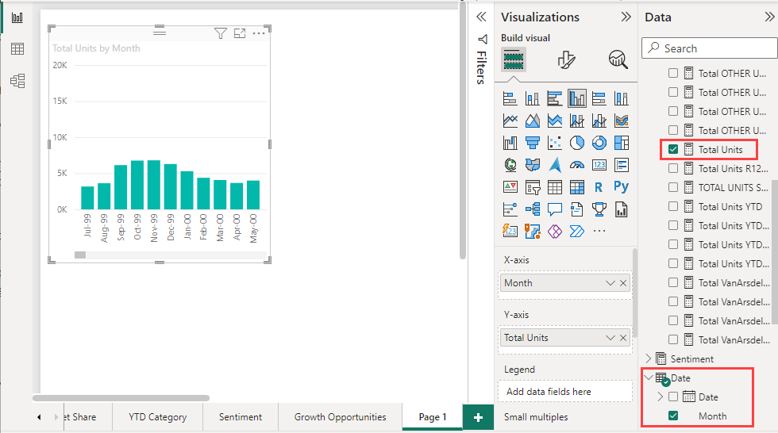

Convert the chart to a line chart by selecting the **Line chart** icon in the **Visualizations** pane:

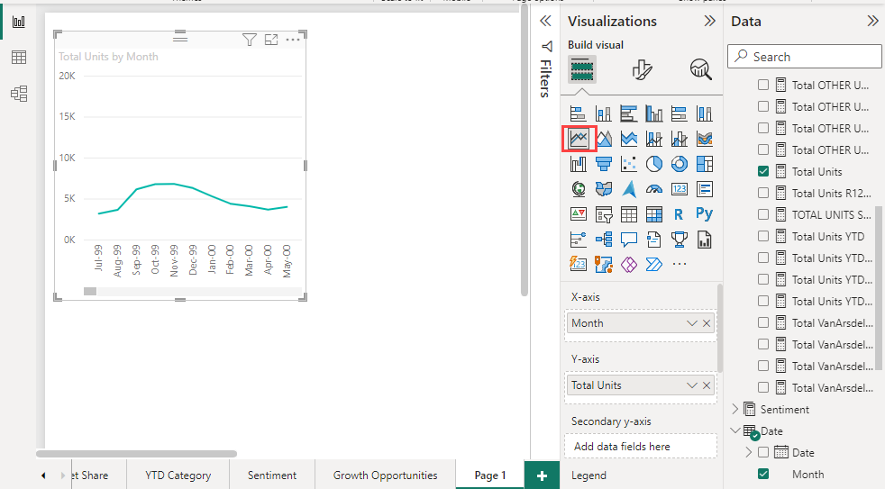

Filter your line chart to show data for the years 2012-2014. If the **Filters** pane is collapsed, expand it. Drag the **Year** field from the **Data** pane to the **Filters** pane. Drop it under the heading **Filters on this visual**:

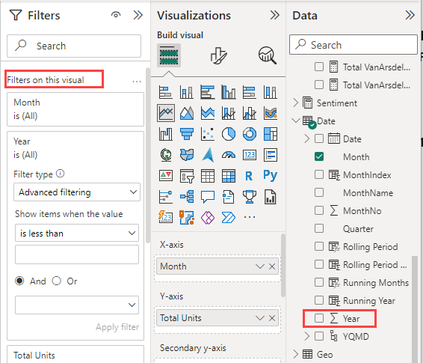

Change **Advanced filtering** to **Basic filtering** and then select **2012**, **2013**, and **2014**.

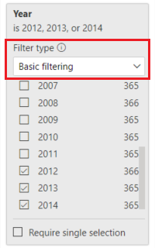

Optionally, [adjust the size and color of the chart's title](https://learn.microsoft.com/en-us/power-bi/visuals/power-bi-visualization-customize-title-background-and-legend).

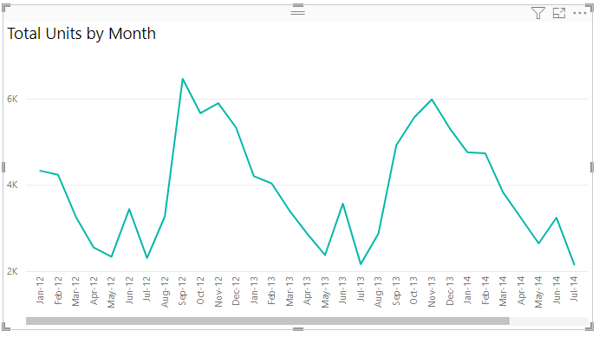

## Add lines to the chart

Line charts can display multiple lines. In some cases, the values on the lines are so different that the lines don't display well together. In this section, you add lines to the chart and learn how to format the chart when the values represented by the lines are different enough to cause display problems.

### Add lines

Instead of looking at total units for all regions as a single line on the chart, you can split out total units by region. Add lines by dragging **Geo** > **Region** to the chart. Here's what it looks like after you add lines:

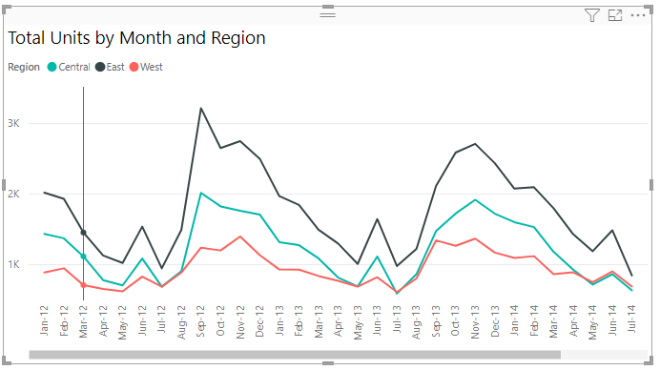

### Use two y axes

What if you want to look at total sales and total units on the same chart? Sales numbers are much higher than unit numbers, so the chart becomes unusable. In fact, the red line for total units appears to be at zero:

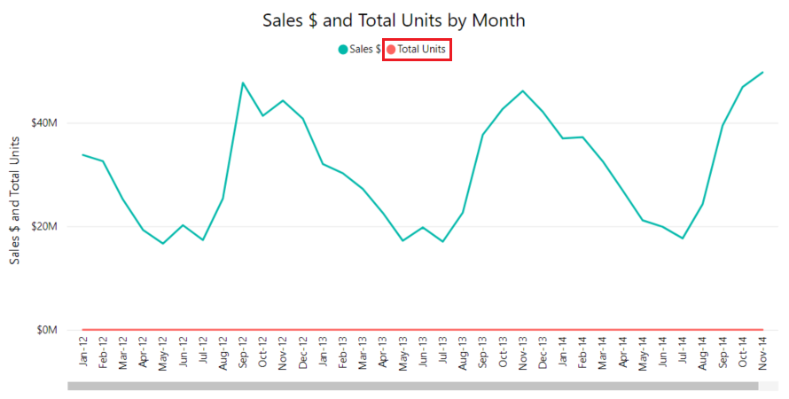

To display highly diverging values on one chart, you can use a combo chart. For more information, see [Combo charts in Power BI](https://learn.microsoft.com/en-us/power-bi/visuals/power-bi-visualization-combo-chart). In the following example, a second y axis is added so we can show sales and total units together on one chart. The new axis is on the right side of the chart.

