Gay Perez

Chairperson

SEAHO Awards and Recognition Committee

Dear Ms. Perez,

It is with great pleasure that I nominate Karen Marrolli for the Graduate Student of the Year for the Southeastern Association of Housing Officers. Karen is a Graduate Hall Director at Louisiana State University and has served in this role for two and a half years. She is a music major who is finishing her dissertation at the present time. I have had the pleasure of supervising Karen over the past semester, and she has constantly demonstrated the qualities of a true leader.

Karen is responsible for all the programming that occurs in the Herget Residential College at LSU, a residential college consisting of 460 residents. Karen has always had a passion for making sure that all programs meet the educational needs of our residents. She provides the staff with a lot of ideas and feedback that assists them in conducting the best programs possible. She works with our rector in order to make sure the academic needs of our residents are being met.

Karen is a wonderful supervisor and does an excellent job managing a twenty-four hour front desk as well a co-supervising the resident assistants. The desk is always fully staffed and Karen has a passion for making sure all our employees are providing excellent customer service. She also serves as a mentor and role model for all our employees at the same time. The Resident Assistants and Desk Assistants always feel comfortable talking to Karen about work problems as well as personal issues.

I cannot think of a graduate student who deserves this award more than Karen does. The residents and staff of Herget Hall are lucky to have her. She is truly a leader and is always willing to go beyond the call of duty.

Sincerely,

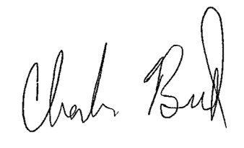

Charles E. Beard

Residence Life Coordinator

Herget Residential College

Department of Residential Life

Louisiana State University

(225) 334-6324

cbeard4@lsu.edu