January 12, 2009

Dear Sir or Madam:

It is with great pleasure that I recommend Laura Templeton for the SEAHO Graduate Student of the Year. I work with her as the Staff Advisory Board advisor at the University of Florida in which she serves as co-advisor from August 2008-Present. The co-advisor is a voluntary position and considered “extra duties” as a graduate assistant. As the SAB advisor, it is important for Laura to be a leader, a role model, and a serious student; all of these things Laura excelled at doing. Laura works hard to successfully maintain her academic status while working twenty-plus hours for residence life and volunteering for the SAB student organization. I see a lot of dedication in Laura. With all of the other activities she was involved in she developed great time management skills in prioritizing her tasks and making time for SAB and students.

Laura has excelled as SAB advisor. Laura serves as a sounding board and gives guidance to the executive board in helping them with programming, staff issues, and recognition efforts. She is very personable and has bonded with the students in a very short time. While the relationships with the individual SAB members are important to Laura, she has been able to balance this professionally with her role as a Graduate Hall Director in East Hall. She is the best cheerleader for the organization, bringing a smile to every meeting and recognizing all members for a job well done. She is essential to the make-up of the executive board dynamic in that she challenges exec board members to think outside the box and is supportive when they do. Laura is a great role model for the SAB organization. Her care and compassion for students is infectious and serves as a template for others to emulate.

Based on my working with Laura, I would highly recommend her for the SEAHO Graduate Student of the Year. If you have any other questions or comments, or would request any further information on Laura, please do not hesitate to contact me at (352) 392-2161 or by email at [jocyndah@housing.ufl.edu](mailto:jocyndah@housing.ufl.edu).

Thank you for your time.

Sincerely,

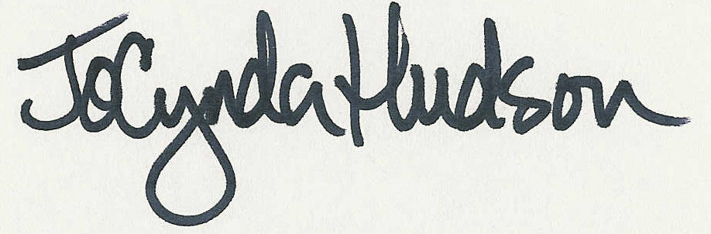

JoCynda Hudson

Coordinator of Residential Judicial Programs

Department of Housing and Residence Education

University of Florida